Pulling twitter data from its REST API
- Overview
In the SMILE application, we have implemented two different searching methods: Searching the content (tweet) by keywords with a set of parameters, and searching the user account by keywords and other parameters. We offer a user-friendly interface to facilitate the searching task, while behind the veil, a GraphQL based data server is handling the heavy lifting of interacting with twitter’s API.

User
Search Interface
(Analytics Server)
Twitter API
GraphQL server
Query
Data

Figure 1. The workflow of pulling data from twitter

GraphQL is a query language for APIs that can full fill queries with any existing data source. In the SMILE application, GraphQL serves as a “middle man” that takes queries from user, assembles the requests and sends them off to Twitter. Twitter’s API provides a way to programmatically access to data from its database using application credentials plus each user’s own credentials. Once twitter have received and validated those requests, data will be returned back correspondingly. GraphQL server then conformed those data to a pre-designed schema and send them back to the analytics server in a JSON format. Analytics server are able to utilize these data for the following computing tasks, as well as be able to convert the data into a tabular format (.csv) and allow downloading.

- Authentication and Authorization
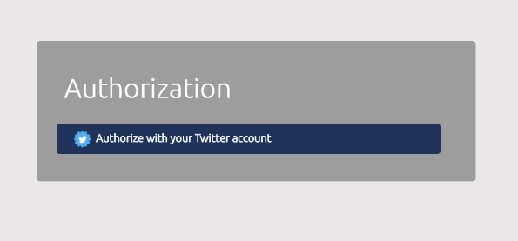
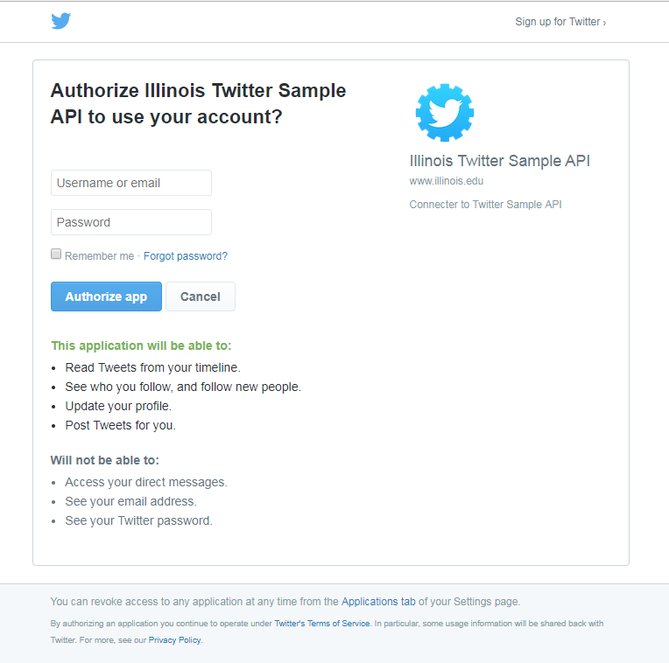

The first time user enters the search page, an authorization must be performed by the user to grant the SMILE application for requesting data from twitter on user’s behalf. After clicking the “Authorize with your Twitter account” button, SMILE will redirect user to the Twitter’s authorize page where it asks for username and password. Once you hit the “authorize app” button, you have successfully fulfilled the process and will be redirect to the SMILE search page. This process follows a generic 3-legged OAuth flow practice.
1
2
3

Figure 2. The authorization process in the SMILE application
OAuth (Open Authorization) is an open protocol for token-based authentication and authorization on the internet. It allows an end user's account information to be used by third-party services (SMILE), without actually exposing the user's password to that services. A 3-legged OAuth flow is illustrated below (figure 3). The main idea behind is: twitter or any social media service will grant the application certain access token which allows application to act on behalf of the user to either retrieve or posting data from those social media.
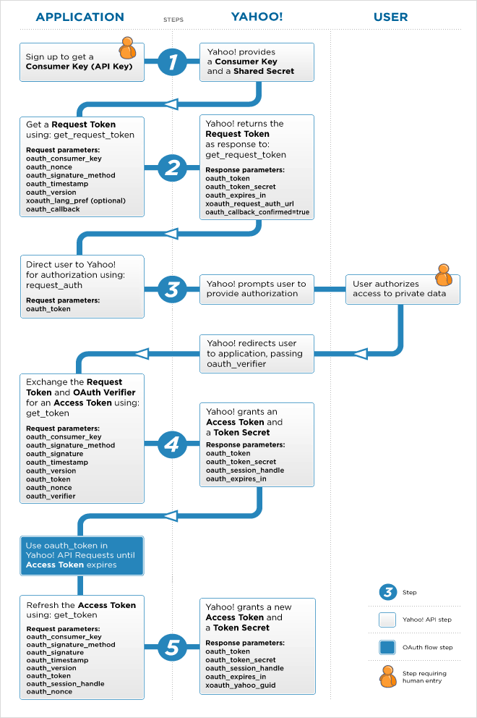
Twitter
SMILE
Twitter
Twitter
Twitter
Twitter
Twitter
Twitter
Twitter
Twitter
Twitter

Figure 3. Three-legged OAuth Flow

- Search Tweets
The Twitter Search API, which is essentially the endpoint of https://api.twitter.com/1.1/search/tweets.json, will return a collection of relevant Tweets matching a specific query. The searches will be performed against a sampling of recent Tweets published in the past 7 days. Each user can specify a few parameters to make their search more accurate:
- English keyword, phrases, numbers, and any combination of them that are no longer than 500 characters
- ; maximum number of tweets

It is important to know that the Search API is focused on relevance and not completeness. This means that some Tweets and users may be missing from search results. If you want to match for completeness you should consider searching against our archived twitter streaming data.
- Search Users
- Pagination
- A Short Intro of GraphQL – the next generation API language
- Data aggregation

https://developer.twitter.com/en/docs
Note: Twitter’s API follows a REST design. REST stands for representational State Transfer which is a web architecture
http://graphql.org/
JSON (JavaScript Object Notation) is a lightweight data-interchange format. It is easy for humans to read and write. It is easy for machines to parse and generate.
https://oauth.net/2/
https://developer.twitter.com/en/docs/tweets/search/api-reference/get-search-tweets.html

