# Object Oriented Programming

# Prof. Fred Stiebler

# ICE-2

# Nischal Shrestha Kasula

SS 1: The initial screen, which is what you see as soon as the app is open

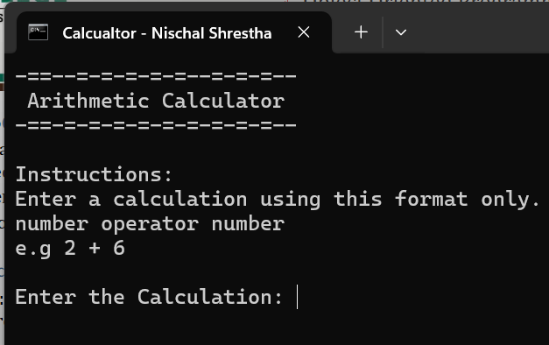

SS 2: Showing the error message and the exit prompt when anything else than ‘/’, ‘*’ ,’+’ ,’-‘ is used.  
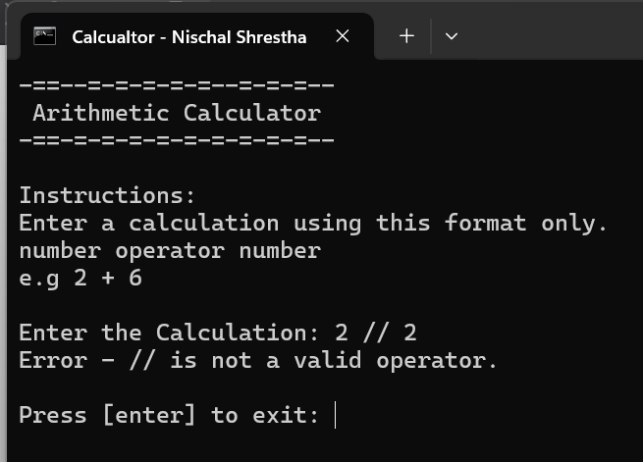

SS 3: Showing the error message and the exit prompt when a calculation with a division by 0 is done.

SS 4: Calculation showing addition of 2 numbers.

SS 5: Calculation showing subtraction of 2 numbers.

SS 6: Calculation showing multiplication of 2 numbers.

SS 7: Calculation showing division of 2 numbers.

❓ QUESTION 1 – In Java what does the arithmetic operator ++ do?  
- It **increments** a variable's value by **1.**

❓ QUESTION 2 – What is the difference between the switch and if statements?  
- Switch cases are used for multiple fixed cases whereas if statements are more flexible, allowing complex conditions, comparisons, and logical operations