Quick Start Guide
A short guide for the Metabolic MRI Processing Toolbox (MeMRI-PTB) which allows converting, processing, quantifying and visualizing raw-export metabolic imaging data i.e. multi-dimensional spectroscopy data from both Siemens and Philips MR platforms in MATLAB.
Designed for both beginner and experienced MATLAB users.
Contents
Installation 1
Github in MATLAB 1
Framework Explained 2
Loading raw data 2
Processing 2
Visualization 3
Quantification 3
Data Converter (Load) 3
Process Data 3

Introduction
Large x-nuclei spectroscopy data sets from high-field MR systems are becoming more prevalent in the recent decades due to technological advances in both hardware and computing power. Increases in RF coil density i.e. phased arrays, allow acquisition over large field of views (FOV) paving the way for upper and lower body MRS applications.
However, MR systems cannot handle these data sets using the conventional reconstruction pipelines and are often poorly documented. New processing methods have been introduced to increase sensitivity through new coil-combination and denoising methods. Therefor raw spectroscopy data is often exported for offline reconstruction.
Multi-centre studies with different MR-system vendors are a crucial part of translating academic research into clinical practice. Unfortunately, there is no consensus on processing methods nor their implementation. Therefore, we collaborated between 4 sites in 3 countries in Europe to streamline data handling and visualization methodology. This resulted in this metabolic MR imaging processing toolbox available for the entire MR spectroscopy community.

Installation
MeMRI PTB can be downloaded from github or retrieved via the MATLAB environment. See below for the latter, assuming git is installed on your PC (see https://gitforwindows.org/ ).
Download: https://github.com/Illuminate-MeMRI/Metabolic-MRI-Processing-Toolbox

Github in MATLAB
Create an empty folder for MeMRI-PTB named Metabolic-MRI-Processing-Toolbox in MATLAB using the “Current Folder” pane via right-click > New > Folder. Open the directory Metabolic-MRI-Processing-Toolbox and right-click inside the white space of the “Current Folder” pane and select “Source Control”. The window below will appear:
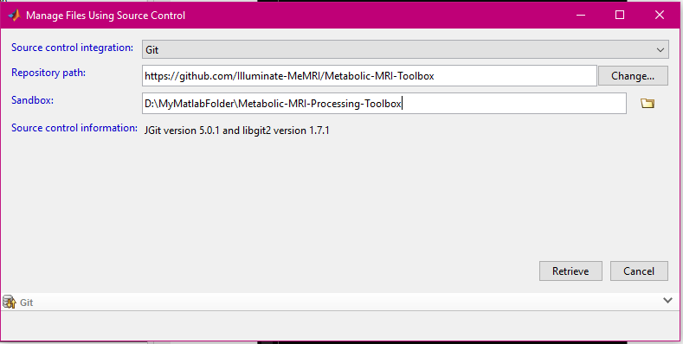
Select Git as “Source Control Integration” and enter the github path “https://github.com/Illuminate-MeMRI/Metabolic-MRI-Processing-Toolbox” in the “Repository path” editfield. Click “retrieve” at the bottom right and wait until MATLAB has downloaded the required files.

Framework
The MeMRI PTB data converter and processing tools can be executed using solely scripts or via a graphical user interface (GUI) and combines four functionalities into one package:
- Converting data
- Processing
- Visualization
- Quantification
The script-of-interest for each function, hard requirements plus a short description is given in the next paragraphs. All scripts-of-interest are found in the root-folder of MeMRI PTB.

Reading raw data
Script(s) of interest: memri_DataConverter_Scripted.m
memri_DataConverter_GUI.m
Convert the raw data into a MATLAB format that includes all necessary parameters to process the spectroscopy data.
Philips exports raw MR spectroscopy data in a list- & data- file format, but lacks and protocol information or parameters. and Siemens exports it in a dat-file format.
The script or GUI load both data sets into MATLAB memory and export is appropriately.,

Processing
Script(s) of interest: memri_Processing_Scripted.m
memri_Processing_GUI.m

Visualization
Script(s) of interest: CSIgui.m
An under-development new light-weight viewing tool will be included in the 2.0 release.

Quantification
Script(s) of interest: memri_Quantification_GUI.m
memri_Quantification_Scripted.m
A customized version of OXSA.

Tutorial
This tutorial will use the example data to demonstrate how to use the MeMRI-PTB. If example data is not present in the root-directory, please check Installation.

Raw Data Converter
Raw MRS data can be loaded into MATLAB’s memory and converted for use with the MeMRI PTB Processing applicatication using the MeMRI PTB DataConverter. In tandem with the memri_loadData() script, conversions are also possible using an application: memri_DataConverter_GUI(). Both use the same underlaying functions to read and preprocess the raw data to a MATLAB friendly format.
Exported data is stored in a struct containing the data

Philips
Raw data from Philips platforms exported as list/data files is supported in combination with a text-file export of protocol information. If the parameter text file is not present, the user is prompted for some hard-requirement parameters, namely: nucleus, magnetic field strength, receiver bandwidth and echo-time.

Siemens
The Siemens twix file contains all necessary information

Noise Measurement
A seperate noise measurement can be added during the conversion process.
List/data also has noise data – if not presented will use that. Siemens standard CSI data does not have this and therefor uses voxel noise.

Process Data

Added new and Clean up of source files. Full module implementation in memriptb app: configuration file to allow new modules i.e. methods. Export and import of all method and parameters plus default options in configuration file. Link between converter and processing app established. Script based processing reduced code - memri-framework implementation across all methods. Many more quality of life improvements. Massive speed improvement overall. Removed lots of memory overhead. Updated function descriptions. Updated sources for specific methods and included pdfs.

Bugfixes everywhere. Output verified with previous pipelines.

