WiDHS Enrollment Service
Scenario Diagrams

Visual examples showing the full lifecycle of enrollment changes
from MMIS starting state through Blue Compass changes
to MMIS transactions and resulting end state

June 28, 2026

Table of Contents

Right-click and select "Update Field" to populate the Table of Contents.

Scenario: S220_001_IRIS (S220/S300) - IRIS New Enrollment Added

1. MMIS Before: No span exists.
2. BC Before: No enrollment exists.
3. BC Change: User adds an IRIS enrollment (03/15/25–12/31/2299). First enrollment for this participant.
4. Txn 1: S300 — Create new enrollment span (Type: O, Status: A, Start Reason: 2L, Stop Reason: not required).
5. MMIS After: Span-A Active (03/15/25–12/31/2299).
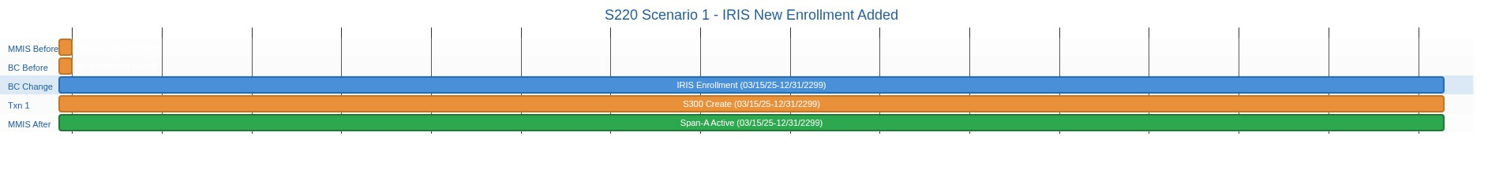
________________________________________________________________________________________________________________________
Enrollment Decision Table Reference (Note: Action #s refer to decision table processing steps which are in a separate document, not diagram rows above):
Scenario: S220_001 - New Enrollment Added. Action #2 sends a new enrollment span to MMIS.

Scenario: S220_001_SDPC (S220/S300) - SDPC New Enrollment Added

1. MMIS Before: No span exists.
2. BC Before: No enrollment exists.
3. BC Change: User adds an SDPC enrollment (03/15/25–12/31/2299). First enrollment for this participant.
4. Txn 1: S300 — Create new enrollment span (Type: A, Status: A).
5. MMIS After: Span-A Active (03/15/25–12/31/2299).
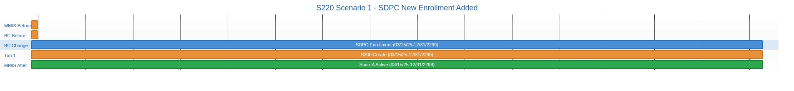
________________________________________________________________________________________________________________________
Enrollment Decision Table Reference (Note: Action #s refer to decision table processing steps which are in a separate document, not diagram rows above):
Scenario: S220_001 - New Enrollment Added. Action #2 sends a new enrollment span to MMIS.

Scenario: S220_002_IRIS (S220/S310/S300) - IRIS Enrollment Begin Date Changed to Earlier Date

1. MMIS Before: Span-B Active (03/15/25–12/31/2299).
2. BC Before: IRIS enrollment (03/15/25–12/31/2299).
3. BC Change: User changes enrollment begin date from 03/15/25 to 02/01/25. Enrollment starts earlier.
4. Txn 1: S310 — Delete existing span (Type: O, Status: I, Start Reason: 2L, Stop Reason: 2W).
5. Txn 2: S300 — Create span with new begin date (Type: O, Status: A, Start Reason: 2L, Stop Reason: not required).
6. MMIS After: Span-B Active (02/01/25–12/31/2299).
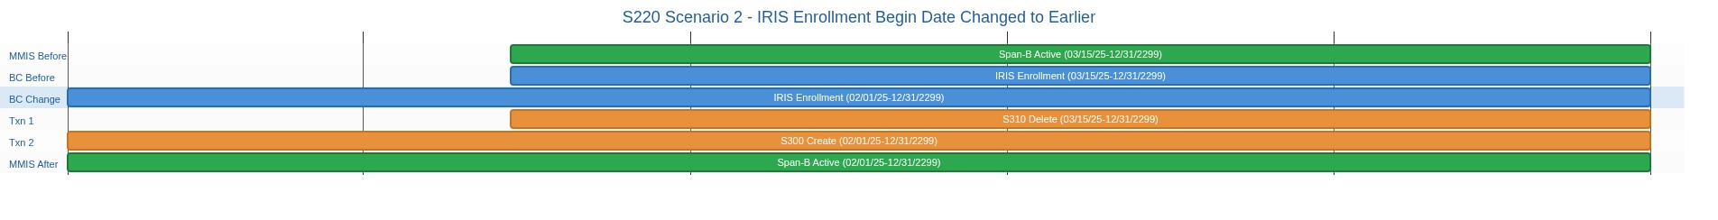
________________________________________________________________________________________________________________________
Enrollment Decision Table Reference (Note: Action #s refer to decision table processing steps which are in a separate document, not diagram rows above):
Scenario: S220_002 - Enrollment begin date changed to earlier date. If a BC enrollment begin date changed then Span-B is the S200-Calculated MMIS span with the earliest begin date and Active status (within the pre-update BC Enrolled span). Action #1 identifies Span-B. Action #4 deletes existing Span-B from MMIS. Action #5 creates a new enrollment span with the new earlier begin date and existing end date.

Scenario: S220_002_SDPC (S220/S310/S300) - SDPC Enrollment Begin Date Changed to Earlier Date

1. MMIS Before: Span-B Active (03/15/25–12/31/2299).
2. BC Before: SDPC enrollment (03/15/25–12/31/2299).
3. BC Change: User changes enrollment begin date from 03/15/25 to 02/01/25. Enrollment starts earlier.
4. Txn 1: S310 — Delete existing span (Type: A, Status: I).
5. Txn 2: S300 — Create span with new begin date (Type: A, Status: A).
6. MMIS After: Span-B Active (02/01/25–12/31/2299).
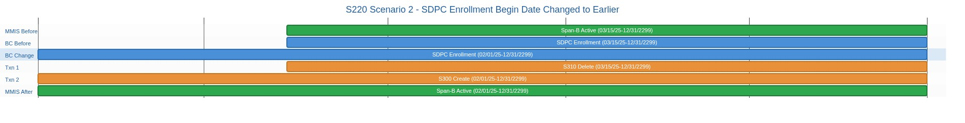
________________________________________________________________________________________________________________________
Enrollment Decision Table Reference (Note: Action #s refer to decision table processing steps which are in a separate document, not diagram rows above):
Scenario: S220_002 - Enrollment begin date changed to earlier date. If a BC enrollment begin date changed then Span-B is the S200-Calculated MMIS span with the earliest begin date and Active status (within the pre-update BC Enrolled span). Action #1 identifies Span-B. Action #4 deletes existing Span-B from MMIS. Action #5 creates a new enrollment span with the new earlier begin date and existing end date.

Scenario: S220_003_IRIS (S220/S310/S300) - IRIS Enrollment Begin Date Changed to Later Date

1. MMIS Before: Span-B Active (02/01/25–12/31/2299).
2. BC Before: IRIS enrollment (02/01/25–12/31/2299).
3. BC Change: User changes enrollment begin date from 02/01/25 to 03/15/25. Enrollment starts later.
4. Txn 1: S310 — Delete existing span (Type: O, Status: I, Start Reason: 2L, Stop Reason: 2W).
5. Txn 2: S300 — Create span with new begin date (Type: O, Status: A, Start Reason: 2L, Stop Reason: not required).
6. MMIS After: Span-B Active (03/15/25–12/31/2299).
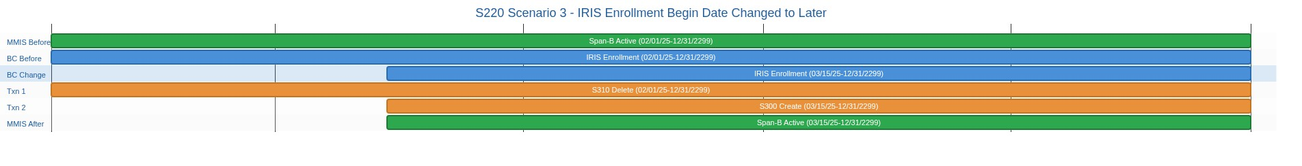
________________________________________________________________________________________________________________________
Enrollment Decision Table Reference (Note: Action #s refer to decision table processing steps which are in a separate document, not diagram rows above):
Scenario: S220_003 - Enrollment begin date changed to later date. If a BC enrollment begin date changed then Span-B is the S200-Calculated MMIS span with the earliest begin date and Active status (within the pre-update BC Enrolled span). Action #1 identifies Span-B. Action #4 deletes existing Span-B from MMIS. Action #5 creates a new enrollment span with the new later begin date and existing end date.

Scenario: S220_003_SDPC (S220/S310/S300) - SDPC Enrollment Begin Date Changed to Later Date

1. MMIS Before: Span-B Active (02/01/25–12/31/2299).
2. BC Before: SDPC enrollment (02/01/25–12/31/2299).
3. BC Change: User changes enrollment begin date from 02/01/25 to 03/15/25. Enrollment starts later.
4. Txn 1: S310 — Delete existing span (Type: A, Status: I).
5. Txn 2: S300 — Create span with new begin date (Type: A, Status: A).
6. MMIS After: Span-B Active (03/15/25–12/31/2299).
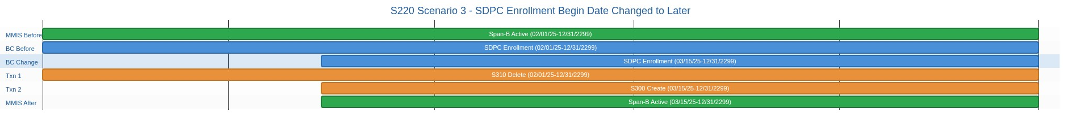
________________________________________________________________________________________________________________________
Enrollment Decision Table Reference (Note: Action #s refer to decision table processing steps which are in a separate document, not diagram rows above):
Scenario: S220_003 - Enrollment begin date changed to later date. If a BC enrollment begin date changed then Span-B is the S200-Calculated MMIS span with the earliest begin date and Active status (within the pre-update BC Enrolled span). Action #1 identifies Span-B. Action #4 deletes existing Span-B from MMIS. Action #5 creates a new enrollment span with the new later begin date and existing end date.

Scenario: S220_004_IRIS (S220/S340) - IRIS Enrollment End Date Changed to Earlier Date (Disenrollment)

1. MMIS Before: Span-B Active (01/01/25–12/31/2299).
2. BC Before: IRIS enrollment (01/01/25–12/31/2299).
3. BC Change: User changes enrollment end date from 12/31/2299 to 06/30/25. Participant disenrolled.
4. Txn 1: S340 — Shorten end date via Closure (Type: C, Status: A, Start Reason: 2W, Stop Reason: 2W). Placeholder — real reason code not yet known.
5. MMIS After: Span-B Active (01/01/25–06/30/25). See next scenario for Step 2 (real reason code).
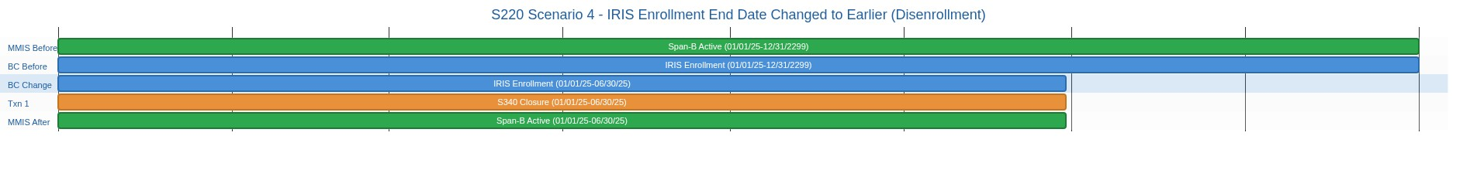
________________________________________________________________________________________________________________________
Enrollment Decision Table Reference (Note: Action #s refer to decision table processing steps which are in a separate document, not diagram rows above):
Scenario: S220_004 - Enrollment end date changed to an earlier date. If a BC enrollment end date changed then Span-B is the S200-Calculated MMIS span with the latest begin date and an Active status (within the pre-update BC Enrolled span). Action #1 identifies Span-B. Action #6 updates Span-B with the new earlier end date.

Scenario: S220_004_SDPC (S220/S340) - SDPC Enrollment End Date Changed to Earlier Date

1. MMIS Before: Span-B Active (01/01/25–12/31/2299).
2. BC Before: SDPC enrollment (01/01/25–12/31/2299).
3. BC Change: User changes enrollment end date from 12/31/2299 to 06/30/25. Participant disenrolled.
4. Txn 1: S340 — Shorten end date via Closure (Type: C, Status: A).
5. MMIS After: Span-B Active (01/01/25–06/30/25).
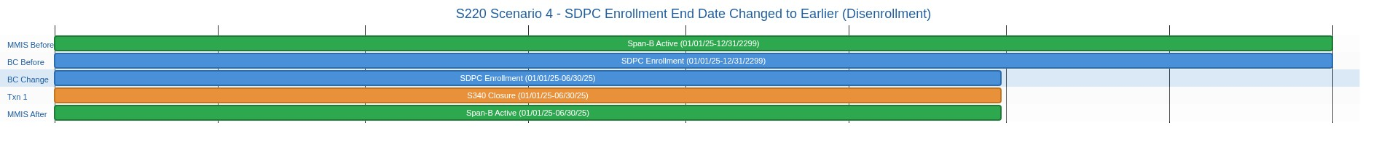
________________________________________________________________________________________________________________________
Enrollment Decision Table Reference (Note: Action #s refer to decision table processing steps which are in a separate document, not diagram rows above):
Scenario: S220_004 - Enrollment end date changed to an earlier date. If a BC enrollment end date changed then Span-B is the S200-Calculated MMIS span with the latest begin date and an Active status (within the pre-update BC Enrolled span). Action #1 identifies Span-B. Action #6 updates Span-B with the new earlier end date.

Scenario: S220_005a_IRIS (S220/S350) - IRIS Enrollment End Date Changed to Later Date (No Suspension)

1. MMIS Before: Span-B Active (01/01/25–06/30/25).
2. BC Before: IRIS enrollment (01/01/25–06/30/25).
3. BC Change: User changes enrollment end date from 06/30/25 to 12/31/2299. Enrollment reopened.
4. Txn 1: S350 — Extend end date (Type: O, Status: A, Start Reason: 2L, Stop Reason: not required).
5. MMIS After: Span-B Active (01/01/25–12/31/2299).
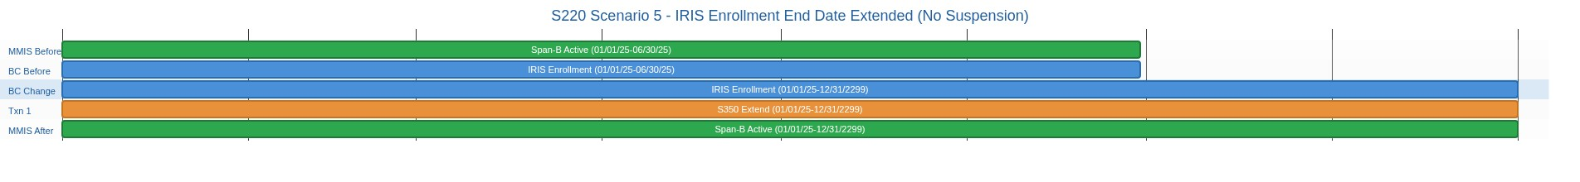
________________________________________________________________________________________________________________________
Enrollment Decision Table Reference (Note: Action #s refer to decision table processing steps which are in a separate document, not diagram rows above):
Scenario: S220_005 - Enrollment end date changed to a later date. If a BC enrollment end date changed then Span-B is the S200-Calculated MMIS span with the latest begin date and an Active status (within the pre-update BC Enrolled span). Action #1 identifies Span-B. Action #7 updates Span-B with the new later end date.

Scenario: S220_005b_IRIS (S220/S350/S360) - IRIS Enrollment End Date Changed to Later Date (With Suspension)

1. MMIS Before: Span-A Active (01/01/25–03/01/25), Span-B Suspended (03/02/25–05/30/25). No Span-C.
2. BC Before: IRIS enrollment (01/01/25–06/30/25), suspension (03/01/25–05/31/25).
3. BC Change: User changes enrollment end date from 06/30/25 to 12/31/2299. Post-suspension span now needed.
4. Txn 1: S350 — Extend Span-A end date (Type: O, Status: A, Start Reason: 2L, Stop Reason: not required).
5. Txn 2: S360 — Create post-suspension enrollment span (Type: O, Status: A, Start Reason: 2Q, Stop Reason: not required).
6. MMIS After: Span-A Active (01/01/25–03/01/25), Span-B Suspended (03/02/25–05/30/25), Span-C Active (05/31/25–12/31/2299).
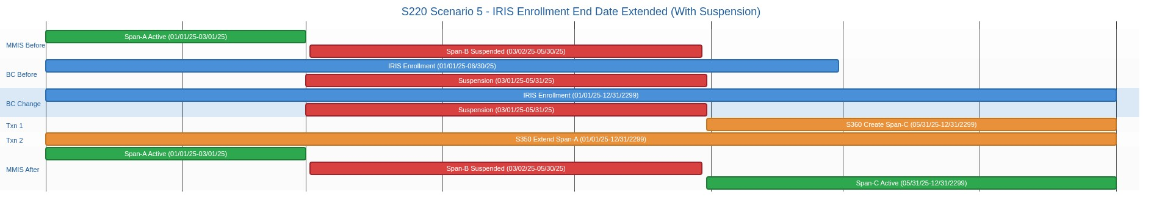
________________________________________________________________________________________________________________________
Enrollment Decision Table Reference (Note: Action #s refer to decision table processing steps which are in a separate document, not diagram rows above):
Scenario: S220_005 - Enrollment end date changed to a later date. If a BC enrollment end date changed then Span-B is the S200-Calculated MMIS span with the latest begin date and an Active status (within the pre-update BC Enrolled span). Action #1 identifies Span-B. Action #7 updates Span-B with the new later end date.

Scenario: S220_005a_SDPC (S220/S350) - SDPC Enrollment End Date Changed to Later Date (No Suspension)

1. MMIS Before: Span-B Active (01/01/25–06/30/25).
2. BC Before: SDPC enrollment (01/01/25–06/30/25).
3. BC Change: User changes enrollment end date from 06/30/25 to 12/31/2299. Enrollment reopened.
4. Txn 1: S350 — Extend end date (Type: A, Status: A).
5. MMIS After: Span-B Active (01/01/25–12/31/2299).
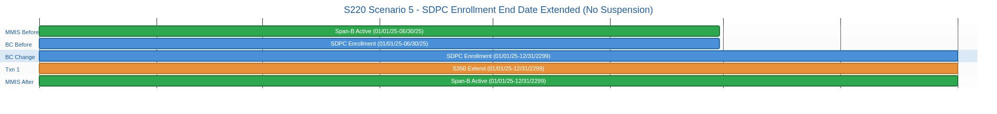
________________________________________________________________________________________________________________________
Enrollment Decision Table Reference (Note: Action #s refer to decision table processing steps which are in a separate document, not diagram rows above):
Scenario: S220_005 - Enrollment end date changed to a later date. If a BC enrollment end date changed then Span-B is the S200-Calculated MMIS span with the latest begin date and an Active status (within the pre-update BC Enrolled span). Action #1 identifies Span-B. Action #7 updates Span-B with the new later end date.

Scenario: S220_005b_SDPC (S220/S350/S360) - SDPC Enrollment End Date Changed to Later Date (With Suspension)

1. MMIS Before: Span-A Active (01/01/25–03/01/25), Span-B Suspended (03/02/25–05/30/25). No Span-C.
2. BC Before: SDPC enrollment (01/01/25–06/30/25), suspension (03/01/25–05/31/25).
3. BC Change: User changes enrollment end date from 06/30/25 to 12/31/2299. Post-suspension span now needed.
4. Txn 1: S350 — Extend Span-A end date (Type: A, Status: A).
5. Txn 2: S360 — Create post-suspension enrollment span (Type: A, Status: A).
6. MMIS After: Span-A Active (01/01/25–03/01/25), Span-B Suspended (03/02/25–05/30/25), Span-C Active (05/31/25–12/31/2299).
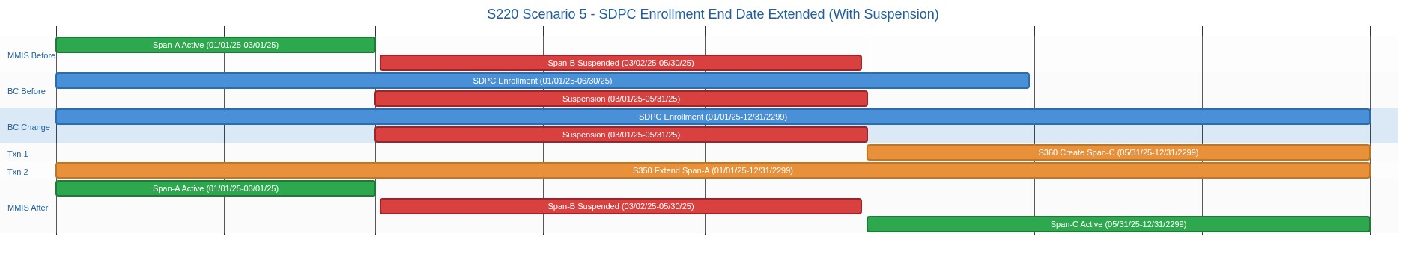
________________________________________________________________________________________________________________________
Enrollment Decision Table Reference (Note: Action #s refer to decision table processing steps which are in a separate document, not diagram rows above):
Scenario: S220_005 - Enrollment end date changed to a later date. If a BC enrollment end date changed then Span-B is the S200-Calculated MMIS span with the latest begin date and an Active status (within the pre-update BC Enrolled span). Action #1 identifies Span-B. Action #7 updates Span-B with the new later end date.

Scenario: S220_006_IRIS (S220/S310) - IRIS Enrollment Deleted (Referral Withdrawn)

1. MMIS Before: Span-B Active (03/15/25–12/31/2299).
2. BC Before: IRIS enrollment (03/15/25–12/31/2299).
3. BC Change: User changes enrollment status to Referral Withdrawn. Enrollment removed entirely.
4. Txn 1: S310 — Delete enrollment span (Type: O, Status: I, Start Reason: 2L, Stop Reason: 2W).
5. MMIS After: No spans remain.
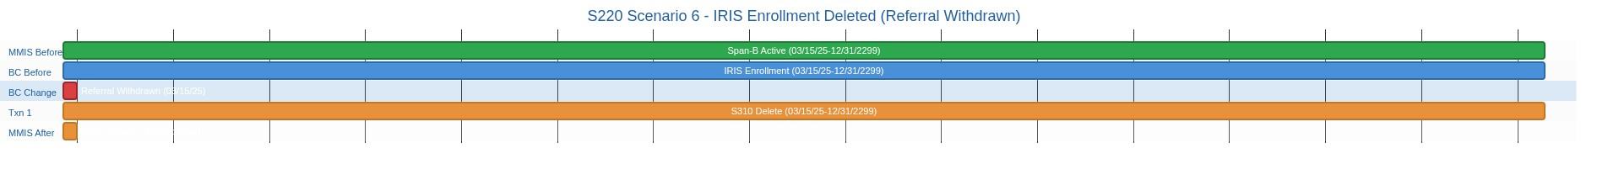
________________________________________________________________________________________________________________________
Enrollment Decision Table Reference (Note: Action #s refer to decision table processing steps which are in a separate document, not diagram rows above):
Scenario: S220_006 - Enrollment status changed from 'Enrolled' to 'Referral Withdrawn'. If BC Enrolled changes to Referral Withdrawn there is only one S200-Calculated MMIS span with an Active Status (dates would match the pre-update BC Enrolled span). Action #1 identifies Span-B. Action #3 sends an Inactivate request to delete Span-B.

Scenario: S220_006_SDPC (S220/S310) - SDPC Enrollment Deleted (Referral Withdrawn)

1. MMIS Before: Span-B Active (03/15/25–12/31/2299).
2. BC Before: SDPC enrollment (03/15/25–12/31/2299).
3. BC Change: User changes enrollment status to Referral Withdrawn. Enrollment removed entirely.
4. Txn 1: S310 — Delete enrollment span (Type: A, Status: I).
5. MMIS After: No spans remain.
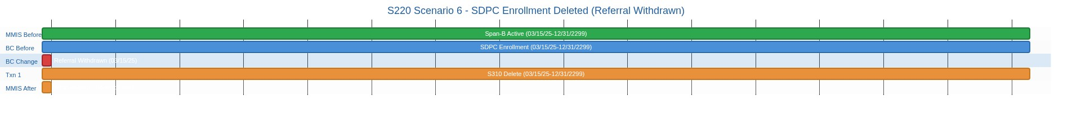
________________________________________________________________________________________________________________________
Enrollment Decision Table Reference (Note: Action #s refer to decision table processing steps which are in a separate document, not diagram rows above):
Scenario: S220_006 - Enrollment status changed from 'Enrolled' to 'Referral Withdrawn'. If BC Enrolled changes to Referral Withdrawn there is only one S200-Calculated MMIS span with an Active Status (dates would match the pre-update BC Enrolled span). Action #1 identifies Span-B. Action #3 sends an Inactivate request to delete Span-B.

Scenario: S230_001_IRIS (S230/S400/S410/S510) - IRIS Suspense Begin Date Changed to Earlier Date

1. MMIS Before: Span-A Active (01/01/25–03/01/25), Span-B Suspended (03/02/25–05/30/25), Span-C Active (05/31/25–12/31/2299).
2. BC Before: IRIS enrollment (01/01/25–12/31/2299), suspension (03/01/25–05/31/25).
3. BC Change: User changes suspension begin date from 03/01/25 to 02/01/25. Suspension starts earlier.
4. Txn 1: S400 — Shorten Span-A end date to 02/01/25 (Type: C, Status: A, Start Reason: 2I, Stop Reason: 2I).
5. Txn 2: S410 — Delete existing Span-B (Type: O, Status: I, Start Reason: 2L, Stop Reason: 2W).
6. Txn 3: S510 — Create new Span-B with earlier begin 02/02/25 (Type: O, Status: S, Start Reason: 2I, Stop Reason: 2I).
7. MMIS After: Span-A Active (01/01/25–02/01/25), Span-B Suspended (02/02/25–05/30/25), Span-C Active (05/31/25–12/31/2299).
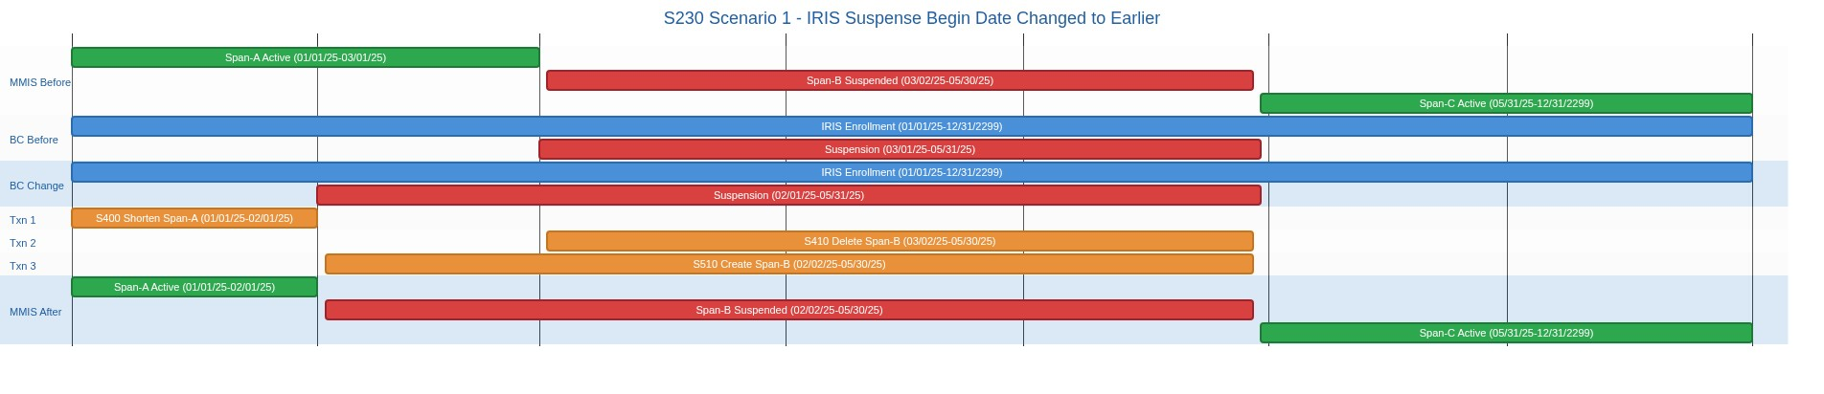
________________________________________________________________________________________________________________________
Enrollment Decision Table Reference (Note: Action #s refer to decision table processing steps which are in a separate document, not diagram rows above):
Scenario: S230_001 - Suspense begin date changed to earlier date. Span-B is the S200-Calculated MMIS Suspense Span that was changed (match on pre-update begin date). Span-A is the S200-Calculated MMIS span that immediately precedes Span-B. Action #1 identifies Span-B. Action #2 identifies Span-A. Action #4 deletes existing Span-A from MMIS (exact begin/end date match, Status I) to make room for the new earlier suspension begin. Action #5 deletes existing Span-B from MMIS (exact begin/end date match, Status I). Action #7 recreates Span-A with original begin date and new end date = (new BC suspension begin date - 1). Action #8 creates a new suspense span with begin date = (new BC suspension begin date [offset: +1 day]) and existing end date. Order is mandatory: S310 first (delete Span-A), S410 second (delete Span-B), S300 third (recreate Span-A), S510 last (create new Span-B). 4 MMIS transactions.

Scenario: S230_001_SDPC (S230/S400/S410/S510) - SDPC Suspense Begin Date Changed to Earlier Date

1. MMIS Before: Span-A Active (01/01/25–03/01/25), Span-B Suspended (03/02/25–05/30/25), Span-C Active (05/31/25–12/31/2299).
2. BC Before: SDPC enrollment (01/01/25–12/31/2299), suspension (03/01/25–05/31/25).
3. BC Change: User changes suspension begin date from 03/01/25 to 02/01/25. Suspension starts earlier.
4. Txn 1: S400 — Shorten Span-A end date to 02/01/25 (Type: C, Status: A).
5. Txn 2: S410 — Delete existing Span-B (Type: A, Status: I).
6. Txn 3: S510 — Create new Span-B with earlier begin 02/02/25 (Type: A, Status: S).
7. MMIS After: Span-A Active (01/01/25–02/01/25), Span-B Suspended (02/02/25–05/30/25), Span-C Active (05/31/25–12/31/2299).
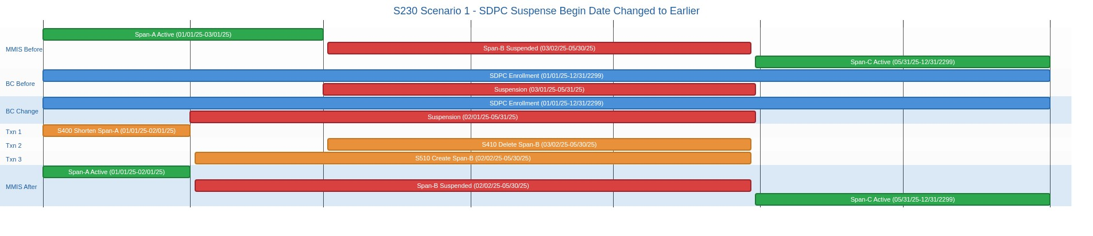
________________________________________________________________________________________________________________________
Enrollment Decision Table Reference (Note: Action #s refer to decision table processing steps which are in a separate document, not diagram rows above):
Scenario: S230_001 - Suspense begin date changed to earlier date. Span-B is the S200-Calculated MMIS Suspense Span that was changed (match on pre-update begin date). Span-A is the S200-Calculated MMIS span that immediately precedes Span-B. Action #1 identifies Span-B. Action #2 identifies Span-A. Action #4 deletes existing Span-A from MMIS (exact begin/end date match, Status I) to make room for the new earlier suspension begin. Action #5 deletes existing Span-B from MMIS (exact begin/end date match, Status I). Action #7 recreates Span-A with original begin date and new end date = (new BC suspension begin date - 1). Action #8 creates a new suspense span with begin date = (new BC suspension begin date [offset: +1 day]) and existing end date. Order is mandatory: S310 first (delete Span-A), S410 second (delete Span-B), S300 third (recreate Span-A), S510 last (create new Span-B). 4 MMIS transactions.

Scenario: S230_002_IRIS (S230/S410/S510/S400) - IRIS Suspense Begin Date Changed to Later Date

1. MMIS Before: Span-A Active (01/01/25–03/01/25), Span-B Suspended (03/02/25–05/30/25), Span-C Active (05/31/25–12/31/2299).
2. BC Before: IRIS enrollment (01/01/25–12/31/2299), suspension (03/01/25–05/31/25).
3. BC Change: User changes suspension begin date from 03/01/25 to 04/01/25. Suspension starts later.
4. Txn 1: S410 — Delete existing Span-B (Type: O, Status: I, Start Reason: 2L, Stop Reason: 2W).
5. Txn 2: S510 — Create new Span-B with later begin 04/02/25 (Type: O, Status: S, Start Reason: 2I, Stop Reason: 2I).
6. Txn 3: S400 — Extend Span-A end date to 04/01/25 (Type: O, Status: A, Start Reason: 2I, Stop Reason: 2I).
7. MMIS After: Span-A Active (01/01/25–04/01/25), Span-B Suspended (04/02/25–05/30/25), Span-C Active (05/31/25–12/31/2299).
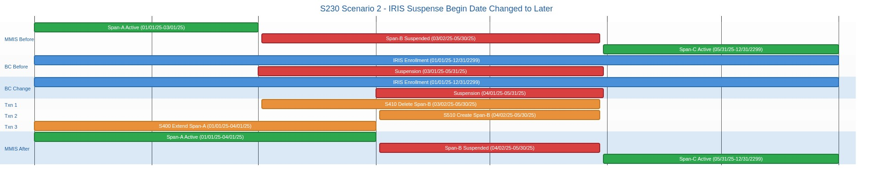
________________________________________________________________________________________________________________________
Enrollment Decision Table Reference (Note: Action #s refer to decision table processing steps which are in a separate document, not diagram rows above):
Scenario: S230_002 - Suspense begin date changed to later date. Span-B is the S200-Calculated MMIS Suspense Span that was changed (match on pre-update begin date). Span-A is the S200-Calculated MMIS span that immediately precedes Span-B. Action #1 identifies Span-B. Action #2 identifies Span-A. Action #5 deletes existing Span-B from MMIS. Action #8 creates a new suspense span with the new later begin date and existing end date. Action #11 extends Span-A end date to backfill the gap. Order: S410 first (delete old Span-B, creates large gap), then S510 (create new Span-B), then S400 (extend Span-A to fill remaining gap). 3 MMIS transactions.

Scenario: S230_002_SDPC (S230/S410/S510/S400) - SDPC Suspense Begin Date Changed to Later Date

1. MMIS Before: Span-A Active (01/01/25–03/01/25), Span-B Suspended (03/02/25–05/30/25), Span-C Active (05/31/25–12/31/2299).
2. BC Before: SDPC enrollment (01/01/25–12/31/2299), suspension (03/01/25–05/31/25).
3. BC Change: User changes suspension begin date from 03/01/25 to 04/01/25. Suspension starts later.
4. Txn 1: S410 — Delete existing Span-B (Type: A, Status: I).
5. Txn 2: S510 — Create new Span-B with later begin 04/02/25 (Type: A, Status: S).
6. Txn 3: S400 — Extend Span-A end date to 04/01/25 (Type: A, Status: A).
7. MMIS After: Span-A Active (01/01/25–04/01/25), Span-B Suspended (04/02/25–05/30/25), Span-C Active (05/31/25–12/31/2299).
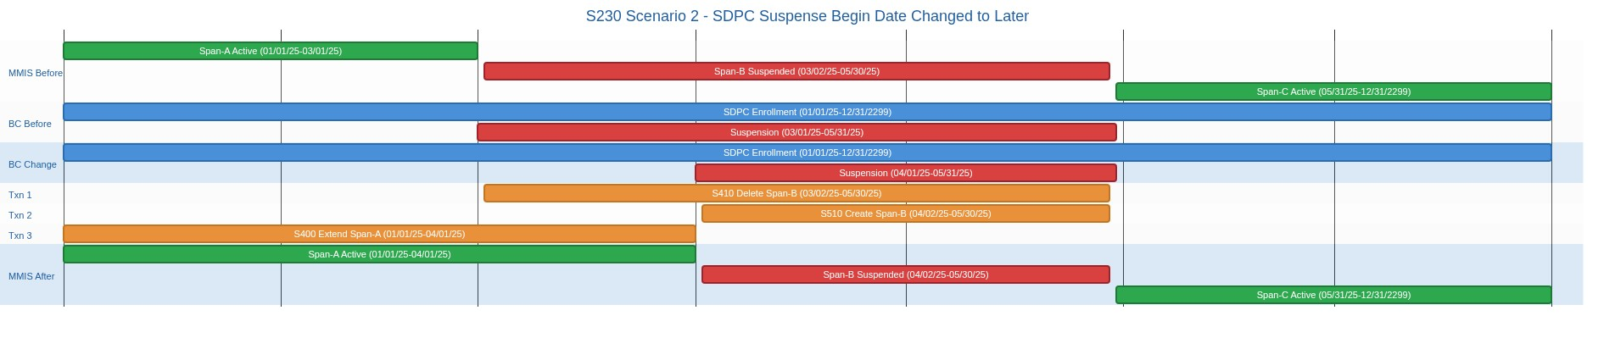
________________________________________________________________________________________________________________________
Enrollment Decision Table Reference (Note: Action #s refer to decision table processing steps which are in a separate document, not diagram rows above):
Scenario: S230_002 - Suspense begin date changed to later date. Span-B is the S200-Calculated MMIS Suspense Span that was changed (match on pre-update begin date). Span-A is the S200-Calculated MMIS span that immediately precedes Span-B. Action #1 identifies Span-B. Action #2 identifies Span-A. Action #5 deletes existing Span-B from MMIS. Action #8 creates a new suspense span with the new later begin date and existing end date. Action #11 extends Span-A end date to backfill the gap. Order: S410 first (delete old Span-B, creates large gap), then S510 (create new Span-B), then S400 (extend Span-A to fill remaining gap). 3 MMIS transactions.

Scenario: S230_003_IRIS (S230/S440/S310/S520) - IRIS Suspense End Date Changed to Earlier Date

1. MMIS Before: Span-A Active (01/01/25–03/01/25), Span-B Suspended (03/02/25–05/30/25), Span-C Active (05/31/25–12/31/2299).
2. BC Before: IRIS enrollment (01/01/25–12/31/2299), suspension (03/01/25–05/31/25).
3. BC Change: User changes suspension end date from 05/31/25 to 04/15/25. Suspension ends earlier.
4. Txn 1: S440 — Shorten Span-B end date to 04/14/25 (Type: C, Status: S, Start Reason: 2Q, Stop Reason: 2W).
5. Txn 2: S310 — Delete existing Span-C (Type: O, Status: I, Start Reason: 2L, Stop Reason: 2W).
6. Txn 3: S520 — Create new Span-C with begin 04/15/25 (Type: O, Status: A, Start Reason: 2Q, Stop Reason: not required).
7. MMIS After: Span-A Active (01/01/25–03/01/25), Span-B Suspended (03/02/25–04/14/25), Span-C Active (04/15/25–12/31/2299).
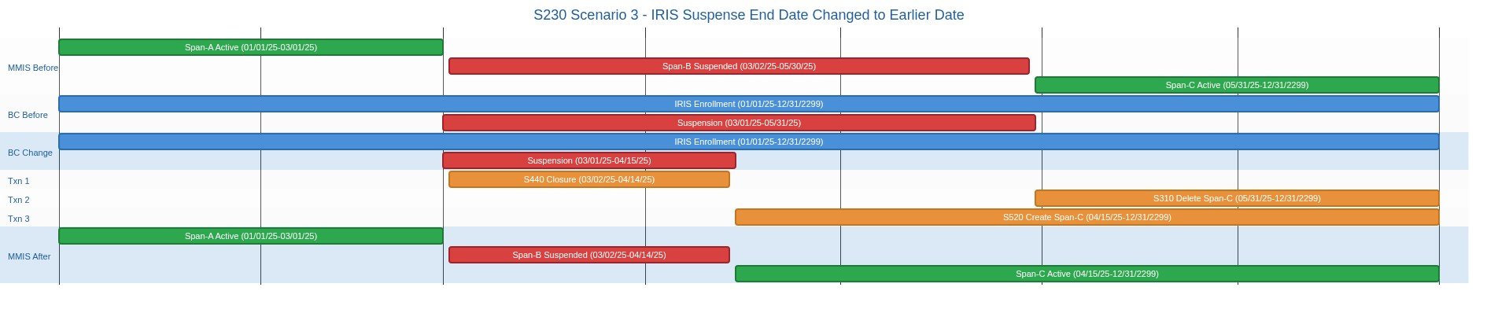
________________________________________________________________________________________________________________________
Enrollment Decision Table Reference (Note: Action #s refer to decision table processing steps which are in a separate document, not diagram rows above):
Scenario: S230_003 - Suspense end date changed from a valid date less than 12/31/2299 to an earlier valid date. Span-B is the S200-Calculated MMIS Suspense Span that was changed (match on pre-update begin date). Span-C is the S200-Calculated MMIS span that immediately succeeds Span-B. Action #1 identifies Span-B. Action #3 identifies Span-C. Action #5 deletes existing Span-B from MMIS (exact begin/end date match, Status I). Action #6 deletes existing Span-C from MMIS (exact begin/end date match, Status I). Action #9 recreates Span-B with original begin date and new earlier end date (new BC suspension end date [offset: -1 day]). Action #10 creates a new active enrollment span (Span-C) with begin date = (Span-B's MMIS end date + 1 = new BC suspension end date) and end date from original Span-C. Order is mandatory: S410 first (delete Span-B), S310 second (delete Span-C), S510 third (recreate Span-B with new end date), S520 last (recreate Span-C). 4 MMIS transactions.

Scenario: S230_003_SDPC (S230/S440/S310/S520) - SDPC Suspense End Date Changed to Earlier Date

1. MMIS Before: Span-A Active (01/01/25–03/01/25), Span-B Suspended (03/02/25–05/30/25), Span-C Active (05/31/25–12/31/2299).
2. BC Before: SDPC enrollment (01/01/25–12/31/2299), suspension (03/01/25–05/31/25).
3. BC Change: User changes suspension end date from 05/31/25 to 04/15/25. Suspension ends earlier.
4. Txn 1: S440 — Shorten Span-B end date to 04/14/25 (Type: C, Status: S).
5. Txn 2: S310 — Delete existing Span-C (Type: A, Status: I).
6. Txn 3: S520 — Create new Span-C with begin 04/15/25 (Type: A, Status: A).
7. MMIS After: Span-A Active (01/01/25–03/01/25), Span-B Suspended (03/02/25–04/14/25), Span-C Active (04/15/25–12/31/2299).
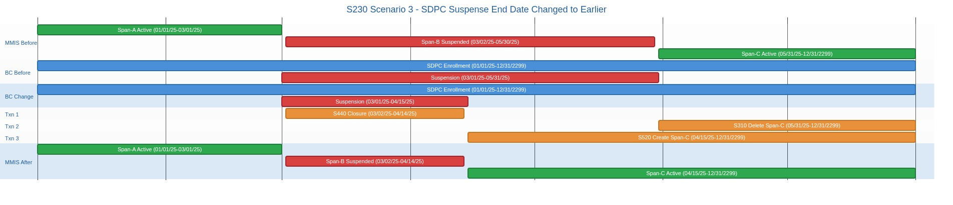
________________________________________________________________________________________________________________________
Enrollment Decision Table Reference (Note: Action #s refer to decision table processing steps which are in a separate document, not diagram rows above):
Scenario: S230_003 - Suspense end date changed from a valid date less than 12/31/2299 to an earlier valid date. Span-B is the S200-Calculated MMIS Suspense Span that was changed (match on pre-update begin date). Span-C is the S200-Calculated MMIS span that immediately succeeds Span-B. Action #1 identifies Span-B. Action #3 identifies Span-C. Action #5 deletes existing Span-B from MMIS (exact begin/end date match, Status I). Action #6 deletes existing Span-C from MMIS (exact begin/end date match, Status I). Action #9 recreates Span-B with original begin date and new earlier end date (new BC suspension end date [offset: -1 day]). Action #10 creates a new active enrollment span (Span-C) with begin date = (Span-B's MMIS end date + 1 = new BC suspension end date) and end date from original Span-C. Order is mandatory: S410 first (delete Span-B), S310 second (delete Span-C), S510 third (recreate Span-B with new end date), S520 last (recreate Span-C). 4 MMIS transactions.

Scenario: S230_004_IRIS (S230/S310/S445/S520) - IRIS Suspense End Date Changed to Later Date

1. MMIS Before: Span-A Active (01/01/25–03/01/25), Span-B Suspended (03/02/25–05/30/25), Span-C Active (05/31/25–12/31/2299).
2. BC Before: IRIS enrollment (01/01/25–12/31/2299), suspension (03/01/25–05/31/25).
3. BC Change: User changes suspension end date from 05/31/25 to 07/15/25. Suspension extended.
4. Txn 1: S310 — Delete existing Span-C (Type: O, Status: I, Start Reason: 2L, Stop Reason: 2W).
5. Txn 2: S445 — Extend Span-B end date to 07/14/25 (Type: O, Status: S, Start Reason: 2I, Stop Reason: 2I).
6. Txn 3: S520 — Create new Span-C with begin 07/15/25 (Type: O, Status: A, Start Reason: 2Q, Stop Reason: not required).
7. MMIS After: Span-A Active (01/01/25–03/01/25), Span-B Suspended (03/02/25–07/14/25), Span-C Active (07/15/25–12/31/2299).
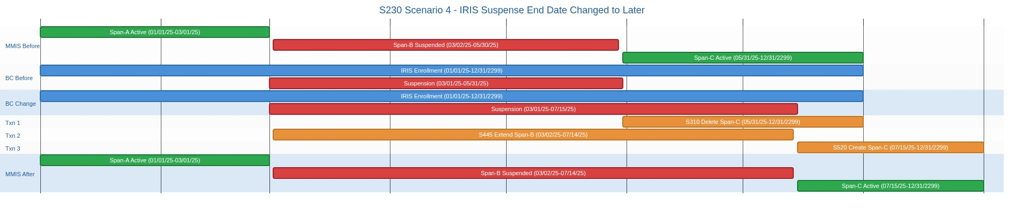
________________________________________________________________________________________________________________________
Enrollment Decision Table Reference (Note: Action #s refer to decision table processing steps which are in a separate document, not diagram rows above):
Scenario: S230_004 - Suspense end date changed from a valid date to a later valid date. Span-B is the S200-Calculated MMIS Suspense Span that was changed (match on pre-update begin date). Span-C is the S200-Calculated MMIS span that immediately succeeds Span-B. Action #1 identifies Span-B. Action #3 identifies Span-C. Action #6 deletes existing Span-C from MMIS. Action #12 extends Span-B end date to the new later BC suspension end date [offset: -1 day]. Action #13 creates a new active enrollment span (Span-C) with begin date = (Span-B's MMIS end date + 1 = new BC suspension end date) and end date from original Span-C. Order: S310 first (delete old Span-C, creates gap), then S445 (extend Span-B end date), then S520 (create new Span-C). 3 MMIS transactions.

Scenario: S230_004_SDPC (S230/S310/S445/S520) - SDPC Suspense End Date Changed to Later Date

1. MMIS Before: Span-A Active (01/01/25–03/01/25), Span-B Suspended (03/02/25–05/30/25), Span-C Active (05/31/25–12/31/2299).
2. BC Before: SDPC enrollment (01/01/25–12/31/2299), suspension (03/01/25–05/31/25).
3. BC Change: User changes suspension end date from 05/31/25 to 07/15/25. Suspension extended.
4. Txn 1: S310 — Delete existing Span-C (Type: A, Status: I).
5. Txn 2: S445 — Extend Span-B end date to 07/14/25 (Type: A, Status: S).
6. Txn 3: S520 — Create new Span-C with begin 07/15/25 (Type: A, Status: A).
7. MMIS After: Span-A Active (01/01/25–03/01/25), Span-B Suspended (03/02/25–07/14/25), Span-C Active (07/15/25–12/31/2299).
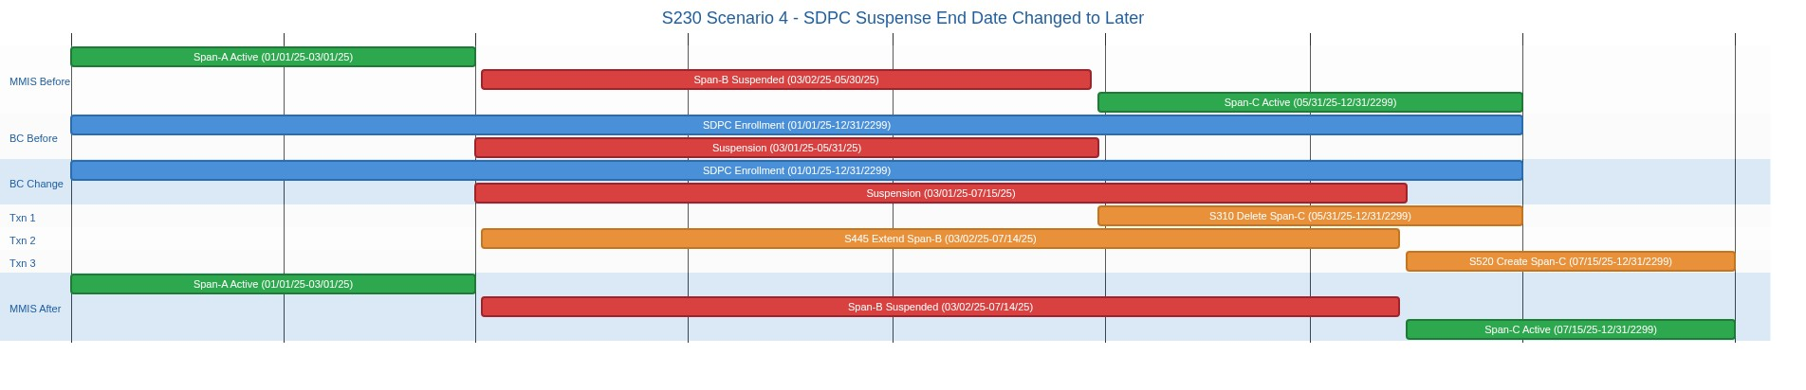
________________________________________________________________________________________________________________________
Enrollment Decision Table Reference (Note: Action #s refer to decision table processing steps which are in a separate document, not diagram rows above):
Scenario: S230_004 - Suspense end date changed from a valid date to a later valid date. Span-B is the S200-Calculated MMIS Suspense Span that was changed (match on pre-update begin date). Span-C is the S200-Calculated MMIS span that immediately succeeds Span-B. Action #1 identifies Span-B. Action #3 identifies Span-C. Action #6 deletes existing Span-C from MMIS. Action #12 extends Span-B end date to the new later BC suspension end date [offset: -1 day]. Action #13 creates a new active enrollment span (Span-C) with begin date = (Span-B's MMIS end date + 1 = new BC suspension end date) and end date from original Span-C. Order: S310 first (delete old Span-C, creates gap), then S445 (extend Span-B end date), then S520 (create new Span-C). 3 MMIS transactions.

Scenario: S230_005_IRIS (S230/S410/S470) - IRIS Suspense Deleted

1. MMIS Before: Span-A Active (01/01/25–03/01/25), Span-B Suspended (03/02/25–05/30/25), Span-C Active (05/31/25–12/31/2299).
2. BC Before: IRIS enrollment (01/01/25–12/31/2299), suspension (03/01/25–05/31/25).
3. BC Change: User deletes the suspension record. Suspension removed entirely.
4. Txn 1: S410 — Delete Span-B (Type: O, Status: I, Start Reason: 2L, Stop Reason: 2W).
5. Txn 2: S470 — Extend Span-A end date to 05/30/25 (Type: O, Status: A, Start Reason: 2Q, Stop Reason: not required).
6. MMIS After: Span-A Active (01/01/25–05/30/25), Span-C Active (05/31/25–12/31/2299). Two contiguous active spans.
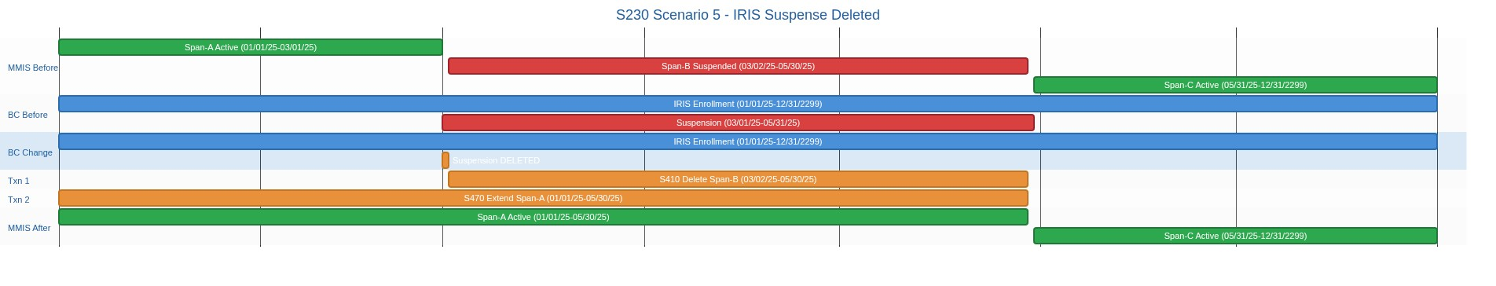
________________________________________________________________________________________________________________________
Enrollment Decision Table Reference (Note: Action #s refer to decision table processing steps which are in a separate document, not diagram rows above):
Scenario: S230_005 - Suspense deleted. Span-B is the S200-Calculated MMIS Suspense Span that was deleted (match on pre-update begin date). Span-A is the S200-Calculated MMIS span that immediately precedes Span-B. Span-C is the S200-Calculated MMIS span that immediately succeeds Span-B. Action #1 identifies Span-B. Action #2 identifies Span-A. Action #3 identifies Span-C. Action #14 deletes Span-B. Action #15 updates Span-A with a new later end date to close the gap. Order: S410 first (delete Span-B), then S470 (extend Span-A). 2 MMIS transactions.

Scenario: S230_005_SDPC (S230/S410/S470) - SDPC Suspense Deleted

1. MMIS Before: Span-A Active (01/01/25–03/01/25), Span-B Suspended (03/02/25–05/30/25), Span-C Active (05/31/25–12/31/2299).
2. BC Before: SDPC enrollment (01/01/25–12/31/2299), suspension (03/01/25–05/31/25).
3. BC Change: User deletes the suspension record. Suspension removed entirely.
4. Txn 1: S410 — Delete Span-B (Type: A, Status: I).
5. Txn 2: S470 — Extend Span-A end date to 05/30/25 (Type: A, Status: A).
6. MMIS After: Span-A Active (01/01/25–05/30/25), Span-C Active (05/31/25–12/31/2299). Two contiguous active spans.
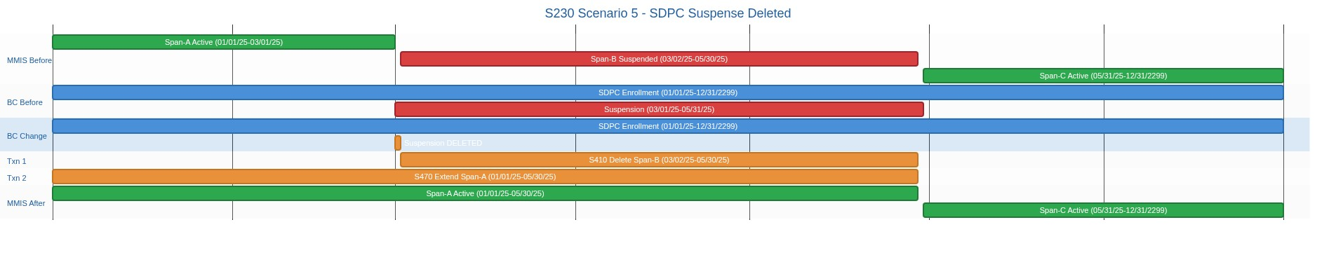
________________________________________________________________________________________________________________________
Enrollment Decision Table Reference (Note: Action #s refer to decision table processing steps which are in a separate document, not diagram rows above):
Scenario: S230_005 - Suspense deleted. Span-B is the S200-Calculated MMIS Suspense Span that was deleted (match on pre-update begin date). Span-A is the S200-Calculated MMIS span that immediately precedes Span-B. Span-C is the S200-Calculated MMIS span that immediately succeeds Span-B. Action #1 identifies Span-B. Action #2 identifies Span-A. Action #3 identifies Span-C. Action #14 deletes Span-B. Action #15 updates Span-A with a new later end date to close the gap. Order: S410 first (delete Span-B), then S470 (extend Span-A). 2 MMIS transactions.

Scenario: S230_006_IRIS (S230/S440/S520) - IRIS Suspense End Date Set from Null to Real Date

1. MMIS Before: Span-A Active (01/01/25–03/01/25), Span-B Suspended (03/02/25–12/31/2299). No Span-C.
2. BC Before: IRIS enrollment (01/01/25–12/31/2299), suspension (03/01/25–open/null end date).
3. BC Change: User sets suspension end date to 05/31/25. Participant returns from indefinite suspension.
4. Txn 1: S440 — Shorten Span-B end date from 12/31/2299 to 05/30/25 (Type: C, Status: S, Start Reason: 2Q, Stop Reason: 2W).
5. Txn 2: S520 — Create new Span-C from 05/31/25 (Type: O, Status: A, Start Reason: 2Q, Stop Reason: not required).
6. MMIS After: Span-A Active (01/01/25–03/01/25), Span-B Suspended (03/02/25–05/30/25), Span-C Active (05/31/25–12/31/2299).
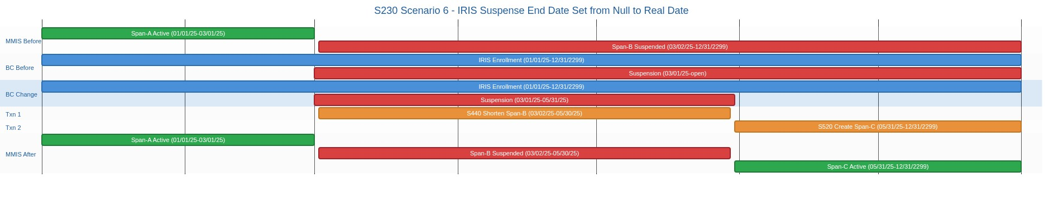
________________________________________________________________________________________________________________________
Enrollment Decision Table Reference (Note: Action #s refer to decision table processing steps which are in a separate document, not diagram rows above):
Scenario: S230_006 - Suspense end date changed from null to a valid date. Span-B is the S200-Calculated MMIS Suspense Span with end date 12/31/2299 (no Span-C exists because the suspension previously had no end date). Action #1 identifies Span-B. Action #16 shortens Span-B end date to the new BC suspension end date [offset: -1 day] using existing begin date as anchor (TransactionType C). Action #17 creates a new active enrollment span (Span-C) with begin date = new BC suspension end date (the participant is treated as active on this date) and end date = Span-A's original end date. Order: S440 first (shorten Span-B), then S520 (create Span-C). 2 MMIS transactions.

Scenario: S230_007_IRIS (S230/S310/S445) - IRIS Suspense End Date Changed from Real to Null

1. MMIS Before: Span-A Active (01/01/25–03/01/25), Span-B Suspended (03/02/25–05/30/25), Span-C Active (05/31/25–12/31/2299).
2. BC Before: IRIS enrollment (01/01/25–12/31/2299), suspension (03/01/25–05/31/25).
3. BC Change: User clears suspension end date (sets to null). Participant now indefinitely suspended.
4. Txn 1: S310 — Delete existing Span-C (Type: O, Status: I, Start Reason: 2L, Stop Reason: 2W).
5. Txn 2: S445 — Extend Span-B end date to 12/31/2299 (Type: O, Status: S, Start Reason: 2I, Stop Reason: 2I).
6. MMIS After: Span-A Active (01/01/25–03/01/25), Span-B Suspended (03/02/25–12/31/2299). No Span-C — indefinitely suspended.
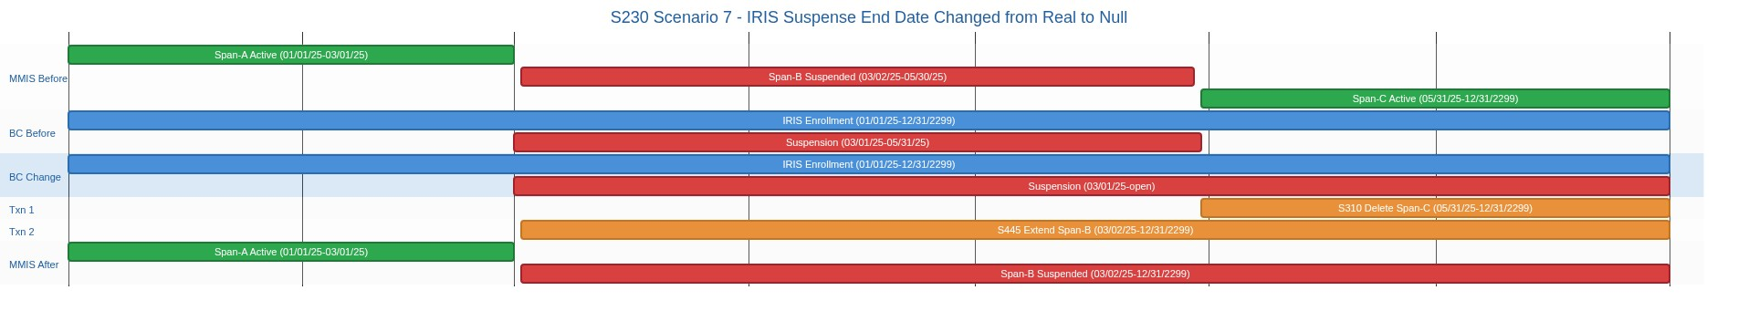
________________________________________________________________________________________________________________________
Enrollment Decision Table Reference (Note: Action #s refer to decision table processing steps which are in a separate document, not diagram rows above):
Scenario: S230_007 - Suspense end date changed from a valid date to null. Span-B is the S200-Calculated MMIS Suspense Span that was changed (match on pre-update begin date). Span-C is the S200-Calculated MMIS span that immediately succeeds Span-B. Action #1 identifies Span-B. Action #3 identifies Span-C. Action #6 deletes existing Span-C from MMIS (exact begin/end date match, Status I). Action #12 extends Span-B end date to 12/31/2299 using existing begin date as anchor (TransactionType O). Order: S310 first (delete Span-C), then S445 (extend Span-B to 12/31/2299). 2 MMIS transactions.

Scenario: S240_001_IRIS (S240/S500/S510/S520) - IRIS New Suspension Added (With End Date)

1. MMIS Before: Span-A Active (01/01/25–12/31/2299).
2. BC Before: IRIS enrollment (01/01/25–12/31/2299).
3. BC Change: User adds suspension (03/01/25–05/31/25). Single active span splits into three.
4. Txn 1: S500 — Shorten Span-A end date to 03/01/25 (Type: C, Status: A, Start Reason: 2I, Stop Reason: 2I).
5. Txn 2: S510 — Create suspension span 03/02/25–05/30/25 (Type: O, Status: S, Start Reason: 2I, Stop Reason: 2I).
6. Txn 3: S520 — Create post-suspension span 05/31/25–12/31/2299 (Type: O, Status: A, Start Reason: 2Q, Stop Reason: not required).
7. MMIS After: Span-A Active (01/01/25–03/01/25), Span-B Suspended (03/02/25–05/30/25), Span-C Active (05/31/25–12/31/2299).
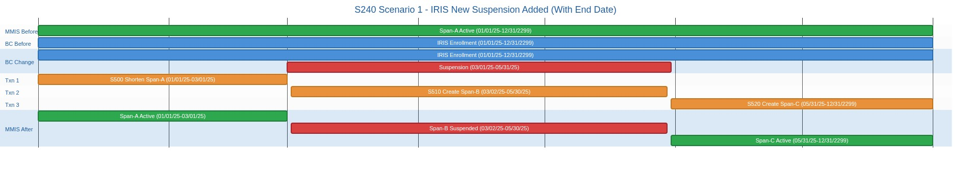
________________________________________________________________________________________________________________________
Enrollment Decision Table Reference (Note: Action #s refer to decision table processing steps which are in a separate document, not diagram rows above):
Scenario: S240_001 - New suspense record has an end date and meets the 3-day minimum duration. Span-A is the S200-Calculated MMIS Enrollment Span that includes the new BC suspense begin date. Action #1 identifies Span-A. Action #2 closes Span-A by setting its end date to the BC suspense begin date (the participant is treated as active on this date). Action #3 creates a new active enrollment span (Span-C) after the suspension with begin date = BC suspense end date (the participant is treated as active on this date). Action #4 adds the new suspense span (Span-B) with begin date = BC suspense begin date [offset: +1 day] and end date = BC suspension end date [offset: -1 day]. 3 MMIS transactions.

Scenario: S240_001_SDPC (S240/S500/S510/S520) - SDPC New Suspension Added (With End Date)

1. MMIS Before: Span-A Active (01/01/25–12/31/2299).
2. BC Before: SDPC enrollment (01/01/25–12/31/2299).
3. BC Change: User adds suspension (03/01/25–05/31/25). Single active span splits into three.
4. Txn 1: S500 — Shorten Span-A end date to 03/01/25 (Type: C, Status: A).
5. Txn 2: S510 — Create suspension span 03/02/25–05/30/25 (Type: A, Status: S).
6. Txn 3: S520 — Create post-suspension span 05/31/25–12/31/2299 (Type: A, Status: A).
7. MMIS After: Span-A Active (01/01/25–03/01/25), Span-B Suspended (03/02/25–05/30/25), Span-C Active (05/31/25–12/31/2299).
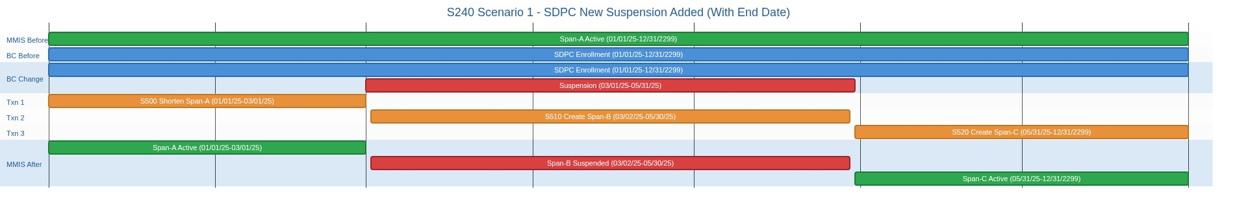
________________________________________________________________________________________________________________________
Enrollment Decision Table Reference (Note: Action #s refer to decision table processing steps which are in a separate document, not diagram rows above):
Scenario: S240_001 - New suspense record has an end date and meets the 3-day minimum duration. Span-A is the S200-Calculated MMIS Enrollment Span that includes the new BC suspense begin date. Action #1 identifies Span-A. Action #2 closes Span-A by setting its end date to the BC suspense begin date (the participant is treated as active on this date). Action #3 creates a new active enrollment span (Span-C) after the suspension with begin date = BC suspense end date (the participant is treated as active on this date). Action #4 adds the new suspense span (Span-B) with begin date = BC suspense begin date [offset: +1 day] and end date = BC suspension end date [offset: -1 day]. 3 MMIS transactions.

Scenario: S240_002_IRIS (S240/S500/S510) - IRIS New Suspension Added (No End Date)

1. MMIS Before: Span-A Active (01/01/25–12/31/2299).
2. BC Before: IRIS enrollment (01/01/25–12/31/2299).
3. BC Change: User adds suspension with begin date 03/01/25 and no end date. Indefinite suspension.
4. Txn 1: S500 — Shorten Span-A end date to 03/01/25 (Type: C, Status: A, Start Reason: 2I, Stop Reason: 2I).
5. Txn 2: S510 — Create open-ended suspension span 03/02/25–12/31/2299 (Type: O, Status: S, Start Reason: 2I, Stop Reason: 2I).
6. MMIS After: Span-A Active (01/01/25–03/01/25), Span-B Suspended (03/02/25–12/31/2299). No Span-C.
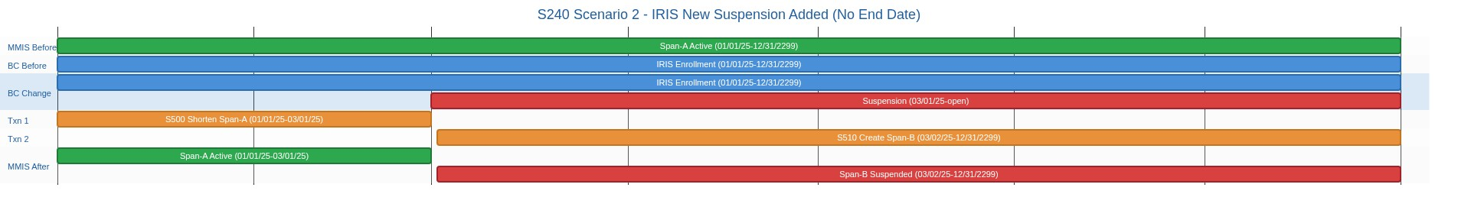
________________________________________________________________________________________________________________________
Enrollment Decision Table Reference (Note: Action #s refer to decision table processing steps which are in a separate document, not diagram rows above):
Scenario: S240_002 - New suspense record does not have an end date and meets the 3-day minimum duration check (open-ended suspensions are always valid because there is no end date to calculate against — only the begin-date +1 offset applies). Span-A is the S200-Calculated MMIS Enrollment Span that includes the new BC suspense begin date. Action #1 identifies Span-A. Action #2 closes Span-A by setting its end date to the BC suspense begin date (the participant is treated as active on this date). Action #4 adds the new suspense span (Span-B) with end date 12/31/2299 (BC null suspension end date is sent to MMIS as 12/31/2299). No Span-C is created because there is no suspension end date — the participant is indefinitely suspended in MMIS. 2 MMIS transactions.

Scenario: S240_002_SDPC (S240/S500/S510) - SDPC New Suspension Added (No End Date)

1. MMIS Before: Span-A Active (01/01/25–12/31/2299).
2. BC Before: SDPC enrollment (01/01/25–12/31/2299).
3. BC Change: User adds suspension with begin date 03/01/25 and no end date. Indefinite suspension.
4. Txn 1: S500 — Shorten Span-A end date to 03/01/25 (Type: C, Status: A).
5. Txn 2: S510 — Create open-ended suspension span 03/02/25–12/31/2299 (Type: A, Status: S).
6. MMIS After: Span-A Active (01/01/25–03/01/25), Span-B Suspended (03/02/25–12/31/2299). No Span-C.
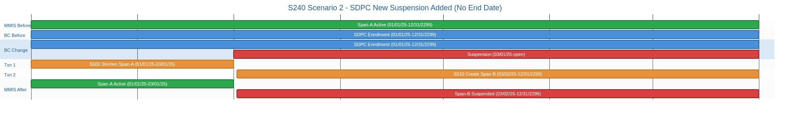
________________________________________________________________________________________________________________________
Enrollment Decision Table Reference (Note: Action #s refer to decision table processing steps which are in a separate document, not diagram rows above):
Scenario: S240_002 - New suspense record does not have an end date and meets the 3-day minimum duration check (open-ended suspensions are always valid because there is no end date to calculate against — only the begin-date +1 offset applies). Span-A is the S200-Calculated MMIS Enrollment Span that includes the new BC suspense begin date. Action #1 identifies Span-A. Action #2 closes Span-A by setting its end date to the BC suspense begin date (the participant is treated as active on this date). Action #4 adds the new suspense span (Span-B) with end date 12/31/2299 (BC null suspension end date is sent to MMIS as 12/31/2299). No Span-C is created because there is no suspension end date — the participant is indefinitely suspended in MMIS. 2 MMIS transactions.

Scenario: S220_007_IRIS (S220/S300) - IRIS Enrollment Reinstated (Disenrolled to Enrolled)

1. MMIS Before: No MMIS span exists for the Disenrolled period.
2. BC Before: Disenrolled span (03/15/25–12/31/2299) in BC only.
3. BC Change: User changes enrollment status from Disenrolled to Enrolled. Participant re-activated.
4. Txn 1: S300 — Create new enrollment span (Type: O, Status: A, Start Reason: 2L, Stop Reason: not required).
5. MMIS After: Span-A Active (03/15/25–12/31/2299).
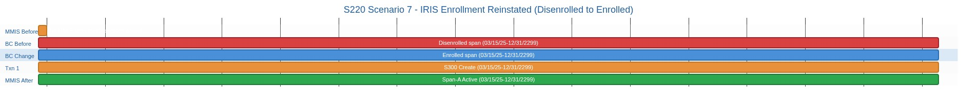
________________________________________________________________________________________________________________________
Enrollment Decision Table Reference (Note: Action #s refer to decision table processing steps which are in a separate document, not diagram rows above):
Scenario: S220_007 - Enrollment status changed from 'Disenrolled' to 'Enrolled'. The Disenrolled span exists only in BC — MMIS has no span for this period because the prior enrollment was already closed when the Disenrolled span was originally created. No Span-B identification is needed. Action #2 sends a new enrollment span to MMIS opening at the Disenrolled span begin date with end date 12/31/2299. StartReasonCode = 2L (New Enrollment). StopReasonCode is Not Required (end date is 12/31/2299).

Scenario: S220_008_IRIS (S220/S345) - IRIS Disenrolled Span Created (Real Reason Code Sent)

1. MMIS Before: Span-B Active (01/01/25–06/30/25) with 2W/2W placeholder reason (from Example 6/S340).
2. BC Before: IRIS enrollment end-dated 06/30/25. No Disenrolled span yet.
3. BC Change: User creates a Disenrolled span starting 06/30/25 and selects disenrollment reason (e.g. Deceased).
4. Txn 1: S345 — Re-send Closure with real reason codes (Type: C, Status: A, Start Reason: 64, Stop Reason: 64).
5. MMIS After: Span-B Active (01/01/25–06/30/25) with real reason code 64 (Deceased).
6. Note: IRIS only — SDPC has no stop reason codes. SDPC disenrollment is complete at S340.
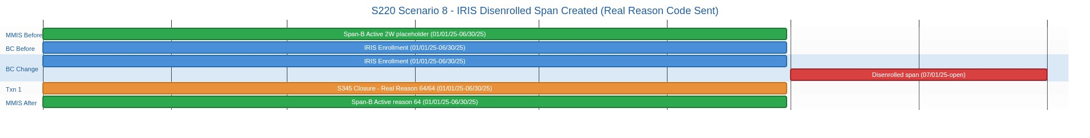
________________________________________________________________________________________________________________________
Enrollment Decision Table Reference (Note: Action #s refer to decision table processing steps which are in a separate document, not diagram rows above):
Scenario: S220_008 - New Disenrolled span created in BC (IRIS only). Span-B is the S200-Calculated MMIS Active span with the latest begin date — this is the enrolled span that was end dated before the disenrolled span was created. Action #1 identifies Span-B. Action #8 calls S345 to re-send the Closure with the real translated disenrollment reason codes.

Scenario: S250_001_IRIS (S250/S600/S255/S610) - IRIS ICA Change (Current Span Active)

1. MMIS Before: Span-B Active (01/01/25–12/31/2299) with ICA-001, FEA-001.
2. BC Before: IRIS enrollment (01/01/25–12/31/2299), ICA assignment ICA-001.
3. BC Change: User assigns new ICA-002 effective 04/01/25. FEA-001 unchanged. Active span splits at ICA boundary.
4. Txn 1: S600 — Close span with old ICA to 03/31/25 (Type: C, Status: A, Start Reason: 2P, Stop Reason: 2P).
5. Txn 2: S610 — Create new span with ICA-002 from 04/01/25 (Type: O, Status: A, Start Reason: 2P, Stop Reason: not required).
6. MMIS After: Span-B Active ICA-001 (01/01/25–03/31/25), Span-C Active ICA-002 (04/01/25–12/31/2299).
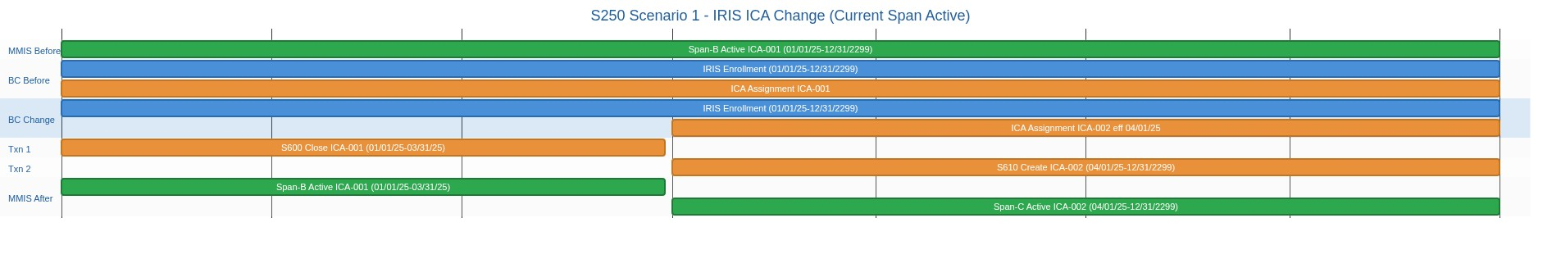
________________________________________________________________________________________________________________________
Enrollment Decision Table Reference (Note: Action #s refer to decision table processing steps which are in a separate document, not diagram rows above):
Scenario: S250_001 - Span-B is Active. Span-B is the S200-Calculated MMIS span that contains the agency change effective date. Action #1 identifies Span-B. Action #2 closes Span-B at (effective date - 1) with old agency. Action #3 iterates S200-Calculated spans from the effective date onward, calling S255 for each. Typically this produces one S255 call for a single active span.

Scenario: S250_002_IRIS (S250/S600/S255/S620/S310/S610) - IRIS FEA Change (Current Span Suspended)

1. MMIS Before: Span-A Active (01/01/25–03/01/25), Span-B Suspended FEA-001 (03/02/25–05/30/25), Span-C Active FEA-001 (05/31/25–12/31/2299).
2. BC Before: IRIS enrollment (01/01/25–12/31/2299), suspension (03/01/25–05/31/25), FEA assignment FEA-001.
3. BC Change: User assigns new FEA-002 effective 05/01/25. ICA-001 unchanged. Suspended span splits at FEA boundary.
4. Txn 1: S600 — Close suspended span with old FEA to 04/30/25 (Type: C, Status: S, Start Reason: 2R, Stop Reason: 2W).
5. Txn 2: S620 — Create new suspended span with FEA-002 from 05/01/25–05/30/25 (Type: O, Status: S, Start Reason: 2R, Stop Reason: 2R).
6. Txn 3: S310 — Delete old Span-C with FEA-001 (Type: O, Status: I, Start Reason: 2L, Stop Reason: 2W).
7. Txn 4: S610 — Create new Span-D Active with FEA-002 from 05/31/25 (Type: O, Status: A, Start Reason: 2R, Stop Reason: not required).
8. MMIS After: Span-A Active (01/01/25–03/01/25), Span-B Suspended FEA-001 (03/02/25–04/30/25), Span-C Suspended FEA-002 (05/01/25–05/30/25), Span-D Active FEA-002 (05/31/25–12/31/2299).
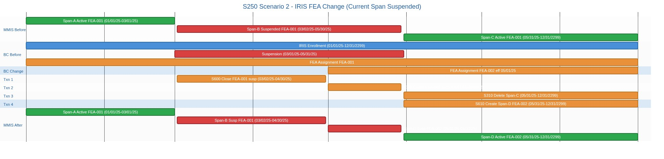
________________________________________________________________________________________________________________________
Enrollment Decision Table Reference (Note: Action #s refer to decision table processing steps which are in a separate document, not diagram rows above):
Scenario: S250_002 - Span-B is Suspended. Span-B is the S200-Calculated MMIS span that contains the agency change effective date. Action #1 identifies Span-B. Action #2 closes Span-B at (effective date - 1) with old agency. Action #3 iterates S200-Calculated spans from the effective date onward, calling S255 for each. This typically produces two S255 calls: first for the new suspended span, then for the post-suspension active span (if S200 calculated one).

