HW2

Due Date: Nov. 26, 2025
Submission requirements:
Please submit your solutions to our class website. Only hand in what is required below.

Part I: written assignment

1.
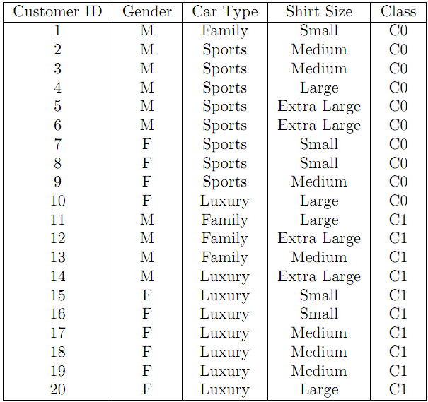

- Compute the Information Gain for Gender, Car Type and Shirt Size. (15 points)
- Construct a decision tree with Information Gain. (10 points)

- (a) Design a multilayer feed-forward neural network (one hidden layer) for the data set in Q1. Label the nodes in the input and output layers. (10 points)
- Using the neural network obtained above, show the weight values after one iteration of the back propagation algorithm, given the training instance “(M, Family, Small, C0)". Indicate your initial weight values and biases and the learning rate used. (10 points)

- Classify the unknown sample Z based on the training data set in Q1: Z = (Gender = M, Car Type = Sports, Shirt Size = Small). What would a naïve Bayesian classifier classify Z? (10 points)

- Consider the data set shown in Table 1（min_sup = 60%, min_conf=70%）.
- Find all frequent itemsets using Apriori by treating each transaction ID as a market basket. (10 points)
- Use the results in part (a) to compute the conﬁdence for the association rules {a, b}→{c} and {c}→{a, b}. Is conﬁdence a symmetric measure? (5 points)
- List all of the strong association rules (with support s and confidence c) matching the following metarule, where X is a variable representing customers, and item_{i} denotes variables representing items (e.g. “A”, “B”, etc.): (5 points)
Table 1. Example of market basket transactions.

TID | Items-bought
T1 | {A, D, B, C}
T2 | {D, A, C, E, B}
T3 | {A, B, E}
T4 | {A, B, D}

Part II: Lab
Question 1
Assume this supermarket would like to promote milk. Use the data in “transactions” as training data to build a decision tree (C5.0 algorithm) model to predict whether the customer would buy pasta or not.
- Build a decision tree using data set “transactions” that predicts milk as a function of the other fields. Set the “type” of each field to “Flag”, set the “direction” of “pasta” as “out”, set the “type” of COD as “Typeless”, select “Expert” and set the “pruning severity” to 65, and set the “minimum records per child branch” to be 95. Hand-in: A figure showing your tree. (5 points)
- Use the model (the full tree generated by Clementine in step 1 above) to make a prediction for each of the 20 customers in the “rollout” data to determine whether the customer would buy pasta. Hand-in: your prediction for each of the 20 customers. (5 points)
- Hand-in: rules for positive (yes) prediction of pasta purchase identified from the decision tree (up to the fifth level. The root is considered as level 1). (5 points)

Question 2

The data contains the following fields. Row 1 contains the headers.
id | a unique identification number
age | age of customer in years
sex | MALE / FEMALE
region | inner_city/rural/suburban/town
income | income of customer
married | is the customer married (YES/NO)
children | number of children
car | does the customer own a car (YES/NO)
save_acct | does the customer have a saving account (YES/NO)
current_acct | does the customer have a current account (YES/NO)
mortgage | does the customer have a mortgage (YES/NO)
pep | did the customer buy a PEP after the last mailing (YES/NO)

Each record is a customer description where the "pep" field indicates whether or not that customer bought a PEP. For other existing customers in the database, we would like to see if PEP should be RECOMMENDED to the customers in the roll-out data.

The firm decides to use decision tree to build the models for PEP recommendation.
Develop a decision tree model using the estimation data. For building this model, you are expected to use the following steps.

Using the “bank-estimation-data”, estimate the decision tree that predicts pep as a function of the other variables. Select “Expert” and set “pruning severity” at 70. Set the “Type” of pep as “Flag” and the “Direction” as “out”. Build decision trees using three options “Minimum records per child branch” values being (a) 56, (b) 15 and (c) 10, not selecting “use global pruning”.

- Hand in: the confusion matrix for (a), (b) and (c) on the validation data. (10 points)
- Hand in: Which of the three trees will you use to score the data in a holdout data list and why? 2-3 lines. (5 points)
- Hand in: For the following data (Appendix 1), using the rules from the best decision tree, fill in the recommendation. (10 points)

Appendix 1.
age | sex | region | income | married | children | car | save_act | current_act | mortgage | RECOMMEND PEP (Y/N)
22 | 0 | 1 | 14000 | 0 | 3 | 0 | 1 | 1 | 0
34 | 1 | 0 | 33000 | 0 | 0 | 1 | 1 | 0 | 0
47 | 0 | 0 | 16700 | 1 | 1 | 0 | 1 | 1 | 0
54 | 1 | 1 | 43400 | 1 | 1 | 1 | 1 | 1 | 0
65 | 1 | 2 | 60000 | 1 | 1 | 0 | 1 | 1 | 0
37 | 0 | 0 | 27700 | 0 | 1 | 1 | 0 | 0 | 0
44 | 0 | 0 | 38784 | 1 | 0 | 0 | 1 | 1 | 0
20 | 1 | 0 | 10200 | 1 | 0 | 0 | 1 | 1 | 1
46 | 0 | 0 | 22000 | 1 | 1 | 1 | 1 | 0 | 1
40 | 1 | 1 | 37400 | 1 | 2 | 0 | 1 | 1 | 0

