How to run the project.

It’s a simple MERN-stack To-Do app.

In order to run the project you need to download and install MongoDB Community Server and set up Node JS environment.

1. Node JS can be found from here - https://nodejs.org/en/download/

2. MongoDB Community Server - https://www.mongodb.com/try/download/community

When preparations are done, we can start.

First thing to do is to run our server. Go to the project folder, then to “backend” folder, and install all modules -

“npm install”

write in a console “npm run server”. Just like that:
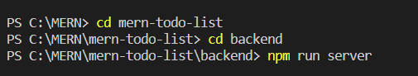

You suppose to see “server started” and “connected to database” messages:

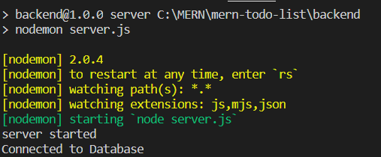

After that open new terminal window and navigate to project root directory. Install there modules for front-end (React) -
“npm install”
After it’s done, run the project -
“npm start”

New window will open in your default browser.
Enjoy using it!

