How to run the project.

This API is about musical albums. You can make a collection of your favourite albums of all times.

In order to run the project you need to download and install couple of programs and set up Node js environment.

1. Node Js can be found from here - https://nodejs.org/en/download/

2. MongoDB Community Server - https://www.mongodb.com/try/download/community

3. Postman - https://www.postman.com/downloads/

When preparations are done, we can start.

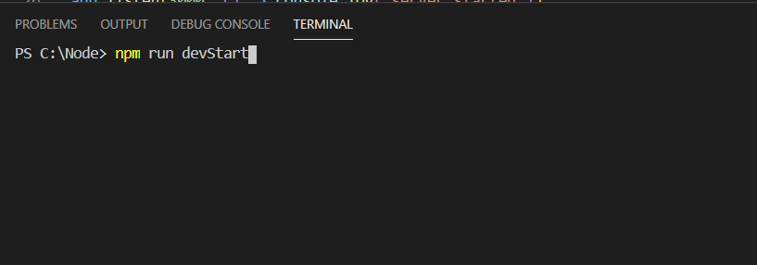
First thing to do is to run our server. Go to the project folder and write in a console “npm run DevStart”. Just like that:

You suppose to see “server started” and “connected to database” messages:

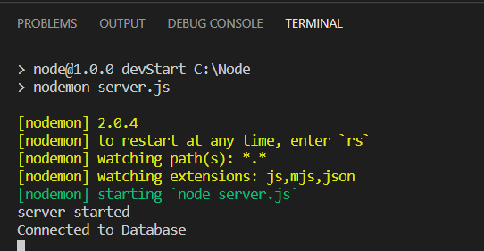

After seeing them we can proceed to the actual test of our small application.
You can check the address http://localhost:3000/albums in your browser to make sure that sever is up. You suppose to see just an empty array for now - [].

Our requests we will be making in the Postman program.

Lets walk through the all possible requests

1. GET all albums.
You just send a GET request to the address http://localhost:3000/albums with an empty body,
and as a respond you will get all available albums. For now its still an empty array, but you can try it again after we POST some info to our database.

2. POST.
To make a new entry to database you suppose to switch method to POST and fill up the body with information about your album in JSON format.
Required fields are
“name” (of the album),
“dateOfRelease” and
“band” which stands for the name of the band who did release this album.
Your POST suppose to look like example on a picture.
Make sure you choose “raw” radio button and pick JSON from dropdown menu.
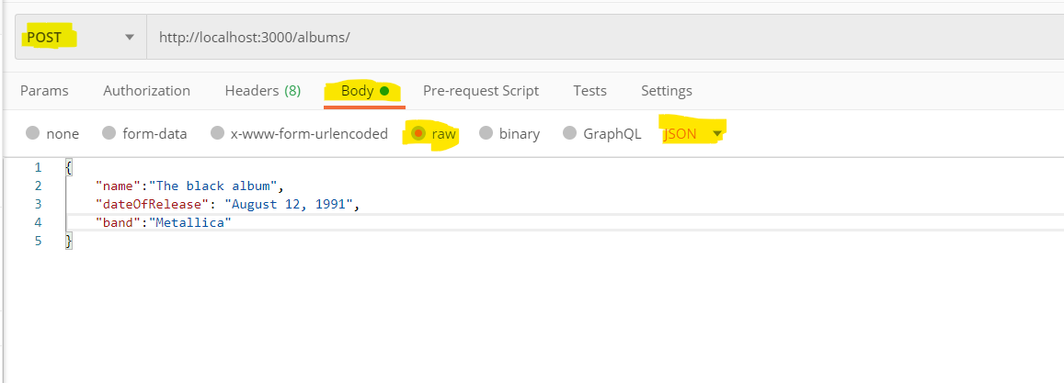
In the response you will get you new database entry with automatically generated ID:
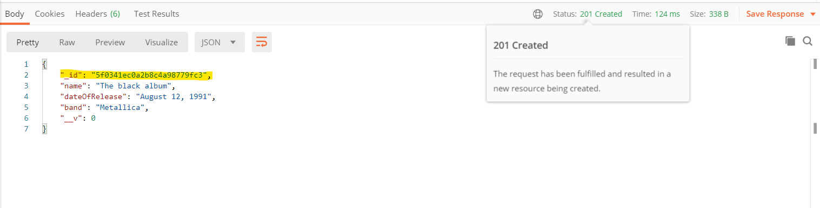
3. PATCH.
You can change information, aka PATCH, in already excising album.
To do so, you need to know the ID of the album which you want to modify. You can go back to GET all and copy desired id form the response.

Then you need to add this id to the address line, in example like that:

http://localhost:3000/albums/5f0341ec0a2b8c4a98779fc3
Switch method to PATCH and then in the body, specify the field that you want to change. This field will be overwritten in the database entry.

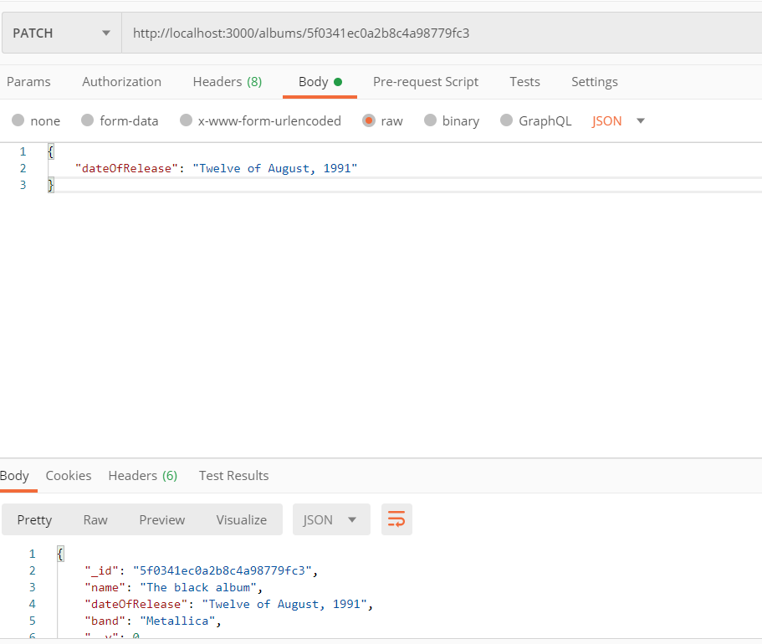

In the response you will get your new entry with modified filed. Just like in illustration above.
4. GET one album by ID.
If you have many entries in your database and you want to GET a one specific post you can easily do it, knowing its ID. Just add this ID to the adress like in previous example and switch method to bacl to GET

5. DELETE album.
And the final thing possible is to delete the entry.
Switch method to DELETE and add the id of the album you want to eliminate after ”/” just like in previous examples.
As response you will get the message ”Deleted Album” See illustration below.

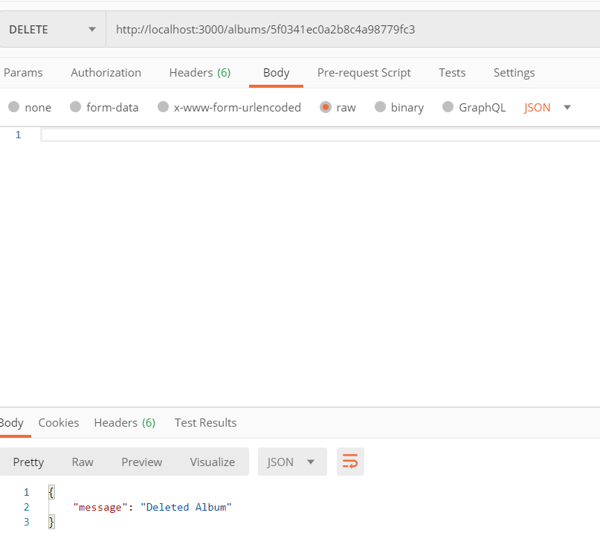

That covers all the functionality. Enjoy using it and best regards!

