|  |  |  |
| --- | --- | --- |
| **Students Details** | HNDSE 24.2 F |  |
| **Module Name:** | Internet of Things |
| **Module Lecturer/Course Coordinator:** | Mr. Bhathiya Seneviratne |
| **Department:** | School of Computing | |
| **Submission Due on:** | 05th July 2025 | |
| **Type of Coursework:** | Group | |
| **Title of the Coursework:** | Implementing an IoT based Health Monitoring System for Asthmatic Patients | |

***Student Details:***

|  |  |  |
| --- | --- | --- |
|  | **Student No.** | **Student Name** |
| **01** | COHNDSE242F- 042 | Azward M A |
| **02** | COHNDSE242F- 041 | Ilma M H F |
| **03** | COHNDSE242F- 063 | Iroshan S G H |

|  |
| --- |
| **Office use only :** |
| Date Stamp Required of the Department |

**NATIONAL INSTITUTE OF BUSINESS MANAGEMENT**

**HIGHER NATIONAL DIPLOMA IN SOFTWARE ENGINEERING**

**COURSEWORK**

**Internet of Things**

**IoT based Health Monitoring System for Asthmatic Patients**

**SUBMITTED BY**

|  |  |
| --- | --- |
| COHNDSE242F- 042 | Azward M A |
| COHNDSE242F- 041 | Ilma M H F |
| COHNDSE242F- 063 | Iroshan S G H |
|  |  |

**Date of Submission:** 05th of July 2025

**Abstract**

With the technological advancement in the modernized world most of the manual processes has been Subject to the automate in order to increase the efficiency, accuracy and the performance. Among those, health care and medicine sector also move to automate in order to provide a better service for the patients. Then considering the asthmatic patient, they need constant care and supervision of the caretaker or doctor. Most of the time the caretaker needs to be continuously monitoring the patient as their specific conditions need prior medical attention. To overcome this by an automated system, we have proposed an IoT based wrist band which will monitor the patient’s heart rate, air quality, SPO2 levels, cough signs and also a location tracker to track the patient's location. To ensure the patient’s privacy, the mobile has a login for the patient to manage (activate and deactivate) the location as well. The system will be connected to a mobile app which has an interface for the caretaker and the patient for giving alerts. The mobile application also contains a dashboard to manage the functions of the wristband as well. Additionally, its mobile application will provide you with the current information collected by the device. By implementing this system, the asthmatic patient’s safety can be increased which reduces the manpower.

**Acknowledgement**

We would like to express my gratitude to my make sure Mr. Bhathiya Seneviratne who guided me to implement this IoT-based Health Monitoring System for Asthmatic Patients by giving the needed instructions and support. Also, I would like to express my thanks to all the open-source platforms which gave us knowledge about IoT concepts and implementation guidance. We would appreciate the online tools which facilitated the project by providing the essential libraries, and tools to enhance our academic and practical experience. And we hereby make this an opportunity to thank our parents and peers for their support given to complete this project as well. The collaboration and teamwork between our team members was the backbone of the successful completion of the project. Finally, we heartfully thank our educational institute NIBM School of Computing, which gave us the opportunity to spend our valuable academic experience in IoT concepts by providing laboratory experience.

Table of Contents

1. Literature Review 5

2. Introduction 6

2.1 Problem Statement 6

2.2 Solution 7

2.3 Objective 7

3. System Design and Architecture 8

3.1 Hardware Components 8

3.2 Software Components 9

3.3 Bill of Materials 10

4. Methodology 12

5. Discussion 15

5.1 Recommendation 15

5.2 Limitations 15

6. Timeline 16

7. References 18

# Literature Review

When it comes to asthmatic patients’ condition, constant monitoring and medication should be provided in order to save their lives and for diagnosing the disease. Many researchers and scientists have suggested number of methodologies and emphasized their focus in relevant field. As Gibson (200) says, to diagnose the smaller the patient needs to monitor symptoms for the disease regularly. He suggests regular checkups, action plans and monitoring the symptoms in a periodic way. According to his research, he focuses on self-monitoring beyond a caretaker. When considering the research report by Mohammed et al (2024), it mentions about the problems faced by asthmatic patient India satisfaction levels. The research was based on a statistical analysis using a survey distributed among the patients. According to the research, it also implies that an automated device for asthmatic patients is an upcoming requirement. But niranjana et al. (2020), focused on solving this problem using IoT based solution assist smart management system. Air quality checker and heart pulse rate identifier were Included in the proposed system. But when considering these research reports, there is a clear gap in field of asthmatic patient study he's identified. Therefore, our system focuses on an automated solution as a variable device for asthmatic patients as mentioned below.

# Introduction

## 2.1 Problem Statement

When considering the healthcare sector, asthma is a vital disease which requires constant supervision of a caretaker in order to ensure their safety. However, constant monitoring is an inaccurate task which can be done by human power. Moreover, the article cannot manually check the yeah quality around the patient, oxygen level, heartbeat level and the SPO2. Even when the monitoring is somewhat efficient the patient is awakened, when considering a situation where the patient gets symptoms of asthma when the individual is sleeping, the possibility to respond to the patient is very less. As a result, increase of death rate due to asthma has been increased by emphasizing the need of focusing on the called problem.

## 2.2 Solution

As the solution for this problem, we have proposed a “IoT based Health Monitoring System for Asthmatic Patients” which include the following features to overcome above-mentioned problems while increasing the user engagement.

The system has been planned to implement a wearable device with the following features to ensure the patients’ safety.

* The device tracks heart rate and oxygen levels
* Monitors air concentration to check whether surrounding is harmful or not
* Heartrate, temperature and humidity measures
* Cough tracking feature to ensure that the caretaker can notify the cough times

The device will grab all the data and send notification to the care takers phone. A dashboard will support the caretaker and the patient to manage the device.

Provided approach will automate the function manually performed and provide details of accurate condition of the patient as well.

## 2.3 Objective

The objective of this product is to minimize the death rate due to improper attention given to asthma patients by an IoT-based solution. By deploying the system, we expect the following.

* Transmitting real time data in between patient and caretaker.
* Providing a user-friendly and compatible mode of solution
* Quick responses for the patients when they face difficulties internally or externally.

# System Design and Architecture

## 3.1 Hardware Components

The proposed system requires following main components in order to fulfil the required functionalities.

* NodeMCU ESP32 WiFi ESP-12E Bluetooth Dual IoT Dev Board – To collect data from sensors and send to firebase
* MAX30102 Pulse Oximeter SpO2 and Heart Rate Sensor Module – To measure the heart rate, oxygen level
* MQ-135 Air Quality Sensor Hazardous Gas Detection Sensor – Check whether there are any harmful gases
* Voice Sound Detection Sensor 3 pin Module, Vibration sensor and – Collectively tracks when patient coughing
* AHT10 sensor to detect Temperature and humidity

Other than these required components will be mentioned in the bill of materials.

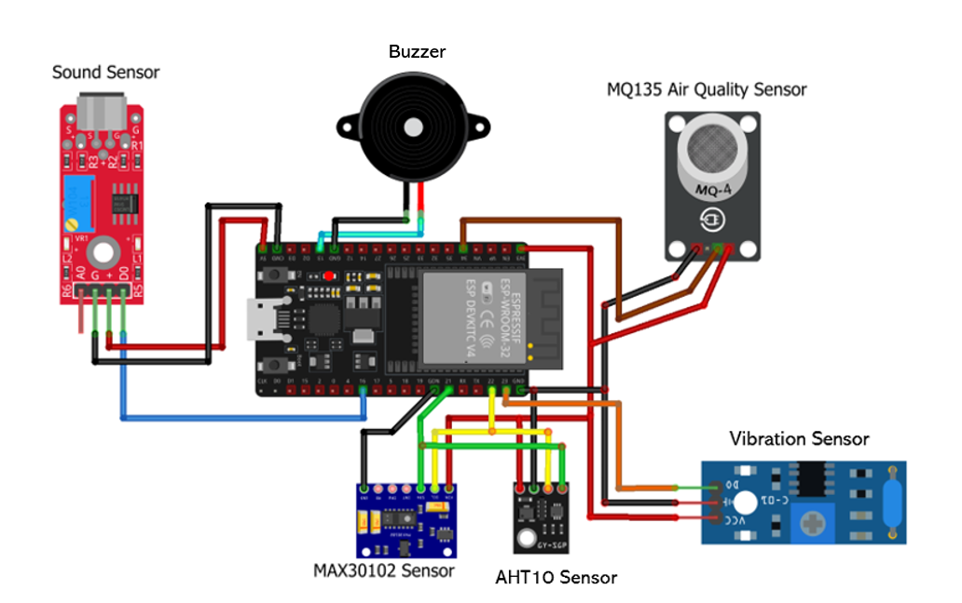

## 3.2 Software Components

The Following software are needed in order to run the IoT based health tracking wristband.

* Arduino IDE – To upload the code to NodeMCU ESP32
* GitHub – Version Control purpose

Other than the above-mentioned software requirements the following are needed to implement the mobile application which is used to manage the system. The mobile application will be managed by the caretaker and patient in order to manage and manipulate collected data and used to view the real-time location of student as well. The application is also used to activate and deactivate relevant features in order to save power and to enhance the user friendliness other than the motion sensor. The following is the tech stack used.

* Tool – Android Studio
* Programing Language – Java
* Real time database – Firebase SDK
* Location – Google map API
* Layout designing - XML

The integration of the above-mentioned tech stack will enhance the efficiency of “IoT based Health Monitoring System for Asthmatic Patients”.

## 3.3 Bill of Materials

|  |  |  |  |
| --- | --- | --- | --- |
| **Component** | **Quantity** | **Amount (Rs)** | **Total (Rs)** |
| NodeMCU ESP32 WiFi ESP-12E Bluetooth Dual IoT Dev Board | 1 | 1100 | 1100 |
| MAX30102 Pulse Oximeter SpO2 and Heart Rate Sensor Module | 1 | 330 | 330 |
| MQ-135 Air Quality Sensor Hazardous Gas Detection Sensor | 1 | 490 | 490 |
| Voice Sound Detection Sensor 3 pin Module | 1 | 220 | 220 |
| 801S Vibration Sensor detection module | 1 | 680 | 680 |
| AHT10 High Precision Digital Temperature and Humidity Sensor | 1 | 350 | 350 |
| Breadboard | 1 | 130 | 130 |
| Jumper Wire Male to Female (10cm) | 2 Pack | 130 | 260 |
| Jumper Wire Male to Male (20cm) | 1 Pack | 160 | 160 |
| USB Cable (For ESP/TTL module) | 1 | 700 | 700 |
| LED | 2 | 50 | 100 |
| Buzzer | 1 | 200 | 200 |
| 10000 mAh Power Bank | 1 | 4500 | 4500 |
| Electrical Tape/Black tape | 1 Role | 200 | 200 |
| Glue Sticks | 6 | 40 | 240 |
| Glue Gun | 1 | 720 | 720 |
| Soldering Iron | 1 | 790 | 790 |
| Soldering Wire | 01 Role | 120 | 120 |
| Soldering Iron Stand | 1 | 490 | 490 |
| Scissor | 1 | 150 | 150 |
| Glue (Normal) | 1 | 115 | 115 |
| Bristol Board | 1 | 55 | 55 |
| Multimeter | 1 | 700 | 700 |
| Paper Cutter | 1 | 200 | 200 |
| Plier | 1 | 1470 | 1470 |
| Resistors (220 Ω, 10000 kΩ) | 02 Pack | 50 | 50 |
| Other |  |  | 200 |

|  |  |  |  |
| --- | --- | --- | --- |
| **Total Amount** |  |  | **Rs.14720** |

# Methodology

The completed methodology and the process flow is shown in the format of a flow chart as follows.

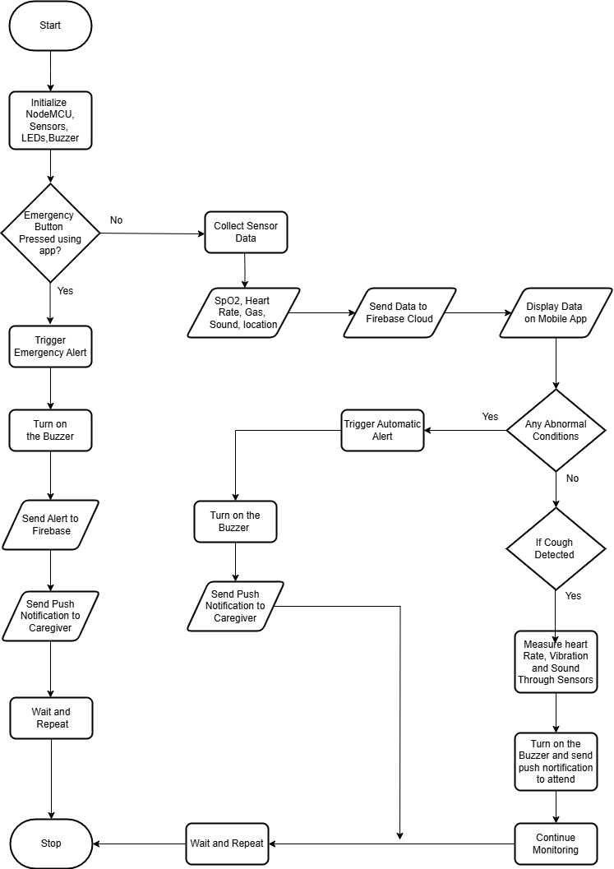

Following flow chart displays the workflow of mobile application.

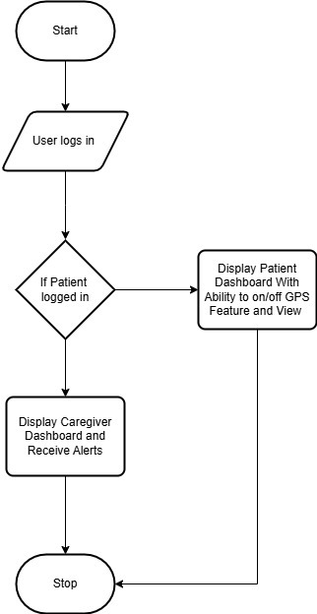

# Discussion

The proposed IOT based wearable device is supporting the caregiver using the above-mentioned oxygen levels, heart rates, environmental air concentration tracking functions along with emergency button to hit when the patient needs support. Also, the device detects the cough symptoms by integrating sound and vibration for notifying the caregiver about patient’s condition. The real time messages will be passed to caregiver’s mobile app while displaying the real tracked data using the sensors. Moreover, there are many features which can be added to the device as well as which should be mitigated in order to enhance the functionality of the device.

## 5.1 Recommendation

* Usage of highly accurate sensors for better results
* Implementation of data storage options to be used when offline
* Confidential data of the user should be protected
* Combine AI in order to emphasize new functionalities such as predictions
* Implementing a display in device for the use of patients to track their own levels

## Limitations

* Accuracy of sensors may affect the functionality of the device
* WIFI connectivity may affect the overall functionality
* Battery life is limited due to multiple sensor usage
* Delays in the firebase network may result in late alerts
* Flash memory scalability issues in NodeMCU esp32
* Database scalability will affect the effectiveness of device

# Timeline

|  |  |  |  |  |  |  |
| --- | --- | --- | --- | --- | --- | --- |
| Phases | Week  01 | Week  02 | Week  03 | Week  04 | Week  05 | Week  06 |
| Research and Feasibility Study |  |  |  |  |  |  |
| Design and Planning |  |  |  |  |  |  |
| Prototyping the Hardware |  |  |  |  |  |  |
| Coding and Mobile app development |  |  |  |  |  |  |
| Testing the functions |  |  |  |  |  |  |
| Debugging the errors |  |  |  |  |  |  |

1. Research and Feasibility Study

Research about the relevant hardware components to implement the system.

1. Design and Planning

Gathering all those hardware components and making the connection in between them.

1. Prototyping the Hardware

Creating an outer cover with relevant hardware components to depict the shape of a wristband with additional hardware components and connections.

1. Coding and implementation of mobile application

Choosing a programming platform and program the system according to the functions needed and developing the mobile application and integrate with the firebase database which has the data retrieved from sensors.

1. Testing the functions

Run the system and identify its errors and areas to improve.

1. Debugging the errors

Debug and modify the system with relevant modifications.

# References

Smart Monitoring System For Asthma Patients Article  in  International Journal of Electronics and Communication Engineering · May 2020 DOI: 10.14445/23488549/IJECE-V7I5P102

Patient experiences of their current asthma care and their views toward providing support for patients with asthma in community pharmacy: A Qualitative study Aseel Mahmoud a,* , Rachel Mullen b,c , Peter E. Penson b,c , Charles Morecroft b,c

Monitoring the patient with asthma: An evidence-based approach Peter G. Gibson, MBBS, FRACP Newcastle, Australia