# Wireframe

Wireframe

[**Insurance Premium_Prediction**](https://github.com/mohiteyashprogrammer/Adult_income_Prediction/tree/main)

Revision Number – 1.0

Last Date of Revision – 29-06-2023

**ILMA ARSHAD**

**Contents**

Wireframe

[**Abstract** 4](https://docs.google.com/document/d/1ZLlZEVdMuxYl3o0PziQjZcUbNmAcz-PR/edit#heading=h.gjdgxs)

**Web Interface 5**

**User Input 5**

**Result Page 6**

**Abstract**

Wireframe

The goal of this project is to provide individuals with personalized estimates of the health insurance coverage they require based on their unique health situations. In the current health insurance landscape, individuals often face challenges in determining the appropriate level of coverage needed to adequately protect themselves and their families. As a result, many individuals end up with either excessive coverage that incurs unnecessary costs or inadequate coverage that leaves them financially vulnerable.

**1. Web Interface**

Wireframe

Our web page is one single interface where both input from the user and the prediction is displayed.

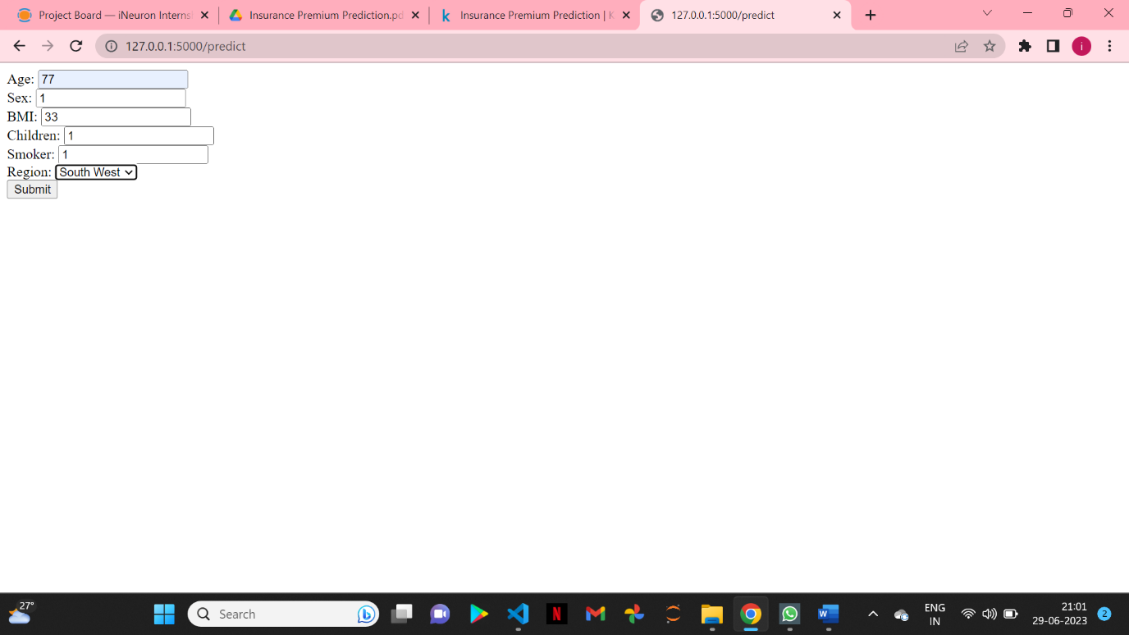

**2. User Input**

Whenever the user hit our url , they first see the user input page here they have to provide the information like:

* Every user input has its own dropdown where the user can select their input.
* After providing the required input and pressing the submit button, the page refreshes and displays the output

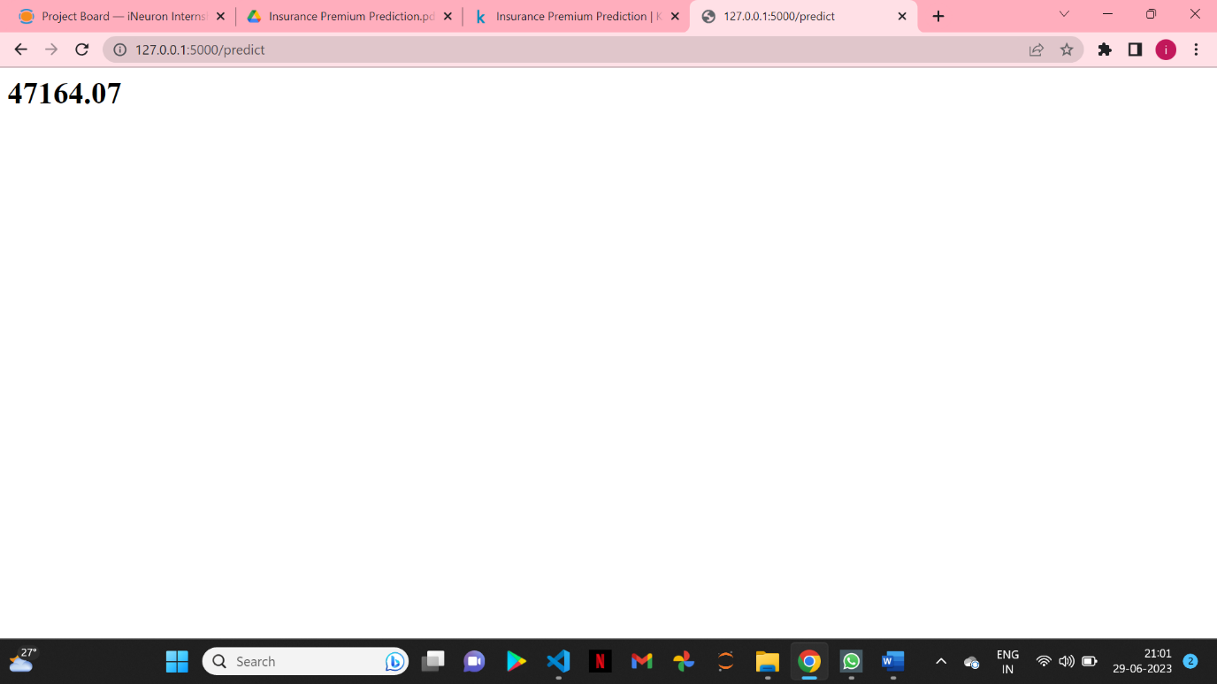

**3. Result Page**

Wireframe

After the user hits the submit button the page gets refreshed and the results are being displayed in the highlighted area in the above frame.

The user can refill all the inputs in same page and get the results in the same way.