ENDOSCOPIC STOMACH SIMULATION
3D Modeling Workflow Plan
Blender · 3D AI Studio · Unity
Submitted: May 2026
8  Anatomical Parts | 8 Weeks  Total Timeline | 1 Week  Per Part | ✓ Done  Shell Status

Project Overview
The stomach shell has already been modeled. This plan covers the internal anatomical surface — generating each endoscopic landmark part-by-part using 3D AI Studio, then merging it into the existing shell in Blender. The final model will be exported to Unity for real-time endoscopic simulation.

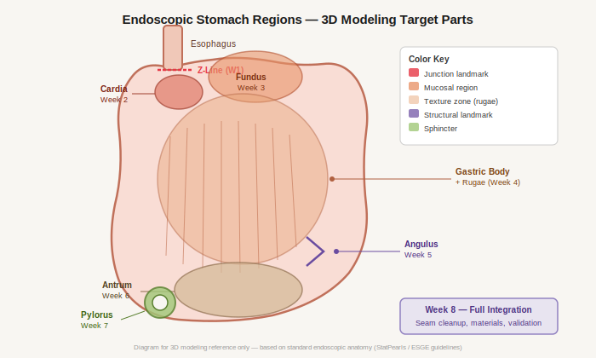
Figure 1 — Endoscopic regions targeted for 3D mesh generation (color-coded by type)

8-Week Part-by-Part Workflow
Each week: collect reference endoscopy images → generate 3D mesh in 3D AI Studio → clean up in Blender → merge with shell. Repeat for each part before moving to the next.

Week 1  1 week | 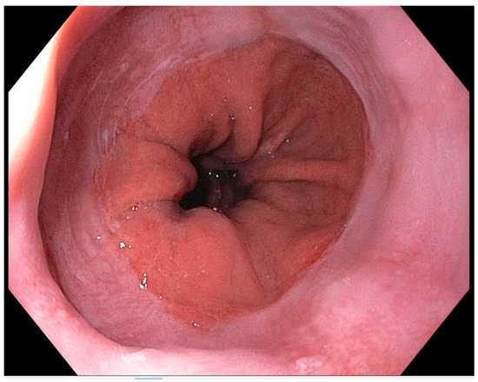 | Z-Line & Gastroesophageal Junction (GEJ)  Duration: 1 week — image collect (2 days) · AI generate (2 days) · merge (1 day)  Image sources: PubMed (NBK532268), gastropath.com.au, PMC10336909, ResearchGate  [ Upload reference endoscopy image above ]
Week 2  1 week | 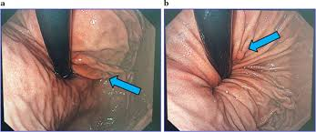 | Cardia Region  Duration: 1 week — image collect (2 days) · AI generate (2 days) · merge (1 day)  Image sources: gastrotraining.com, ResearchGate MCE fig, StatPearls NBK532268  [ Upload reference endoscopy image above ]
Week 3  1 week | 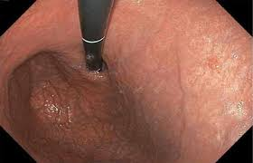 | Fundus (Retroflexed View)  Duration: 1 week — image collect (2 days) · AI generate (2 days) · merge (1 day)  Image sources: PMC5731161 (ESGE), StatPearls, Radiology Key stomach chapter  [ Upload reference endoscopy image above ]
Week 4  1 week | 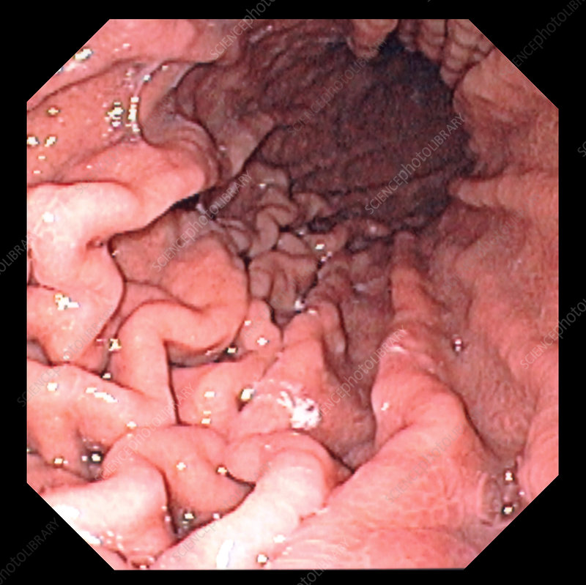 | Gastric Body & Rugae Folds  Duration: 1 week — image collect (1 day) · AI generate (3 days) · merge (1 day)  Image sources: PubMed rugae EGD, ResearchGate MCE landmarks, gastrotraining.com  [ Upload reference endoscopy image above ]
Week 5  1 week | 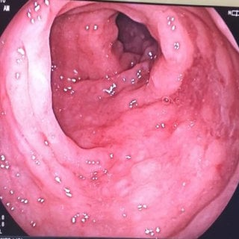 | Angulus / Incisura Angularis  Duration: 1 week — image collect (2 days) · AI generate (2 days) · merge (1 day)  Image sources: PubMed angulus EGD, Bazarbashi AoS fig 2, gastrotraining.com  [ Upload reference endoscopy image above ]
Week 6  1 week | 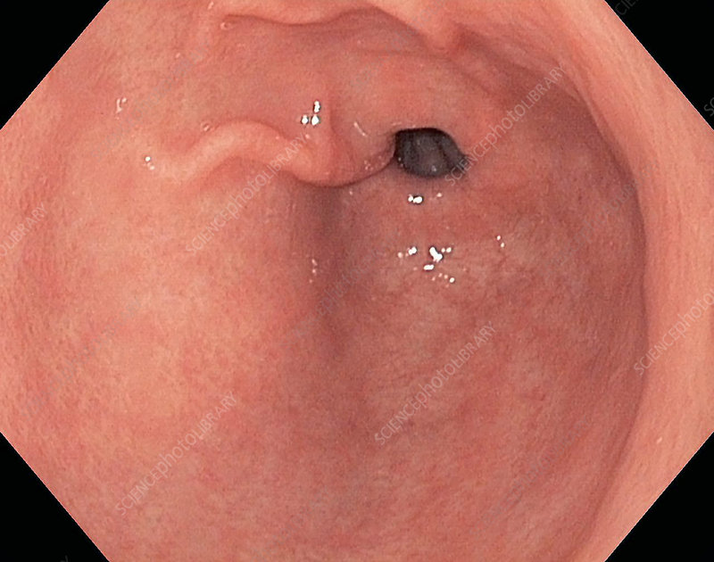 | Pyloric Antrum  Duration: 1 week — image collect (2 days) · AI generate (2 days) · merge (1 day)  Image sources: PubMed antrum EGD, ResearchGate MCE fig, StatPearls NBK532268  [ Upload reference endoscopy image above ]
Week 7  1 week | 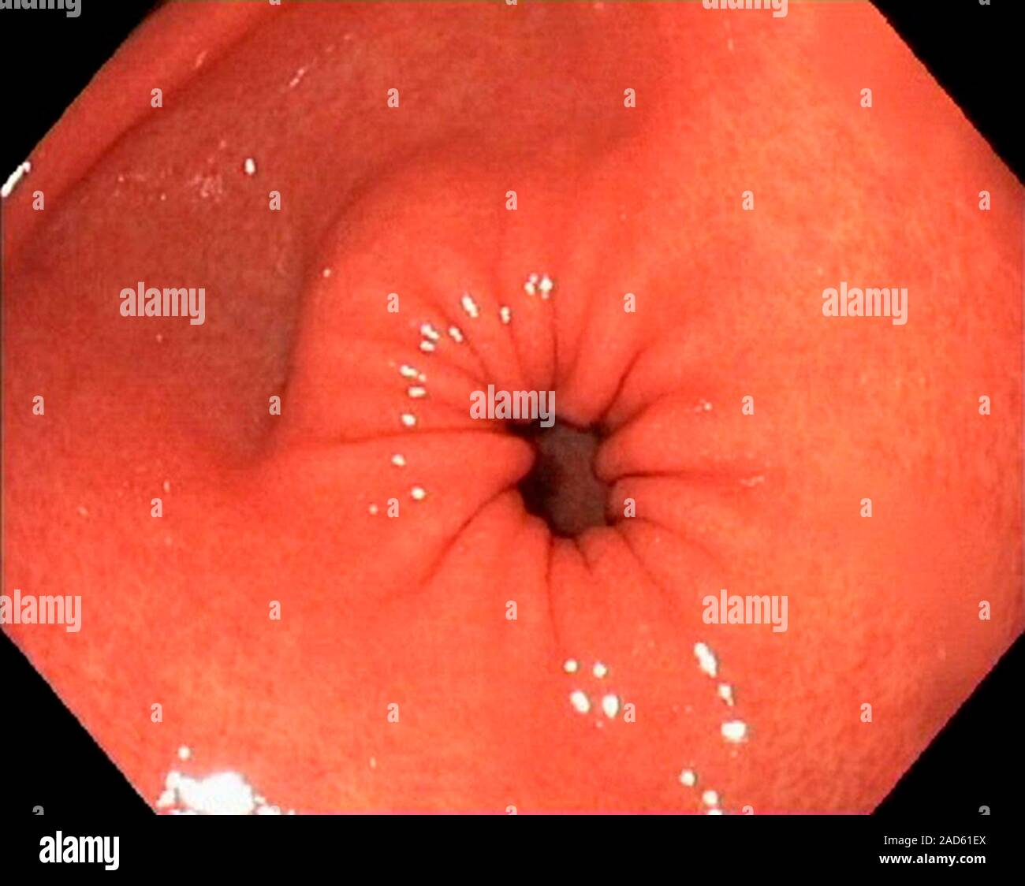 | Pylorus & Pyloric Sphincter  Duration: 1 week — image collect (2 days) · AI generate (3 days) · merge (2 days)  Image sources: PubMed pylorus EGD, absurgery.org EGD PDF, ResearchGate fig G  [ Upload reference endoscopy image above ]
Week 8  1 week | 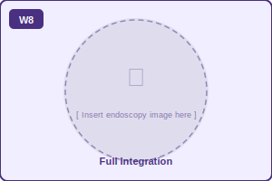 | Full Integration, Polish & Validation  Duration: 1 week — seam audit (2 days) · materials/render (2 days) · validation + export (1 day)  Image sources: All prior sources · Blender docs · ESGE PMC5731161 · Supervisor review  [ Upload reference endoscopy image above ]

Notes & Conventions
Image sources: All reference images should be collected from PubMed, ResearchGate, and open-access gastroenterology resources. Prioritize clear, well-lit endoscopy photographs with minimal artefacts.

Merge rule: Always complete and validate the merge step before starting the next week's part. Do not move forward with a pending mesh issue.

Naming convention: Name every Blender object as PART_W[n]_[RegionName] (e.g. PART_W4_GastricBody) for easy Unity identification later.

