I | P | O
mark1  mark2ü(1.1) | GET mark1, mark2  average = (mark1 +mark2) \ 2ü(1.2)  if average >= 50”ü(1.3)  “Exam admission GRANTED”  Else  “Exam admission DENIED” | ICASS  Appropriate messageü(1.4)
QUESTION 1

QUESTION 2

# 7409070054081ü(2.8)

# Input
mark1ü(2.1) = intü(2.2) (input("Enter the first mark:"))
mark2ü(2.1) = intü(2.2) (input("Enter the second mark:"))

# Processing
averageü(2.1) = (mark1 +ü(2.3) mark2)ü(2.3) /ü(2.3) 2ü(2.3)

# Selection and output
print(f"{average:.2ü(2.4) f} mark.")ü(2.5)

if average >= 50:
print("Examination admission GRANTED.")ü(2.6)
else:
print("Examination admission DENIED.")ü(2.7)

QUESTION 3

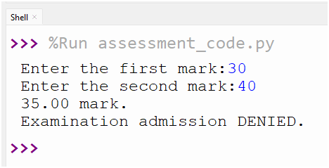

ü(3.1)

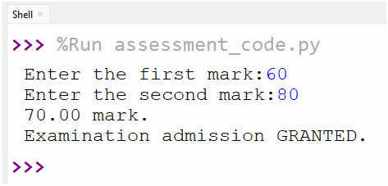

ü(3.2)

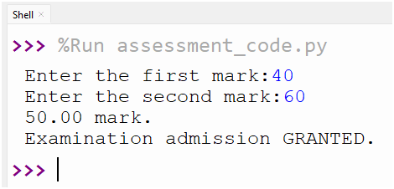

ü(3.3)

QUESTION 4

- isdigit() only checks for characters that are digits ü
- If the input string contains characters that are not valid digits, such as a space or a non-digit character, the conversion to an int will fail, leading to an error. ü
- Converting the input to an int before checking its validity can lead to loss of input context. ü
- isdigit() is a simple method to check for digit characters in a string. ü
- Using isdigit() alone can lead to errors if the input string contains characters that are not valid digits.

