a)

SELECT name , telegram_contact  
FROM student  
WHERE city='Казань' OR city='Москва'  
ORDER BY name DESC;

Output:

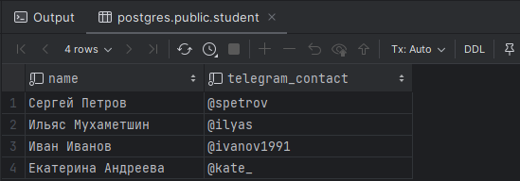

б)

SELECT ('университет: '|| name || '; количество студентов: '|| size)  
 as "полная информация"  
from college  
ORDER BY "полная информация";

Output:

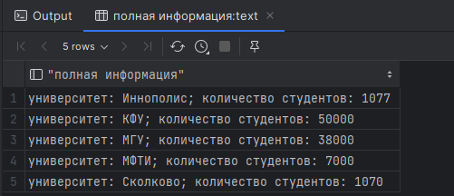

с)

SELECT name, size  
FROM college  
WHERE id IN (10, 30, 50)  
ORDER BY size, name;

Output:

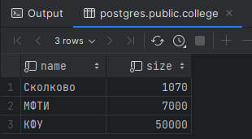

D)

SELECT name, size  
FROM college  
WHERE id NOT IN (10, 30, 50)  
ORDER BY size, name;

Output:

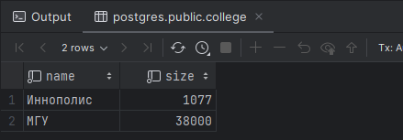

e)

SELECT name, amount_of_students  
FROM course  
WHERE amount_of_students  
BETWEEN 27 and 310  
ORDER BY name DESC, amount_of_students DESC;

Output:

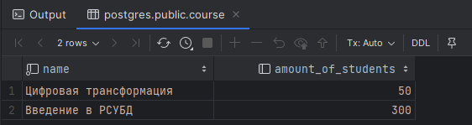

f)

SELECT student.name, course.name  
FROM student  
JOIN student_on_course ON student.id = student_on_course.student_id  
JOIN course ON student_on_course.course_id = course.id  
ORDER BY student.name DESC, course.name DESC;

Output:

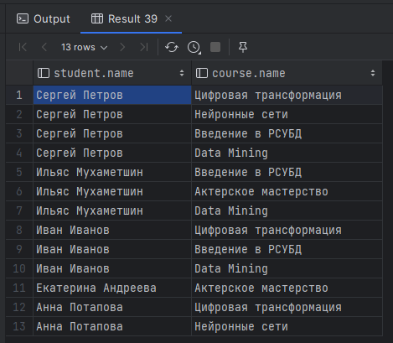

g)

SELECT college.name AS name, 'university' AS type  
FROM college  
UNION ALL  
SELECT course.name AS name, 'course' AS type  
FROM course  
ORDER BY type DESC, name DESC;

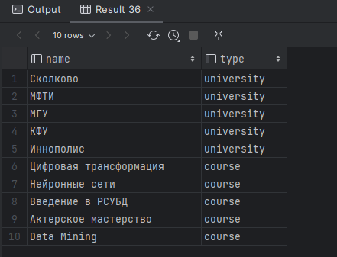

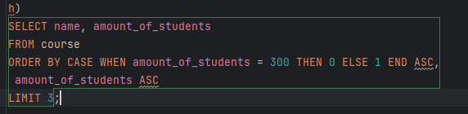

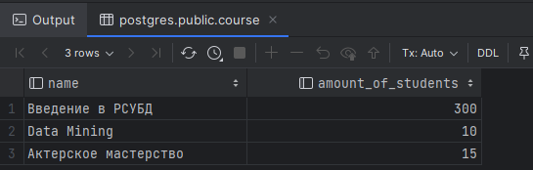

i)

INSERT INTO course (id, name, is_online, amount_of_students, college_id)  
VALUES (60, 'Machine Learning', false, 17, (SELECT course.id FROM course WHERE course.name = 'Data Mining') ) ;

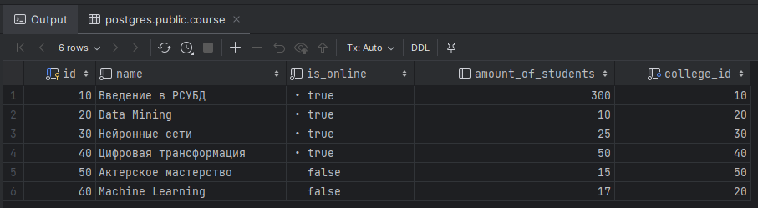

j)

SELECT course.id FROM course  
EXCEPT  
SELECT student_on_course.id FROM student_on_course  
UNION ALL  
SELECT student_on_course.id FROM student_on_course  
EXCEPT  
SELECT course.id FROM course  
ORDER BY id;

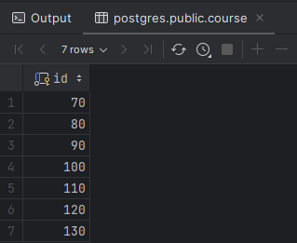

k)

SELECT student.name, course.name, college.name student_college, student_on_course.student_rating  
FROM student  
JOIN student_on_course ON student.id = student_on_course.student_id  
JOIN course ON student_on_course.course_id = course.id  
JOIN college ON student.college_id = college.id  
WHERE student_on_course.student_rating > 50 AND college.size > 5000  
ORDER BY student.name, course.name;

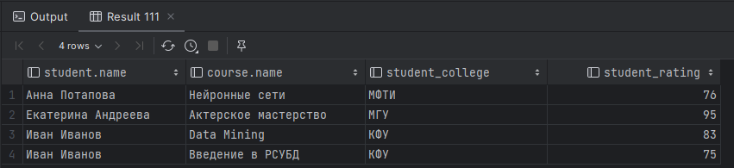

.

i)

SELECT DISTINCT *GREATEST*(s1.name, s2.name) AS student_1, *LEAST*(s1.name, s2.name) AS student_2, s1.city  
FROM student s1  
JOIN student s2 ON s1.city = s2.city AND s1.id < s2.id  
ORDER BY student_1 ;

