**Concept**

Create mini game where a user can visit different famous places in London during one day.

1. User has multiple choices where to move next in the graph
2. If there is no choice, display results
3. User progress should be kept. In a case if user already is registered, ask if they want to start over the game.
4. To show that we learned not only to SELECT from tables, we can also create table which holds users results. For example, at the beginning of the game ask user’s name, INSERT row with some basic information (name, date, game status = unfinished). In the end of the game UPDATE the record: did user finish game successfully, which way he took through graph etc.

**Quick notes**

1. ***Graphs and graphs elements***

The graph represents a city of London.

Each node in the graph holds famous location

***Graph example:***

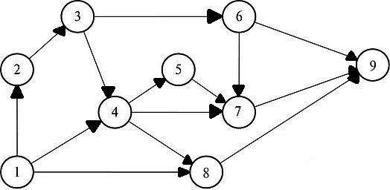

The graph and its nodes can be represented as DB tables.

***Table [Loactions]***

Holds information about each node of the graph

|  |  |  |
| --- | --- | --- |
| **Field name** | **Type** | **Description** |
| id | int | Unique key. Primary. |
| name | Varchar(255) | Name of place |
| street | varchar(255) | Address |
| intro | varchar(4000) | Some textual information |

***Table [Connection]***

Holds information how each node of the graph is connected

|  |  |  |
| --- | --- | --- |
| **Field** | **Type** | **Description** |
| id | int | Unique key. Primary. |
| starting_node | int | Starting node unqkey. Foreign key [Addresses.id] |
| ending_node | int | Ending node unqkey. Foreign key [Addresses.id] |

Algorithm scheme

Ending point(node 9)

Does node has connection to another node? nodenode?

No Not Yes

User chooses node

Adjacency Matrix

|  |  |  |  |  |  |  |  |  |  |
| --- | --- | --- | --- | --- | --- | --- | --- | --- | --- |
|  | **node1** | **node2** | **node3** | **node4** | **node5** | **node6** | **node7** | **node8** | **node9** |
| **node1** | 0 | 1 | 0 | 1 | 0 | 0 | 0 | 1 | 0 |
| **node2** | 0 | 0 | 1 | 0 | 0 | 0 | 0 | 0 | 0 |
| **node3** | 0 | 0 | 0 | 1 | 0 | 1 | 0 | 0 | 0 |
| **node4** | 0 | 0 | 0 | 0 | 1 | 0 | 1 | 1 | 0 |
| **node5** | 0 | 0 | 0 | 0 | 0 | 0 | 1 | 0 | 0 |
| **node6** | 0 | 0 | 0 | 0 | 0 | 0 | 1 | 0 | 1 |
| **node7** | 0 | 0 | 0 | 0 | 0 | 0 | 0 | 0 | 1 |
| **node8** | 0 | 0 | 0 | 0 | 0 | 0 | 0 | 0 | 1 |
| **node9** | 0 | 0 | 0 | 0 | 0 | 0 | 0 | 0 | 0 |

One day tour of London

|  |  |  |  |
| --- | --- | --- | --- |
|  | Name of place | Address | Some information |
| 1 | London Eye | London SE1 7PB | Huge observation wheel giving passengers a privileged bird's-eye view of the city's landmarks |
| 2 | SEA LIFE Centre London | London SE1 7PB | Sea life is an aquarium with a large collection of marine animals and is the largest collection of coral reefs in the UK. |
| 3 | Big Ben | London SW1A 0AA | Big Ben is the famous clock in London. |
| 4 | Westminster Abbey | London SW1P 3PA | Since 1066, the Abbey has hosted every coronation, and is the final resting place for the great kings, queens, poets, musicians, scientists and politicians of our past. |
| 5 | St James's Park | London SW1A 2BJ | Green space with a lake with daily pelican feeding, a grass-roofed cafe and ceremonial displays. |
| 6 | Buckingham Palace | London SW1A 1AA | You might be getting a treat to watch the Queen's guards marching and watch Changing of the guards ceremony. The official start time of the ceremony is 11:00 AM |
| 7 | Piccadilly Circus | London W1J 9HS | The square is famous for its neon signs, different displays and the Eros fountain. Piccadilly Circus offers a variety of cinemas, theatres, shops and restaurants, including famous traditional English pubs. |
| 8 | Trafalgar Square | London WC2N 5DN | Trafalgar Square is one of the most important and bustling squares in London: designed in 1830 to commemorate the British victory against the French and Spanish fleets in the Battle of Trafalgar. |
| 9 | The National Gallery | London WC2N 5DN | The National Gallery is a truly amazing place to be, especially for art lovers. Founded in 1824, it houses a collection of over 2,300 paintings dating from the mid-13th century to 1900. Admission to the gallery is completely free. |

1. We can connect table “Progress” to “Locations” via foreign key progress id:

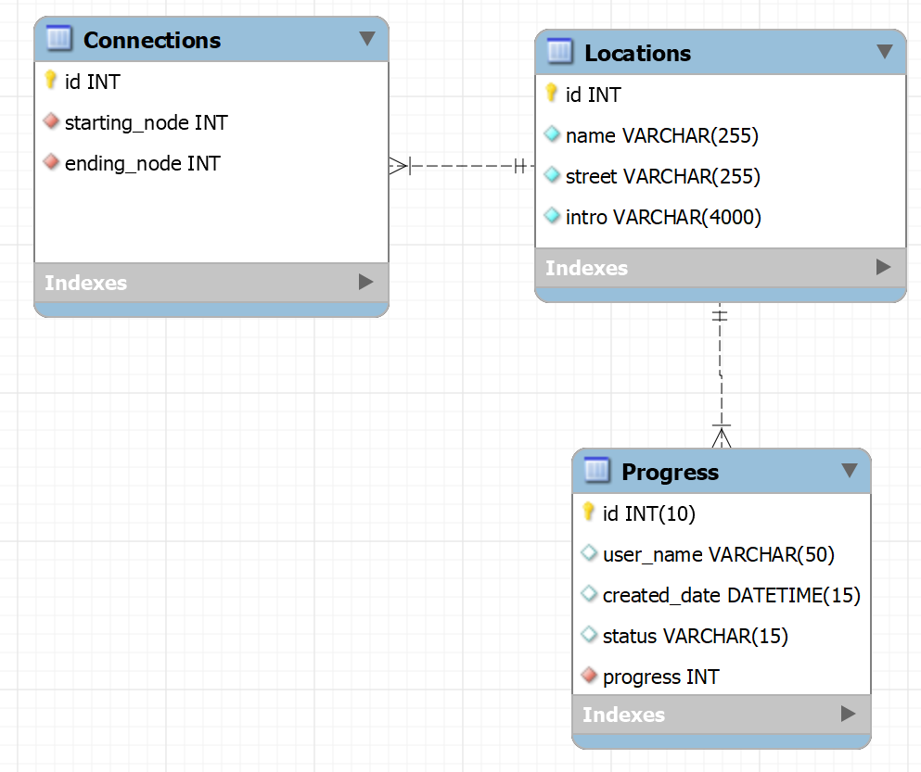

1. We can print out progress table where we can see also visited places:

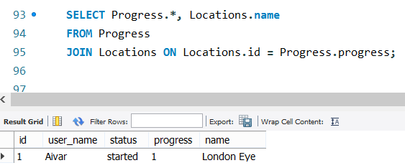

For example(all places were visited):

|  |  |  |  |  |
| --- | --- | --- | --- | --- |
| id | user_name | created_date | status | progress |
| 12 | user | 2021-05-06 19:40:14.000000 | visited | 1 |
| 13 | user | 2021-05-06 19:40:30.000000 | visited | 8 |
| 14 | user | 2021-05-06 19:40:31.000000 | finished | 9 |
| 5 | user1 | 2021-05-06 19:24:30.000000 | visited | 1 |
| 6 | user1 | 2021-05-06 19:24:32.000000 | visited | 2 |
| 7 | user1 | 2021-05-06 19:24:33.000000 | visited | 3 |
| 8 | user1 | 2021-05-06 19:24:34.000000 | visited | 4 |
| 9 | user1 | 2021-05-06 19:24:35.000000 | visited | 7 |
| 10 | user1 | 2021-05-06 19:24:37.000000 | finished | 9 |
| 51 | user2 | 2021-05-06 20:45:59.000000 | visited | 1 |
| 52 | user2 | 2021-05-06 20:46:02.000000 | visited | 8 |
| 53 | user2 | 2021-05-06 20:46:04.000000 | finished | 9 |
|  |  |  |  |  |

3 We have to save progress and insert it in the table Progress for all nodes

