***The site design of Crociera di piacere company***

**The company specializes in the providing ideas and fulfilling travel dreams**

*The site is created with the following goals:*

* Informing users about interesting offers for rest
* Attracting new users for the company’s services
* Increase demand of services
* Get more users and applications
* Service promotion

*Visual wishes:*

* In the first page to be shown the name of company
* Subtopics with their description
* Every page has a tabbed ribbon and a contact tape
* Useful information in every page

*Main page menu items:*

* The name of company
* Subtopics
* 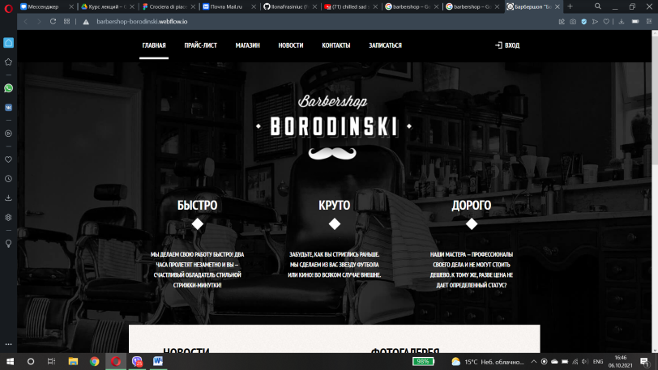Tabbed ribbon
* Contact tape

*Description*

For my site I chose the topic “Tourism”. For the cover of site I inspired by the Barbershop website.

Firstly its interface looks very attractive. Secondly interface is confortable constructed for users. Also I had to look for basic information from various sources, and simply, to carry a research work.

In the first page is “Home”, the main information is the name of this site which is in Italian. Also there are subtopics that have theire description. This page as others has a tabbed ribbon and a contact tape.

The second page is named “Useful information”, it consists useful information about services, that company can offer.

The third and the forth pages present interesting ideas for a nice trip and the most popular reguests.