Supplementary Information Draft

Title
Supplementary Information for "Seasonal Methane Isotope Phasors Constrain the Methane OH 13C Kinetic Isotope Effect"

SI Scope
This supplementary draft documents data screening, sensitivity experiments, and diagnostic analyses that support the main manuscript without overloading the main text. The main manuscript retains the Southern Hemisphere phasor-corrected KIE constraint as the central result. Northern Hemisphere residuals, biomass burning, Ganesan spatial wetland source signatures, and transport-lag sensitivities are treated here as robustness and diagnostic material.

S1. Atmospheric Data Pairing And Site Screening
We began from 12 sites with co-located atmospheric delta13C-CH4 and deltaD-CH4 observations. CH4 mole fractions were taken from the NOAA GML surface-flask product of Lan et al. (2025), delta13C-CH4 from the NOAA/INSTAAR product of Michel et al. (2023), and deltaD-CH4 from the multi-laboratory data set analyzed by Riddell-Young et al. (2025). The deltaD-CH4 observations were harmonized following the laboratory-offset framework described by Riddell-Young et al. (2025), Umezawa et al. (2018), and Dasgupta et al. (2025).
Table S1. Candidate site coverage.
Site | Latitude | Paired monthly means | Overlap years | Use in main analysis
ALT | 82.45 | 52 | 4.7 | Clean site
ZEP | 78.91 | 16 | 1.4 | Clean site
BRW | 71.32 | 41 | 5.0 | Clean site
CBA | 55.21 | 14 | 1.4 | Clean site
MHD | 53.33 | 31 | 4.4 | Clean site
AZR | 38.77 | 28 | 4.7 | Excluded/diagnostic
MLO | 19.54 | 46 | 4.6 | Excluded/diagnostic
KUM | 19.56 | 36 | 4.7 | Clean site
ASC | -7.97 | 46 | 4.9 | Excluded/diagnostic
SMO | -14.25 | 36 | 4.4 | Excluded/diagnostic
CGO | -40.68 | 29 | 4.1 | Clean site, SH constraint
SPO | -89.98 | 33 | 4.6 | Clean site, SH constraint

The clean set used for the primary phasor analysis is ALT, ZEP, BRW, CBA, MHD, KUM, CGO, and SPO. The Southern Hemisphere KIE constraint is based on CGO and SPO because the wetland source correction is smallest there and because their corrected seasonal phases are consistent with an austral-summer sink maximum.
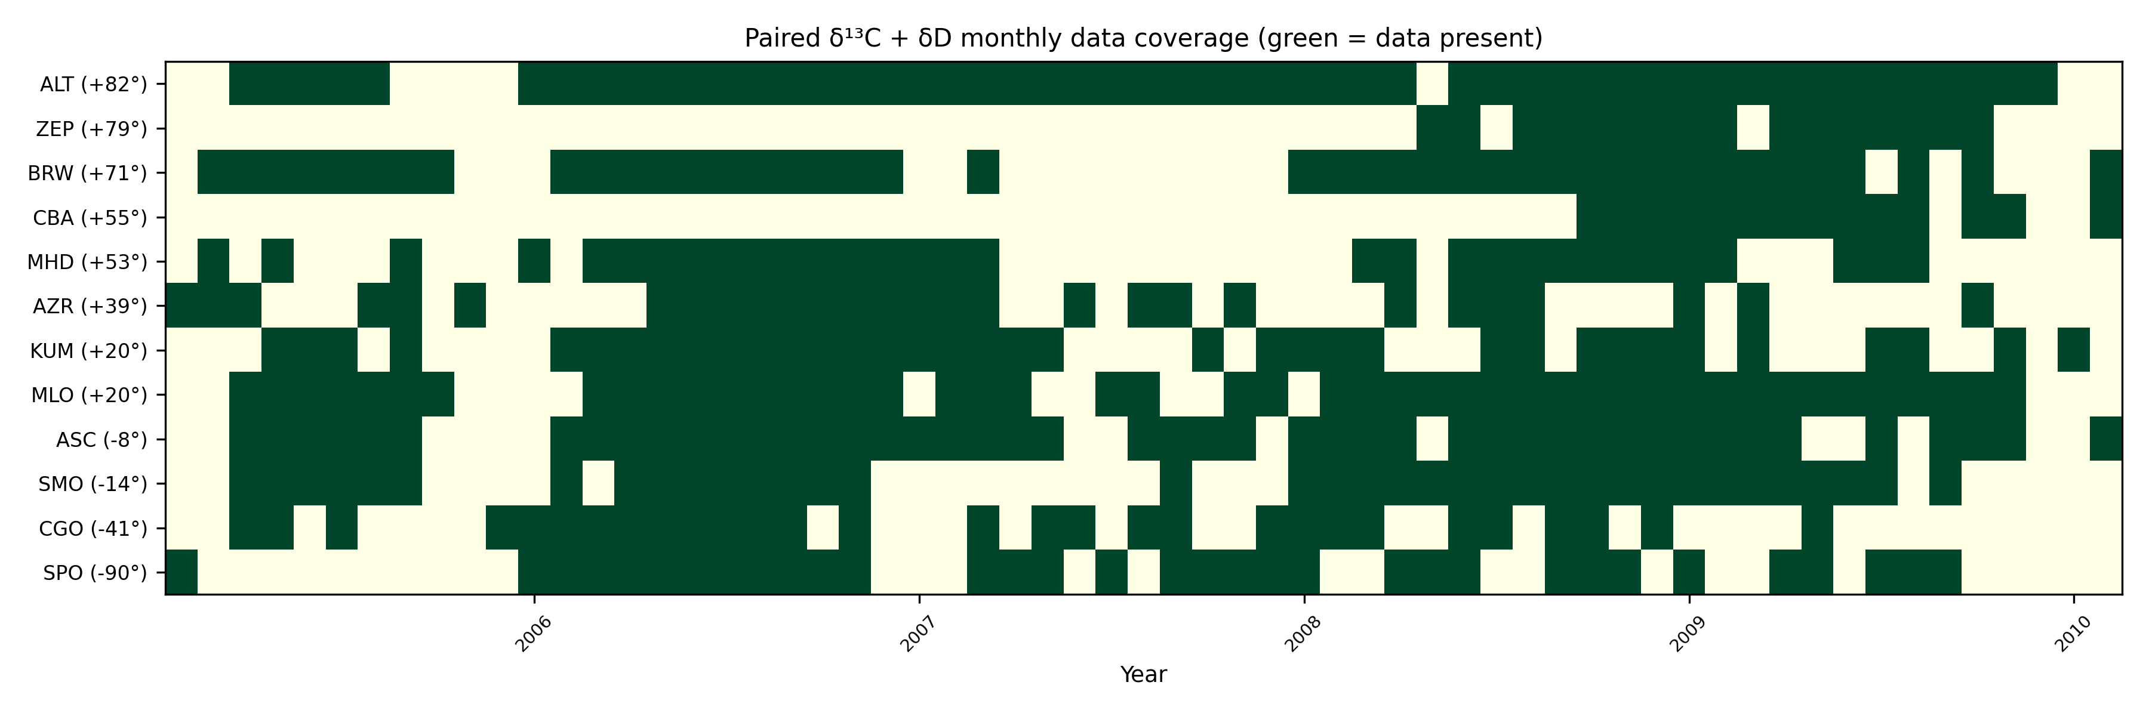
Figure S1. Paired monthly data coverage by site.
Figure S1. Paired monthly data coverage by site. Green cells mark months with co-located delta13C-CH4 and deltaD-CH4 observations after monthly pairing. Site ordering follows latitude from north to south. The figure documents the coverage limitations behind the harmonic fits and the emphasis on CGO and SPO for the Southern Hemisphere constraint. Data sources are Lan et al. (2025), Michel et al. (2023), and the Riddell-Young et al. (2025) deltaD-CH4 archive.

S2. Harmonic Fits And Robustness To Seasonal Model Choice
The base analysis fits an annual harmonic plus a linear trend to paired monthly means:
y(t) = c0 + c1 (t - tref) + B sin(2 pi t) + C cos(2 pi t).
The harmonic coefficients are stored as Z = B + iC. The base manuscript uses the annual harmonic because it is the minimal model that preserves seasonal amplitude and phase and is stable for the short 2005-2010 paired isotope interval. Figure S3 compares four ways of estimating the same seasonal amplitude ratio: the base annual harmonic, the annual component of an annual-plus-semiannual fit, a monthly fixed-effect half peak-to-trough amplitude, and leave-one-year-out annual fits. These tests show that some sites are stable under model choice, whereas sparse or low-amplitude sites can have larger year-to-year scatter than the nominal full-period bootstrap interval.
The four estimates in Figure S3 use the same paired monthly isotope data but process the seasonal cycle differently. The annual harmonic first removes a linear trend and then fits one annual sine-cosine pair; this is the main analysis because it gives both amplitude and phase with few parameters. The annual-plus-semiannual fit adds a second harmonic to absorb twice-per-year structure, and Figure S3 plots only the annual component from that fit. The monthly fixed-effect estimate first averages the detrended observations by calendar month and then uses half of the peak-to-trough range as the amplitude, so it is less model-based but more sensitive to sparse monthly coverage. Finally, the leave-one-year-out estimate repeats the annual-harmonic fit after removing one calendar year at a time; its vertical range shows how much the ratio changes when any single year is omitted.
The main implication is conservative: the Southern Hemisphere constraint is useful but should not be overinterpreted as excluding either laboratory alpha13C_OH value. Northern Hemisphere multi-site estimates should be reported as diagnostic because they remain sensitive to residual source structure and model choice.
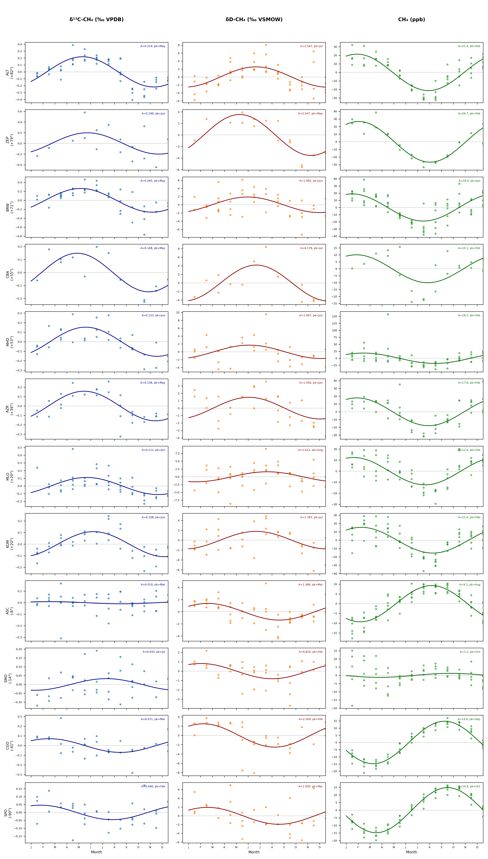
Figure S2. Folded seasonal cycles used for annual harmonic fitting.
Figure S2. Folded seasonal cycles used for annual harmonic fitting. Monthly anomalies of delta13C-CH4, deltaD-CH4, and CH4 are folded by calendar month and shown with annual harmonic fits. The figure is a diagnostic view of the paired observations used to estimate seasonal amplitudes and phases.
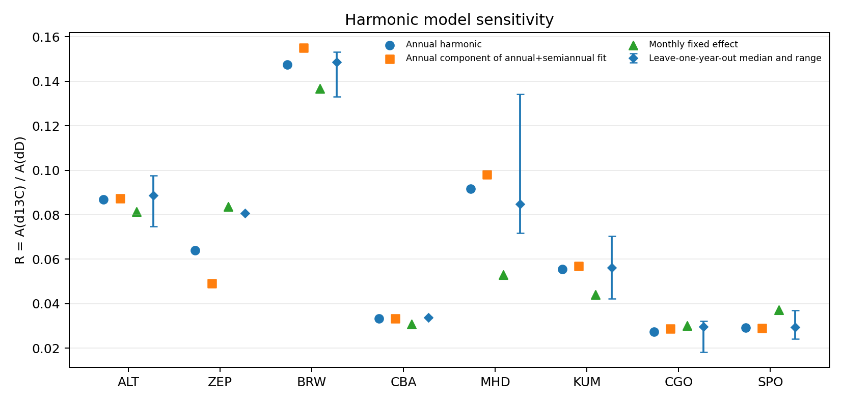
Figure S3. Harmonic-model sensitivity.
Figure S3. Harmonic-model sensitivity. Annual-only, annual-plus-semiannual, monthly fixed-effect, and leave-one-year-out estimates are compared for the clean-site set. Points show the ratio R = A(delta13C)/A(deltaD). For the leave-one-year-out diagnostic, diamonds show the median ratio and vertical bars span the minimum-to-maximum range obtained by excluding one calendar year at a time. This diagnostic supports the choice of a minimal annual phasor model for the main analysis while identifying sites where sparse coverage or low amplitude increases sensitivity to model choice.
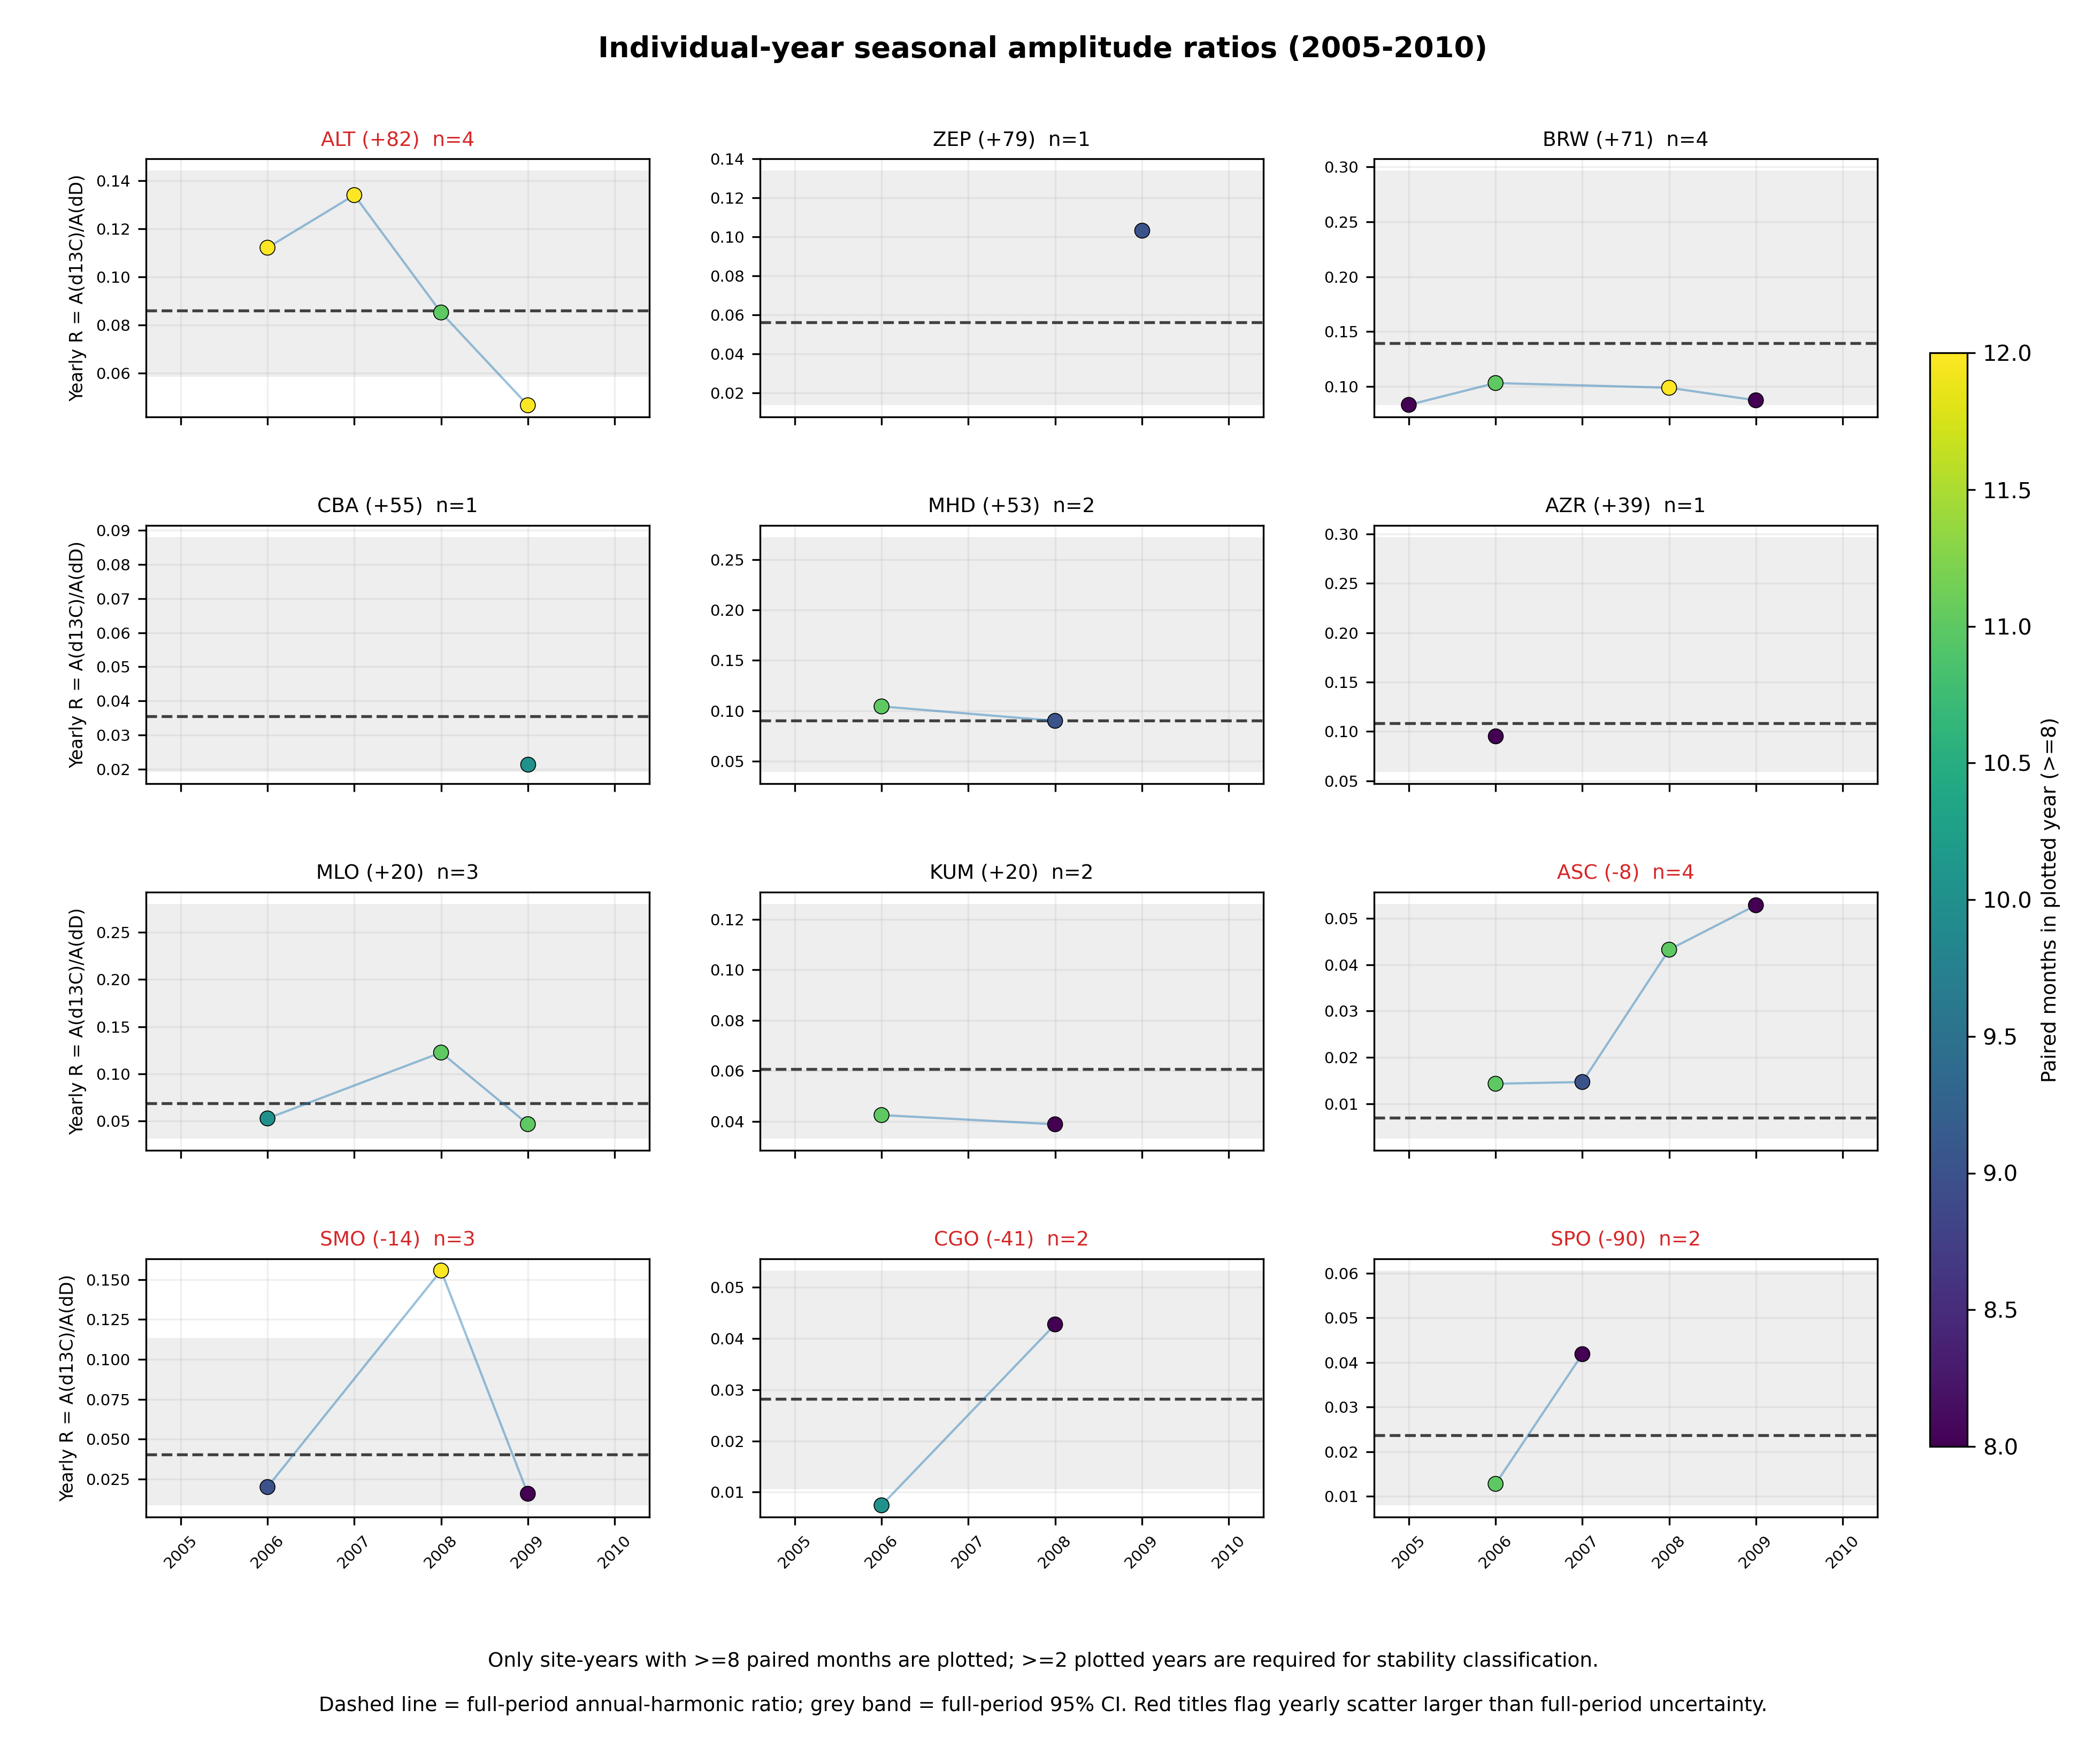
Figure S4. Individual-year stability of amplitude ratios.
Figure S4. Individual-year stability of amplitude ratios. Site-by-site yearly amplitude ratios are shown where enough paired months are available. A "usable" site-year is defined as a calendar year with at least 8 paired monthly means; years below this threshold are not plotted. At least two usable years are required to classify a site-level yearly-stability diagnostic. Point color shows the number of paired months in each plotted year, the dashed line is the full-period annual-harmonic ratio, and the grey band is the full-period 95% interval. The comparison highlights the sampling penalty of the short 2005-2010 overlap interval.

S3. Wetland Emission Source Phasors
Wetland methane source phasors were constructed from Li et al. (2026) monthly natural vegetated wetland methane emissions for 2000-2025. The main analysis uses the 2005-2010 climatological annual harmonic in four source bands: 60-90 N, 30-60 N, 30 S-30 N, and 90-30 S.
Table S2. Wetland emission-band climatology used for source phasors.
Band | Latitude range | Annual emissions | Peak season | Main manuscript role
NH high | 60-90 N | 10.9 Tg yr-1 | Boreal summer | ALT, ZEP, BRW source phasor
NH mid | 30-60 N | 29.7 Tg yr-1 | Boreal summer | CBA, MHD source phasor
Tropics | 30 S-30 N | 114.0 Tg yr-1 | Weak annual cycle | KUM source phasor; SH sensitivity
SH extra | 90-30 S | 2.9 Tg yr-1 | Austral summer | CGO/SPO base source phasor

These bands are emission phasors, not transport footprints. This distinction is important for Southern Hemisphere interpretation: assigning CGO and SPO to global wetland emissions would overcorrect their small observed isotope cycles.
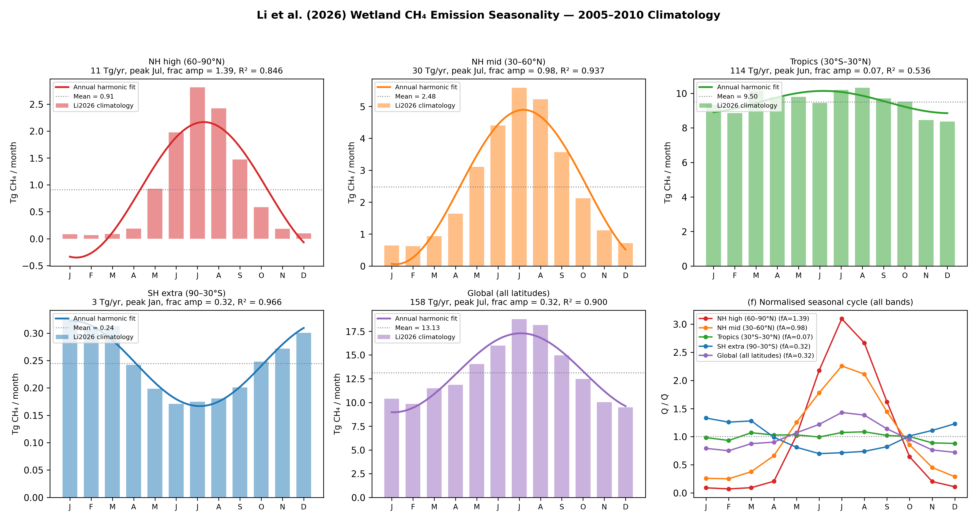
Figure S5. Wetland emission seasonality by latitude band.
Figure S5. Wetland emission seasonality by latitude band. Monthly natural vegetated wetland methane emissions from Li et al. (2026) are summarized by the four latitude bands used for the phasor correction. The annual harmonic fit to each band supplies the wetland source phasor amplitude and phase used in the main analysis.
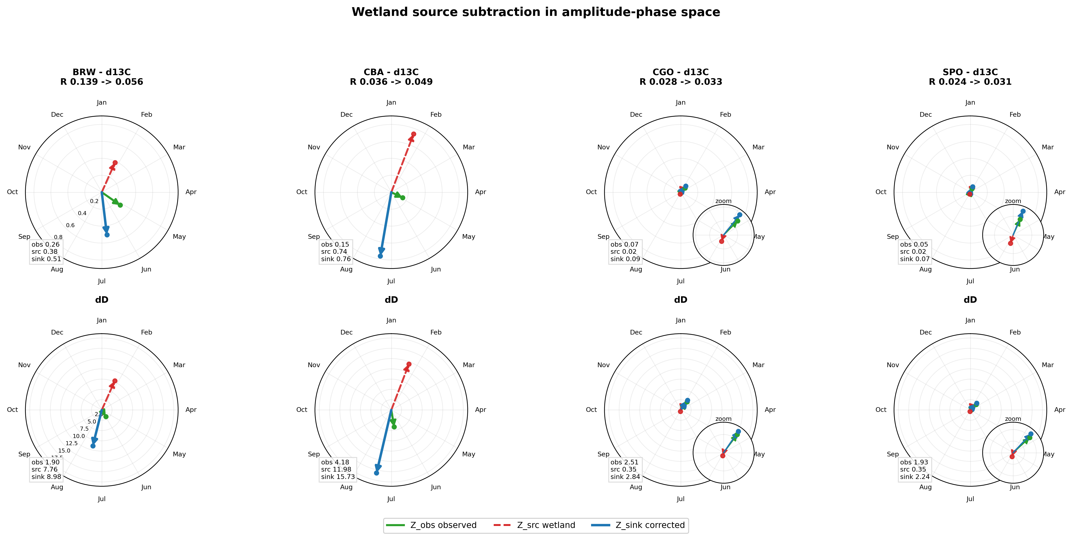
Figure S6. Example wetland source phasor subtraction.
Figure S6. Example wetland source phasor subtraction. Polar phasor clocks show observed, wetland-source, and corrected sink phasors for representative sites. The northern examples illustrate why scalar amplitude subtraction is not appropriate; the Southern Hemisphere examples show that local wetland phasors are small relative to the observed isotope cycles.

S4. Wetland Isotope Source Signatures
The base analysis uses delta13C_wetland = -62 permil with a 5 permil uncertainty. This is a global wetland/microbial prior supported by Ganesan et al. (2018) and Riddell-Young et al. (2025). It should not be interpreted as a site-specific wetland value.
deltaD_wetland is more spatially variable and is treated with site- or band- specific values. The source-signature database uses Douglas et al. (2021) relationships between freshwater methane deltaD-CH4 and environmental water, with OIPC v3.1 precipitation delta2H estimates as a predictor/cross-check. For background sites where local precipitation is not a direct wetland source, Douglas et al. zonal wetland values are preferred.
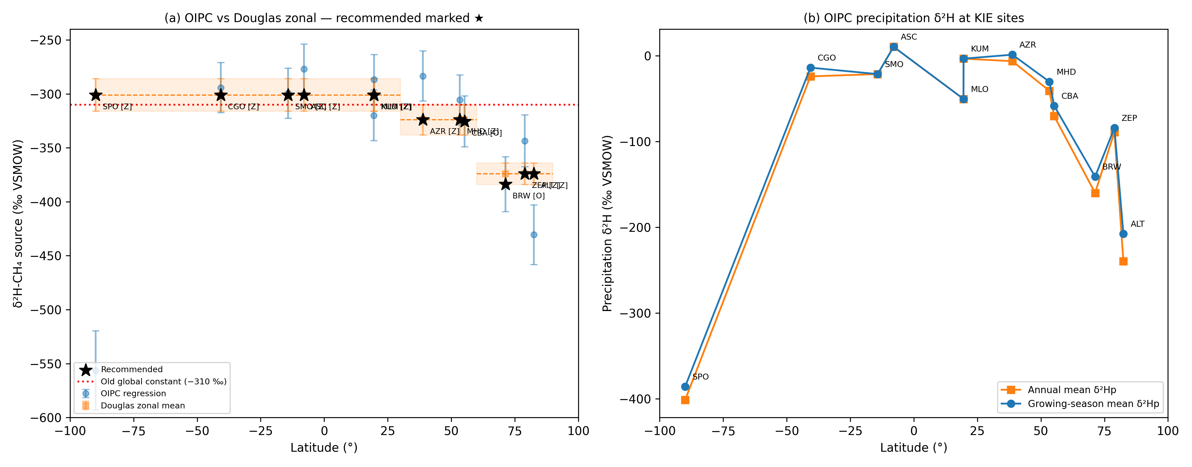
Figure S7. Wetland `deltaD-CH4` source-signature alternatives.
Figure S7. Wetland `deltaD-CH4` source-signature alternatives. The deltaD-CH4 source-signature database compares site or band values derived from Douglas et al. (2021) relationships with OIPC v3.1 precipitation-isotope estimates. These values are used as wetland source-signature inputs and uncertainty bounds in the phasor correction.

S5. Ganesan Spatial `delta13C_wetland` Sensitivity
The compact sensitivity replaces the uniform delta13C_wetland = -62 permil base case with a banded Ganesan et al. (2018) source signature:
Source influence | Base value | Banded sensitivity value
High-latitude/boreal wetland influence | -62 permil | about `-67.8 permil
Tropical wetland influence | -62 permil | about `-56.7 permil
Ambiguous/global influence | -62 permil | -62 permil

The expected effect is largest at Northern Hemisphere sites where wetland source phasors are largest. The main text keeps the uniform base case, and the SI records how the inferred Southern Hemisphere alpha13C_OH responds when regional wetland delta13C signatures are used.
The resulting corrected-ratio shifts are shown in Figure S8b. Replacing the uniform value with the high-latitude/boreal value increases corrected ratios at ALT, ZEP, BRW, CBA, and MHD by about 0.014-0.022. Replacing the tropical value at KUM decreases its corrected ratio by about 0.015. CGO and SPO are unchanged in this compact test because the ambiguous/local Southern Hemisphere case retains the base -62 permil value. Thus the Ganesan-style spatial delta13C_wetland sensitivity mainly amplifies the conclusion that northern sites retain unresolved source structure; it does not alter the preferred Southern Hemisphere KIE constraint.
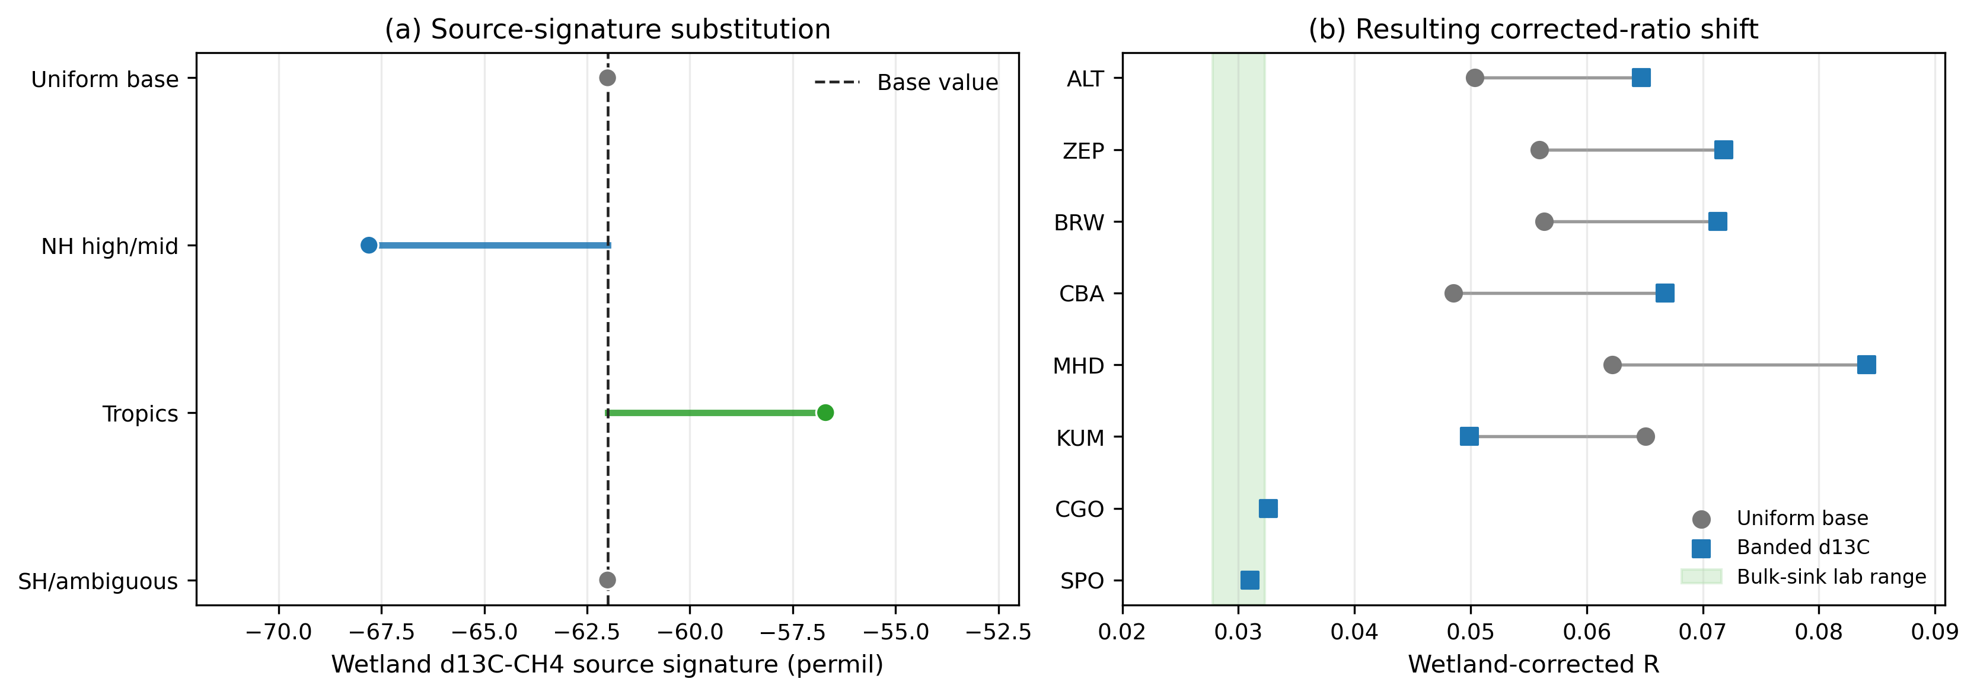
Figure S8. Banded wetland `delta13C-CH4` source-signature sensitivity.
Figure S8. Banded wetland `delta13C-CH4` source-signature sensitivity. The base analysis uses a uniform delta13C_wetland = -62 permil. (a) The sensitivity replaces that value with approximate high-latitude/boreal and tropical wetland signatures based on the spatially resolved wetland source-signature framework of Ganesan et al. (2018), while retaining the global value where the source influence is ambiguous. (b) Resulting site-level corrected ratios for the uniform and banded source-signature cases. Line segments show the direction and magnitude of the correction change.

S6. Sink Fraction And KIE Parameter Alignment
Riddell-Young et al. (2025) SI Table S3 provides a compact modern sink/KIE parameter set. The analysis uses closely related values. The main manuscript reports the values actually used in the analysis, while this SI section compares them against Riddell-Young et al. Table S3.
Table S3. Base analysis sink/KIE values compared with Riddell-Young et al. (2025) SI Table S3.
Sink term | Base analysis | Riddell-Young SI Table S3 | Interpretation
OH fraction | 0.84 | 0.835 | Aligned within rounding
Cl fraction | 0.035 | 0.035 | Aligned
Stratospheric fraction | 0.065 | 0.06 | Close; base analysis uses closure
Soil fraction | 0.06 | 0.07 | Close; include as sensitivity if rerun
OH `alpha13C | 1.0039` and `1.0054 | 1.0054 | Main uncertainty of interest
OH `alphaD | 1.294 | 1.294 | Aligned
Cl `alpha13C | 1.066 | 1.066 | Aligned
Cl `alphaD | 1.508 | 1.520 | Close
Soil `alpha13C | 1.022 | 1.020 | Close
Soil `alphaD | 1.066 | 1.083 | Difference is minor in bulk because soil fraction is small
Stratospheric `alpha13C | 1.013 | 1.003 | Difference is minor in bulk but should be stated
Stratospheric `alphaD | 1.16 | 1.179 | Close
Net sink `alpha13C | 1.0078-1.0090 | 1.0082 | Base-analysis range brackets Riddell-Young
Net sink `alphaD | 1.2791 | 1.281 | Aligned

If the manuscript changes base sink/KIE values to match Riddell-Young Table S3 exactly, the relevant analyses must be rerun before submission.

S7. Southern Hemisphere Source-Region Sensitivity
The main analysis assigns CGO and SPO to local Southern Hemisphere extratropical wetland phasors. This is conservative because the local wetland phasor is small and avoids imposing unconstrained delayed Northern Hemisphere source influence.
The sensitivity values in this section are deterministic source-region comparisons based on nominal phasor subtraction. The main-text atmospheric constraint instead combines the CGO and SPO corrected-ratio Monte Carlo samples before converting to alpha13C_OH, giving 1.0046 [0.9969, 1.0158]. The nominal phasor values are therefore interpreted as diagnostic/reproducibility quantities rather than as the reported central KIE estimate. This distinction explains why the zero-imported-response point in Figure S9 is about 1.0052, close to the Cantrell et al. (1990) value: it is the simple deterministic mean of the nominal CGO and SPO phasor-corrected ratios. It is not the preferred Southern Hemisphere Monte Carlo constraint shown in the main text.
We therefore run two distinct Southern Hemisphere source-region diagnostics. The first is a mass-conserving source-region response mixture. It mixes local Southern Hemisphere, tropical, and delayed high-latitude Northern Hemisphere wetland phasors with weights that sum to one:
Z_source = w_SH Z_SH + w_Tropics Z_Tropics + w_NH Z_NH_high,delayed
w_SH + w_Tropics + w_NH = 1.
The delayed high-latitude Northern Hemisphere weight is limited to 0.04, 0.06, 0.08, and 0.10. The tropical weight spans 0.00-0.50, and the remaining weight is assigned to local Southern Hemisphere wetlands. Across the 24 mass-conserving scenarios, the mean inferred alpha13C_OH spans about 0.9989-1.0062; the corresponding mean corrected ratio spans about 0.0126-0.0348.
Two one-dimensional mass-conserving slices separate the tropical and delayed high-latitude Northern Hemisphere effects. With tropical influence only, the deterministic mean inferred alpha13C_OH changes from about 1.0052 at zero tropical weight to a minimum of about 1.0028 near tropical weights 0.20-0.30, then increases to about 1.0071 at tropical weight 0.50. With delayed high-latitude Northern Hemisphere influence only, the deterministic mean inferred alpha13C_OH increases from about 1.0052 to 1.0061 across weights 0.00-0.10.
The combined grid is not expected to be monotonic everywhere. The corrected ratio is calculated from vector magnitudes after subtracting isotope-specific source phasors, not from a scalar mixture of ratios. At fixed tropical weight, increasing the delayed high-latitude Northern Hemisphere weight simultaneously reduces the local Southern Hemisphere weight; this can rotate the corrected delta13C and deltaD sink phasors differently and produce local minima or maxima in A(delta13C)_sink / A(deltaD)_sink.
The second diagnostic is the older additive transport stress test. These scenarios are not mass-conserving source mixtures; their scaling factors are effective transported annual-harmonic response coefficients. They are retained only as upper-bound structural tests:
Scenario group | Mean inferred `alpha13C_OH | Interpretation
SH-only baseline | about `1.0052` in deterministic sensitivity | Matches the main source assignment, but is not the MC central estimate
Tropics low to high | about `1.0029-1.0060 | Tropical influence is modest
NH low to high delayed | about `1.0071-1.0140 | Delayed NH influence can be large but is an additive stress test
Full low to high | about `1.0055-1.0158 | Combined additive envelope; not a mass-conserving correction

The main text uses the mass-conserving grid for the primary sensitivity statement. The additive delayed Northern Hemisphere scenarios are retained as non-plotted stress-test diagnostics to show how large the inferred shift could be if a delayed Northern Hemisphere annual harmonic were imposed without enforcing source-region weights that sum to one.
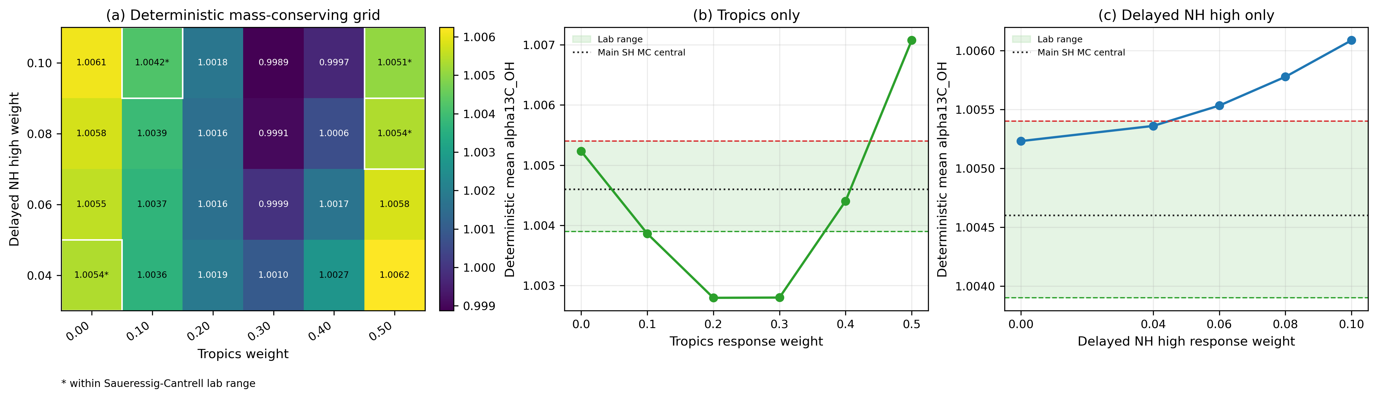
Figure S9. Southern Hemisphere source-region sensitivity.
Figure S9. Southern Hemisphere source-region sensitivity. CGO/SPO wetland source phasors are tested with deterministic mass-conserving source-region mixtures. (a) Combined grid of mean inferred alpha13C_OH values, with delayed high-latitude Northern Hemisphere and tropical response weights varied and the remaining weight assigned to local Southern Hemisphere wetlands. Asterisks mark cells that fall within the Saueressig-Cantrell laboratory range. (b) Tropical response only, with the remaining weight assigned to local Southern Hemisphere wetlands. (c) Delayed high-latitude Northern Hemisphere response only, with the remaining weight assigned to local Southern Hemisphere wetlands. The dotted black line in panels (b) and (c) marks the preferred main-text Southern Hemisphere Monte Carlo central estimate.

S8. Biomass Burning Sensitivity
Biomass burning has an isotopically enriched delta13C-CH4 signature and a seasonal cycle that can alter northern isotope phasors. It is therefore important for diagnosing residual Northern Hemisphere structure. However, the main Southern Hemisphere KIE constraint does not require biomass burning to explain the result, and the uncertainty attribution assigns biomass burning a smaller diagnostic contribution than observations, wetland phasors, wetland isotope signatures, sink fractions, and alphaD_OH.
The following diagnostics show:
- Biomass burning source phasor seasonality by source band.
- Wetland-only versus wetland-plus-biomass-burning corrected ratios.
- Whether the Southern Hemisphere alpha estimate changes materially.
- Why biomass burning remains a secondary main-text issue but an important
northern residual diagnostic.
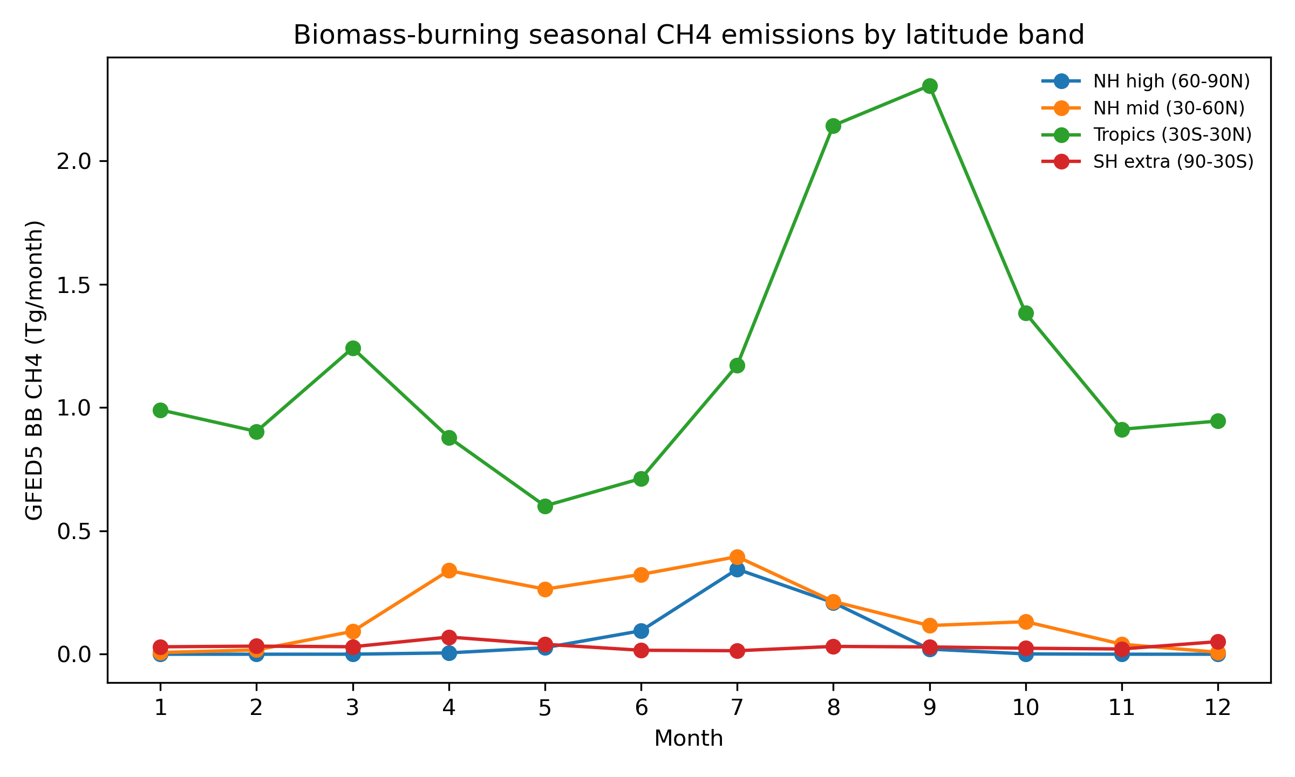
Figure S10. Biomass-burning seasonality by source band.
Figure S10. Biomass-burning seasonality by source band. Biomass-burning seasonality is summarized by source band to diagnose how enriched combustion signatures could affect isotope phasors, especially at Northern Hemisphere sites.
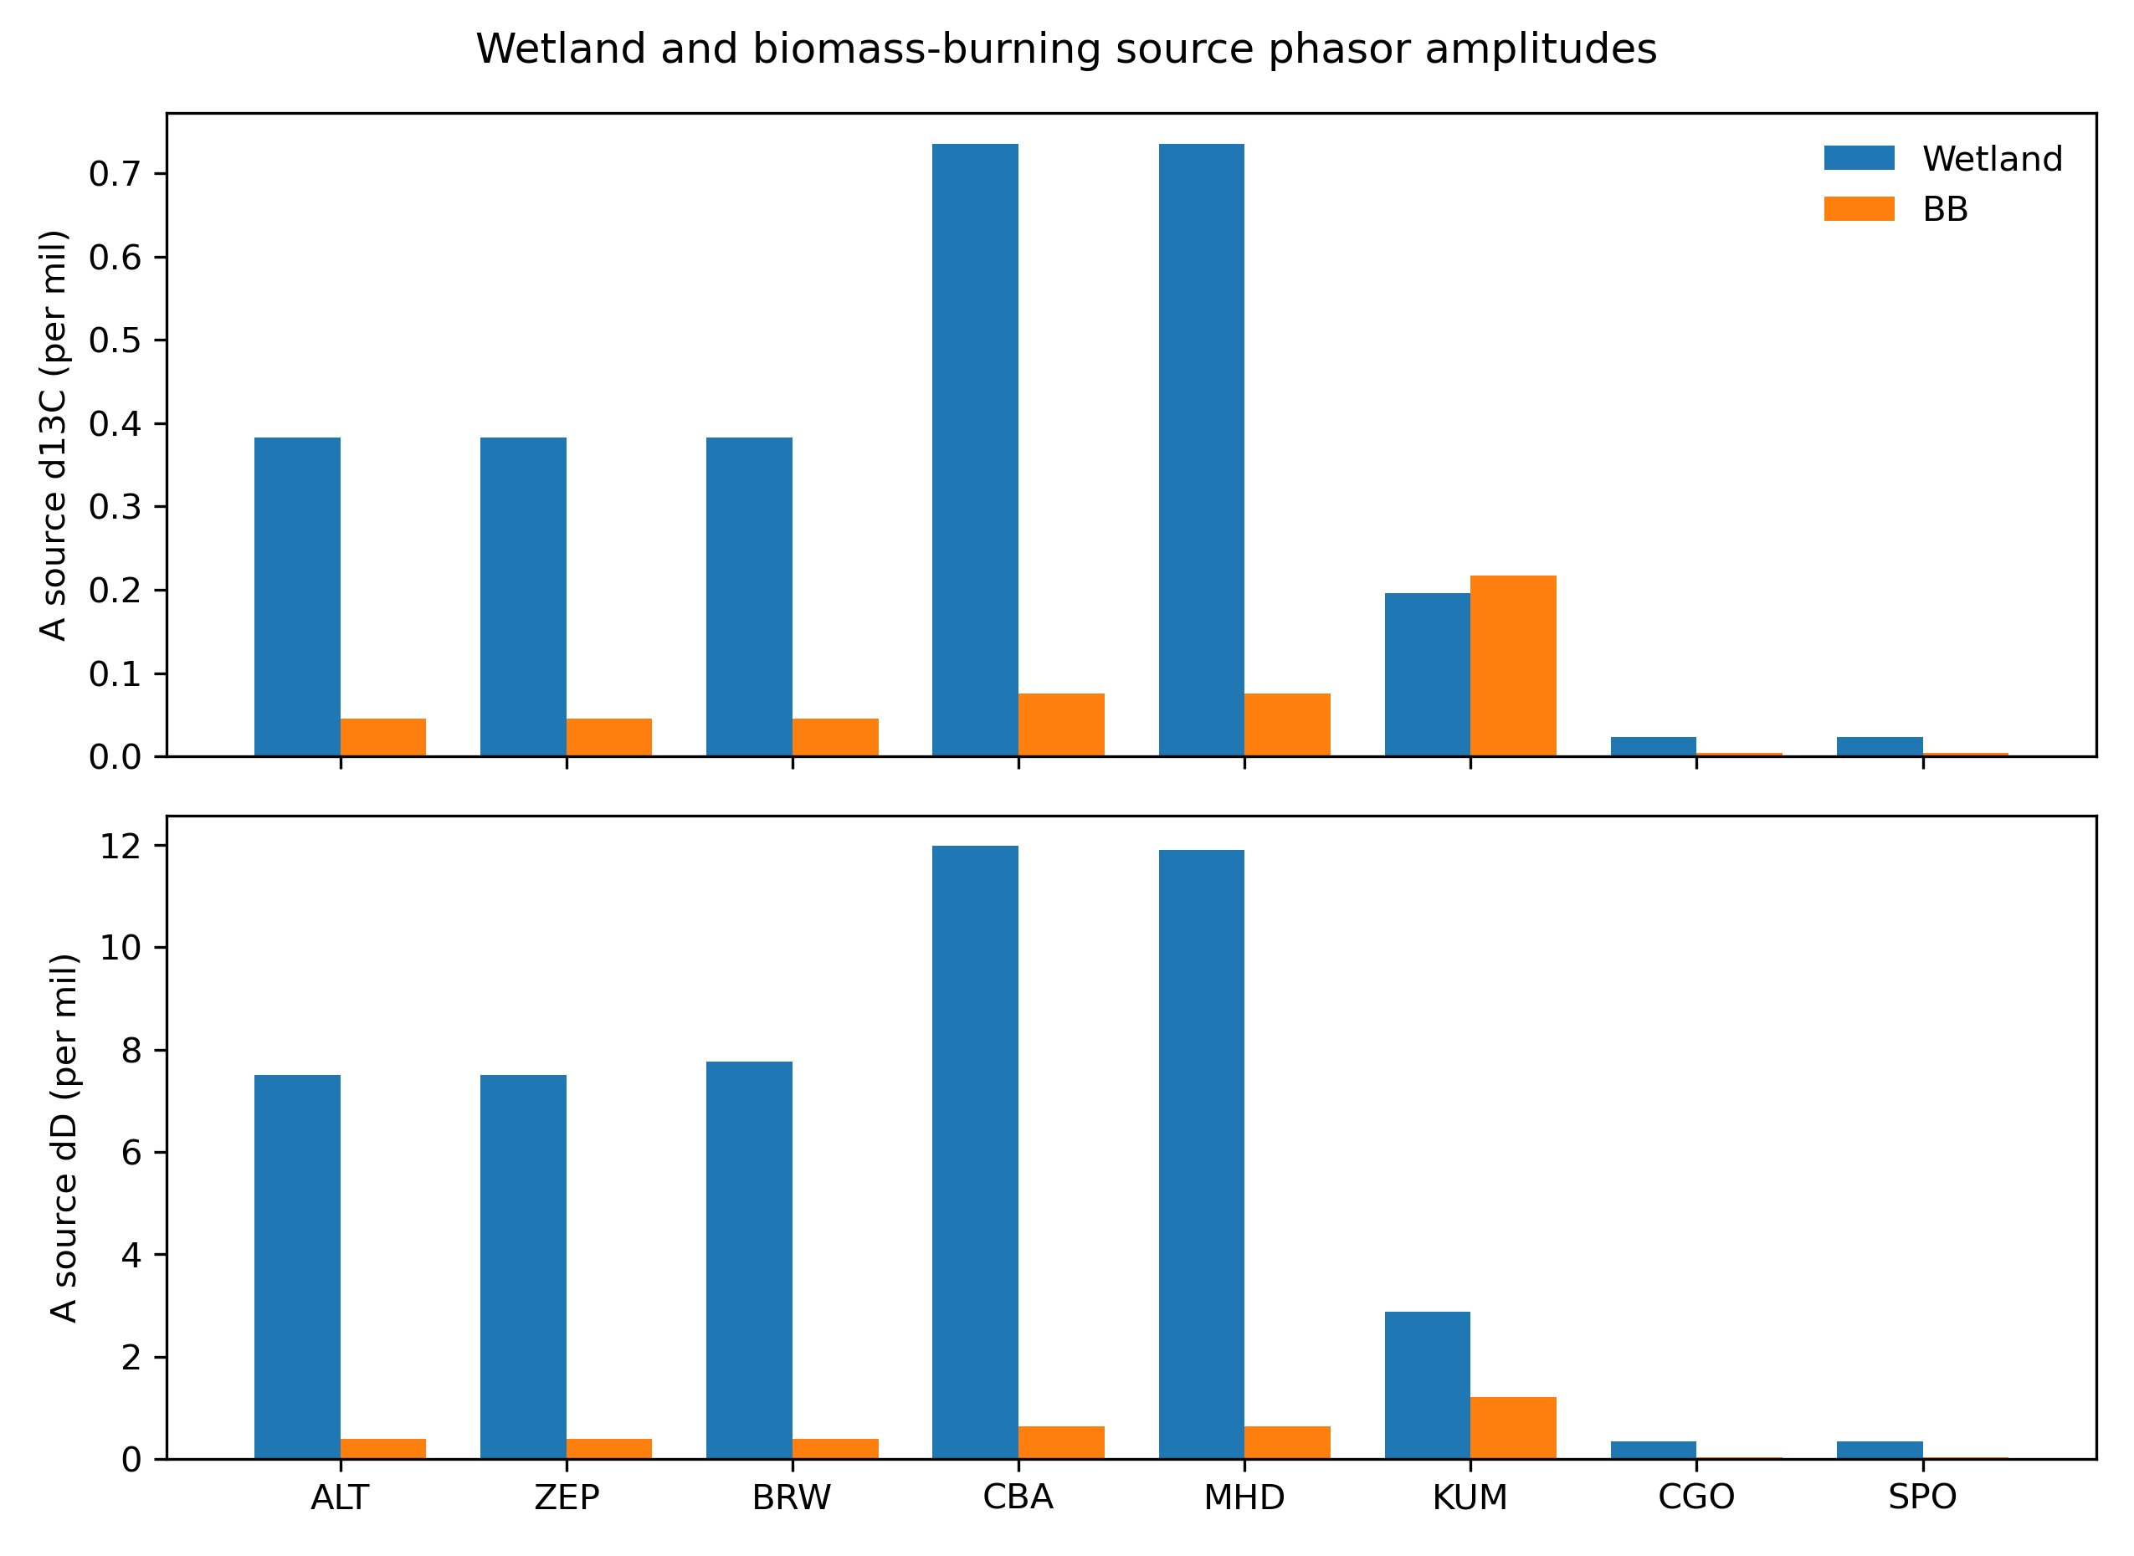
Figure S11. Biomass-burning source phasors.
Figure S11. Biomass-burning source phasors. Biomass-burning source phasors are compared with wetland source phasors in the same annual-harmonic framework. This provides the geometric basis for treating biomass burning as a supplementary correction rather than a main-text driver of the SH constraint.
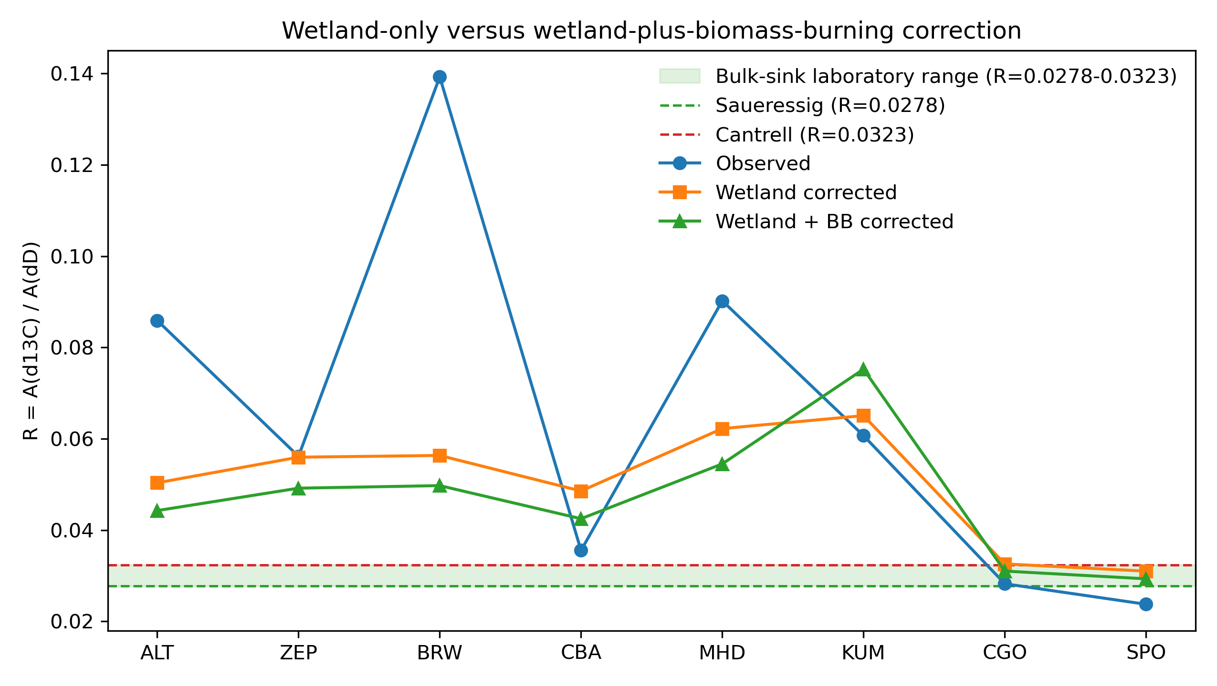
Figure S12. Wetland-only versus wetland-plus-biomass-burning correction.
Figure S12. Wetland-only versus wetland-plus-biomass-burning correction. Corrected amplitude ratios are compared before and after the biomass-burning phasor adjustment. The figure diagnoses northern residual structure while showing why biomass burning is not emphasized in the main Southern Hemisphere constraint. The green band is the same bulk-sink laboratory reference range used in the main ratio figures, not the OH-only ratio range.

S9. OSSE And Scalar-Amplitude Bias
Synthetic monthly OSSE tests show that a scalar amplitude-ratio method can be unbiased in a pure-OH seasonal cycle but biased when a seasonal source phasor is added. In the wetland-contaminated OSSE with true alpha13C_OH = 1.0039, the raw amplitude ratio retrieves an apparent alpha13C_OH of about 1.0086, illustrating how source phasors can mimic a larger OH 13C KIE. This motivates the phasor formulation used in the main analysis.
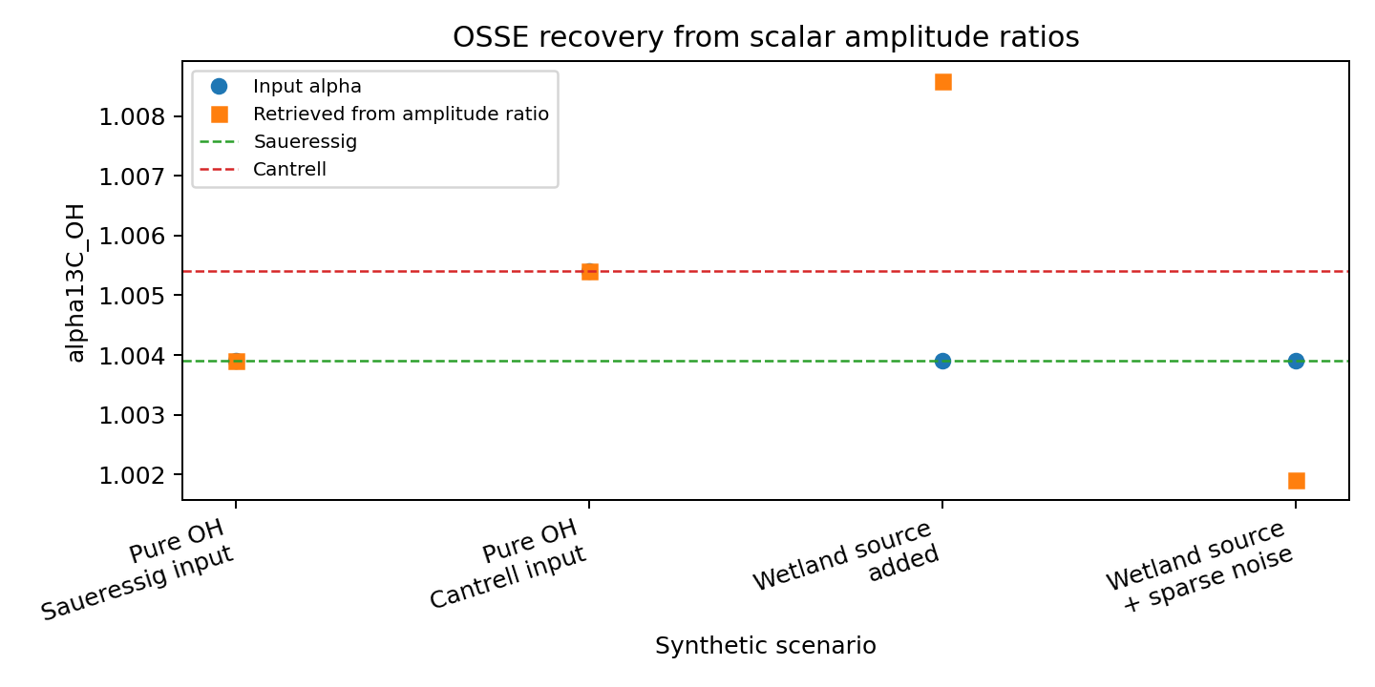
Figure S13. OSSE recovery of `alpha13C_OH`.
Figure S13. OSSE recovery of `alpha13C_OH`. Synthetic seasonal cycles are used to compare scalar amplitude-ratio retrievals against known input alpha values. Blue points are the prescribed input values, and orange squares are the values retrieved from the scalar ratio A(delta13C) / A(deltaD). The source-contaminated case recovers a spuriously high apparent alpha13C_OH, motivating the vector phasor correction used in the manuscript. This figure is a method diagnostic, not an additional atmospheric KIE constraint.
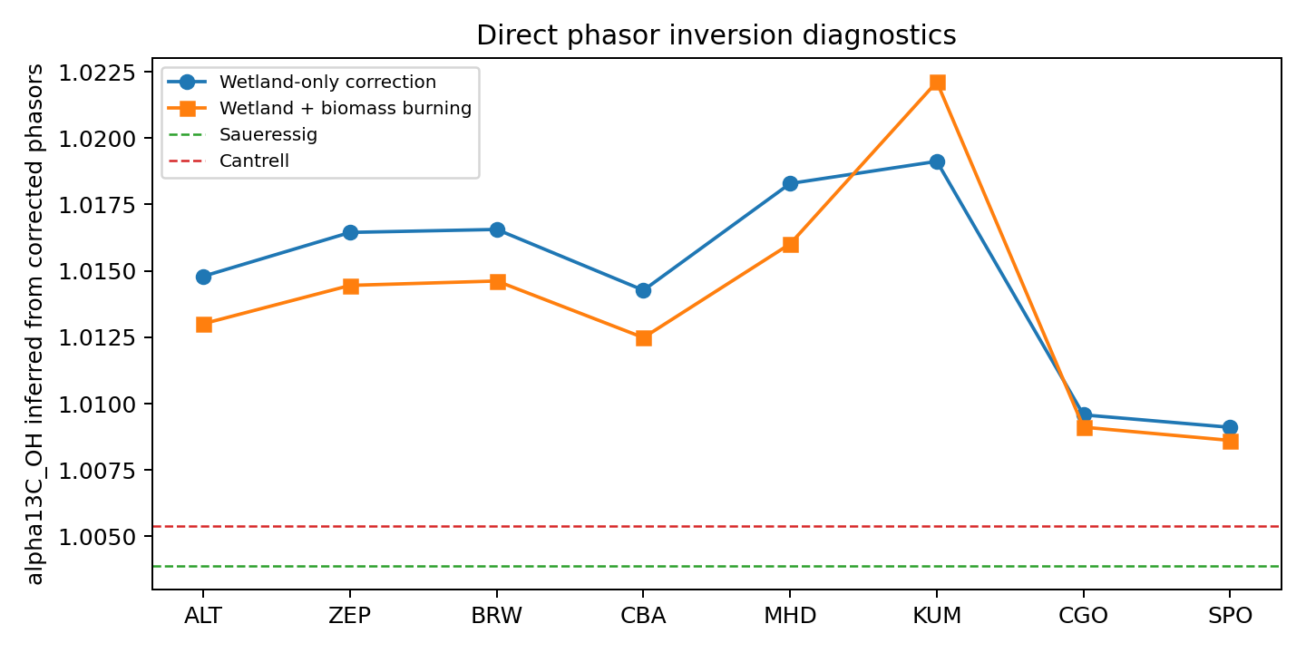
Figure S14. Phasor inversion diagnostics.
Figure S14. Phasor inversion diagnostics. Direct phasor-inversion diagnostics show how site-level corrected isotope phasors translate into apparent alpha values and where sparse or source-contaminated sites become unstable.

S10. Uncertainty Attribution
One-at-a-time diagnostic uncertainty attribution ranks uncertainty sources as:
Source group | Fraction of diagnostic variance
Observation/harmonic uncertainty | 0.39
Wetland phasor uncertainty | 0.21
Wetland isotope source signatures | 0.14
Sink fractions | 0.09
alphaD_OH | 0.08
Biomass burning correction | 0.05
Non-OH KIEs | 0.03

These fractions are diagnostic and should not replace the full Monte Carlo intervals reported in the main text. They identify the most valuable future improvements: longer paired isotope records, better wetland phasors, and better wetland isotope source signatures.
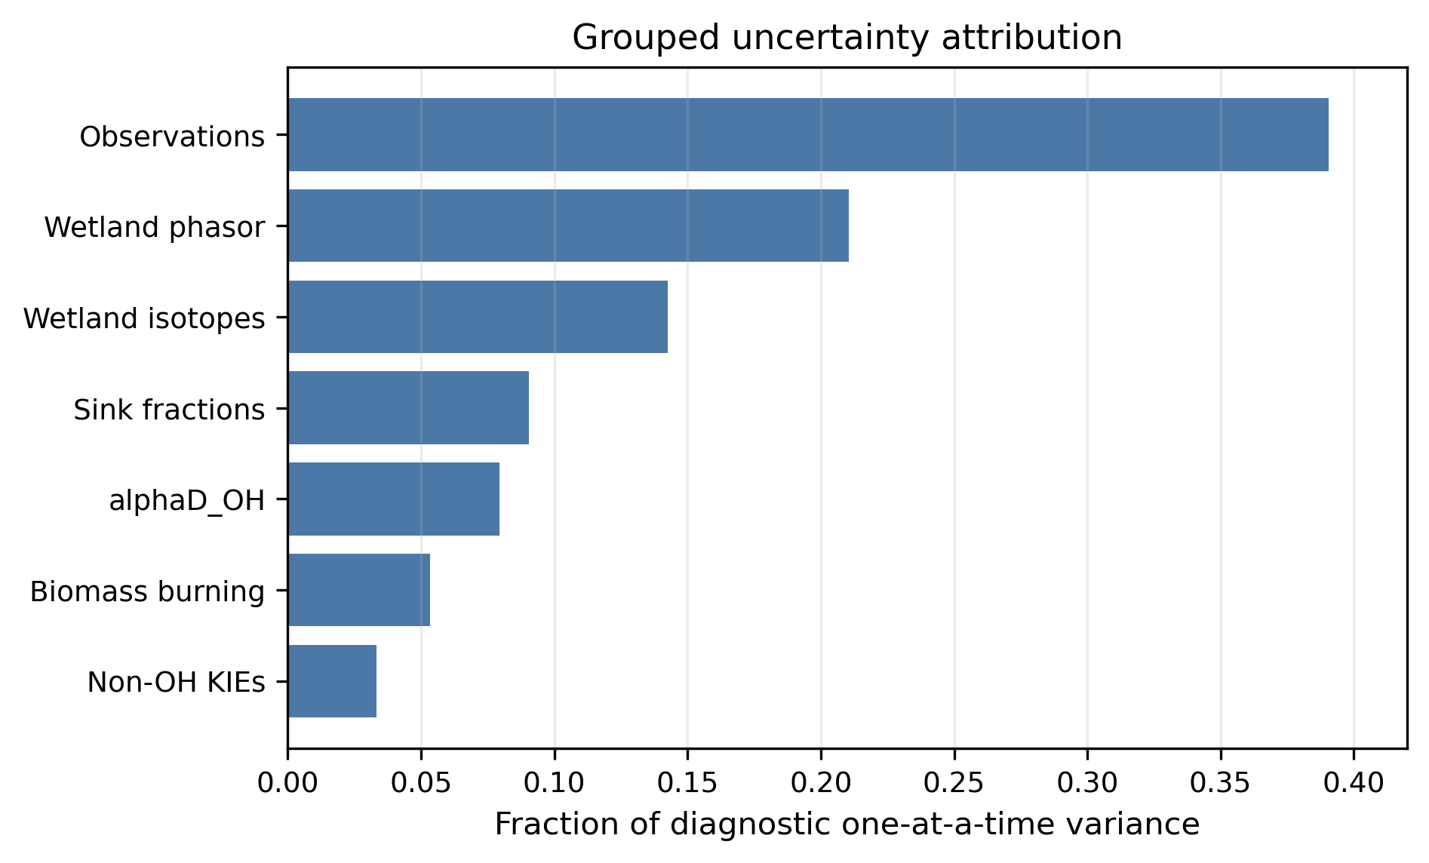
Figure S15. Grouped uncertainty attribution.
Figure S15. Grouped uncertainty attribution. One-at-a-time grouped uncertainty perturbations rank the dominant contributors to alpha uncertainty. Observation and harmonic-fit uncertainty is largest, followed by wetland phasor and wetland isotope-source uncertainty.

S11. Supplementary Figure List
Figure S1. Paired monthly data coverage by site.
Figure S2. Folded seasonal cycles used for annual harmonic fitting.
Figure S3. Harmonic-model sensitivity.
Figure S4. Individual-year stability of amplitude ratios.
Figure S5. Wetland emission seasonality by latitude band.
Figure S6. Example wetland source phasor subtraction.
Figure S7. Wetland deltaD-CH4 source-signature alternatives.
Figure S8. Banded wetland delta13C-CH4 source-signature sensitivity.
Figure S9. Southern Hemisphere mass-conserving source-region sensitivity.
Figure S10. Biomass-burning seasonality by source band.
Figure S11. Biomass-burning source phasors.
Figure S12. Wetland-only versus wetland-plus-biomass-burning correction.
Figure S13. OSSE recovery of alpha13C_OH.
Figure S14. Phasor inversion diagnostics.
Figure S15. Grouped uncertainty attribution.

