**A**

**Project Report**

on

**Courier management system**

Submitted to

**UKA TARSADIA UNIVERSITY**

in

partial fulfilment for the degree of

**BACHELOR OF TECHNOLOGY**

**in**

**Computer Science and Engineering**

by

Memon Ilsa(202203103520016)

Guided by

Mr.Darshan Chauhan



Asha M. Tarsadia Institute of Computer Science and Technology Uka Tarsadia University

Bardoli, Surat November – 2022

**Software Requirements Specification**

1. **Introduction**
   1. Background

* *Objective/Purpose of conducting a project*

The courier service is one of the solutions of these problems. It is used to send some things to any person in the world within time. The courier company has number of branches, which are spread over the country or the world. So that when person wants to send things then he has to contact at nearest courier service branch. The courier company creates the schedule & gives internal/external services. The courier service work as destination office or source office.

* *Scope of Project*

To gain maximum business region, customer demands good service. So to make more profit and gain maximum business region, their administration must also have a system to tackle all these problems on time. Its administration can take immediate orders and provide a receipt which will include all the details of the products along with appropriate price to their customers. Thus saving time and eliminating line making process

* 1. Overview
* *Overview of your project*

This **Courier Management System** Project will have different modules. The login section will have login facility for the user who will operate this system. While taking orders from its customers, it will take all the details of its customers who is placing the orders and all the details for the recipient such as its address, name, mobile number. Through the tracking id, customers or its recipient will able to track their products from any location using internet. It will provide status of the product after placing orders within 1 minute. Using the courier service person can easily send his/her parcel to other person in the particular destination within the time.

* 1. Environmental Characteristics

1. Hardware Requirement

* HARD DISK: 250 GB or more hard disk.
* RAM: 4 GB RAM.
* PROCESSOR: PC with i3 and above.

1. Software Requirement

* OPERATING SYSTEM: windows, Linux
* LANGUAGE: PHP
* DATABASE: MySQL server
* WEBSERVER : apache
* BROWSER: chrome, Firefox, etc.
* SERVER: XAMPP

1. **Diagram**
   1. ER diagram

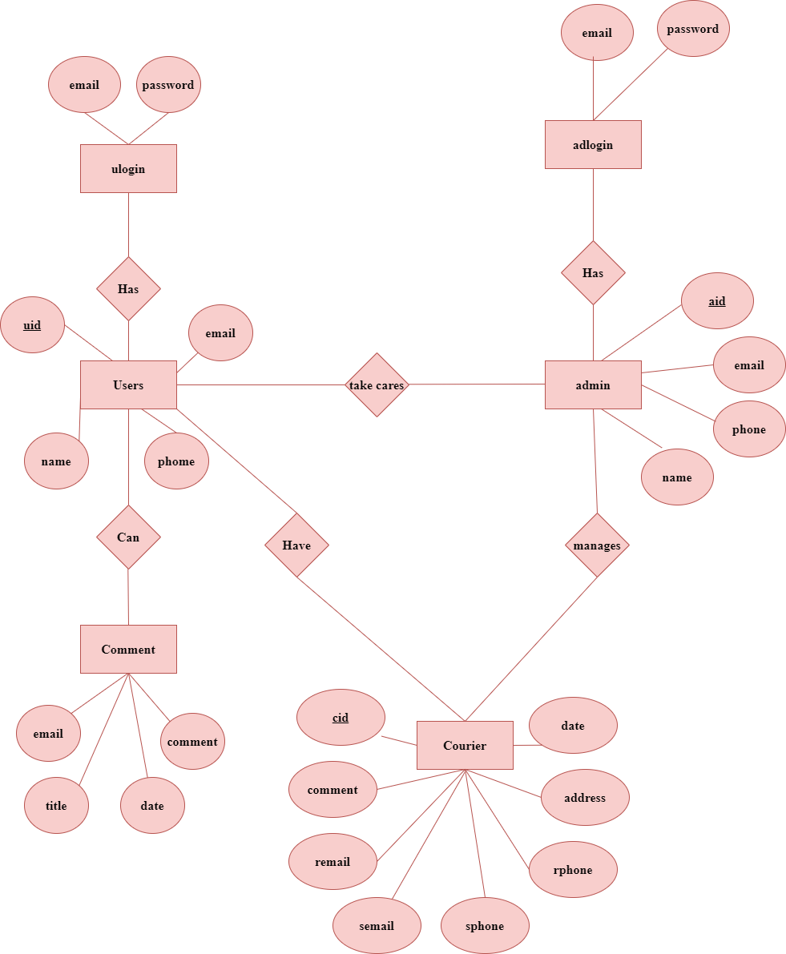

* 1. Data Flow Diagram

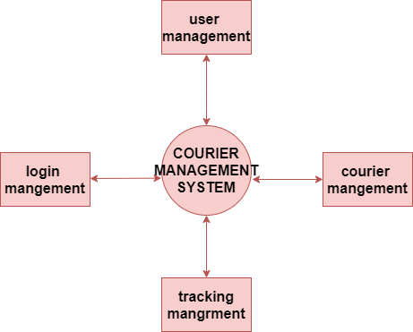

1. **Implementation Screenshot**

