My Reproducible Manuscript
Ilse Bosman
# Load penguins
library(ggplot2)
# Read data
penguins <- read.csv("C:/Users/ilseb/Documents/mlarpis/my-reproducible-manuscript/data/data.csv")

Meet Quarto
Quarto enables you to weave together content and executable code into a finished document. To learn more about Quarto see https://quarto.org.

Meet the penguins
The penguins data from the palmerpenguins package contains size measurements for 344 penguins from three species observed on three islands in the Palmer Archipelago, Antarctica (Horst et al. 2022). Borboroglu and Boersma (2015) describe more information about penguins in their book.
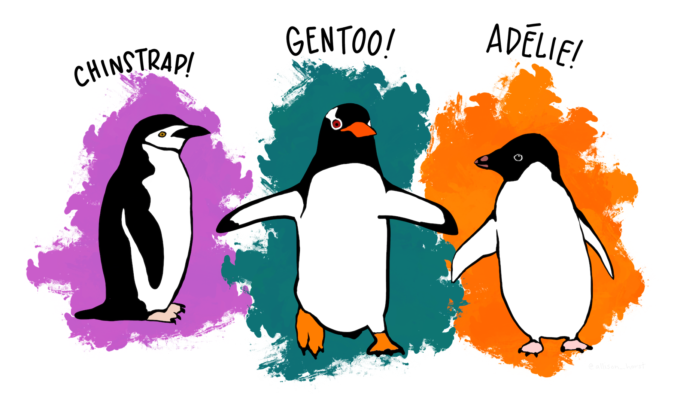

Results
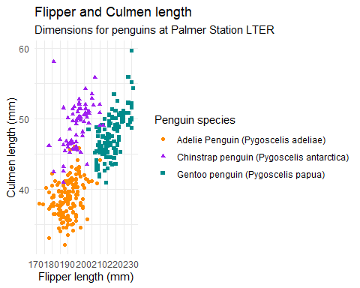
There are 68 Chinstrap penguins. Which is more than 50, but less than 70.

Addition
do_addition <- function(number1, number2){
# Check that arguments provided are numberic
if(class(number1) != "numeric" | class(number2) != "numeric"){
print("Error: one or more of your inputs are not numeric")
# Perform simple addition and return the result
} else{
result <- number1 + number2
return(result)
}
}
do_addition(500, 50)
[1] 550
Borboroglu, Pablo Garcia, and P Dee Boersma. 2015. Penguins: Natural History and Conservation. University of Washington Press.
Horst, Allison M, Alison Presmanes Hill, and Kristen B Gorman. 2022. “Palmer Archipelago Penguins Data in the Palmerpenguins r Package-an Alternative to Anderson’s Irises.” R Journal 14 (1): 244.

