№1

1)

1. 1. Stop the virtual machine: Before you start the cloning process, make sure your virtual machine is turned off or stopped.
2. Open VirtualBox: Start the VirtualBox program on your computer.
3. Select the virtual machine to clone: In the VirtualBox window, select the virtual machine you want to clone. It should be highlighted in the list of available virtual machines.
4. Clone the virtual machine: From the Machine menu, select the Clone option.

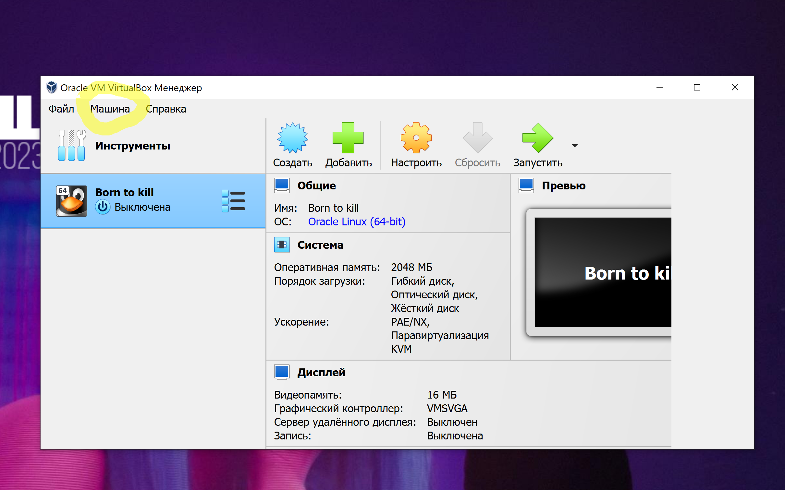

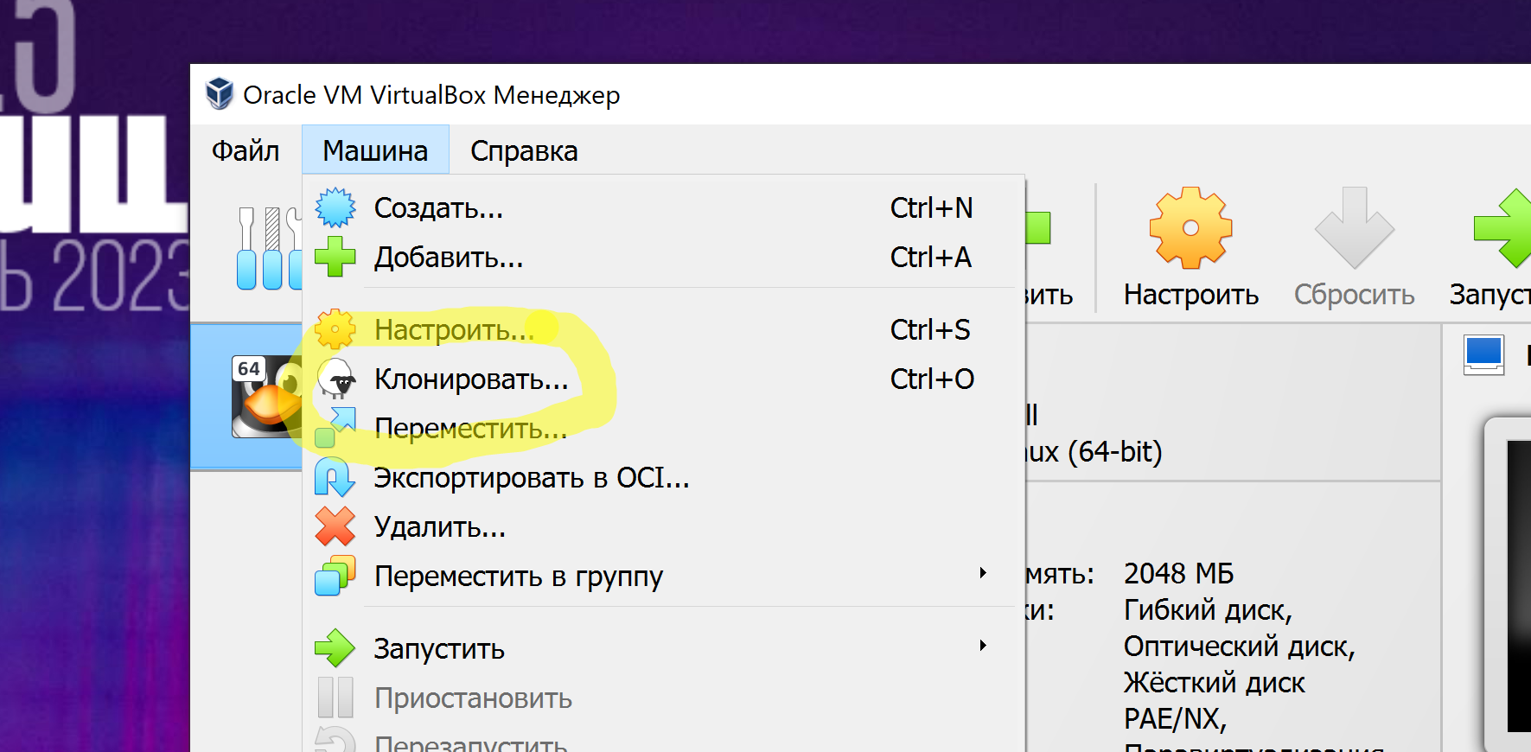

1. Configure cloning: You'll be asked to enter a name for the new cloned virtual machine and select a clone type. There are two types of cloning in VirtualBox:

* Full Clone: Creates an exact copy of the virtual machine, including all files and settings.
* Linked Clone: Creates a clone that shares virtual disks with the original virtual machine. It takes up less disk space but requires the original virtual machine to run.

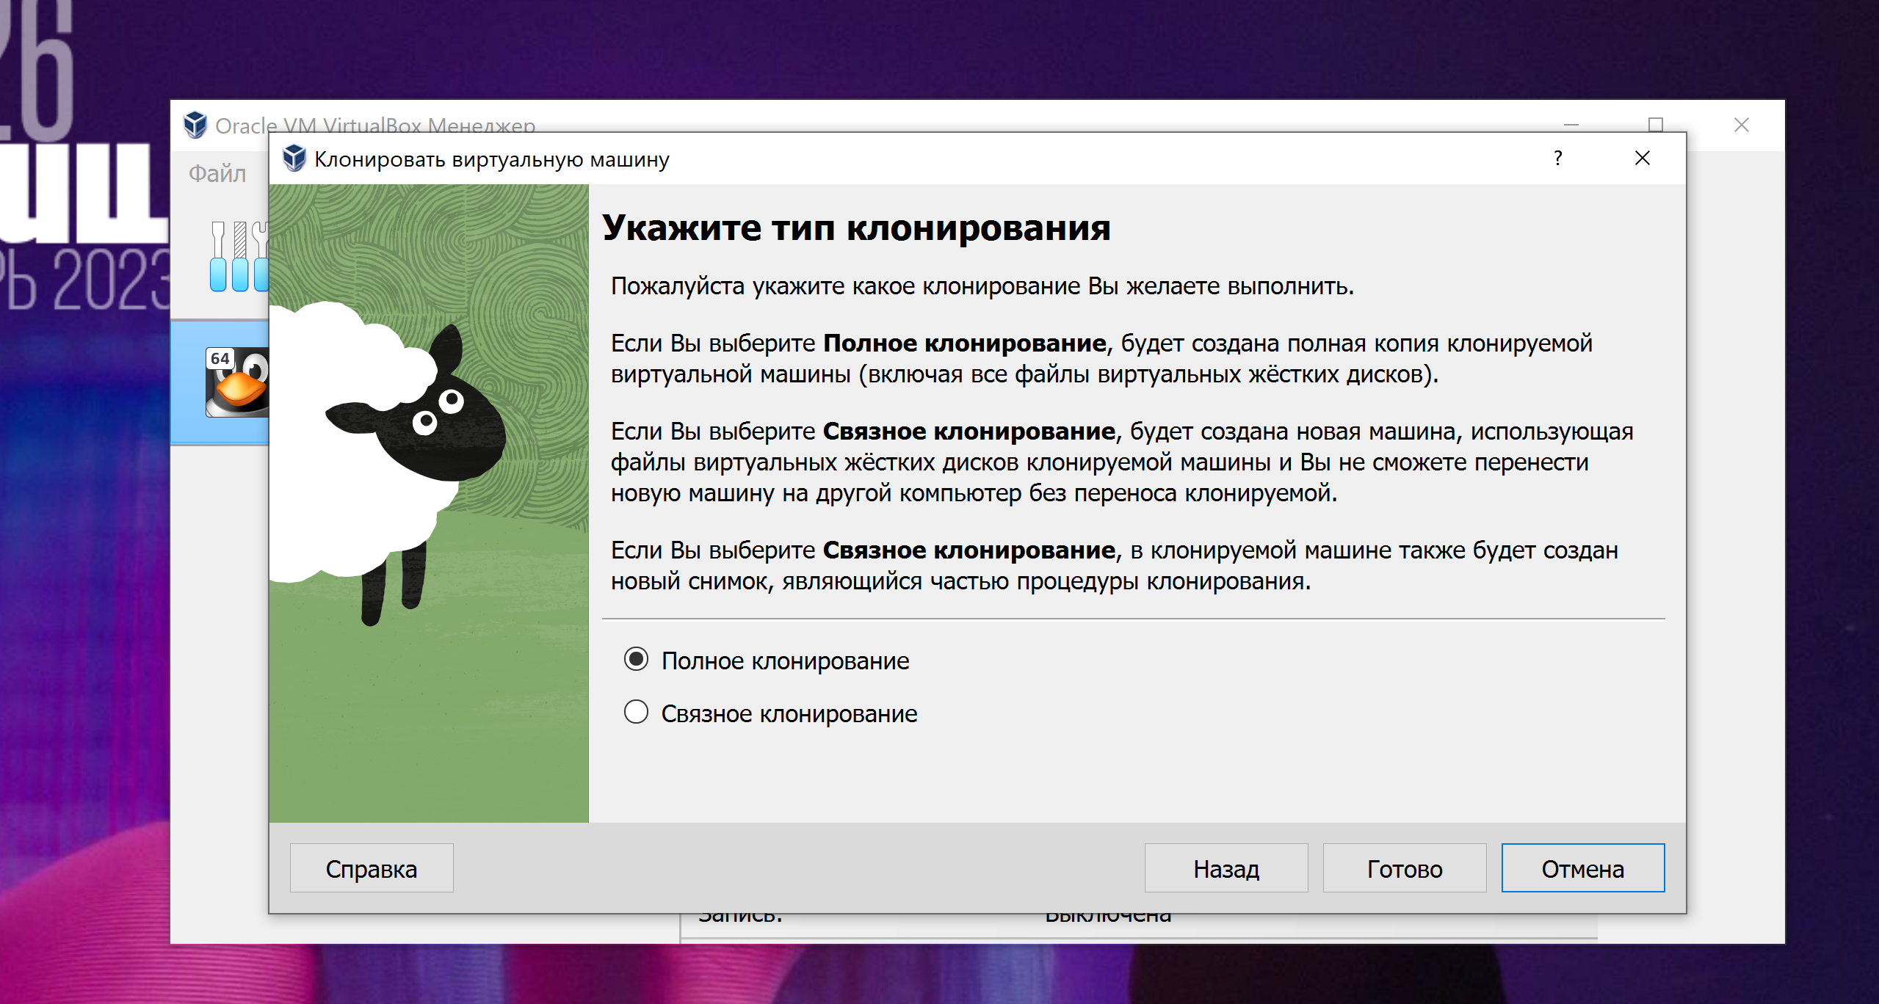

1. Select a clone type and click Clone. A copy of the virtual machine will be created according to your choice.
2. Complete the settings: If you selected Full Clone, the new virtual machine is created and ready to use. If you selected Link to clone, you will be asked to specify which virtual machine you want to connect the cloned disk to. Select the original virtual machine and complete the setup.

2)

1. Stop the virtual machine: Before starting the export process, make sure that your virtual machine is turned off or stopped.
2. Open VirtualBox: Start VirtualBox on the computer where your virtual machine is located.
3. Select the virtual machine: In the VirtualBox window, select the virtual machine you want to export. It should be highlighted in the list of available virtual machines.
4. Export the virtual machine: From the File menu, select the Export Selected VM option.
5. Select a location to save: You will be asked to select a location on your computer where the export file for the virtual machine will be saved. Select the location and file name, and click Save.
6. Wait for the export to complete: The export process may take some time, depending on the size of the virtual machine.
7. Complete the export: After the export is complete, you will receive an exchange file with the ".ova" (Open Virtualization Format Archive) extension that contains information about your virtual machine.

You can now move this ".ova" file to another computer with VirtualBox installed and import the virtual machine by following these steps:

1. Open VirtualBox on the other computer.
2. Select the File -> Import Appliance option.
3. Select the ".ova" file that you exported earlier.
4. Configure the import settings that work for you and click Import.

№2

In a virtual machine environment, different types of network connections are supported, each with its own characteristics:

1. Network Address Translation (NAT): In this mode, virtual machines connect to an external network through a virtual router. It uses network address translation to allow virtual machines to access the network. All virtual machines in the NAT network share a common external IP address, and access to them from the external network is accomplished using port mapping. The main feature is the lack of direct access to internal IP addresses of virtual machines and their isolation from the external network.
2. Network bridge (Bridged): In this mode, virtual machines are connected directly to the physical network, just like real physical computers. They have their own IP addresses and can communicate with other devices on the network, including other virtual machines and external servers. This mode allows virtual machines to actually exist on a real network and participate in all network operations.
3. Virtual host adapter (Host-only): In Host-only mode, virtual machines can communicate with each other and with the host system, but cannot access the external network. This creates an isolated local area network where virtual machines can only communicate with each other and with the host computer.
4. Internal Network: This mode creates an internal network that only virtual machines can connect to. They can communicate with each other, but do not have access to an external network or host system. This mode is useful for creating a separate local area network for internal use.

Each of these network connection modes has its own used scenarios, and the choice depends on the needs and requirements of your project or virtualization test environment.