Cable Name: AT- ETX-2i10G/CBL13

|  |  |
| --- | --- |
| MicroUsb  (20 cm from CBL-UUSB-DB9F) | RJ45 Plug  RTA2788-AF06 |
| 2 | 5 |
| 3 | 6 |
| 5 | 4 |

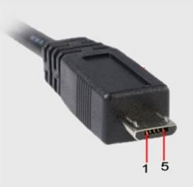

Quantity: 2 units

Length: 20 cm

Cable type: CBL-UUSB-DB9F

Please attach the label with Cable Name to the cable.

|  |  |
| --- | --- |
| Catalog number | Quantity (per 1 unit) |
| RTA2788-AF06 | 1 |
| CBL-UUSB-DB9F | 1 |