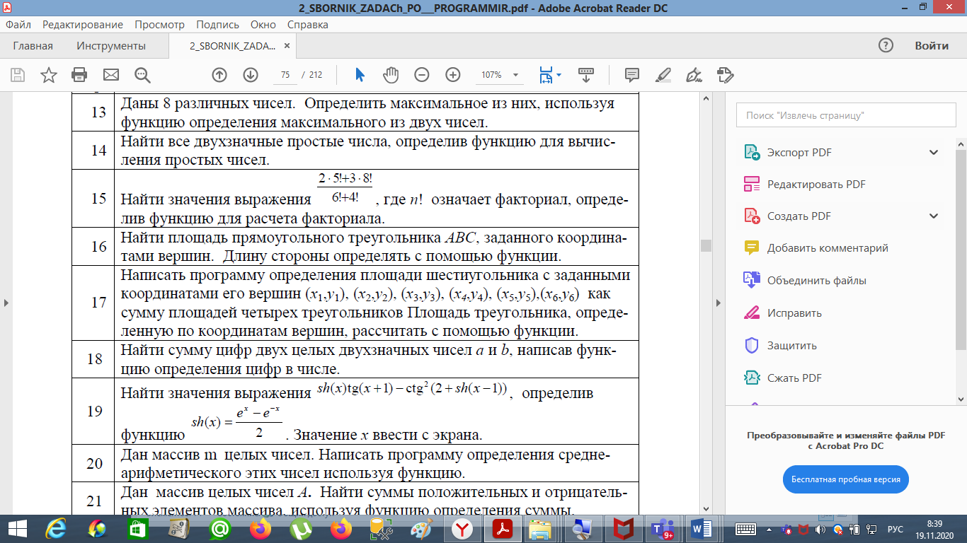

list_of_numbers_m = [1, 2, 3, 4, 99, 88, 77, 45, 87, 66, 55, 34, 88, 99, 44, 6655, 9988]  
  
  
**def** sum_and_average(m):  
 summ = 0  
 n = len(m)  
 **for** i **in** m:  
 summ += i  
 average = summ / n  
 **return** average  
  
  
print(**f'Среднее арифметическое массива - {**round(sum_and_average(list_of_numbers_m), 2)**}'**)

