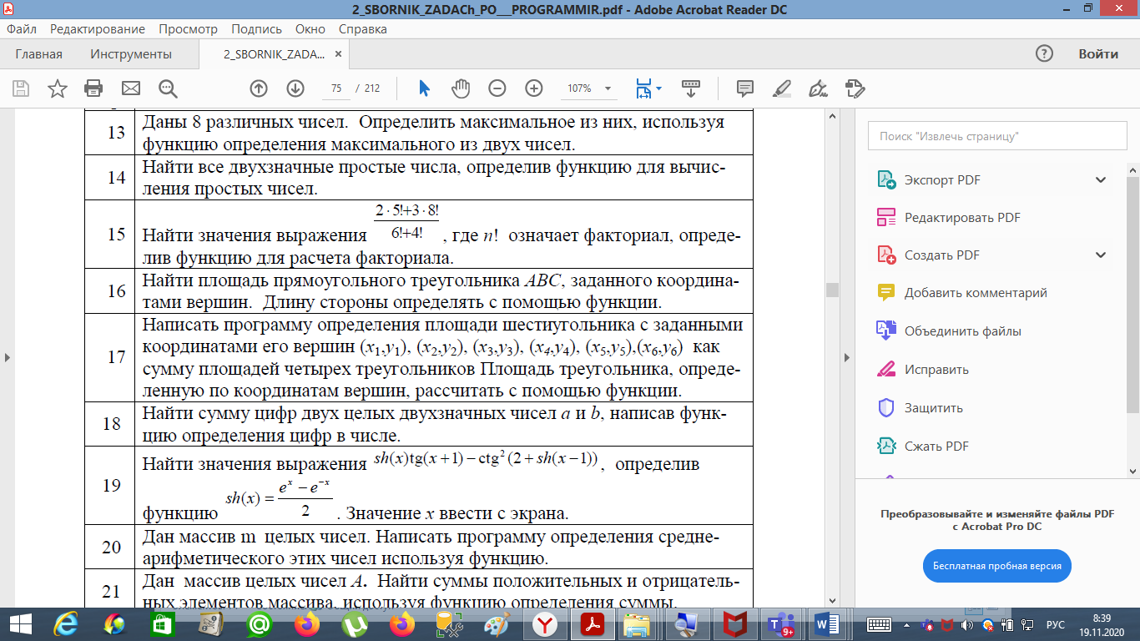

**import** math  
  
x = int(input(**'Введите x - '**))  
  
  
**def** sh_1(x):  
 sh = (math.e ** x - math.e ** (-x)) / 2  
 **return** sh  
  
  
**def** sh_2():  
 sinh = math.sinh(sh_1(x)) * math.tan(x + 1)  
 **return** sinh  
  
  
**def** sh_3():  
 sinh_3 = math.sqrt(1 - math.sin(2 + sh_1(x - 1)))  
 **return** sinh_3  
  
  
print(sh_2() - sh_3())

