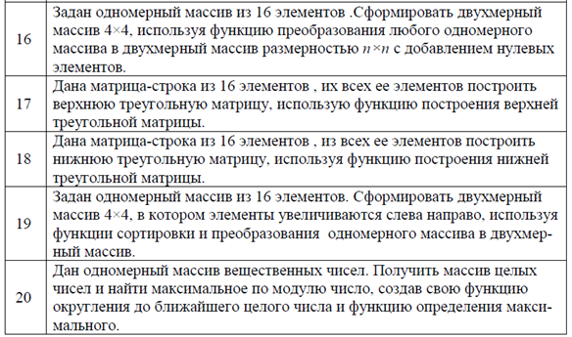

numbers = [0.6, 15.65, 79.87, 45.6, 3.9]  
  
  
**def** round_numbers(nums):  
 **for** q **in** range(len(nums)):  
 nums[q] = round(nums[q])  
 print(**f'Список с округленными числами - {**nums**}'**)  
 **return** nums  
  
  
**def** maximum():  
 list_num = round_numbers(nums=numbers)  
 maximum_par = 0  
 **for** i **in** list_num:  
 **if** i > maximum_par:  
 maximum_par = i  
 **else**:  
 **pass  
 return** maximum_par  
  
  
print(**f'Ответ - {**maximum()**}'**)

