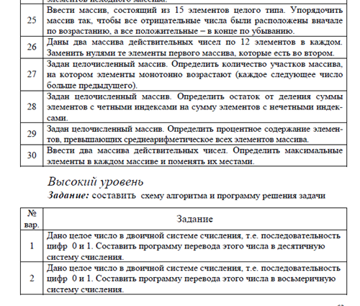

first_list = [1, 2, 3, 4, 5, 6, 7, 8, 9, 10, 11]  
second_list = [1, 3, 6, 7, 8, 9, 10, 11, 12, 13, 19]  
**for** i **in** range(len(first_list)):  
 **for** j **in** range(len(second_list)):  
 **if** first_list[i] == second_list[j]:  
 first_list[i] = 0  
 **else**:  
 **continue**print(**'Массив с измененными данными:'**)  
**for** answer **in** first_list:  
 print(answer, end=**', '**)

