LAB 4 Yelubayev Ilyas

1)SELECT UPPER(airline_name) AS airline_name_upper FROM Airline;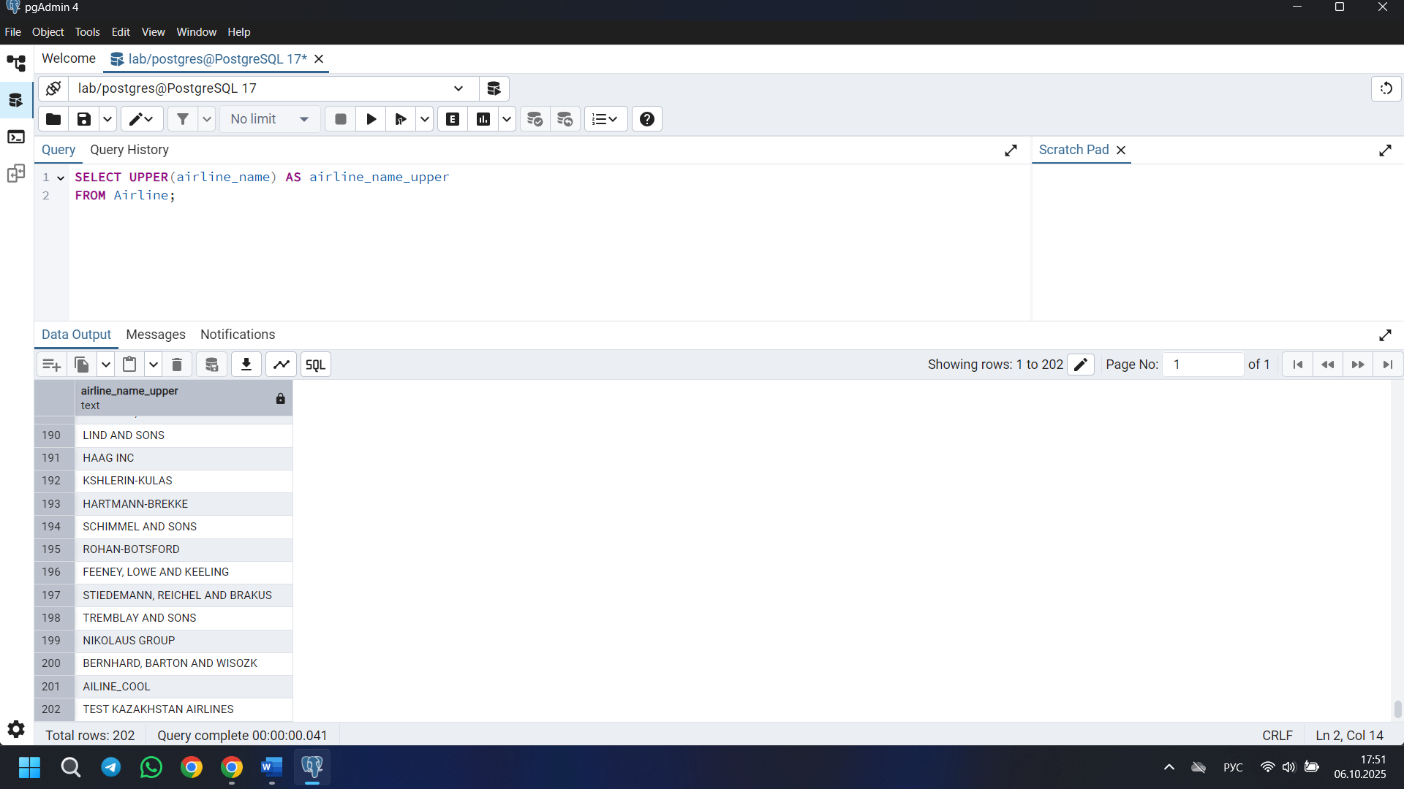

2) SELECT REPLACE(airline_name, 'Air', 'Aero') AS airline_name_mod
FROM Airline;

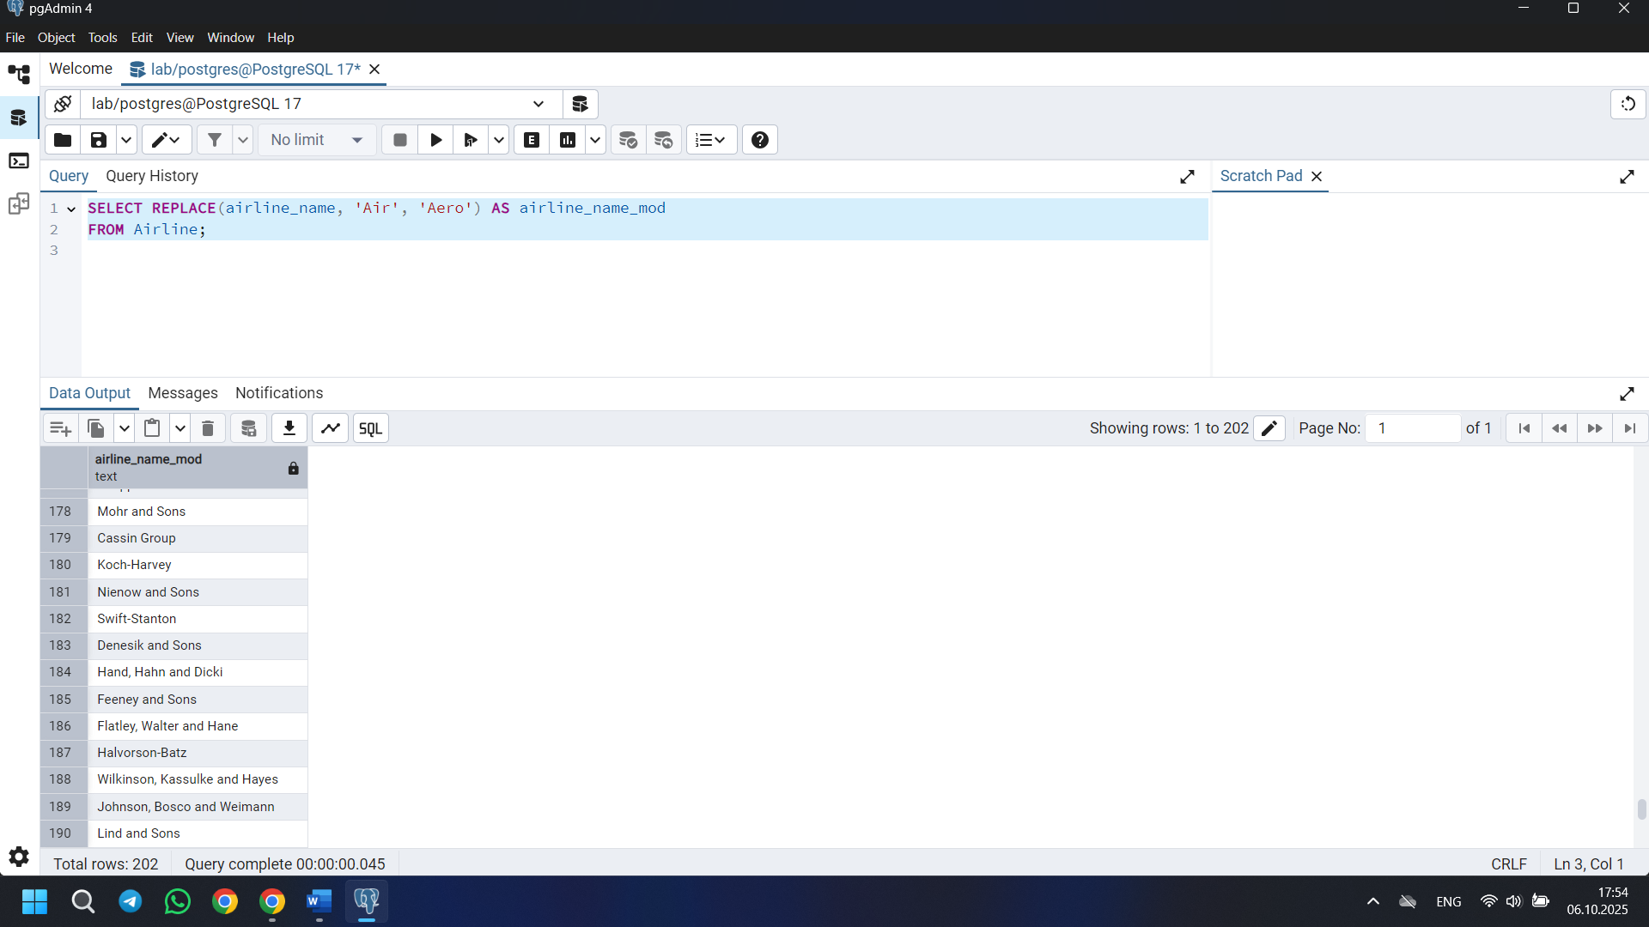

3)
SELECT flight_id
FROM Flights
WHERE airline_id = 1
AND (departing_airport_id, arriving_airport_id) IN (
SELECT departing_airport_id, arriving_airport_id
FROM Flights
WHERE airline_id = 2
);
the task is a little unclear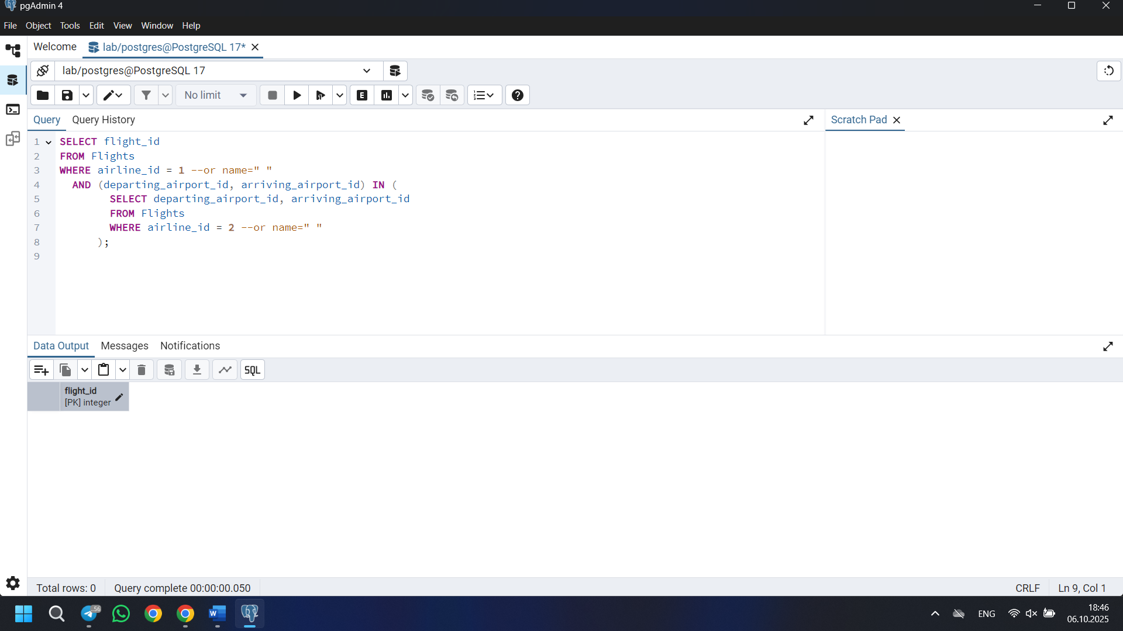

4) SELECT airport_name FROM Airport WHERE airport_name ILIKE '%Regional%' AND airport_name ILIKE '%Air%';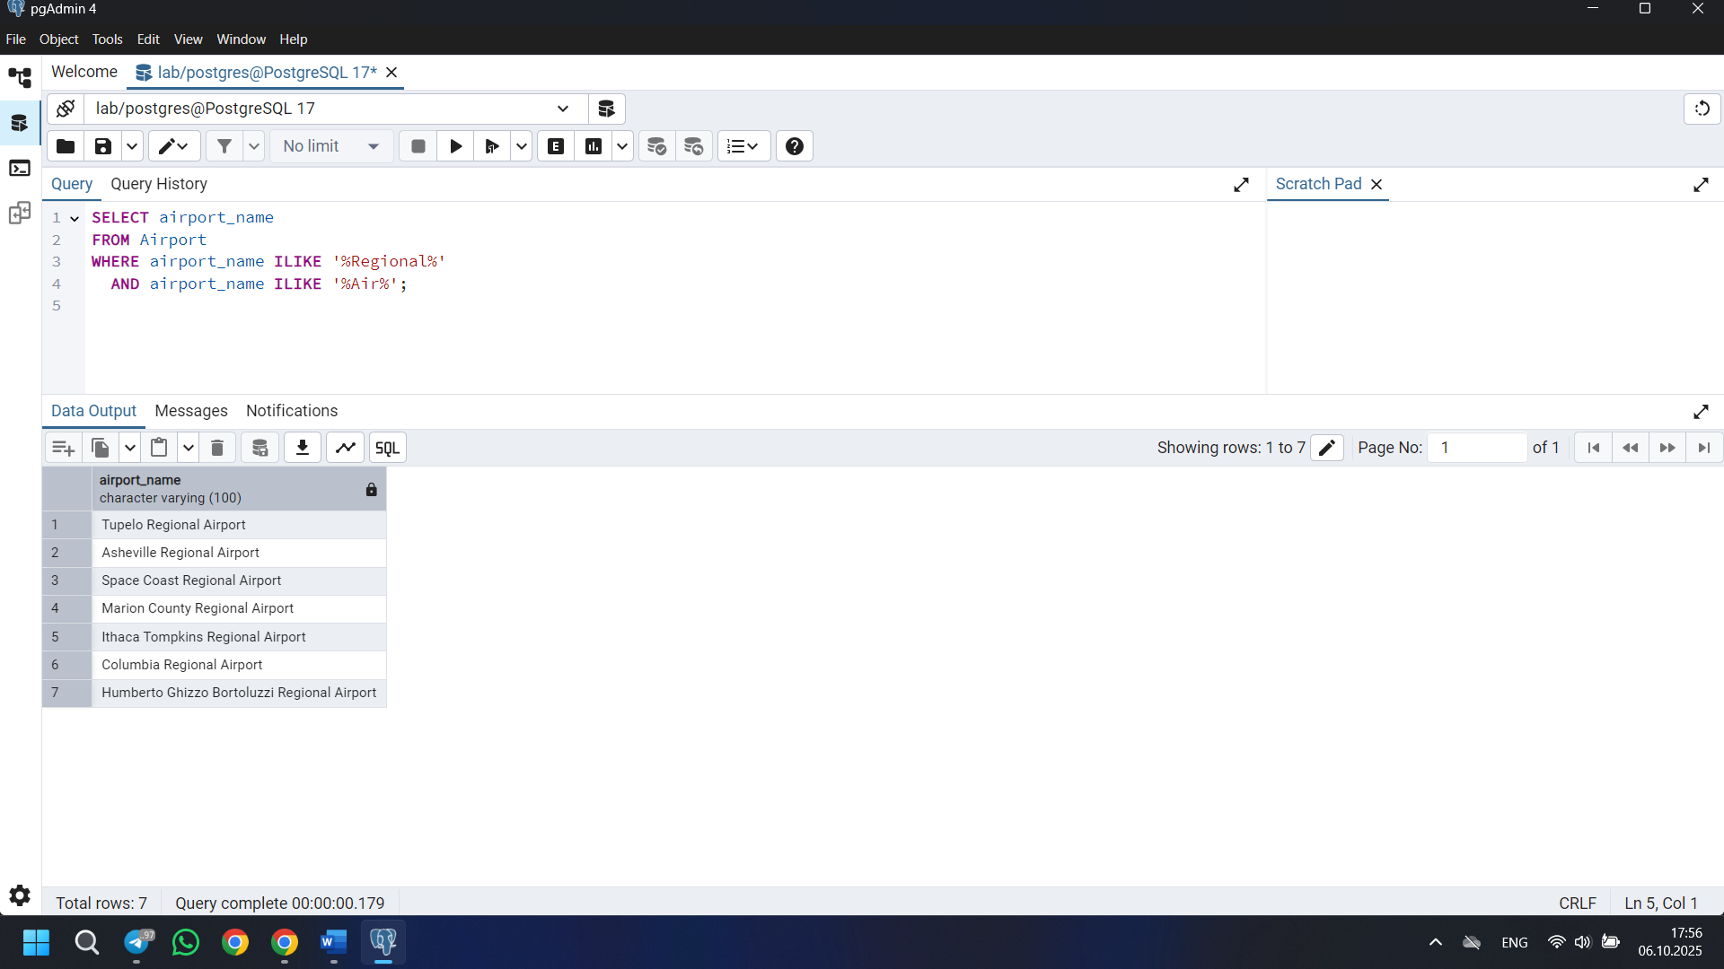

5) SELECT first_name ||' '|| last_name AS full_name,
TO_CHAR(date_of_birth, 'Month-DD-YYYY') AS formatted_birthdate
FROM Passengers;
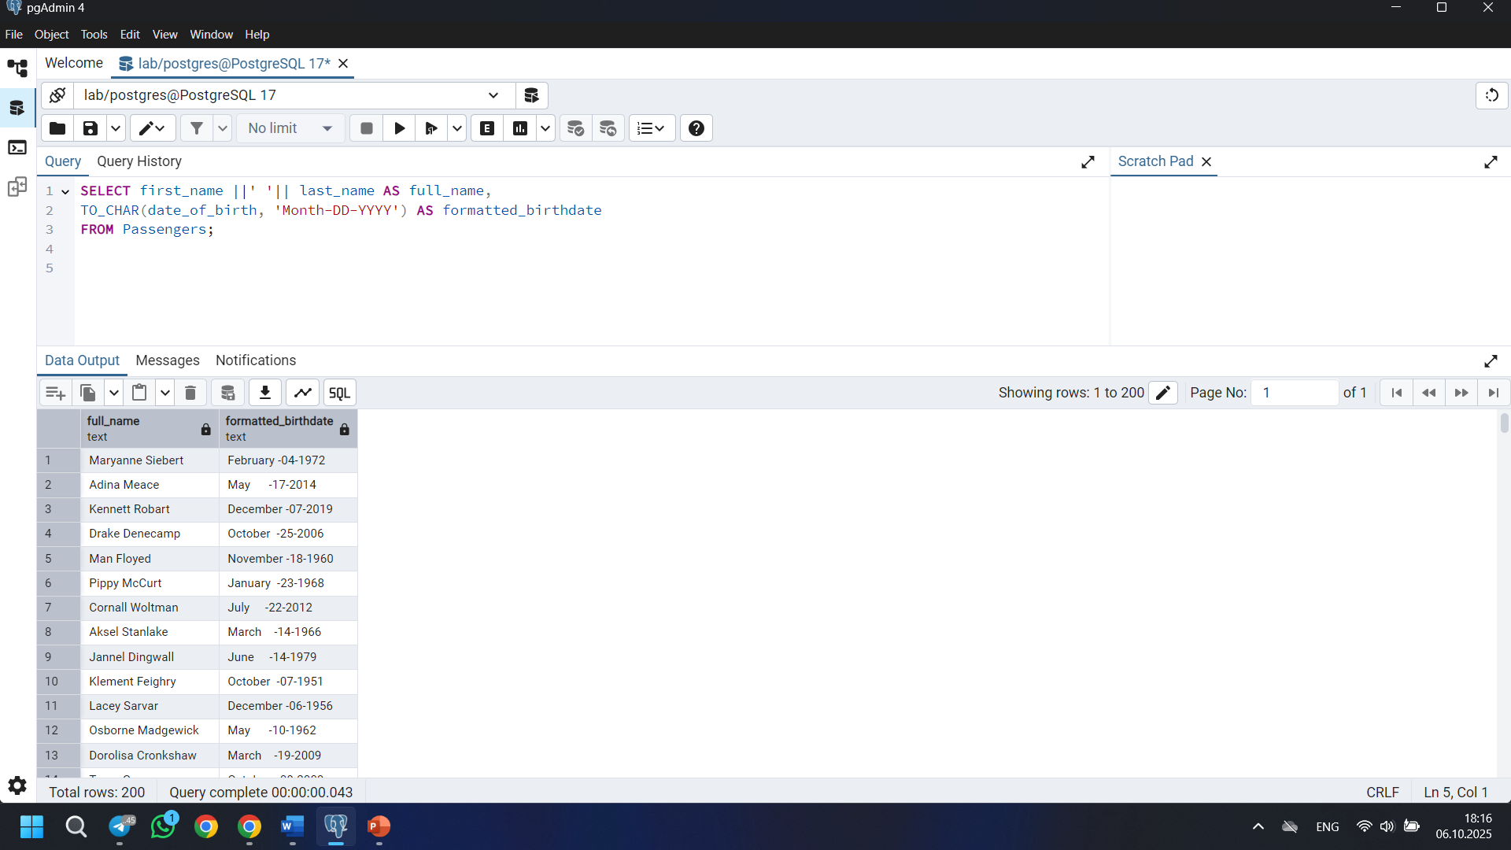

6) SELECT flight_id FROM Flights WHERE act_arrival_time > sch_arrival_time;
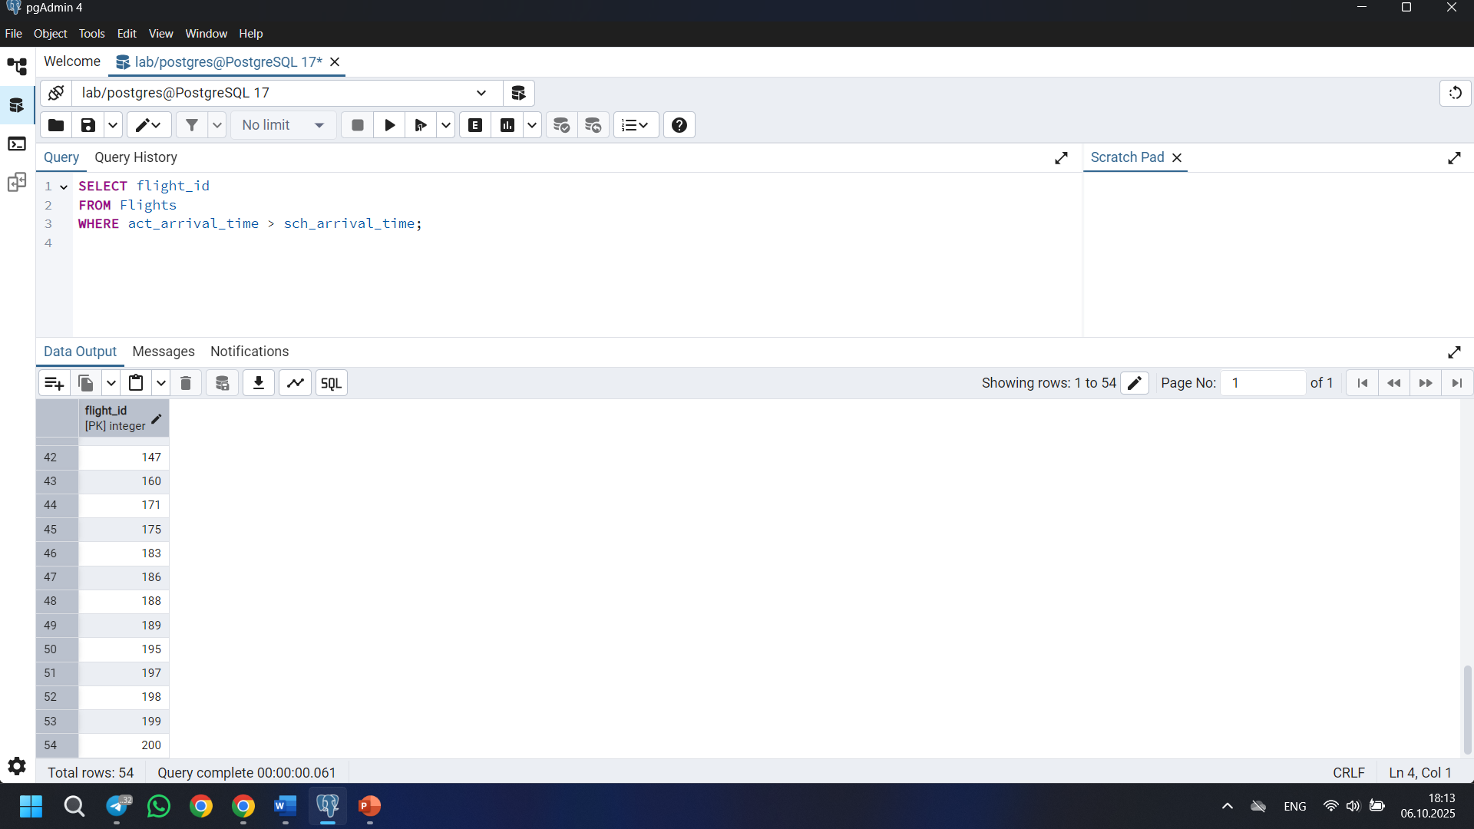

7) SELECT
first_name ||' '|| last_name as full_name,
CASE
WHEN DATE_PART('year', AGE(date_of_birth)) BETWEEN 18 AND 35 THEN 'Young'
WHEN DATE_PART('year', AGE(date_of_birth)) BETWEEN 36 AND 55 THEN 'Adult'
END AS age_group
FROM Passengers;
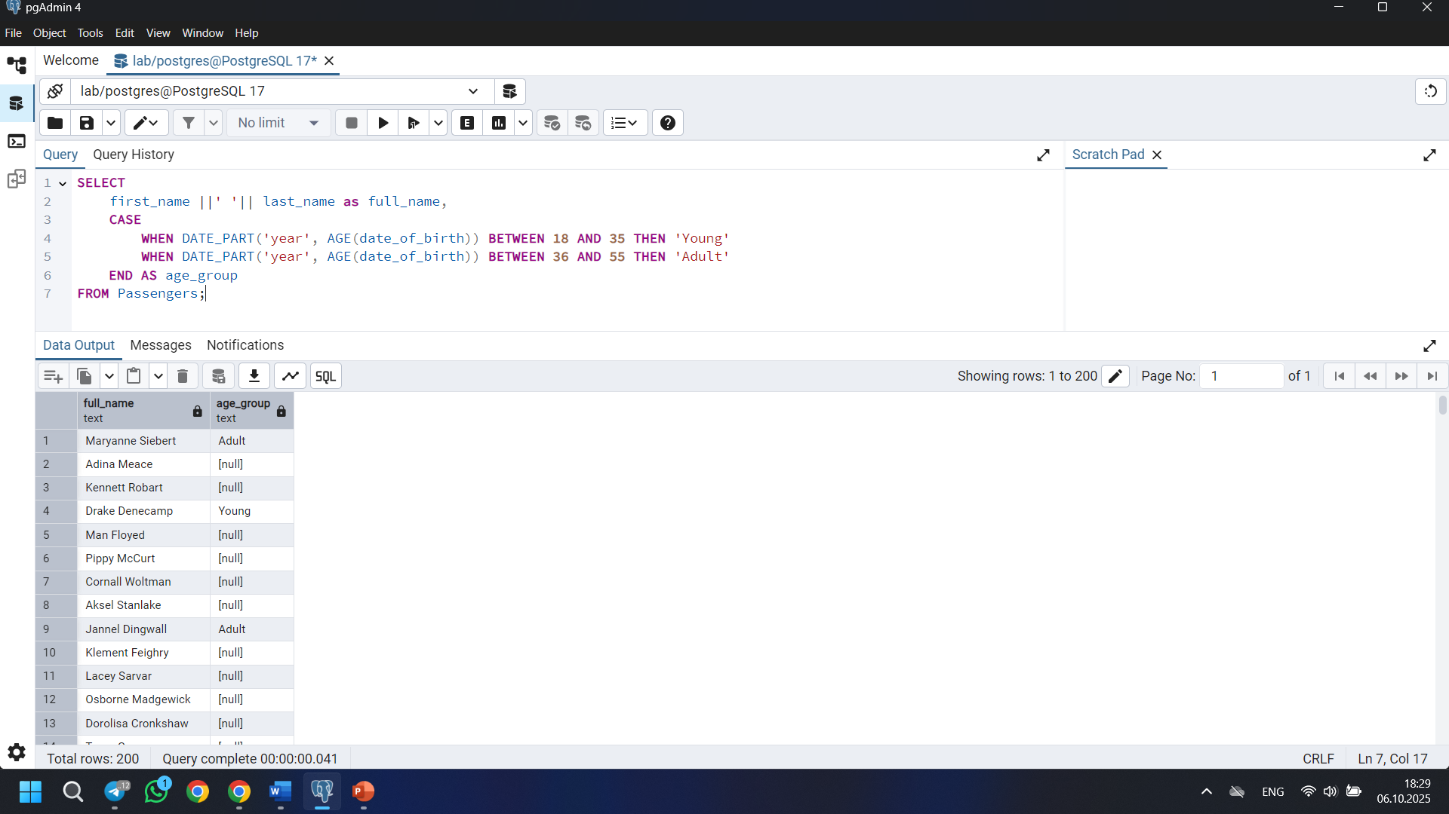

8) SELECT
booking_id,
ticket_price,
CASE
WHEN ticket_price < 100 THEN 'Cheap'
WHEN ticket_price BETWEEN 100 AND 500 THEN 'Medium'
ELSE 'Expensive'
END AS price_category
FROM Booking;
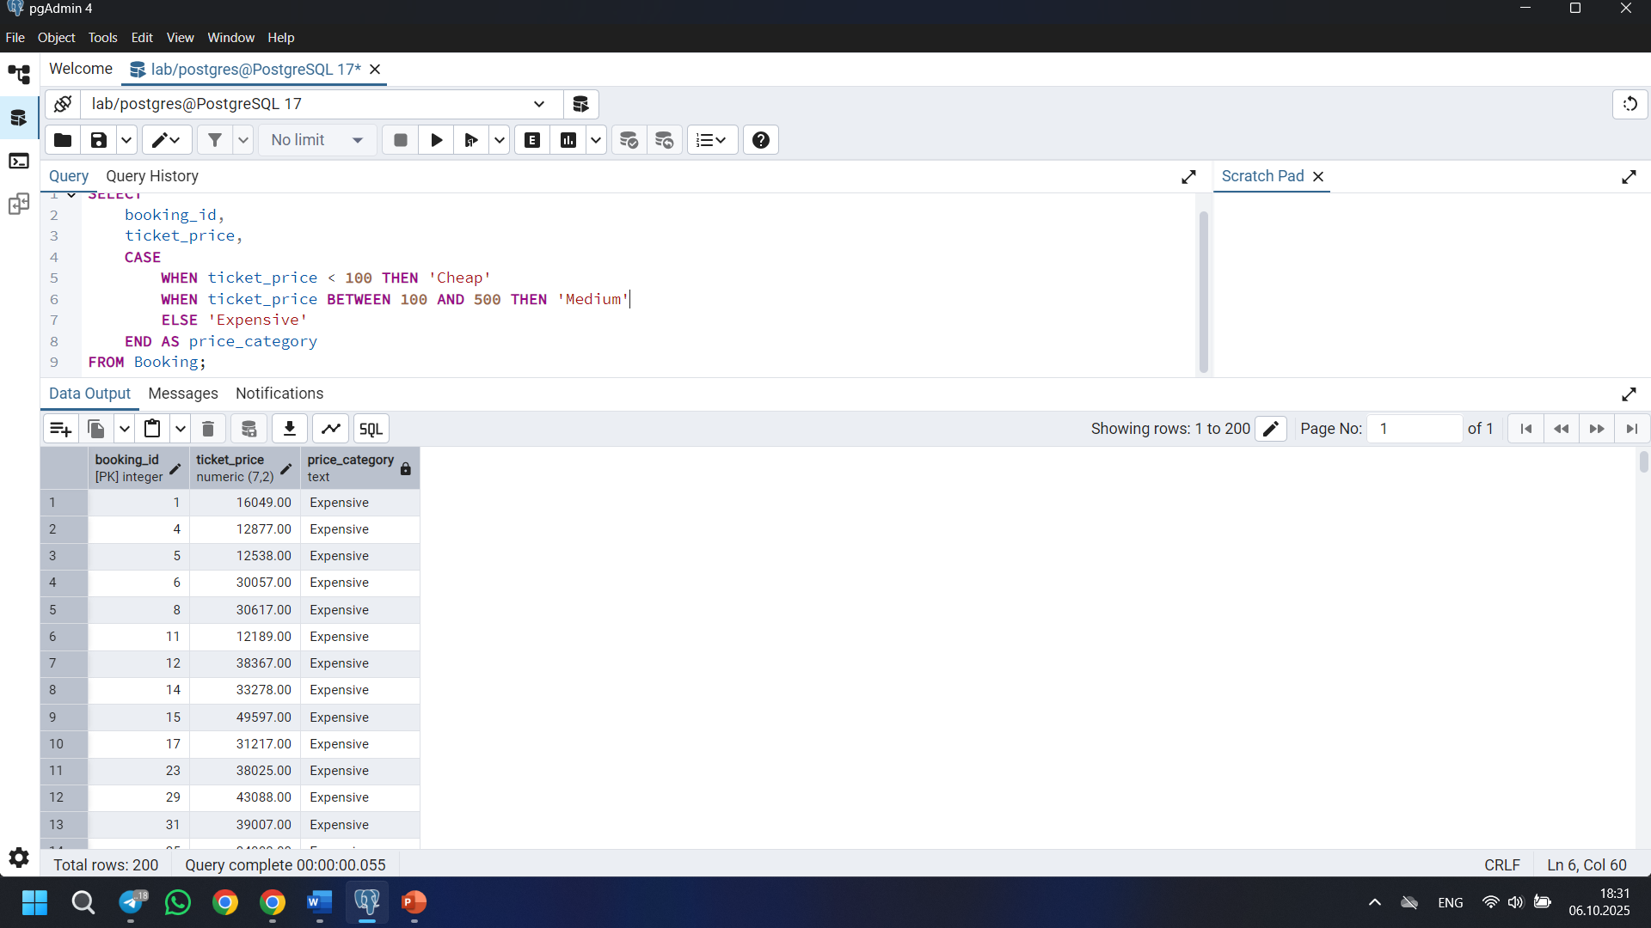

9) SELECT
airline_country,
COUNT(*) AS airline_count
FROM Airline
GROUP BY airline_country;
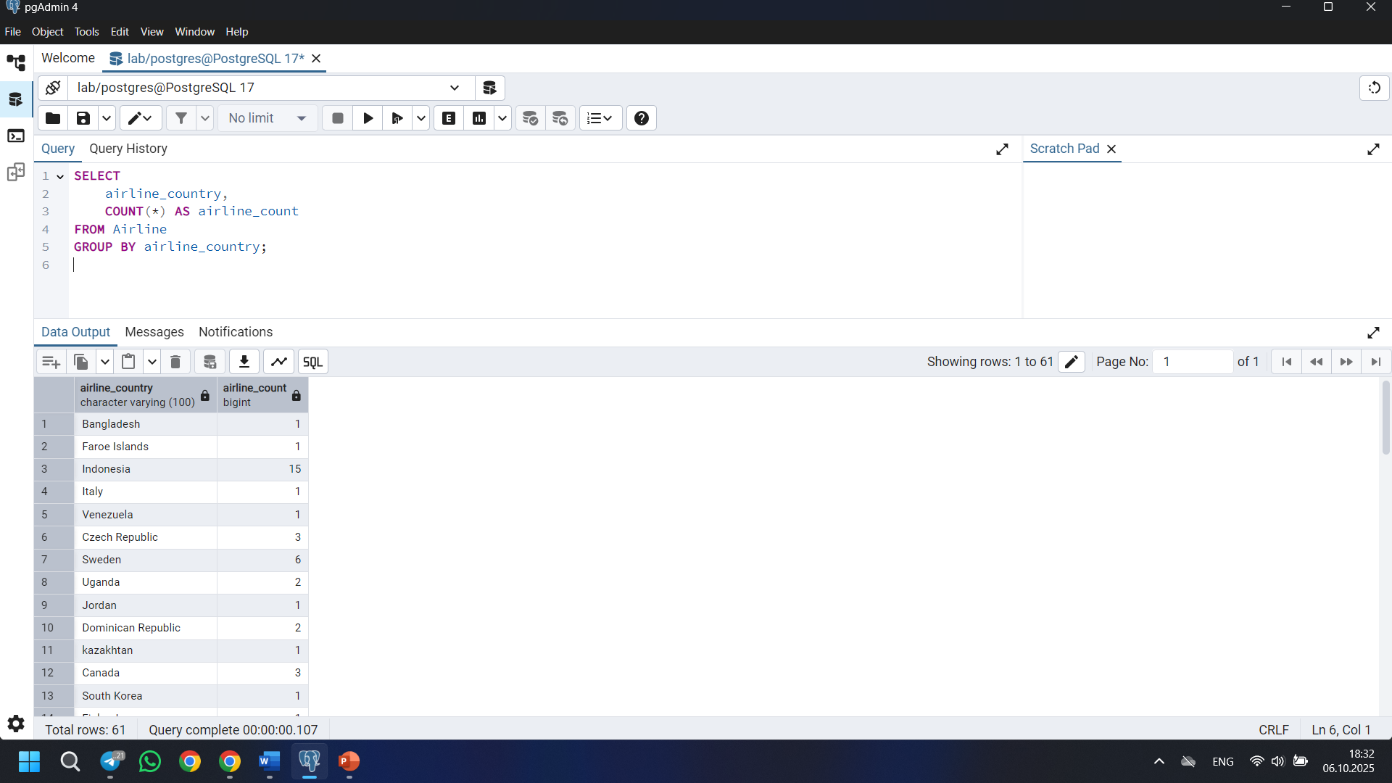

10) SELECT
flight_id,
sch_arrival_time,
act_arrival_time
FROM Flights
WHERE act_arrival_time > sch_arrival_time;
