**OEL#2**



Name:Muhammad Ilyas khan

Roll No: 23-CS-115

Subject: DSA

Q1) A simple text editor needs to implement an Undo feature. Every time a user performs an operation(like typing or deleting text), it should be possible to undo the last action. Use a stack to achieve this functionality.

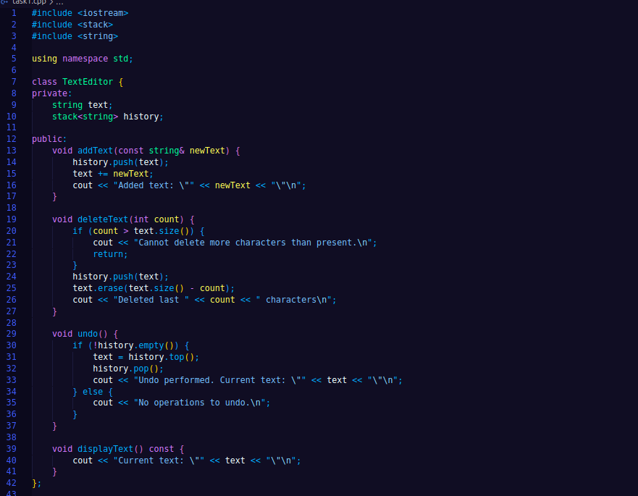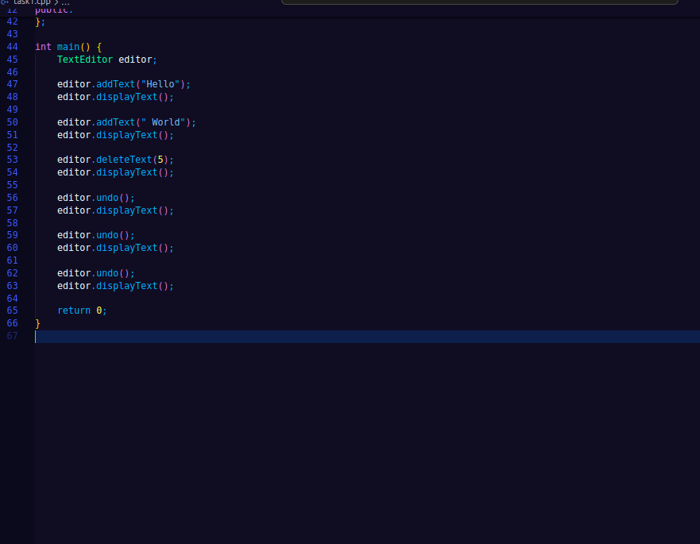

OUTPUT:

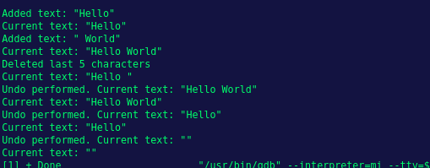

Q2) Check the CHILDREN SUM PROPERTY in the Binary tree, i.e. for every node data value must be

equal to the sum of data values of the left and right child.

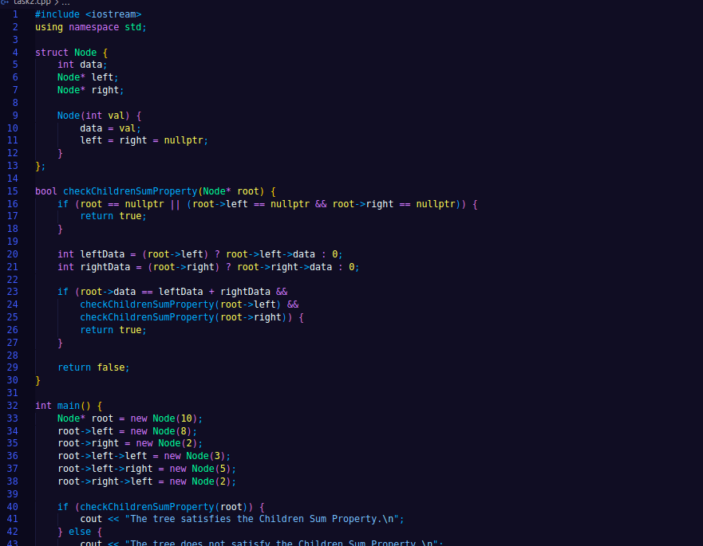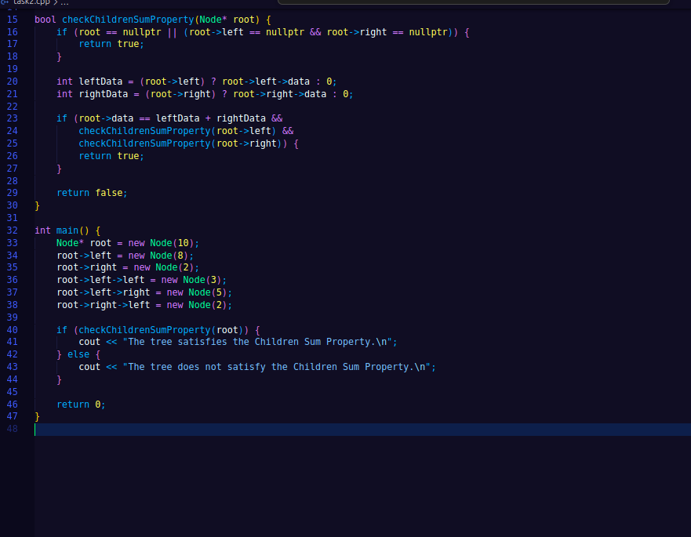OUTPUT;

