**Database Comparison: MongoDB (NoSQL) vs. SQL (Relational)**

**Slide 1: Introduction to Data Paradigms**

**Title:** Relational vs. Document: Choosing the Right Data Store

|  |  |  |
| --- | --- | --- |
| **Category** | **SQL (Relational)** | **NoSQL (MongoDB)** |
| **Paradigm** | Traditional RDBMS (Relational Database Management System) | Non-relational, Document-Oriented Database |
| **Examples** | MySQL, Oracle, PostgreSQL, SQL Server | MongoDB, Cassandra, Redis, DynamoDB |
| **Core Goal** | Data integrity, consistency, and complex relationships. | High availability, rapid iteration, and horizontal scale. |

**Key Takeaway:** The choice depends entirely on the nature of your data and the application's required performance characteristics (consistency vs. flexibility/speed).

**Slide 2: SQL - The Relational Standard**

**Title:** SQL: Structured, Consistent, and Relational

SQL databases (like MySQL) are defined by the relational model, which treats data as a collection of linked tables.

**Key Functionalities & Features:**

* **Data Structure:** Rigid, predefined **Schema**. Data is stored in **Tables** (relations) with **Rows** (records) and **Columns** (attributes).

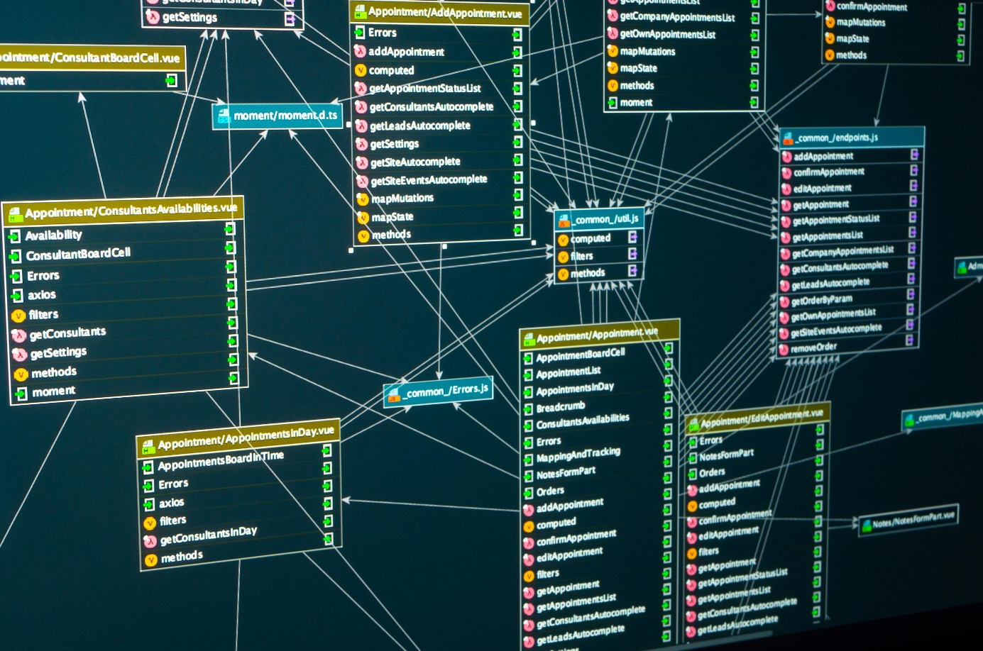

Shutterstock

* **Query Language:** **Structured Query Language (SQL)**, used for complex Joins across multiple tables to reconstruct related data.
* **Integrity:** Governed by **ACID Properties** (Atomicity, Consistency, Isolation, Durability), guaranteeing data is always valid and transactions are reliable.
* **Relationships:** Based on Primary and Foreign Keys, ensuring that links between data points are strictly maintained.

**Best Used For:** Financial systems, inventory management, or any application where data integrity and complex, multi-table transactions are critical.

**Slide 3: MongoDB - The Document Store**

**Title:** MongoDB: Flexible, Scalable, and Document-Oriented

MongoDB is the leading document database, storing data in a format that maps naturally to objects in application code.

**Key Functionalities & Features:**

* **Data Structure:** Flexible, **Schema-less** design. Data is stored in **Collections** of **Documents** (JSON-like BSON format).
* **Query Language:** **MongoDB Query Language (MQL)**, which uses JSON-like syntax for filtering, sorting, and aggregation.
* **Scalability:** Designed for **Horizontal Scaling** (sharding), allowing data to be distributed across many low-cost servers to handle massive read/write loads.
* **Relationships:** Data is often **embedded** (denormalized) within a single document, reducing the need for costly joins. References (linking) are used for one-to-many relationships.

**Best Used For:** Content management systems, mobile apps, real-time analytics, or applications where data models evolve quickly.

**Slide 4: Direct Comparison (Structure & Scale)**

**Title:** Head-to-Head: Data Handling and Scalability

|  |  |  |
| --- | --- | --- |
| **Feature** | **SQL (RDBMS)** | **MongoDB (NoSQL)** |
| **Data Model** | Tables, Rows, and Columns (Relational) | Collections and Documents (Document-Oriented) |
| **Schema** | **Rigid** (Defined before use, enforced on write) | **Flexible** (Schema-less, fields can vary by document) |
| **Joins** | Excellent, core functionality using JOIN clauses. | Limited/Manual. Relationships often handled via embedding or application logic. |
| **Consistency** | **Strong Consistency** (ACID compliant) | **Eventual Consistency** (BASE principles) |
| **Scaling** | Primarily **Vertical** (Scale up: beefing up a single server) | Excellent **Horizontal** (Scale out: adding more servers via Sharding) |

**Slide 5: Use Cases and Conclusion**

**Title:** When to Use Which Database

|  |  |  |
| --- | --- | --- |
| **Scenario** | **Recommendation** | **Rationale** |
| **Banking / Finance** | **SQL** | Requires strong ACID compliance and transaction integrity. |
| **CMS / User Profiles** | **MongoDB** | Data structure is highly flexible and subject to change; requires fast reads and writes. |
| **E-commerce Orders** | **SQL** | Requires consistent records, complex reporting, and transactional integrity (Order linked to Customer, linked to Inventory). |
| **IoT Sensor Data** | **MongoDB** | Massive volume of data that must be ingested quickly; flexible schema handles varied sensor inputs. |

**Conclusion:**

* Choose **SQL** if you have structured data, need strong transactional guarantees, and the relationships between your data are complex and consistent.
* Choose **MongoDB** if you require rapid iteration, high scalability for massive data volumes, and your data structure is fluid or hierarchical.