1. Go to RStudio -> Tools -> Global options

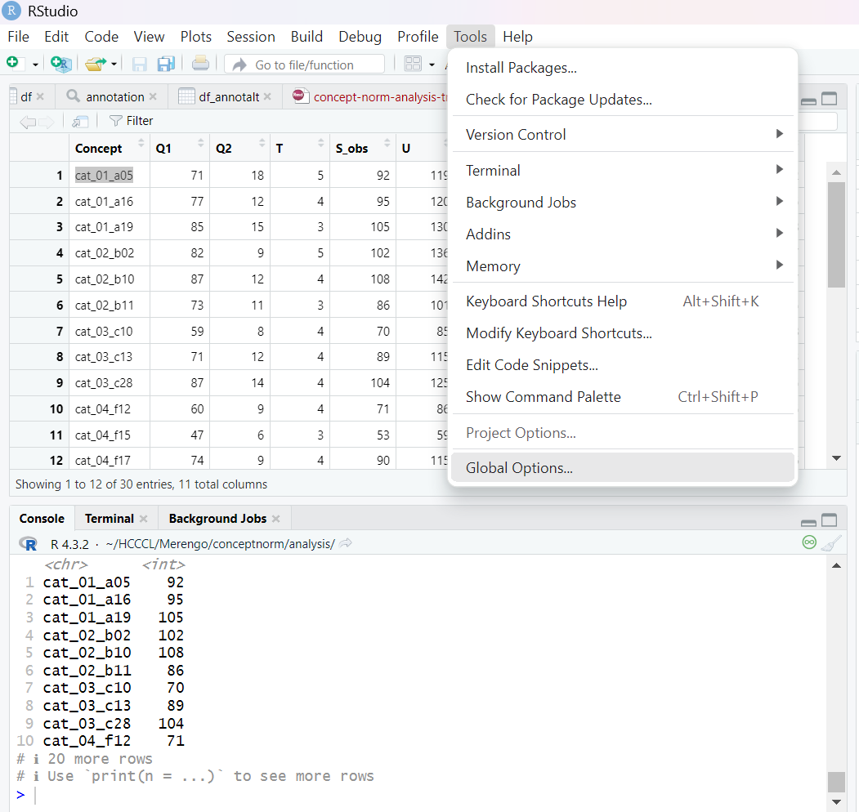2. Select Spelling -> scrollbar -> Add languages and a list like this should be imported -> Apply

