Homework 5

Yann-bor Wen

Math 6311

Dr. Li

3 October 2018

**Centroid Method for Digit Recognition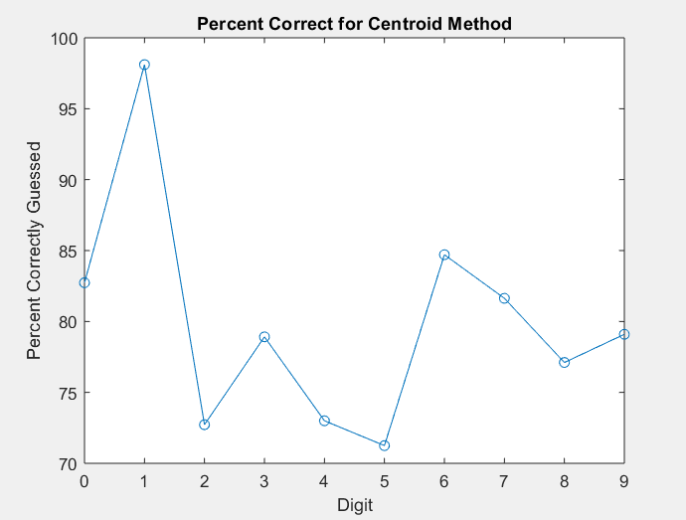 SVD Method for Digit Recognition**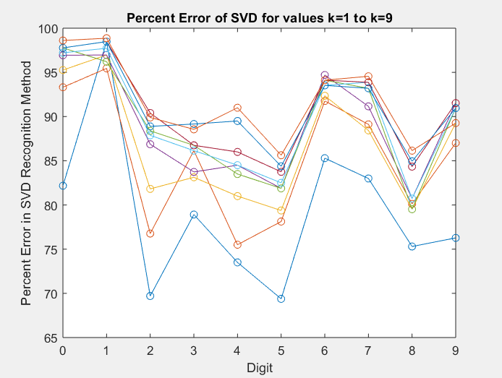

**Code for Centroid Method**

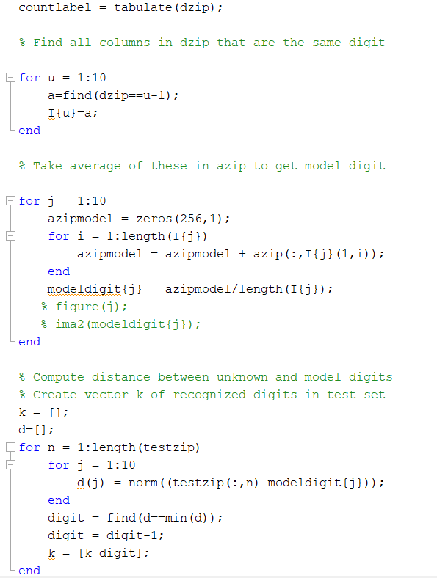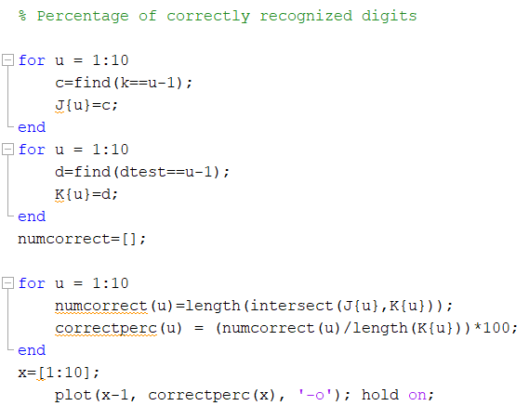

**Code for SVD Method**

