Git is a version control system

Git stores important data such as author, time stamp, commits and data

Github and Gitlab and bit bucket are source code management system platforms that allows you to store your source code

Git is a CLI whereas Github is an GUI and also provides CI/CD pipelines

To initialize an version control system:  
1. Run git init

This creates an empty git repository

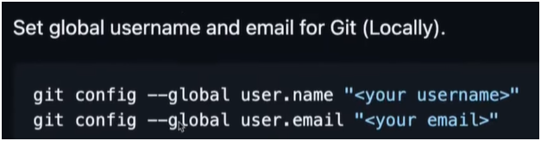

.git folder is generally hidden, to make it visibe:  
ctrl + shift + p in vscode

Search preferences:workspace settings (json)

In that paste this code: {

"files.exclude": {

"**/.git": false

}

} save and reopen ide

To know the status of the git repo: run **git status**

in version control system(vcs) there are 3 stages : untracked, staged and tracked

in file system they are untracked in vcs they are tracked

to move a file from untracked to stages: **git add filename.extension** for specific file

or **git add .** for all files at once

then file is added to staged state

to move back to untracked state run: **git rm --cached** testing.py for specific file

or git rm --cached for all files at once

to move from staged to tracked run: **git commit -m “message to be added”** message is compulsory

before that make sure you set user.name and user.email shown before

now if the files are deleted then you can recover using: **git recover filename**

**Note:** we cannot recover a file from staged mode but only from tracked mode

After making the files tracked now we have to push files from local to github

**Steps to move files to github:**

1. Create new repo
2. Same name as given for local workspace folder
3. Make as public
4. To get access to github account we use Personal Access Token **(PAT)**
5. git remote add origin <https://github.com/Im-Inevitable007/gitworkshop.git> paste this in terminal and run, this command will be given when we create a repo
6. git remote -v to check the status of remote repo

local repo is called master, remote repo is called main

Before pushing the repo we have to generate a PAT:

1. Go to profile settings
2. Developer Settings as last
3. Personal access tokens
4. Tokens (classic)
5. Generate new token
6. New token classic
7. Check the field repo
8. Generate
9. Copy the token
10. In local terminal run: git remote set-url origin <https://(paste> the token here) @github.com/Im-Inevitable007/gitworkshop.git
11. Run **git push origin master** this will create a new branch named master in the github repo