**Poject details:**

**Project Name:** LockedMe.com

**Project Objective:**Digitize the project, LockedMe.com and add Generic features plus three operations, “Add, Search, delete” to the project.

**Product’s capabilities:**

1. A user can retrieving the file names in an ascending order
2. User can add a file to the application.
3. User can search a specific file in the application.
4. User can delete a specific file from the application.
5. User can also sort the files in ascending or descending order to maintain the files in the organized matter.
6. Navigation option to close the current execution context and return to the main context option to close the application.

**FlowChart:**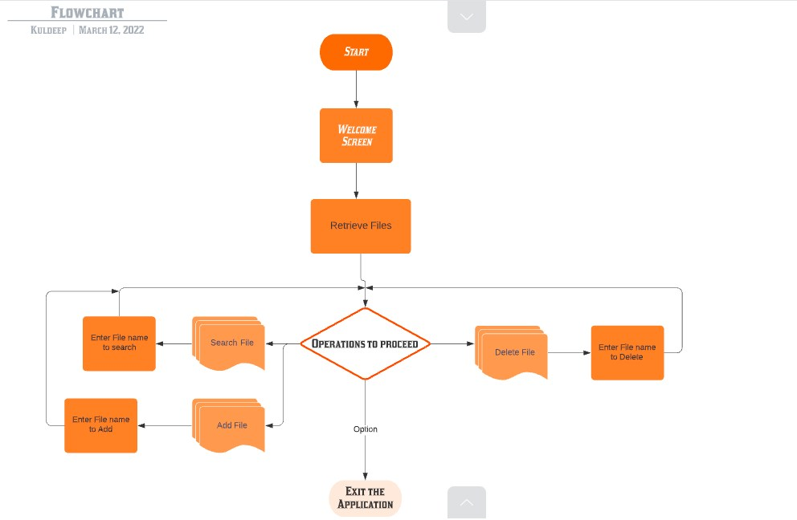

**Coding:**

1. **Class Lockme_com(Main class):**

package Lockme;

import java.util.InputMismatchException;

import java.util.Scanner;

public class Lockme_com

{

public static void main(String[] args)

{

// TODO Auto-generated method stub

Welcome_Page w=new Welcome_Page();

w.welcome(); //welcome screen

SortFiles S=new SortFiles();

Scanner sc= new Scanner(System.in); //System.in is a standard input stream

System.out.println(" Please enter file path in the similar format E:\\Full Stack developer\\Lockme");

String path=sc.nextLine();

S.retrieve(path);

FileOperations F =new FileOperations();

//

try{

theLabel: while (true) {

System.out.print("Please select a number from the below options \r\n "+

"1 to search a file in the current folder\r\n"+

"2 to add file in the current folder\r\n"+

"3 to Delete a file in the current folder\r\n"+

"9 to close the application\r\n"+"\r\n");

int number= sc.nextInt();

switch(number)

{

//Case statements

case 1: F.search(path);

continue theLabel;

case 2: F.addfile(path);

continue theLabel;

case 3: F.deleteFile(path);

continue theLabel;

case 9: System.exit(0);

//Default case statement

default:System.out.println(number+" is not present in the option list");

continue theLabel;

}

}}

catch(InputMismatchException exception)

{

System.out.println("Wrong input");

}sc.close();

}

}

1. **Class to Retrieve files in Ascending order:**

package Lockme;

import java.io.File;

import java.io.FileFilter;

import java.util.Arrays;

import java.util.Comparator;

public class SortFiles

{

void retrieve(String path)

{

File dir = new File(path);

if(dir.isDirectory())

{

// Fetching the list from the directory

File[] files = dir.listFiles();

//Creating a filter to return only files.

FileFilter fileFilter = new FileFilter()

{

@Override

public boolean accept(File file) {

return !file.isDirectory();

}

};

files = dir.listFiles(fileFilter);

System.out.println("\n Retrieving file names in ascending order..................");

//Sort files by name

Arrays.sort(files, new Comparator<Object>()

{

@Override

public int compare(Object f1, Object f2) {

return ((File) f1).getName().compareTo(((File) f2).getName());

}

});

//Prints the files in file name ascending order

for(File file:files)

{

System.out.println(file.getName());

}

}

}

}

1. **Class to perform operations(Search, Delete, Add or close the application):**

package Lockme;

import java.io.File;

import java.io.IOException;

import java.util.Scanner;

public class FileOperations

{

SortFiles s=new SortFiles();

Scanner sc= new Scanner(System.in);

void search(String path)

{

System.out.println("Please enter file name to Search");

String name=sc.nextLine();

File f0 = new File(path,name);

if(f0.exists())

{

System.out.println("File is present");

}

else

{

System.out.println("File not found");

}

}

void addfile(String path)

{

try

{

// Creating an object of a file

System.out.println("Please enter file name to add");

String name=sc.nextLine();

File f0 = new File(path,name);

if (f0.createNewFile()) {

System.out.println("File " + f0.getName() + " is created successfully.");

} else {

System.out.println("File is already exist in the directory.");

}

}

catch (IOException exception)

{

System.out.println("An unexpected error is occurred.");

exception.printStackTrace();

}

}

void deleteFile(String path)

{

System.out.println("Please enter file name to delete");

String name=sc.nextLine();

File f0 = new File(path,name);

**if**(f0.delete())

{

System.out.println(f0.getName()+ " file is deleted successfully.");

}

else

{

System.out.println("File not found");

}

}

}

**Screenshots:**

**Welcome screen:**

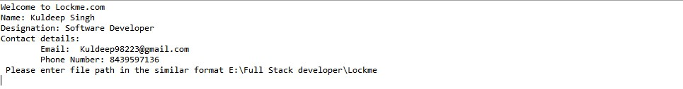

**Retrieve File in ascending order:**

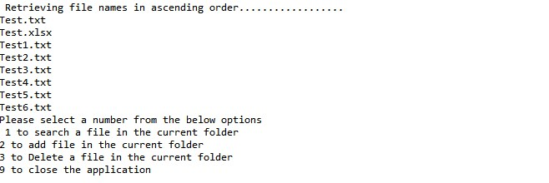

**Search File:**

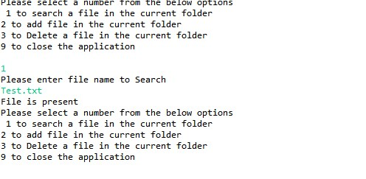

**Add File:**

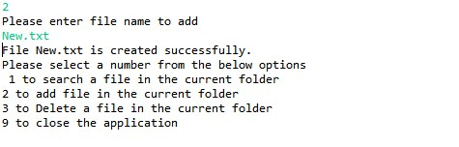 **Delete File:**

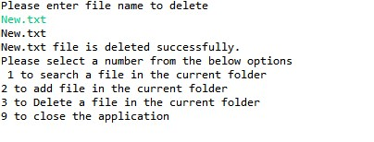

**Developer Details:**

**Name:** Kuldeep Singh  **Designation:** Software Developer **Contact details:  
 Email:** Kuldeep98223@gmail.com **Phone Number:** 8439597136