1. **INTRODUCTION**

## PROJECT PROFILE

* **Project partners**
* Strength: - 10
* Name: -
* Vikas Laljibhai Rathod
* Jaisal Shah
* **Hardware & Software requirement**
* **Hardware**
* Pentium IV processor or any higher processor
* 256 MB RAM or more
* 700 MB Hard Disk or more
* **Software**
* Operating System
* Windows XP or higher operating system
* **Development Tools**
* Microsoft Asp.NET 2008
* Database-Microsoft SQL Server 2005
* **Documentation & Presentation Tools**
* Microsoft word 2007
* Microsoft PowerPoint 2007

## SYSTEM OVERVIEW

* In today’s world with the increasing traffic and longer commuting distances it is becoming very difficult for people to travel for their particular licenses issue.
* Also most of the people today work for longer hours and do not have the flexibility to take a break from work to give the licenses tests.
* People have not spent more time for licenses test.
* The People want a facility where they can have easy to issue their licenses.
* The facility to achieve schedule date by SMS, call or mail...
* The people collect their license from post and travel from long distance for issuing license. So, the people waste their money.

## OBJECTIVE

* So, require to build new Website according to RTO office infrastructure and Facilities.
* So that all the people can get information about the e-RTO.
* Create a web application to be used in place of old system.
* Use ASP.NET and SQL Server technology to create strong and secured database connectivity.
* To maintain and improve the skill management for the department personnel.
* To ensure transparency in the day-to-day management and administration of the officials.

## SCOPE

* This project prepared RTO office to maintain all the records like issuing the LL, DL, Vehicle registration, Vehicle ownership transfer etc. Once all these get computerized to work efficiency of the employee will get increases.

## DETAIL DESCRIPTION

**Functionalities:**

* Issue of Duplicate Registration Certificate.
* Issue of Learning Licenses.
* Issue of Regular Driving License.
* Renewal of Driving Licenses.
* Issue of a Duplicate Driving License.
* Issue of Conductors Licenses.
* Issue of Taxi/Maxi Cabs/Auto Rickshaw and Private Service Vehicle Permits.
* Message Facility (Expire Date, Result Display)

**Goal:**

* + - * The main goal of the project is to maintain the records of issuing the LL, DL, Vehicle registration, User Details, RTO Test Facility etc.
      * “RTO Management System” has been designed to automate the process of registration of vehicle and issuing driving license process. System can make the daily activities efficient and providing the fast response to store and retrieve information to the people By Using SMS or E-Mail.

2 **. PROJECT MANAGEMEN**

## PROJECT DEVELOPMENT APPROACH

**Software process model**

To solve actual problems in an industry, software developer or a team of developers must incorporate a development strategy that encompasses the process, methods and tools layers and generic phases. This strategy is often referred to as process model or 3 software developing paradigm. A process model for software developing is chosen based on the nature of project and application, the methods and tools to be used, and the controls and deliverables that are required. All software development can be characterized as a problem solving loop in which four distinct stages are encountered: Status quo, problem definition, technical development and solution integration. Regardless of the process model that is chosen for a software project all of the stages coexist simultaneously at some level of detail.

**Our project follows the waterfall model**

* **THE WATERFALL MODEL**

The steps of the typical waterfall model are:

1. Requirement definition
2. System & software design
3. Implementation
4. Integration & system testing
5. Operation and maintenance

Feasibility Study

User Requirements

Analysis

System Design

Operation

Testing

Coding

Program Design

**[FIG: - WATERFALL MODEL]**

There have been some variations from the typical waterfall model for this project lifecycle.

**They are**: - Maintenance has been omitted from the current project. Not all testing methods which are present in theoretical model are implemented.

## STUDY ABOUT SOFTWARE

* **ASP.NET 3.5 using Visual studio 2008**

ASP.NET 3.5is the big step back in the right direction. Microsoft recognized that one thing people who build web sites don’t want to do is have to code. Code is dull; code is geeky. However, Microsoft also recognized that some people still have to code for a living. And more hand that, these coders have to build the same things, over and over again: a login mechanism, a menu system, a shopping cart, a funky theme for your site’s backdrop applied to every page—something every web site requires. Two guiding principles seem to be at work here: make it easier for the novice to use and reduce the amount of repetitive work the developer has to do. Claims for ASP.NET 3.5 boast “70 percent less code” is needed; ASP.NET 3.5 also comes with a multitude of controls to enable the developer to create login systems and menus in minutes.

Late in 2008 we saw the previews of the new version of Active Server Pages named ASP.NET 3.5. Everyone knew that these claims weren’t just hyperbole and that the way developers create web applications was going to change fundamentally. Microsoft expanded the powerful features of earlier ASP versions while greatly reducing the effort to implement those features. The ease of implementation meant a reduction in the cost of developing complex sites. Or, put another way, there would now be a large expansion of the number of people that have the capability to build a complex site.

In addition to ASP.NET 3.5 comes a new, affordable tool for creating these web sites: Visual Web Developer Express. Microsoft’s previous attempts at providing tools for helping create dynamic web sites have been clunky (Front Page) or have never really taken off (Visual Interdev), but this time they’ve got it right. Visual Web Developer is part of the Visual Studio.NET suite, but a scaled-down version of Visual Web Developer Express will be free in the foreseeable future. It allows you to drag and drop a site together within minutes, is instantly recognizable to developers, and allows easy creation and management of your web pages.

This book leads you step-by-step through creating dynamic, data-driven, complex web sites using ASP.NET 3.5. To those ends, this chapter explains the basic ideas and examines the completed sample site. You then learn how to use Visual Web Developer Express (VWD) to build ASP.NET 3.5 sites.

* **Microsoft SQL Server 2005**

After a long gap in the release of SQL Server databases, Microsoft recently released SQL Server 2005 (formerly code-named Yukon). In this substantial upgrade, they've packed the new database engine full of features. Probably the most significant one that will catch your attention is the price tag – it’s up to 25% higher than SQL Server 2000. A single processor license for SQL Server 2005 Enterprise Edition will set you back approximately $25,000. That’s not cheap, but Microsoft has made some great advances in functionality that make up the difference.

In this first part of our series on this new product, let’s take a look at the four different editions of SQL Server 2005 that Microsoft plans to release:

* **SQL Server 2005 Express** replaces the Microsoft Data Engine (MSDE) as the free version of SQL Server for application development and lightweight use. It remains free and retains the limitations of MSDE with respect to client connections and performance. It’s a great tool for developing and testing applications and extremely small implementations, but that’s about as far as you can run with it.
* **SQL Server 2005 Workgroup** is the new entrant in the product line. It’s billed as a “small business SQL Server” and it offers an impressive array of functionality for a $3,899 price tag per processor. (It’s also available under a 5-user license for $739). Workgroup edition maxes out at 2 CPUs with 3GB of RAM and allows for most of the functionality you’d expect from a server-based relational database. It offers limited replication capabilities as well.
* The workhorse **SQL Server 2005 Standard Edition** remains the staple of the product line for serious database applications. It can handle up to 4 CPUs with an unlimited amount of RAM. Standard Edition 2005 introduces database mirroring and integration services. It’s priced at $5,999 for a processor or $2,799 for 5 users.
* The big kid on the block is **SQL Server 2005 Enterprise Edition**. With the release of 2005, Enterprise Edition allows unlimited scalability and partitioning. It’s truly an enterprise-class database and its hefty price tag ($24,999 per processor or $13,499 for 5 users) reflects its value.

**3. System Requirement Study**

## USER CHARACTERISTICS

* This system will be used in two modules which are Administrator, user. As all of these have different requirements the modules are designed to meet their needs and avoid any type of confusion. The uses of all two user modules have been described below.

1. **Administrator can do the following function**

* Update the act and rules.
* Manage the user information.
* Send the acknowledgement to user.
* Cancel the user registration.
* Manage the user account.
* Update the news.
* Issue the license.
* Renew the license.
* Take demo test, driving test.

1. **User can do the following function**

* Register their information and create account.
* Select Demo test And Give That test.
* See the demo test result at the time.
* See The Information regarding RTO.
* See the act and Rules Updated by admin.

## HARDWARE SOFTWARE REQUIREMENT

**Minimum Software Requirement**

Server side:-

* Window Xp or any Server OS
* ASP.net
* My Sql Server 2005

Client side:-

* Windows Xp or Above
* Internet Explorer 5.0 or Above
* Google Chrome
* Mozilla Firefox

**Minimum Hardware Requirement**

Server side:-

* Pentium-4 or Above
* 512MB RAM
* 700 MB Hard Disk

Client side:

* Pentium 4 or above
* 256 MB RAM
* 700 MB hard disk

**4. System Analysis**

## DRAWBACK OF CURRENT SYSTEM

* Existing system is very complex, waste of time & many more

Real-life problem.

* Many employees are needed to handle current system.
* It is more expensive process.
* Immediate responses to the queries are difficult.
* Lots of times are consumed for each report generation.
* So, require to build new Website according to RTO office

Infrastructure and Facilities.

* So that all the people can get information about the e-RTO.

## FEATURES OF NEW SYSTEM

* By using this system we can get Information about RTO.

Information like Driving License, Learning License and all the

RTO service online.

* This system helps to solve the time related problem.
* System helps customer to find his/her requirement in various

RTO Information online.

* It also Provide Online RTO tests.
* We can get the information at any time by using this system about.
* This system reduces all the paper work.

## FEASIBILITY STUDY

The following three areas were taken into consideration while deciding the feasibility of the proposed system.

* Technical Feasibility
* Economic Feasibility
* Operational Feasibility
* **Technical Feasibility**

The company is an efficient company with excellent infrastructure so as to successfully support me, as a developer, and support the website. The system, which is being developed in the latest web technology available, can efficiently use the resources available and maximize output.

* **Economic Feasibility**

The project will be quite beneficial economically as it will be designed to cater a global audience as per the company's market presence requirements. It shall ensure a richer customer base that spreads across the globe thanks to the transaction facilities that will be implemented.

* **Operational Feasibility**

The project once completed shall be useful to the company and the company will be able to manage it very effectively using the administration tools that shall be incorporated within the said system. The general difficulty level of the project has been kept low so as to ensure ease of operation.

**5. System design**

**5.1 SYSTEM FLOW CHART**

**[Process of system For User]**

**5.2 DATA FLOW DIAGRAM (DFD)**

The DFD (also known as bubble chart) is a simple graphical formalism that can be used to represent a system in terms of the input data into the system, various process carried on these data and the output data generated by the system.

The main reason why the DFD technique is so popular is because the fact that the DFD is very simple formalism – it is simple to understand use. A DFD is a very limited number of primitive symbols to represent the functions performed by a system and the data flow among the functions. Starting with a set of high-level functions that a system performs, a DFD model hierarchy represents various sub-functions.

* **Data Flow :**

A line with an arrow represents data flows. The arrow shows the direction of flow of data. The name of the data appears next to the line. Data more in a specific Direction from an origin to a destination. The data flow is a ‘packet’ of data.

* **Process:**

A Circle is used to despite a process. Processes are numbered and given a name.

* **Data Store :**

A data store stores the data. Two parallel lines with square depict a data store. Processes may store or retrieve data from a data store. If an arrow points to the store, it indicates operation of writing in the store. If it points away from the store, it indicates operation of reading from the store.

* **External Entity :**

External Entities are represented by the rectangle, and are outside the system, such as venders or customers wit that the system interacts. The designers have no control over them.

* **DATA FLOW DIAGRAM**
* **Context level DFD**
* **First level DFD**
* **Second level DFD**

* **CONTEXT LEVEL DFD**
* **FIRST LEVEL DFD [Admin]**
* **FIRST LEVEL DFD FOR USER**

* **E-R Diagram:**

**5.3 DATA MODELING**

* **Data Dictionary:**

**TABLE 1:-** Admin_master

**Descriptions:** - This table keeps The Information about Admin.

|  |  |  |  |  |  |
| --- | --- | --- | --- | --- | --- |
| **Sr.no.** | **Field name** | **Data type** | **Constrain** | **Size** | **Description** |
| **1.** | Admin_id | int | Primary key | - | Id of admin master. |
| **2.** | User_name | Varchar | Not null | 50 | Name of user |
| **3.** | Password | Varchar | Not null | 50 | Password of user |
| **4.** | F_name | Varchar | Not null | 50 | First name of user |
| **5.** | L_name | Varchar | Not null | 50 | Last name of user |
| **6.** | Address | Varchar | Not null | 50 | Address of user |
| **7.** | City | Varchar | Not null | 50 | City of user |
| **8.** | Mobile | Decimal | Not null | 18 | Mobile number of user |
| **9.** | E-mail | Varchar | Not null | 50 | Email address of user |
| **10.** | Seq_que | Varchar | Not null | 50 | Security question |
| **11.** | Seq_ans | Varchar | Not null | 50 | Security answer |
| **12.** | Status | Varchar | Not null | 50 | Status |

**TABLE 2:-** Registration

**Descriptions:**- This table keeps The Information about User Registration.

|  |  |  |  |  |  |
| --- | --- | --- | --- | --- | --- |
| Sr.no. | Field name |  | Constrain | Size | Description |
| 1. | Reg_id | Int | Primary key | - | Id of registration. |
| 2. | User_name | Varchar | Not null | 50 | Name of user |
| 3. | Password | Varchar | Not null | 50 | Password of user |
| 4. | F_name | Varchar | Not null | 50 | First name of user |
| 5. | L_name | Varchar | Not null | 50 | Last name of user |
| 6. | Address | Varchar | Not null | 50 | Address of user |
| 7. | City | Varchar | Not null | 50 | City of user |
| 8. | Mobile | Decimal | Not null | 18 | Mobile number of user |
| 9. | E-mail | Varchar | Not null | 50 | Email address of user |
| 10. | Seq_que | Varchar | Not null | 50 | Security question |
| 11. | Seq_ans | Varchar | Not null | 50 | Security answer |
| 12. | Status | Varchar | Not null | 50 | Status |
| 13. | Temp | Varchar | Not null | 50 | Document |
| 14. | Photo | Varchar | Not null | 50 | Photos |

**TABLE 3:-** Contact Us

**Descriptions:** -This table keeps The Information about Contact Us.

|  |  |  |  |  |  |
| --- | --- | --- | --- | --- | --- |
| Sr.no. | Field name | Data type | Constrain | Size | Description |
| 1. | Cont_id | int | Primary key | - | Id of contact us. |
| 2. | Name | Varchar | Not null | 20 | Name of user |
| 3. | Date | Date time | Not null | 30 | Date |
| 4. | Mobile | Decimal | Not null | 18 | Mobile number of user |
| 5. | E-mail | Varchar | Not null | 50 | Email address of user |
| 6. | Detail | Varchar | Not null | 50 | Detail about |

**TABLE 4:-** Download

**Descriptions**:- This table keeps the information of the download form.

|  |  |  |  |  |  |
| --- | --- | --- | --- | --- | --- |
| Sr.no. | Field name | Data type | Constrain | Size | Description |
| 1. | D_id | int | Primary key | - | Id of download form |
| 2. | Title_eng | Varchar | Not null | Max | Name of English form |
| 3. | Title_guj | Varchar | Not null | Max | Name of Gujrati form |
| 4. | File name eng | Varchar | Not null | Max | Name of English file |
| 5. | File name guj | Varchar | Not null | Max | Name of Gujrati file |
| 6. | Category | Varchar | Not null | 50 | Category of form |
| 7. | Detail | Varchar | Not null | Max | Detail about |
| 8. | Status | Varchar | Not null | 50 | Status |

**TABLE 5**:- Feedback

**Descriptions**:-This table keeps the information about feedback

|  |  |  |  |  |  |
| --- | --- | --- | --- | --- | --- |
| Sr.no. | Field name | Data type | Constrain | Size | Description |
| 1. | Feed_id | int | Primary key | - | Id of feedback form. |
| 2. | Date | Date time | Not null | 30 | Date |
| 3. | Name | Varchar | Not null | 50 | Name of user |
| 4. | Mobile | Decimal | Not null | 18 | Mobile number of user |
| 5. | E-mail | Varchar | Not null | 10 | e-mail address of user |
| 6. | Comments | Varchar | Not null | 50 | Category of form |

**TABLE 6:-** RTO-Test

**Descriptions:**- This table keeps information about RTO test.

|  |  |  |  |  |  |
| --- | --- | --- | --- | --- | --- |
| Sr no. | Field name | Data type. | Constrain | Size | Description |
| 1. | Que_id | int | Primary key | - | Question id. |
| 2. | Que_name | Varchar | Not null | Max | Question name. |
| 3. | Opt_1 | Varchar | Not null | Max | Option 1. |
| 4. | Opt_2 | Varchar | Not null | Max | Option 2. |
| 5. | Opt_3 | Varchar | Not null | Max | Option 3. |
| 6. | Ans | Varchar | Not null | 1 | Answer of question |
| 7. | Image | Varchar | Not null | 50 | Image |

**TABLE 7:-** Result

**Descriptions:** - This table keeps information about Result.

|  |  |  |  |  |  |
| --- | --- | --- | --- | --- | --- |
| Sr no. | Field name | Data type. | Constrain | Size | Description |
| 1. | Id | int | Primary key | - | Id. |
| 2. | User_Id | Varchar | Not null | 20 | User id |
| 3. | Date | Date Time | Not null | 30 | Test Date |
| 4. | Marks | int | Not null | 20 | Obtain Mark |
| 4. | Result | Varchar | Not null | 20 | Pass/Fail |

**Admin Page:**

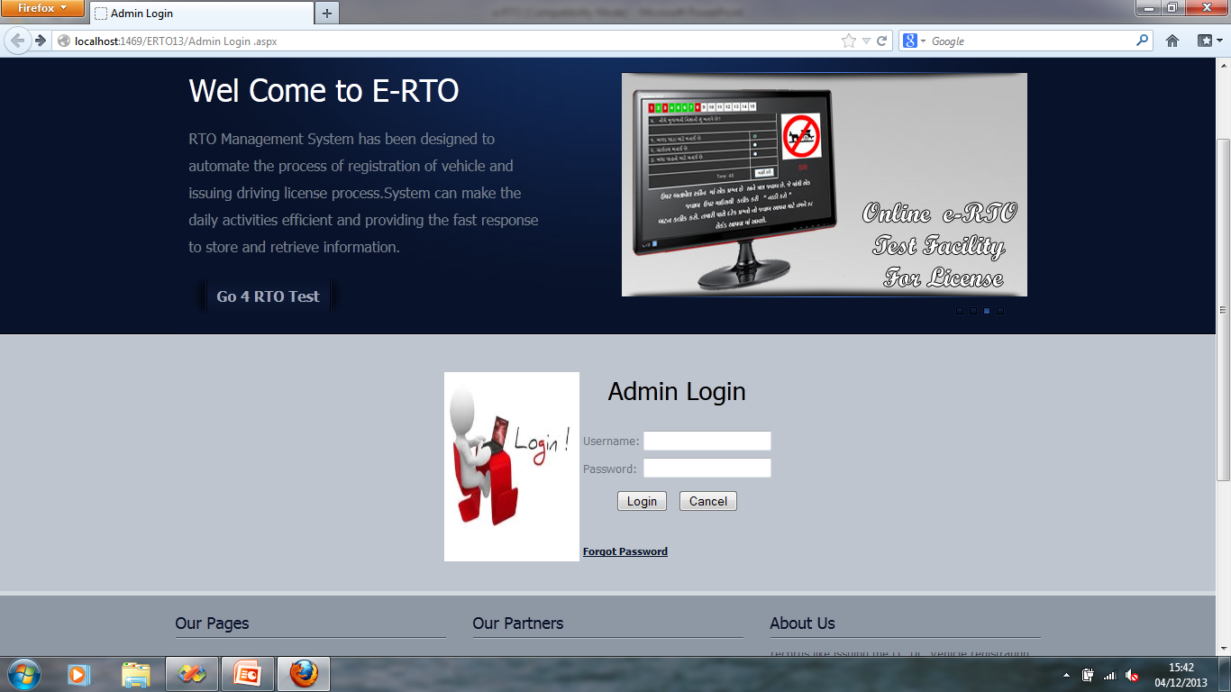

**Admin Registration Page:**

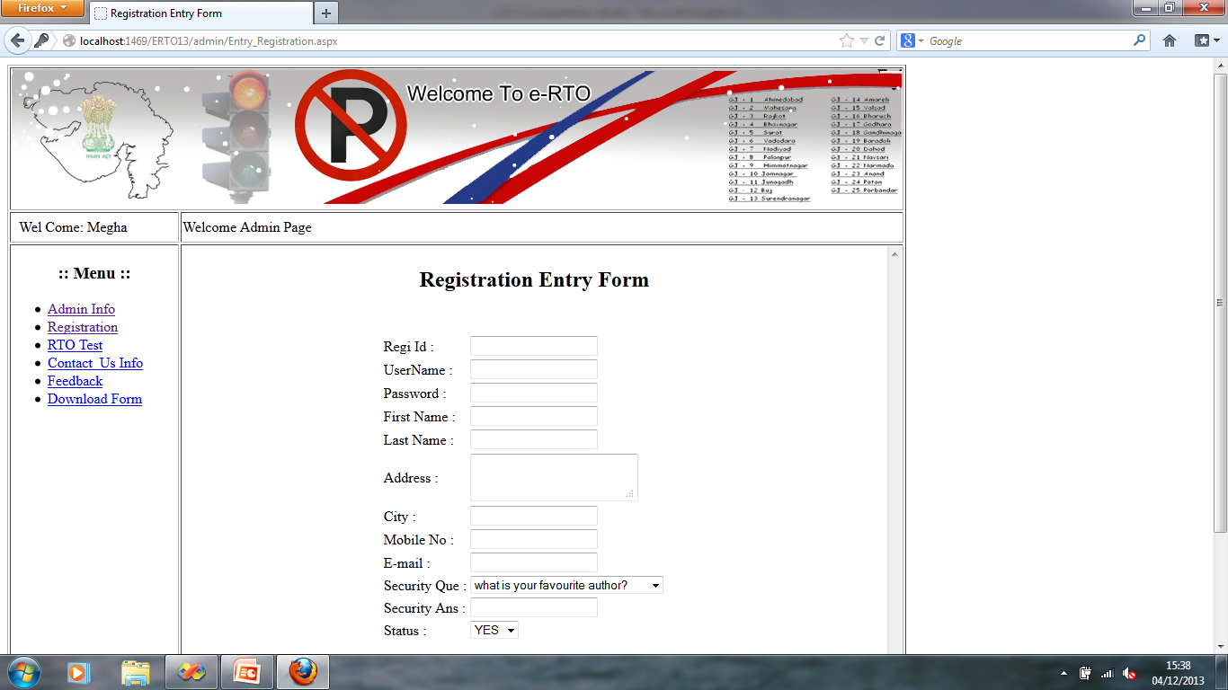

**Admin RTO Test Page:**

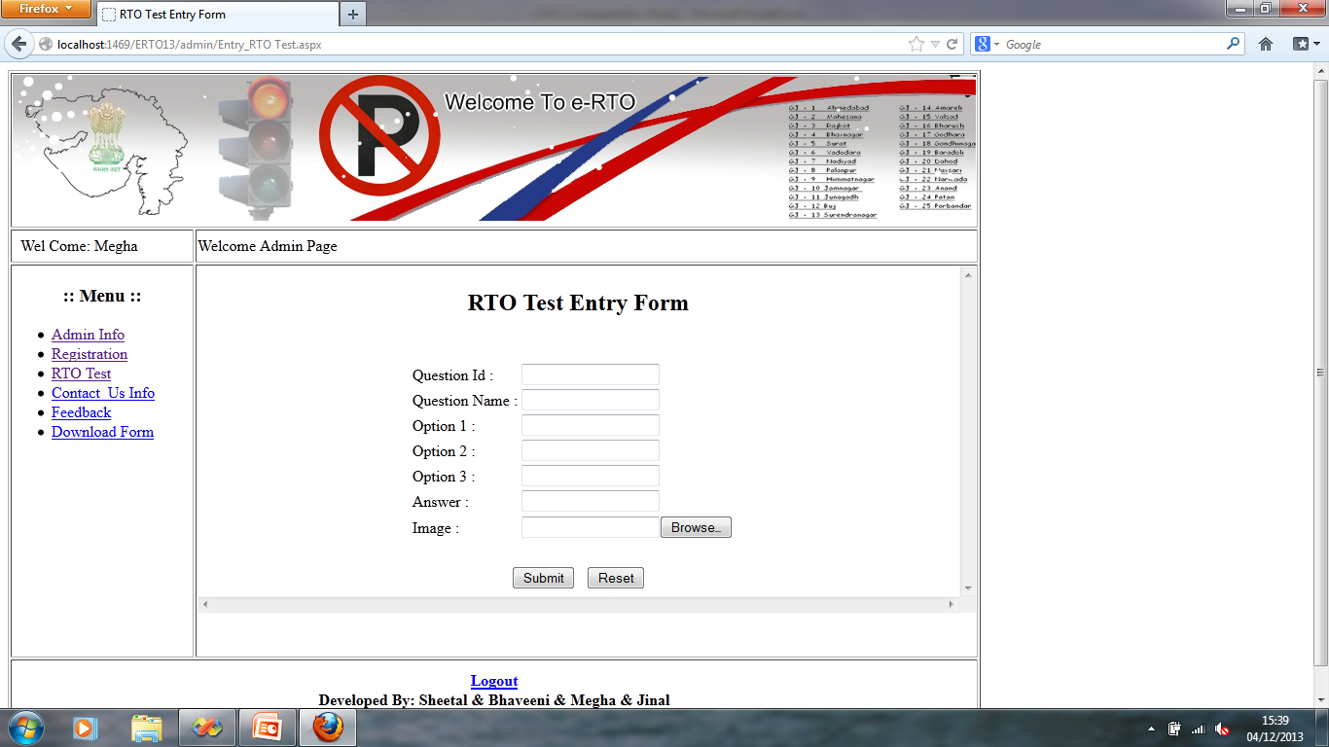

**User Home Page:**

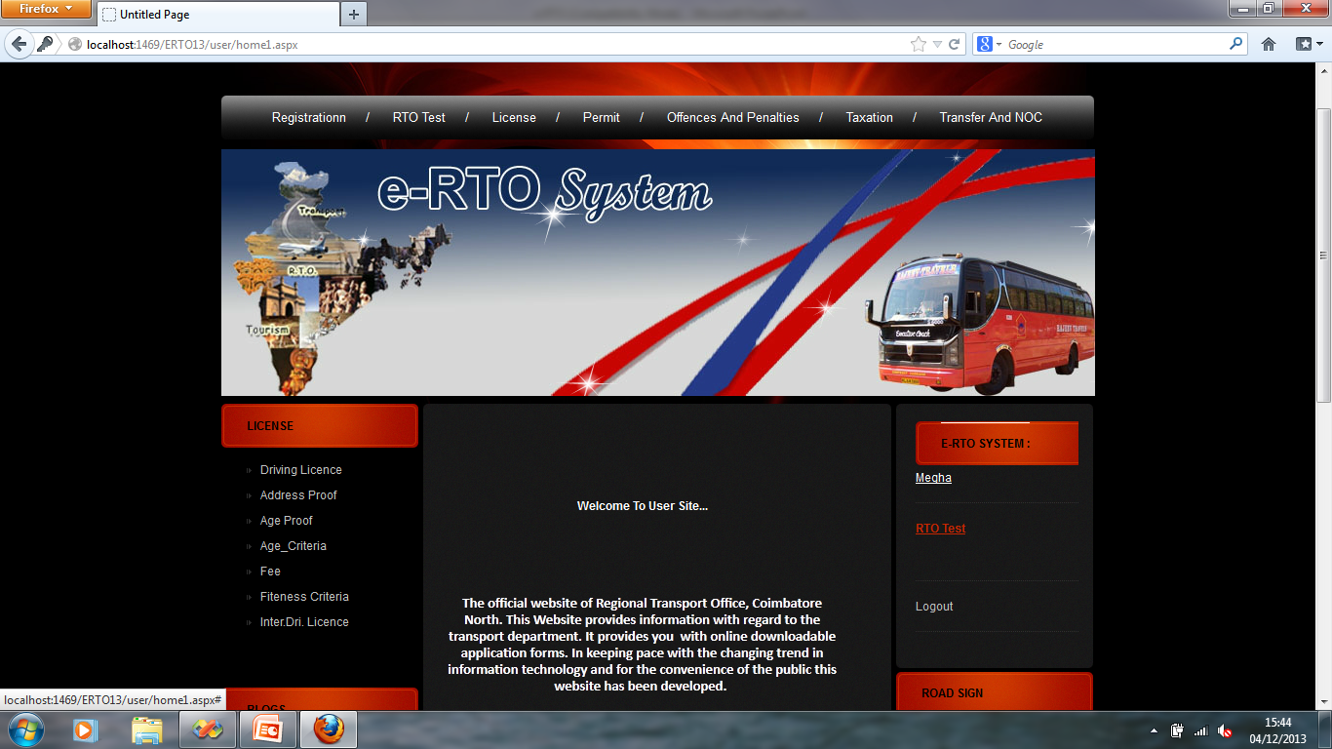

**RTO Test:**

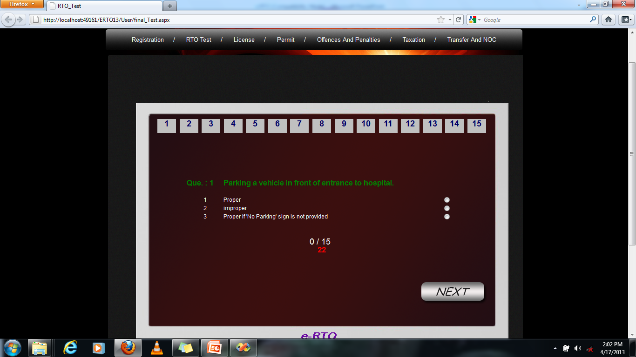

**Forgot password:**

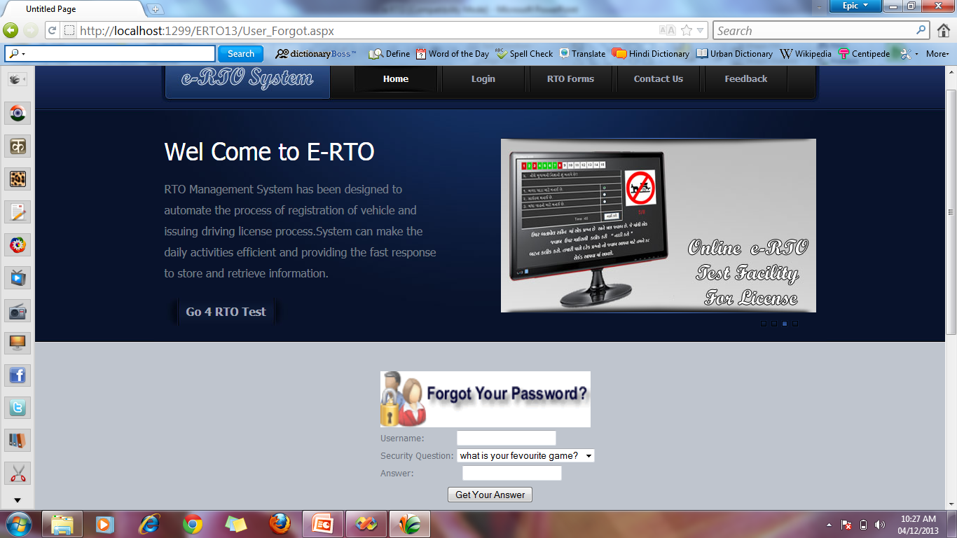

**Feedback Page:**

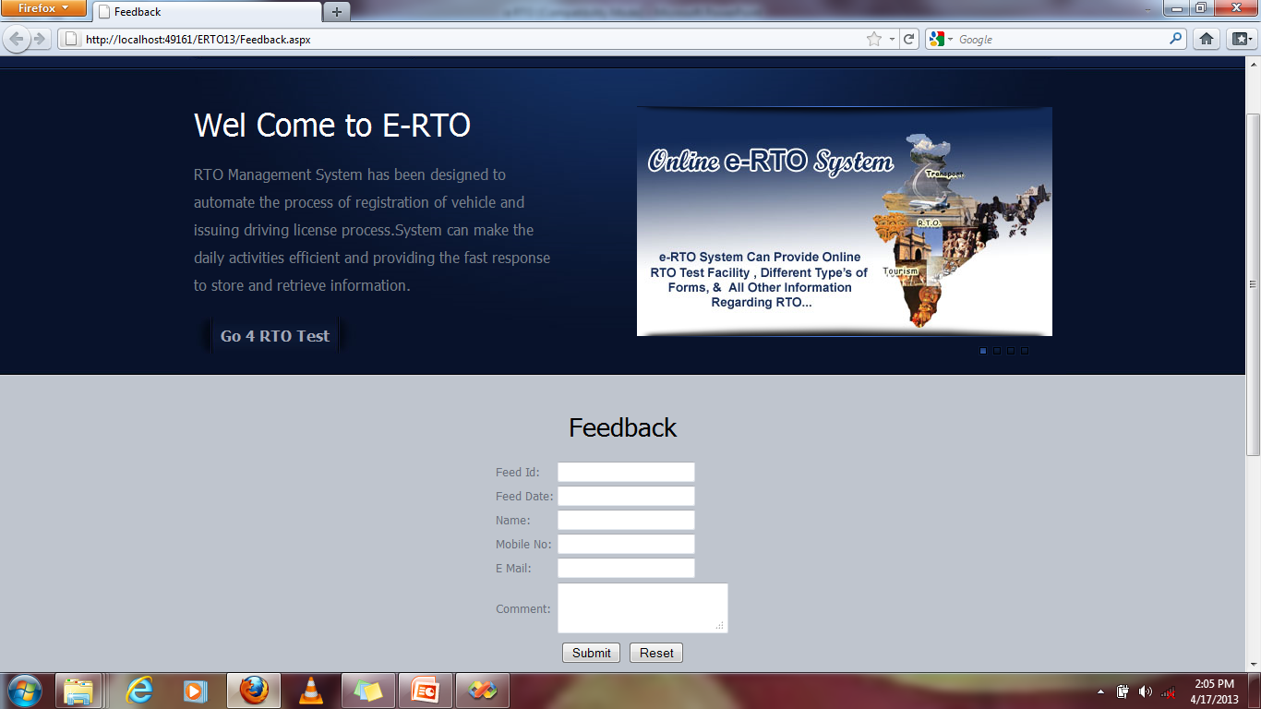

**Contact Us Page:**

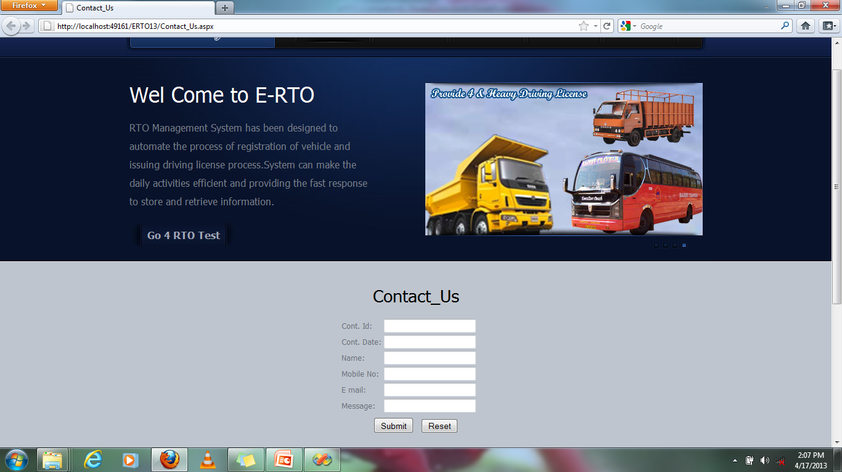

**Download Page:**

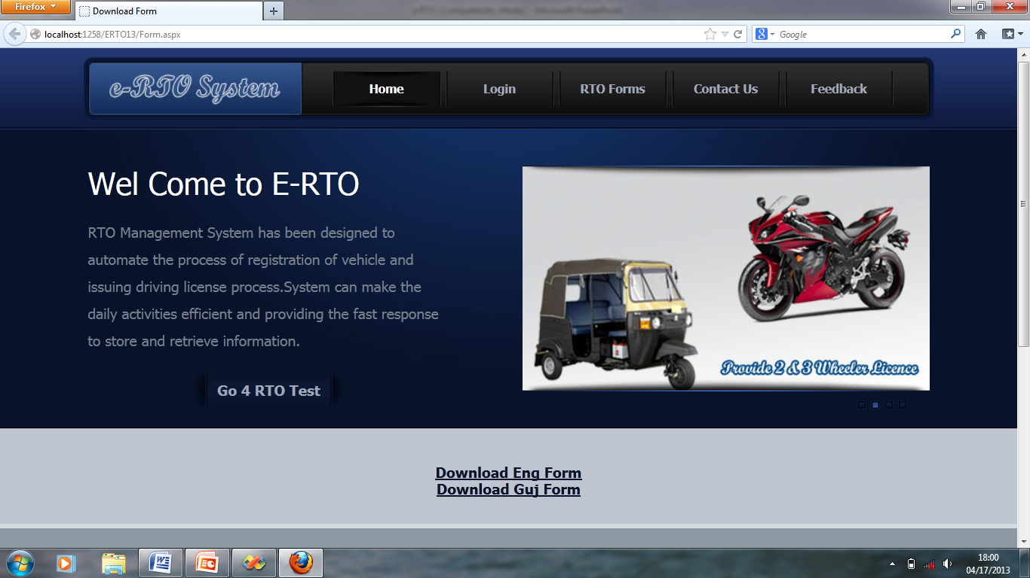

**Validation Control Page:**

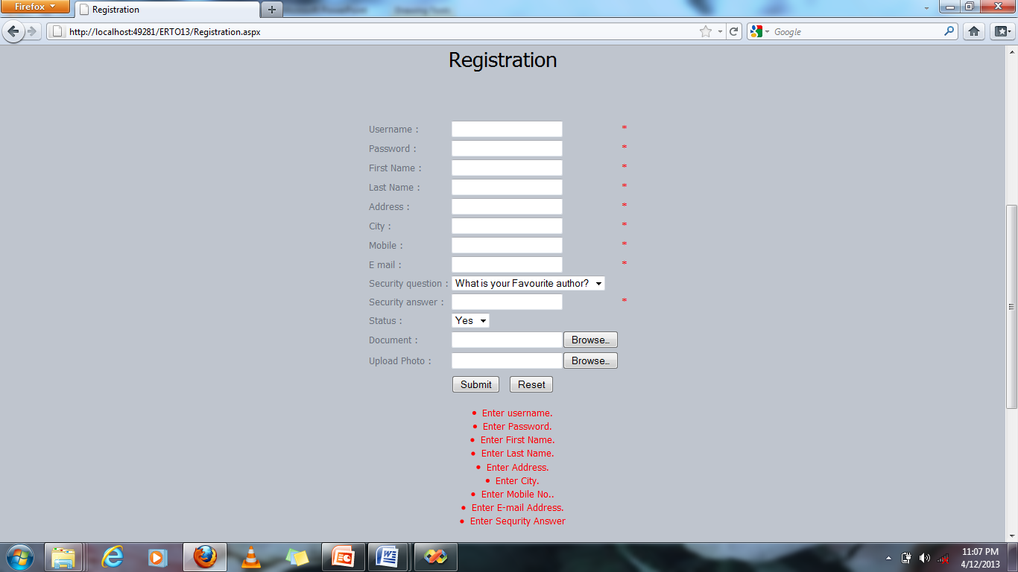

**7. Summary**

## 7.1 SUMMARY OF PROJECT WORK

* **Project Title**
* e-Regional Transport Office System
* **Software used**
* Microsoft Visual Studio 2008
* Database-Microsoft SQL Server 2005
* **Documentation Tools**
* Ms-Office 2007
* **Internal Project Guide**
* Mr. Chandresh Patel
* **External Project Guide**
* Mr. Chandresh Patel
* **Submitted By**
* **Submitted To**
* **Project Duration**
* YEAR

**8. Conclusion**

## 8.1 CONCLUSION

* In today’s world with the increasing traffic and longer commuting distances it is becoming very difficult for people to travel for their particular licenses issue.
* Also most of the people today work for longer hours and do not have the flexibility to take a break from work to give the licenses tests. People have not spent more time for licenses test.
* The People want a facility where they can have easy to issue their licenses.
* The facility to achieve schedule date by SMS, call or mail.
* The people collect their license from post and travel from long distance for issuing license. So, the people waste their money.
* We like this opportunity to convey our special thanks to all those who played role in making this project a success and a great learning experience for us.
* **Reference**
* **Appendix –A List of Useful Websites**
  + [www.drivingschool.com](http://www.drivingschool.com)
  + www.transportindia.in
* **Appendix –B List of Useful Book**
  + C# BIBLE, WILEY
  + PRO ASP.NET IN C# 3.5
  + SQL SERVER 2005 BIBLE