NIIHAN seaport navigation validation results
Draft report 20 October 2026
The NIIHAN rover completed 21 of 21 waypoint checks across 7 seaport layouts, with 7 layouts meeting the complete route acceptance criteria. This experiment evaluates whether the same navigation procedure can reach fixed supervision waypoints when nearby cargo moves slightly.
For the 21 verified arrivals after GPS final approach, mean horizontal waypoint error was 4.7 cm and the largest error was 4.9 cm. The acceptance limit was 10 cm. All arrival errors are horizontal east and north distances scored against simulator ground truth. Altitude and heading accuracy are not evaluated.
Measure | Observed result
Layouts passing | 7 of 7
GLIM 3D maps saved | 7 of 7
Waypoints passing | 21 of 21
GPS model | Ideal Gazebo NavSat with synthetic sky display
Environment change | Seven cargo centres shifted within fixed port geometry
Claim supported | Measured performance on this straight clear lane only
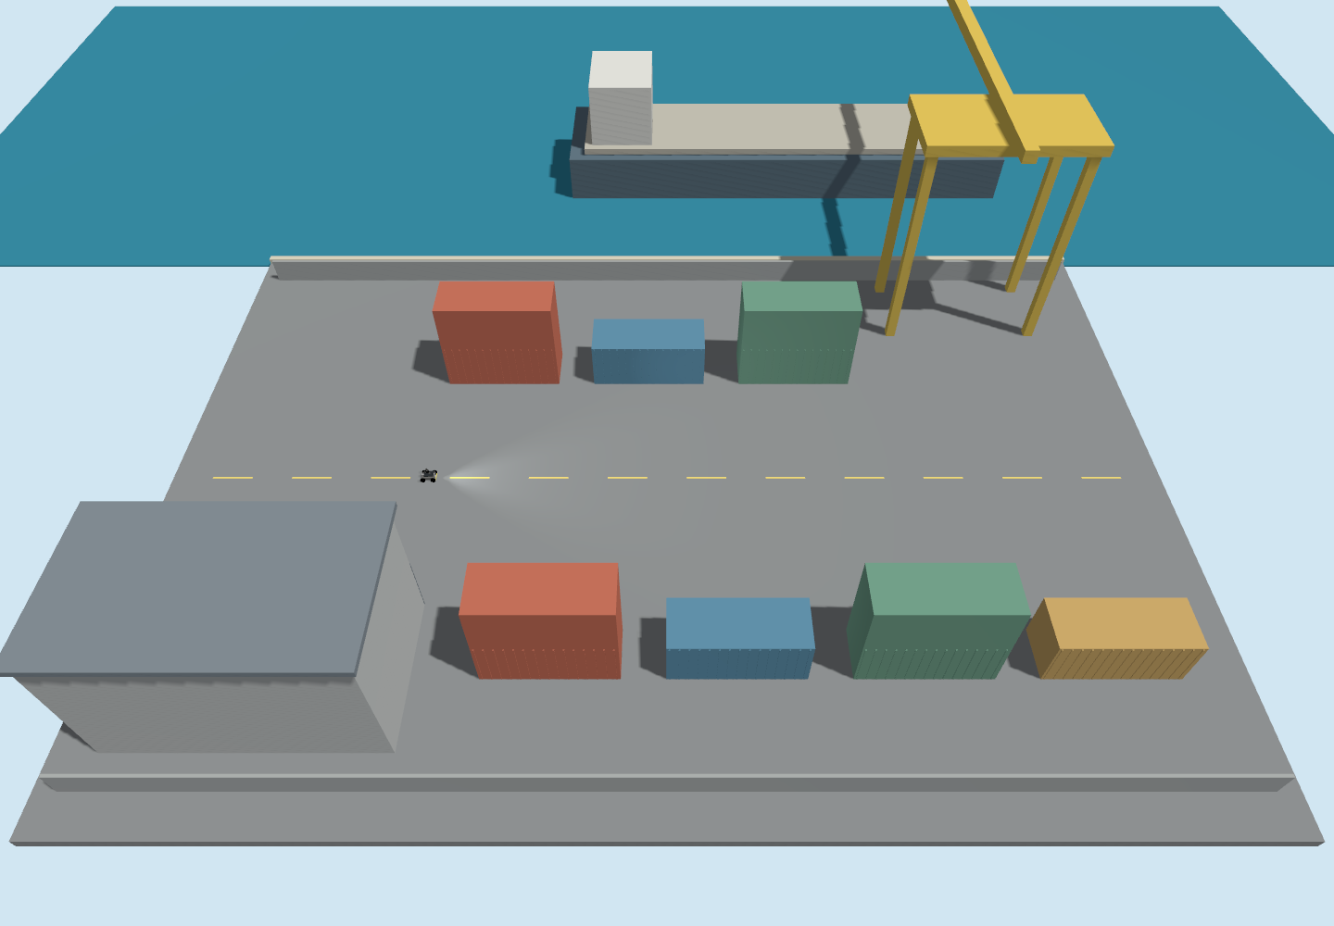
Figure 1 Actual Gazebo camera capture of layout 1. The port is a simplified simulation scene with physical cargo obstacles and recognisable maritime structures.
These results do not establish navigation independence from arbitrary surroundings. The simulator uses ideal GPS, a clear patrol corridor and a fresh online map in every layout. Hardware GPS precision and operation with moving cargo remain untested.

Experiment method and simulated GPS
Each run uses an isolated ROS domain and Gazebo partition, with cleanup of owned child processes. Each run starts the installed niihan_description rover in Gazebo Harmonic with GLIM 3D LiDAR inertial SLAM and Nav2. The quay, crane, vessel, warehouse, robot, seed and waypoint procedure remain fixed. Seven cargo centres move by at most 0.8 m east or west and 0.6 m north or south. Stacked containers move with their base cargo.
Setting | Value
Spawn in world frame | East -12 m North 0 m Yaw 0
Waypoint targets in world frame | 1 (-9, 0) m 2 (-6, 0) m 3 (-3, 0) m
Geographic datum | 13.0827000 N 80.2707000 E Elevation 0 m
Nav2 baseline arrival tolerance | 0.20 m in the SLAM map frame
GPS final approach | Maximum 1 m correction radius and 0.08 m/s speed
Final verification | Within 0.05 m GPS deadband and stopped for at least 1 simulation second
Acceptance | Every waypoint within 0.10 m in GPS and ground truth
Local protection | Fresh GPS IMU odometry and scan required Scan clearance at least 0.75 m
Nav2 plans and executes the coarse approach. A separate final approach controller then uses GPS east and north coordinates plus simulated IMU heading, sending bounded commands through the existing command arbiter. Antenna offset is removed using the robot transform and IMU heading. Ground truth never feeds this controller. GPS is not fused into the SLAM estimate.
Gazebo produces ideal geographic positions. Twelve synthetic sky markers provide the requested satellite display, but do not determine the position. The dashboard marks the feed as simulated, leaves dilution of precision unavailable, and reports no RTK lock. No satellite range solution, multipath, atmospheric delay or correction service is simulated.

GLIM point cloud and 2D navigation views
The 3D SLAM tab displays the measured GLIM point cloud and estimated rover pose. The images below replay the saved map and telemetry from layout 3. The 2D NAV MAP tab displays the occupancy projection used by Nav2. Both remain enabled during every trial. Port model imagery appears in this report as actual Gazebo camera captures.
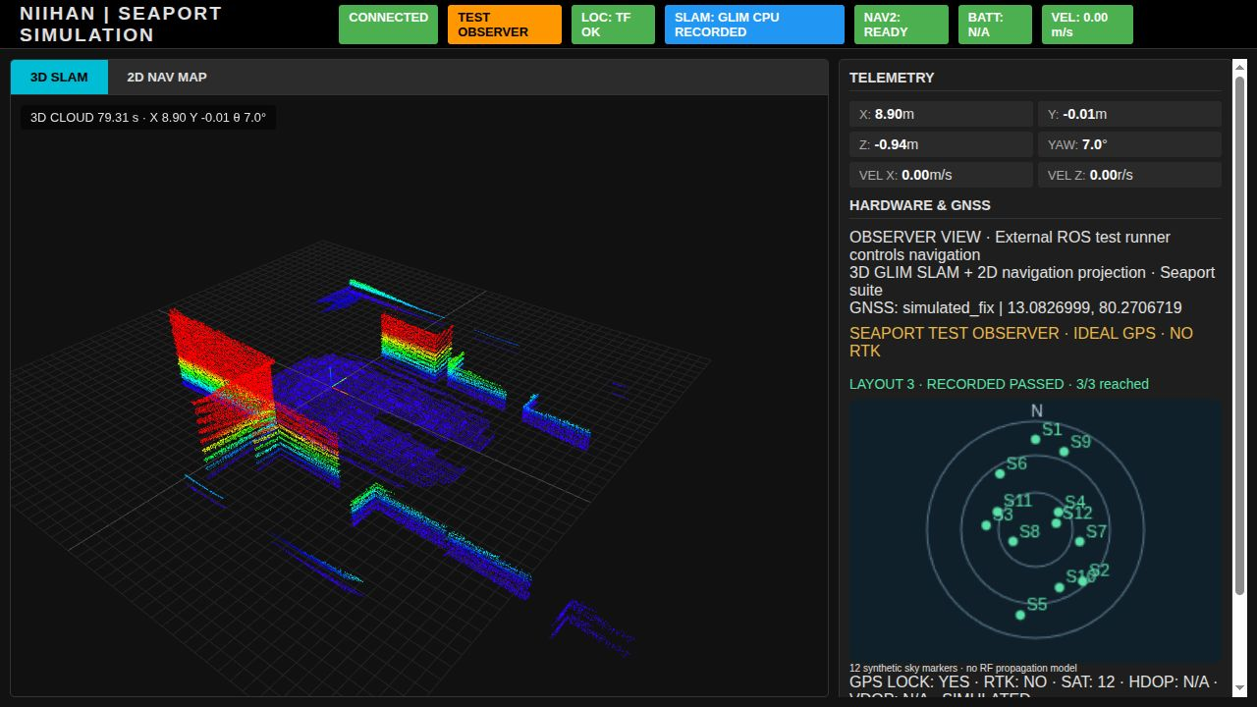
Saved GLIM 3D point cloud replay from layout 3
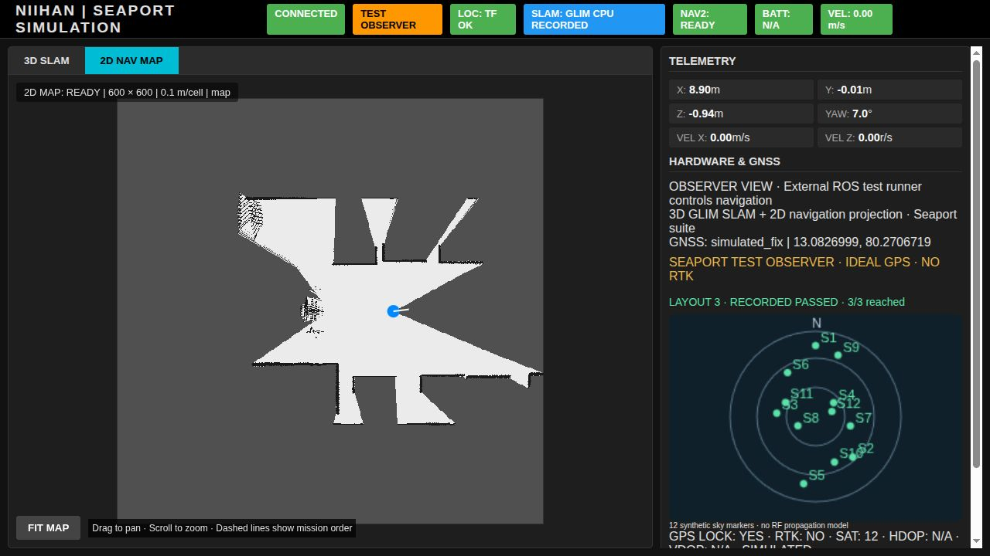
Figure 2 Measured GLIM 3D SLAM above, with the 2D navigation projection below. GPS coordinates, synthetic sky markers and recorded waypoint progress are displayed alongside each view.

Measured waypoint results
The final experiment uses identical straight eastbound waypoints in the free central lane of all seven worlds. All seven layouts completed the route. Saved non empty GLIM 3D maps were recorded in 7 of seven layouts.
Layout | Reached | Route | Arrival max cm | Saved 3D points | Wall time s
1 | 3/3 | PASS | 4.8 | 37227 | 73.0
2 | 3/3 | PASS | 4.9 | 36789 | 75.4
3 | 3/3 | PASS | 4.9 | 38256 | 78.1
4 | 3/3 | PASS | 4.7 | 37485 | 79.3
5 | 3/3 | PASS | 4.8 | 36750 | 82.1
6 | 3/3 | PASS | 4.8 | 35875 | 82.7
7 | 3/3 | PASS | 4.7 | 36271 | 81.9
Across the 21 endpoints that completed Nav2 and GPS approach, mean error decreased from 25.9 cm at Nav2 completion to 4.7 cm after GPS final approach, a 81.9% reduction. This is a paired before and after measurement of the combined procedure, not a controlled comparison against an equally strict Nav2 controller.
Arrival maximum is calculated only for verified arrivals. Aborted goals have no arrival measurement and remain failures in route and waypoint totals.
The maximum sampled departure from the straight lane centreline was 5.6 cm across the recorded trajectories. The desired centreline is world north coordinate zero.

Interpretation and limits
The final procedure passed 7 of seven cargo arrangements. GPS final approach reached the 10 cm criterion whenever Nav2 delivered the rover to the approach area. These observations apply to the tested straight clear corridor and do not establish robustness to arbitrary route or obstacle changes. It does not prove a universal environment independent navigation stack.
Each run builds a fresh GLIM map. One trial per layout and a fixed seed do not establish reliability with a frozen reference map, blocked lanes or moving cargo. GPS and IMU are simulated without realistic GPS noise or outages. Altitude and heading accuracy are not evaluated. Cliff detection is disabled; slope, drop off and 3D reconstruction accuracy are not benchmarked.
The smallest sampled geometric clearance to warehouse and cargo footprints was 5.83 m after subtracting a conservative 0.45 m rover radius. This sampled geometry check is not a complete contact sensor or continuous collision certification.

Development findings retained with the evidence
A preliminary route with a turn and return passed three of seven layouts; four return goals were marked occupied by Nav2. Those separate results are archived under prior_return_route and are not pooled with this straight-route experiment. The final route uses the revised clear straight lane protocol.
Further validation should repeat several seeds and test frozen map reuse, blocked lanes, moving cargo and GPS degradation before expanding the robustness claim.

Seaport layouts 1 and 2
Figure 3 Layout 1. Maximum cargo displacement 0.00 m east or west and 0.00 m north or south. Route passed; largest verified arrival error 4.8 cm.
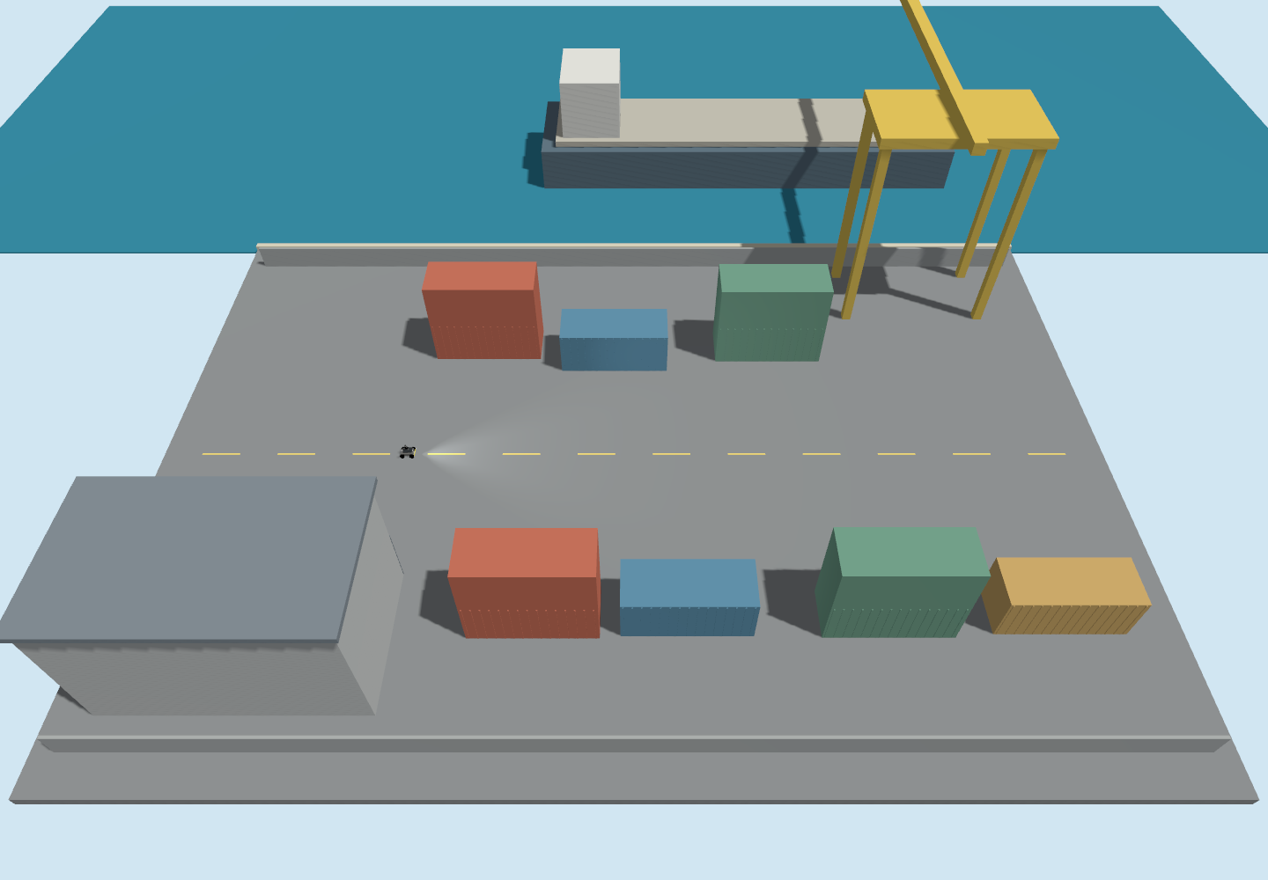
Figure 4 Layout 2. Maximum cargo displacement 0.79 m east or west and 0.56 m north or south. Route passed; largest verified arrival error 4.9 cm.

Seaport layouts 3 and 4
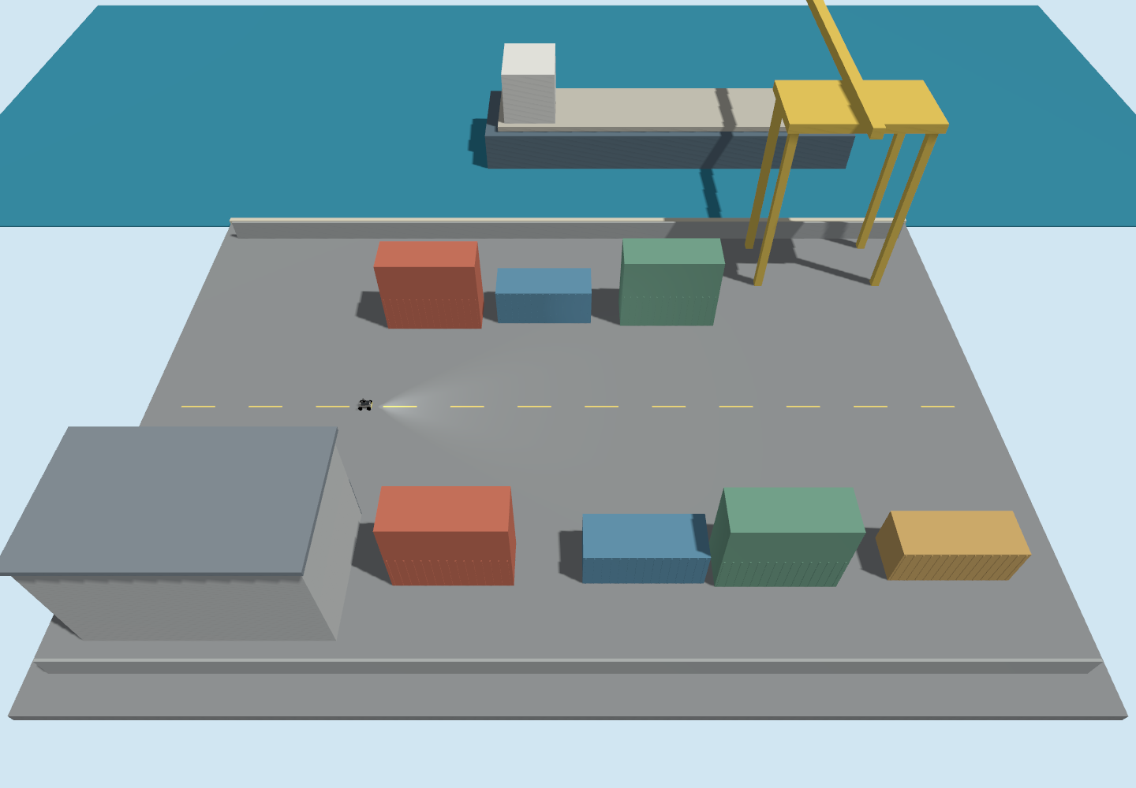
Figure 5 Layout 3. Maximum cargo displacement 0.76 m east or west and 0.48 m north or south. Route passed; largest verified arrival error 4.9 cm.
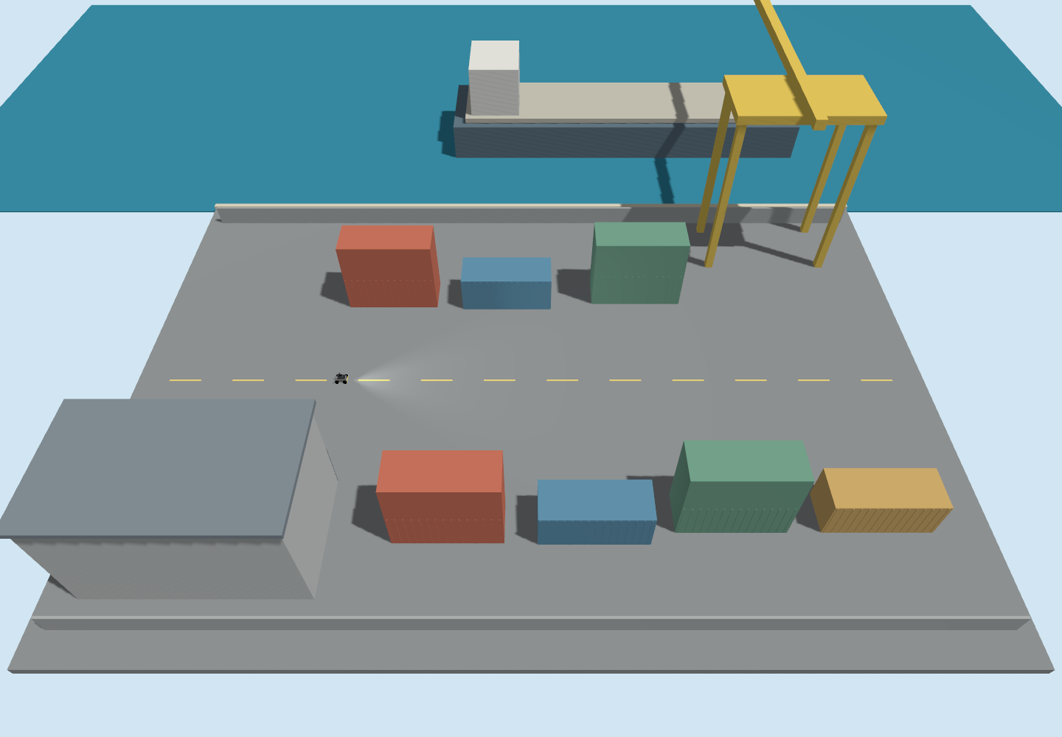
Figure 6 Layout 4. Maximum cargo displacement 0.66 m east or west and 0.48 m north or south. Route passed; largest verified arrival error 4.7 cm.

Seaport layouts 5 and 6
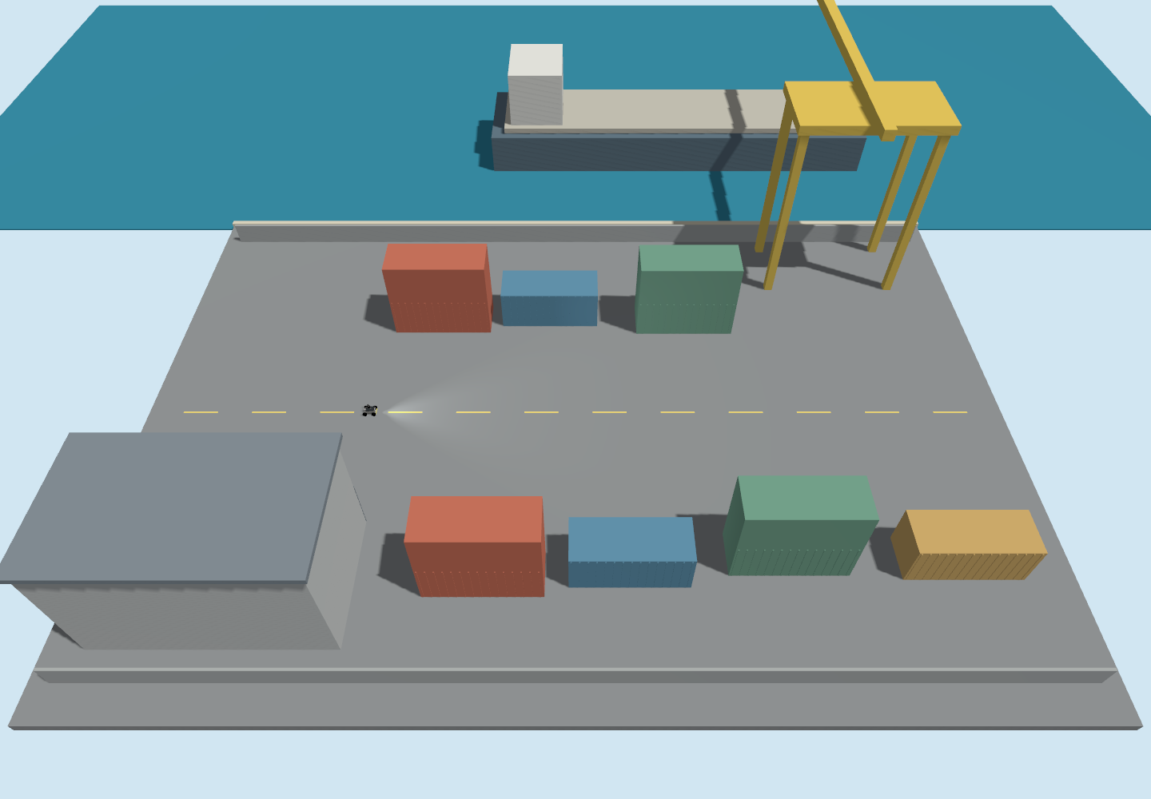
Figure 7 Layout 5. Maximum cargo displacement 0.63 m east or west and 0.59 m north or south. Route passed; largest verified arrival error 4.8 cm.
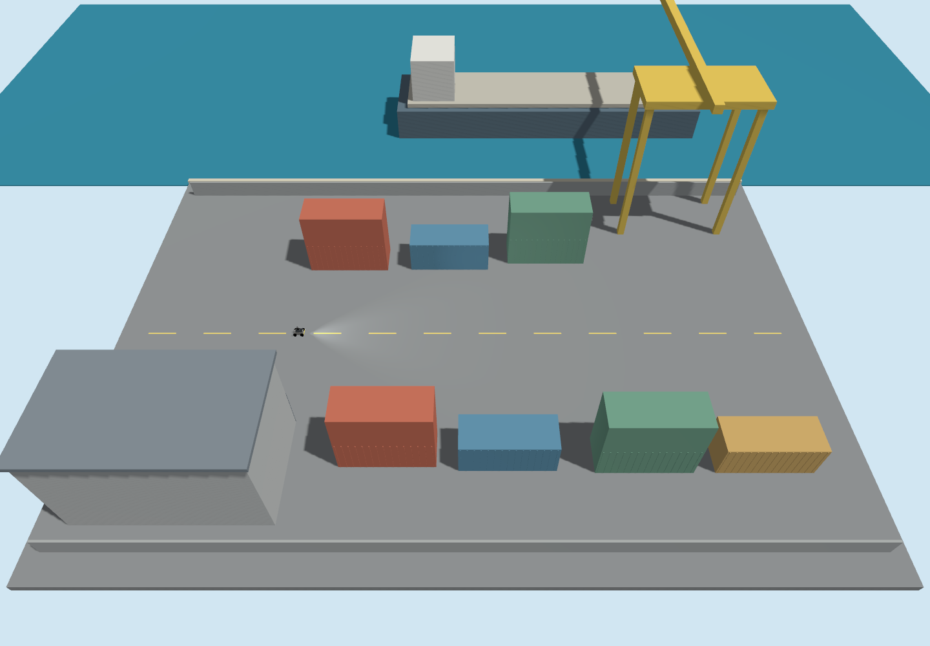
Figure 8 Layout 6. Maximum cargo displacement 0.60 m east or west and 0.49 m north or south. Route passed; largest verified arrival error 4.8 cm.

Seaport layout 7 and evidence record
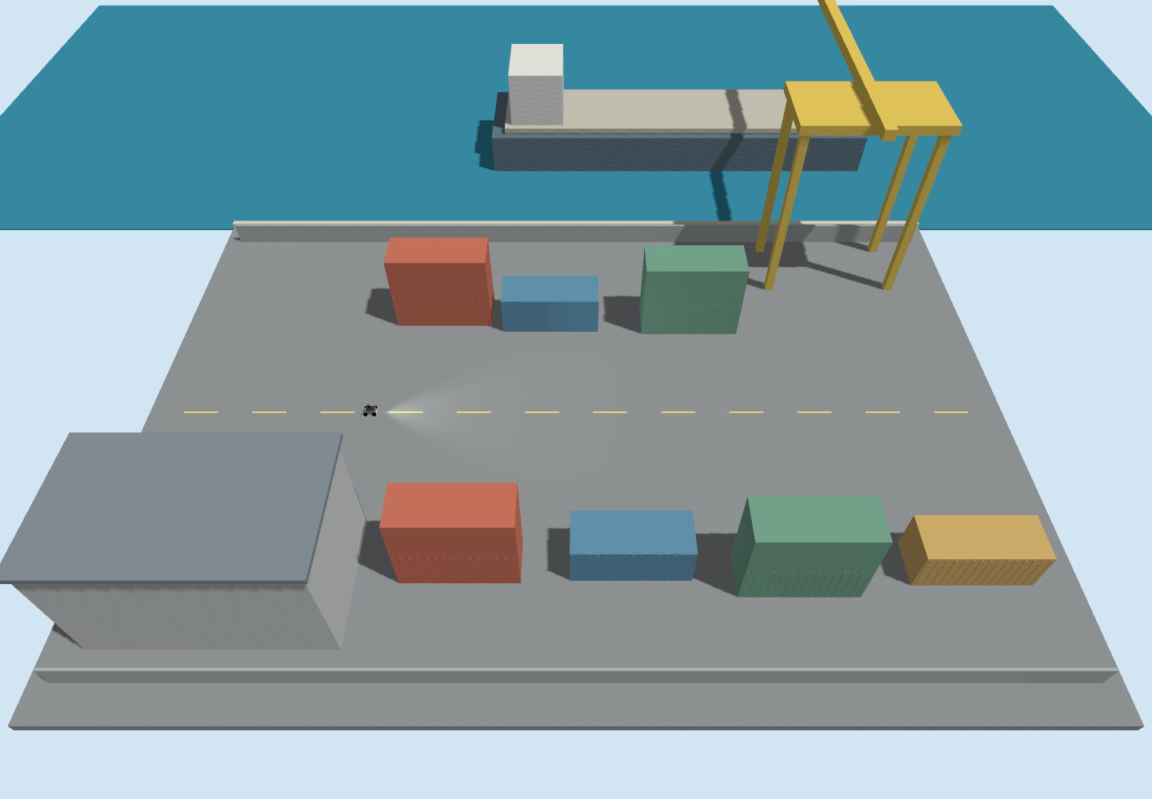
Figure 9 Layout 7. Fixed maritime structures are unchanged; cargo positions follow the recorded layout manifest.

Reproduction and traceability
The accompanying seaport package contains seven SDF worlds, the cargo layout manifest, the common test protocol, a result file and trajectory trace for each run, camera captures, dashboard telemetry, process logs and a CSV summary. Run the suite shell script after loading the NIIHAN ROS environment. The runner starts and stops each layout independently.
Evidence paths are relative to the accompanying seaport package. worlds contains the SDF inputs. results/world_01 through results/world_07 contain the final trials. results.csv and summary.json contain aggregate measurements. protocol.json records settings and source hashes. The scripts folder contains the exact controller, probe, dashboard observer and runner used for reproduction.
Workspace revision c2835df936637cbb47ee7b63df125e5eb4611a08. Existing local workspace changes were present; the recorded source hashes identify the tested configuration more precisely than the revision alone.
Controller checks cover arrival stopping, invalid inputs, obstacle clearance, output bounds and reverse approach. Four checks passed. Simulation images in this report are camera captures from the actual worlds; they are not generated illustrations.
Suggested wording for presenting the result
With the same rover and navigation procedure, 7 of seven seaport layouts completed the fixed supervision route within the 10 cm endpoint criterion. The layouts varied nearby cargo positions while preserving the straight patrol corridor. Ideal simulated GPS supported a bounded final approach. The result is limited to these layouts and the clear straight route; it does not establish general environmental independence. Real GPS performance requires further validation.

