**salary and performance management system – federated insurance**

System Design Specification Document

1. Introduction

**1.1 Purpose:**

The purpose of this system is to replace the current Salary and Performance Management System. The new system will be made organization wide and will be implemented for all users within the organization.

**1.2 Overview:**

The Salary and Performance Management System is an updated system for conducting salary and performance changes, updates, and reporting for Federated Insurance. Furthermore, the system will also be used to monitor, store, and track performance and salary for employees. The application will be web designed with a simplified GUI.

**1.3 Scope:**

The scope of the project will remain within the boundaries of projected and actual performance review calculations, projected and actual salary calculations, and finally communications. The salary changes may result from promotions, merit, or other scenarios. Features that are considered out of scope: Bonuses, PTO, 401k, insurance, and the payment process.

**1.4 Assumptions:**

We assume that the access to the data will be secure. We also will assume that a shared database will be pursued, and that the scope of the application will be significantly different than the current salary management system.

1. System Components

**2.1 User Interface:**

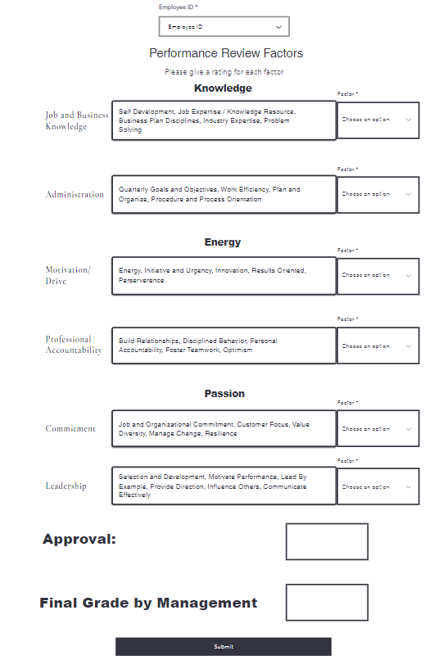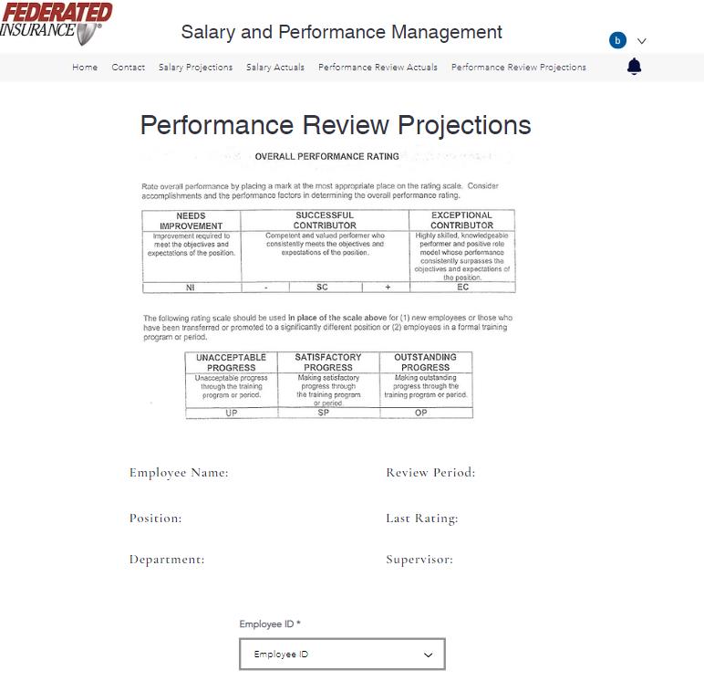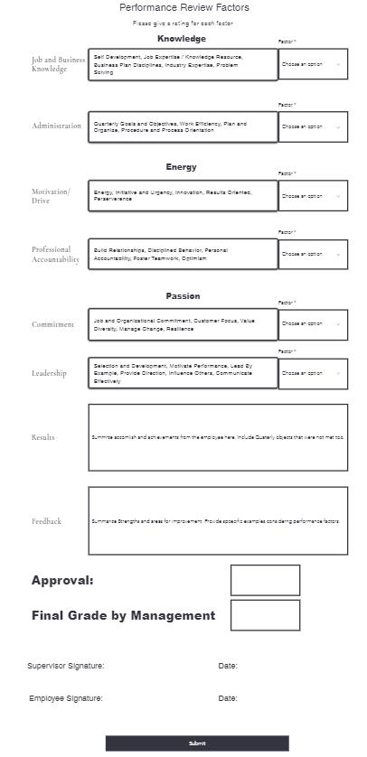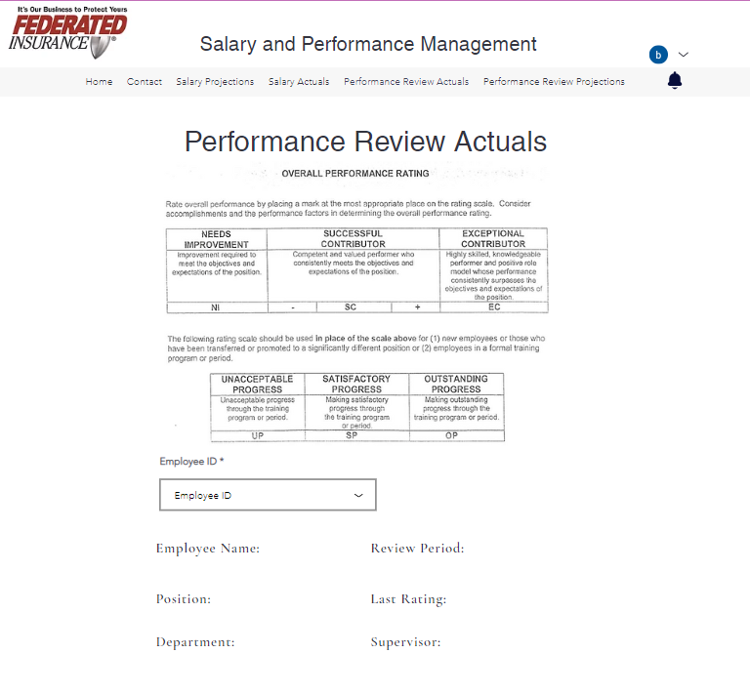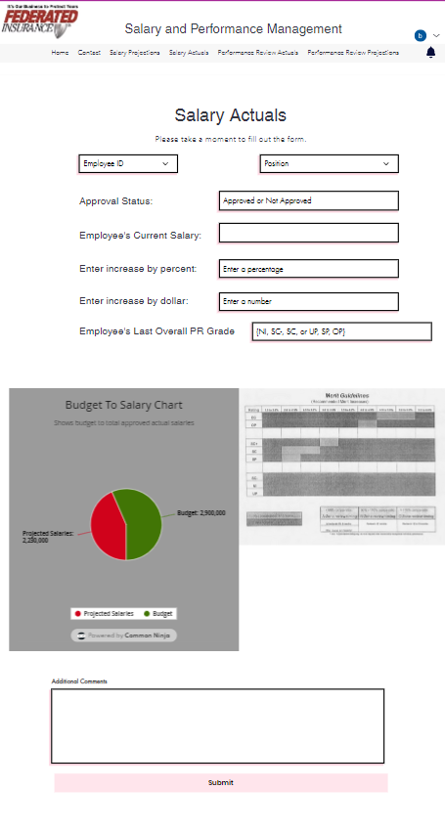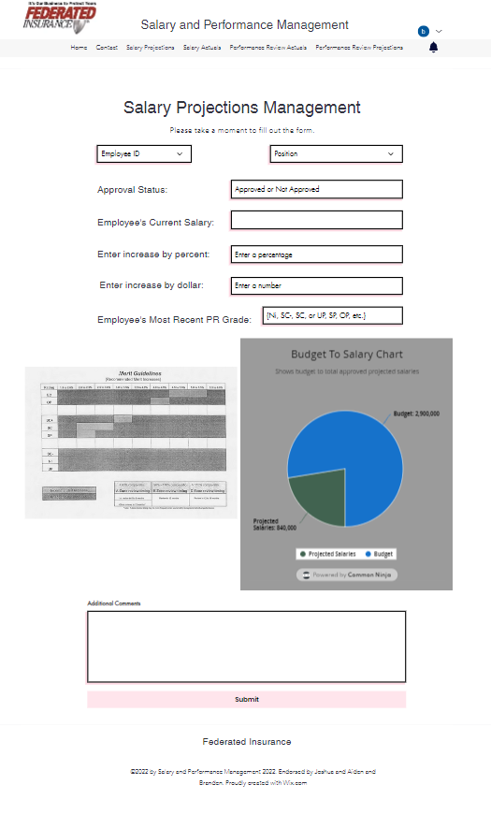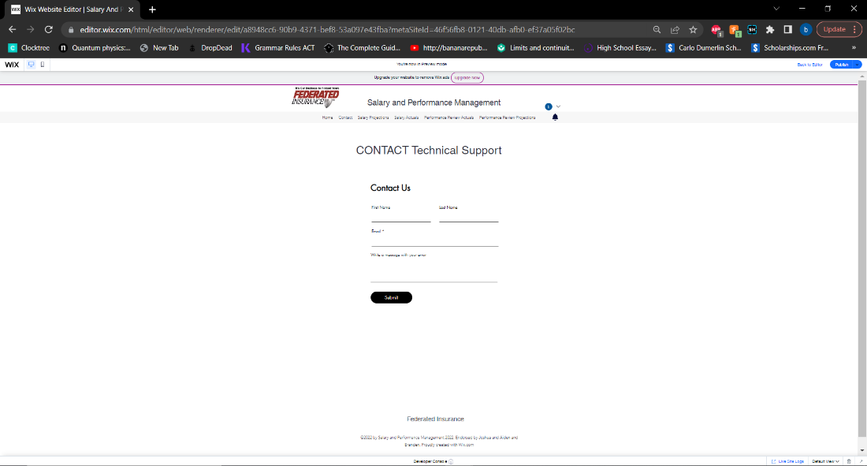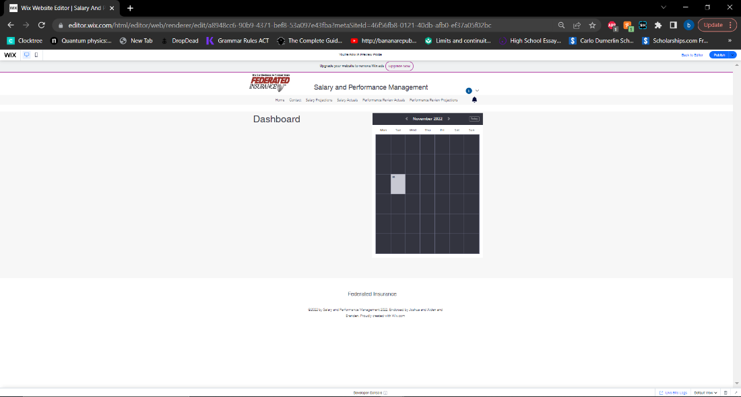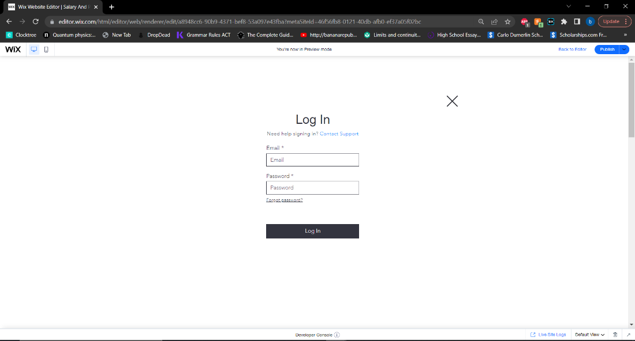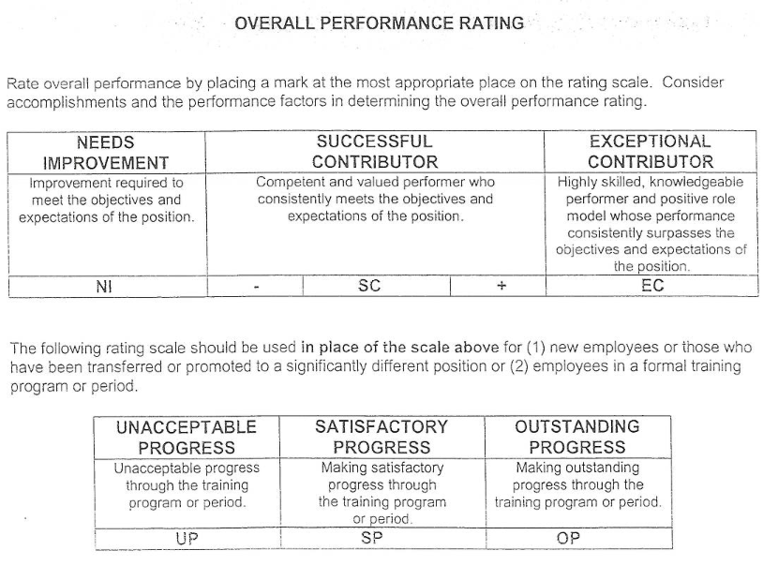

**2.2 Inputs and Outputs:**

Inputs for the system will include the budget, performance review grades, salary increases, employee information and IDs, requests, projected salary range info, actual salary range info, and merit guidelines. Outputs for this system will include the projected salary report, actual salary report, projected performance report, actual performance report, budget process notification, and salary range.

**2.3 Database, Integration, and Network Specifications**

The database must be connected to or be able to communicate with the HR database. It must also be able to securely transmit data to and from users. Integration must be possible with the database and the HR database. The network that this system runs upon must be able to handle at least 300 concurrent users at once.

**2.4 Application Detailed Design**

The logic of the salary and performance management system can be broken down into three main branches. The salary management aspect of the system will manage salary projections and actuals. It will then consider the merit guidelines in relation to both and output projected salary ranges and actual salary ranges. The performance management branch of the system will spread out into three main sections: Management of Performance Projections, Performance Feedback, and Management of Performance Actuals. Performance projections will split further into performance factors and the resulting projected performance rating. Performance feedback will illustrate both areas for improvement and strengths. Performance actuals will, similarly to projections, split into performance factors and the resulting actual performance rating. The third and final segment of the system, Reporting, will split into three pieces. The first piece, Reporting the actuals to user, continues further into requesting an acknowledgement from said user. The next piece, report team projections to supervisor, continues into reporting team actuals to supervisor and then further into requesting an acknowledgement from said supervisor. The third and final piece of reporting, reporting salary overages, continues into requesting executive approval.

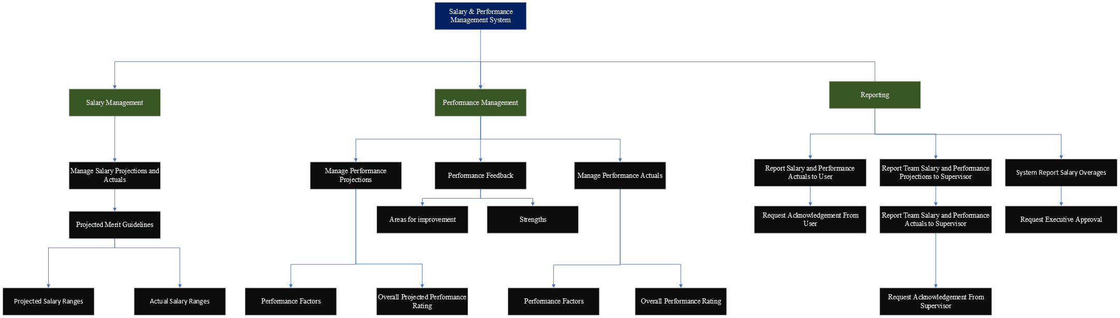

3.0 System Environment

**3.1 Hardware:**

The purpose of this system is to replace the current Salary and Performance Management System. The new system will be made organization wide and will be implemented for all users within the organization. The hardware requirements will include materials needed to implement a company wide network with a DMZ to ensure security. Components needed in the creation of servers will also be needed.

**3.2 Communication detailed design**

There is a server found under a DMZ that provides coverage to public ip addresses (but not private addresses). Additionally, the main server resides in the private domains behind the firewall. This server is only accessible to private ip addresses within the firewall. The packets of data are sent through TCP, UDP, and ICMP requests (each with their own type of data grouping). The Local Area Network design is secured with screened subnet architecture and relies on a DMZ to protect the internal servers.

**3.3 Support Processing (Back up and Recover, Start-up processing, etc)**

The data will communicate with the HR database through middleware. All input and output data will be sent through the middleware. On start-up, the client system is connected to the Performance and Salary Management server. The system sends a request to the database for employee information and notifications are received from other users on the server. Files are encrypted as hashes within the database and the necessary security controls are implemented. Employees can only read their assigned actuals and only supervisors may overwrite information.

**3.4 Update Frequency for the Database**

The update frequency of most files, tables, views, areas, and records within the database will likely fall within a yearly update schedule. The exceptions to this being operations that don’t occur on a yearly basis such as the O salary increase which is more dependent on the current market environment. Performance and salary information for employees will be stored for a maximum of five years and then it will be purged from the system. Within the table found below one can see that a single full iteration of this system’s process includes at least 15 transactions.

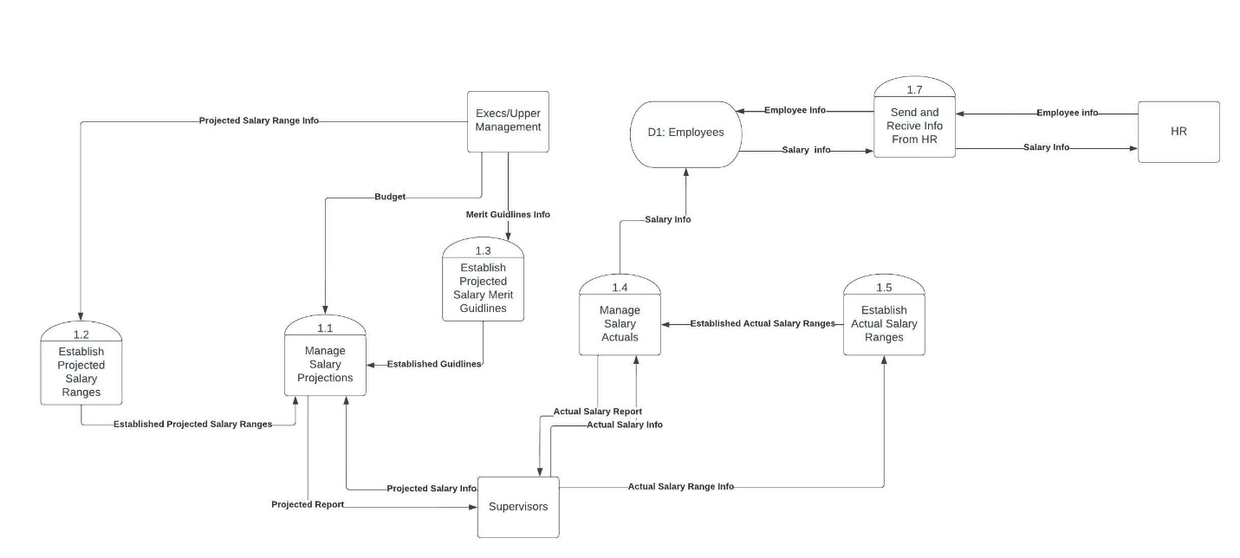

**3.5 Communication Detailed Design**

The system must communicate securely and efficiently. Below we have a network topology that this network will use to both efficiently and securely communicate.

