Geostatistical Visualization of Mineral Distribution Using Variogram Modeling and Kriging

Abstract
This study presents a geostatistical approach to modeling and visualizing spatial distribution of mineral concentrations using variogram analysis and Ordinary Kriging. A spatial dataset representing mineral concentration was analyzed to quantify spatial dependence through an experimental variogram. A spherical variogram model was fitted and subsequently used to interpolate values across a continuous domain. The resulting prediction and uncertainty maps demonstrate the effectiveness of geostatistical methods in estimating mineral distribution and identifying zones of high variability. The workflow highlights the applicability of these techniques for mineral exploration and resource estimation.

- Introduction
Understanding the spatial distribution of minerals is a fundamental problem in geology and mineral exploration. Since sampling is inherently limited and unevenly distributed, interpolation techniques are required to estimate values at unsampled locations.
Traditional interpolation methods fail to account for spatial correlation. In contrast, geostatistical methods explicitly model spatial dependence, enabling more accurate predictions.
This study applies:
- variogram analysis
- spherical model fitting
- ordinary kriging
to simulate and visualize mineral distribution in a two-dimensional domain.

2. Theoretical Background

2.1 Spatial Dependence
Geological variables exhibit spatial autocorrelation: nearby observations tend to have similar values. This property forms the basis of geostatistics.

2.2 Variogram
The spatial dependence is quantified using the variogram:
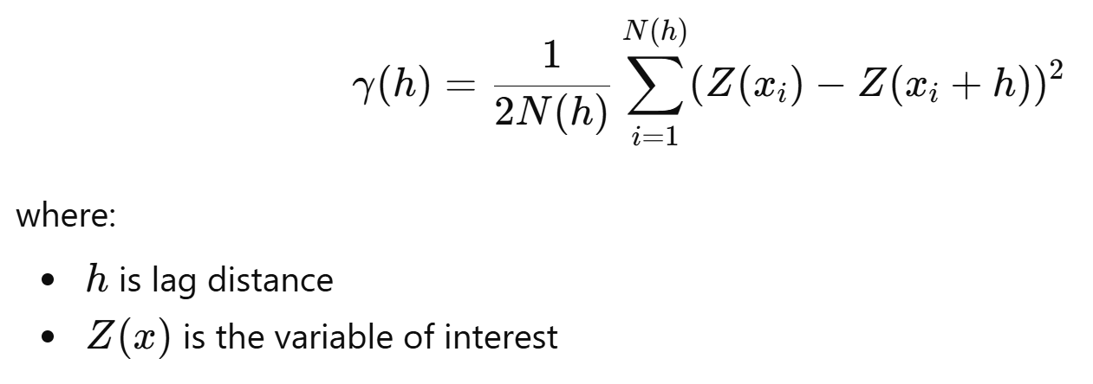
Key parameters:
Nugget: micro-scale variation or measurement error
Sill: total variance
Range: distance of spatial correlation

2.3 Variogram Model
A spherical model is used:
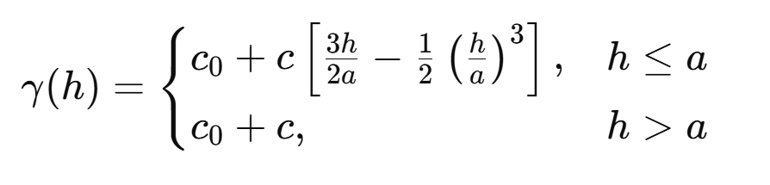

2.4 Kriging
Ordinary Kriging estimates unknown values as:
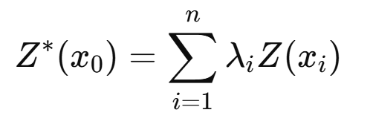
where weights λi are derived from the variogram model.

3. Methodology

3.1 Data Generation
A synthetic dataset was generated to simulate mineral concentration:
- 50 spatial points
- coordinates: (x,y)∈[0,100]
- concentration defined as:
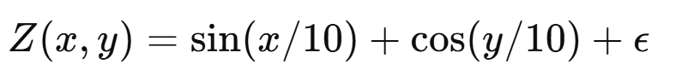
where ϵ is Gaussian noise.

3.2 Experimental Variogram
Pairwise distances and semivariances were computed. Values were grouped into distance bins to produce the experimental variogram.

3.3 Model Fitting
A spherical variogram model was fitted manually by adjusting:
- nugget
- sill
- range
to match the empirical data.

3.4 Kriging Interpolation
Ordinary Kriging was applied on a 2D grid using the fitted variogram model. Two outputs were generated:
- predicted mineral concentration
- estimation variance

4. Results

4.1 Variogram Analysis
The experimental variogram exhibited:
- low semivariance at short distances
- increasing trend with distance
- clear sill indicating spatial independence beyond a threshold
This confirms the presence of spatial structure.

4.2 Prediction Map
The Kriging interpolation produced a smooth spatial distribution map. High and low concentration zones correspond to underlying simulated geological patterns.

4.3 Uncertainty Map
The Kriging variance map showed:
- low uncertainty near sampled points
- high uncertainty in sparsely sampled regions
This demonstrates the reliability limits of interpolation.

5. Discussion
The results highlight the importance of spatial modeling in geological analysis. The variogram effectively captures spatial continuity, while Kriging provides both prediction and uncertainty estimation.
The synthetic dataset mimics real geological behavior by combining structured variation and random noise. The approach can be directly applied to real-world datasets such as:
- drill hole assays
- geochemical surveys
- environmental contamination studies

6. Conclusion
This study demonstrates a complete geostatistical workflow:
- spatial data analysis
- variogram modeling
- Kriging interpolation
The approach provides both predictive capability and uncertainty quantification, making it highly suitable for mineral exploration and resource evaluation.
Future work may include:
- 3D modeling
- anisotropy analysis
- multi-variable geostatistics

7. Keywords
Geostatistics, Variogram, Kriging, Mineral Distribution, Spatial Analysis, Geological Modeling.

