SE322 - Software Architecture

Project - Phase 2

2021-22 Spring

Puffy-Cookies

04.05.22

// Table of Contents //

Catalog

1. The Health Monitoring System 4

2. Github Repo 7

# The Health Monitoring System

## The system in a nutshell

TAEL, is a health monitoring system that uses various devices to gather information about the patients current state and different action accordingly.

Patient uses a simple wristband which has various sensors within, for example, blood pressure sensor, respiration sensor and accelerometer, that measures various data about the patient such as heart heart and tension from blood pressure sensor and respiration sensor respectively.

Overall system also has the capability of deciding patient current state, such as if the patient needs emergency medical attention or are all the sensor working as they intended. Additionally, system has build in features that will alarm the patients relatives and medical staff in a state of emergency.

TAEL also able to store information about patient, patients relatives and doctor(s) of the patient, locally and in the cloud just in case of an emergency or routine check ups.

## Views

### Module View

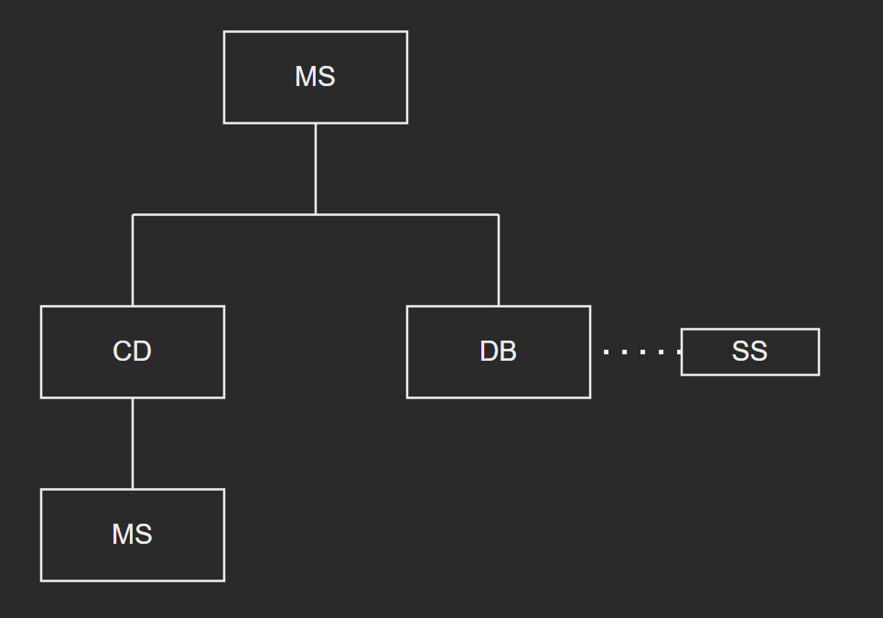

*Provide a module decomposition diagram or a class diagram for the whole system.*

### C&C View

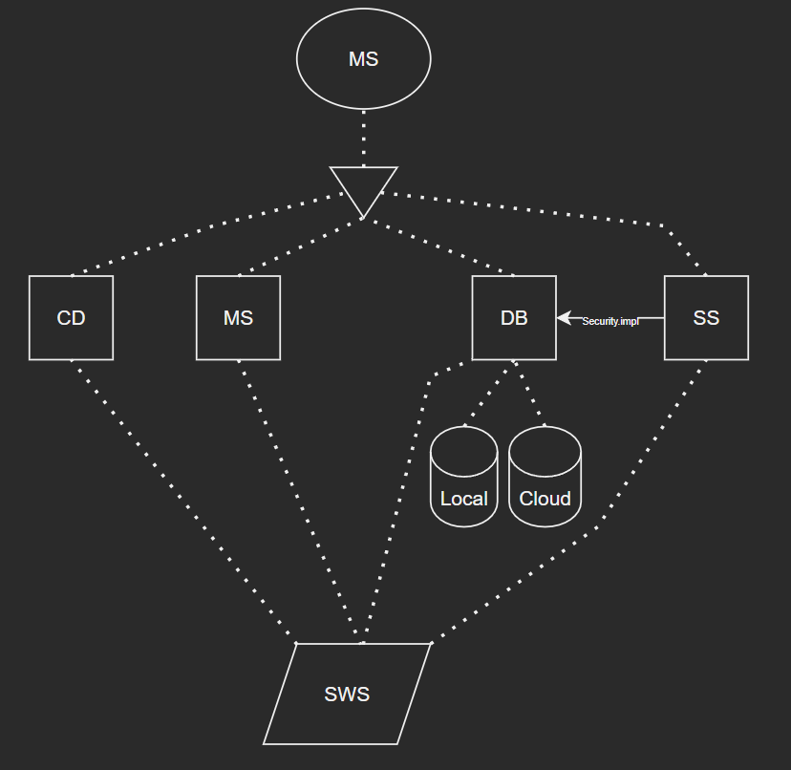

*Provide a set of sequence diagrams or activity diagrams to represent how the system works.*

### Allocation View

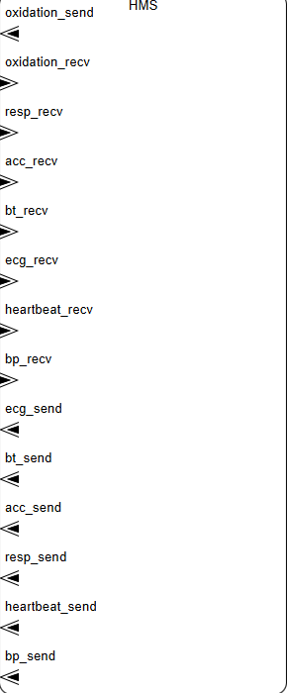

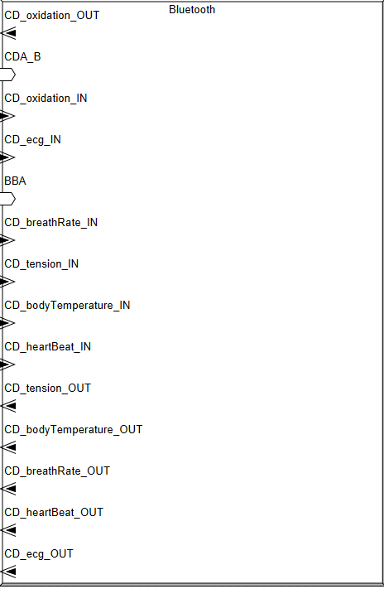

*(Even though I formed the connections between elements ostate does not show them on graph)*

*Provide a deployment diagram for the whole system.*

## Architectural Diagrams by OSATE

*Provide necessary architectural diagrams created automatically by OSATE tool including components (systems, processes, threads, etc) for the system.*

# Github Repo

*Provide your github repo link*