LAB – 1 REPORT

Section 1 – Blink
Code for Blink:
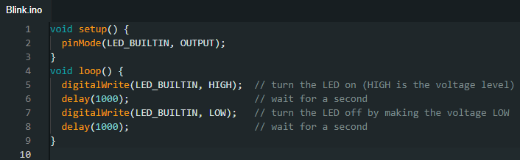

Built in led on and off. Also included a video of it in the folder.
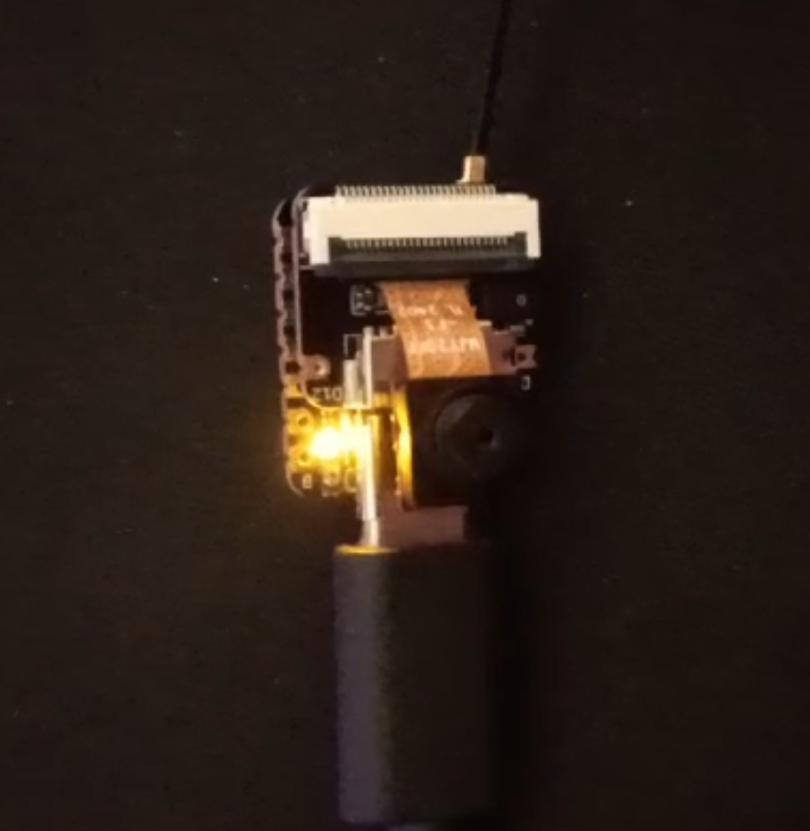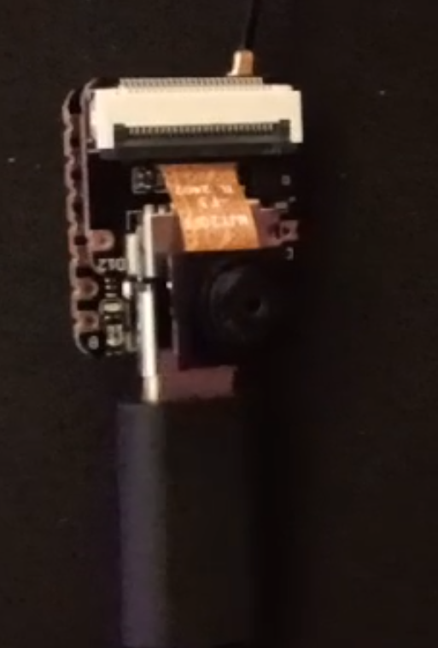

Section 2 – Signal Reading
Base signal that we are trying to achieve:
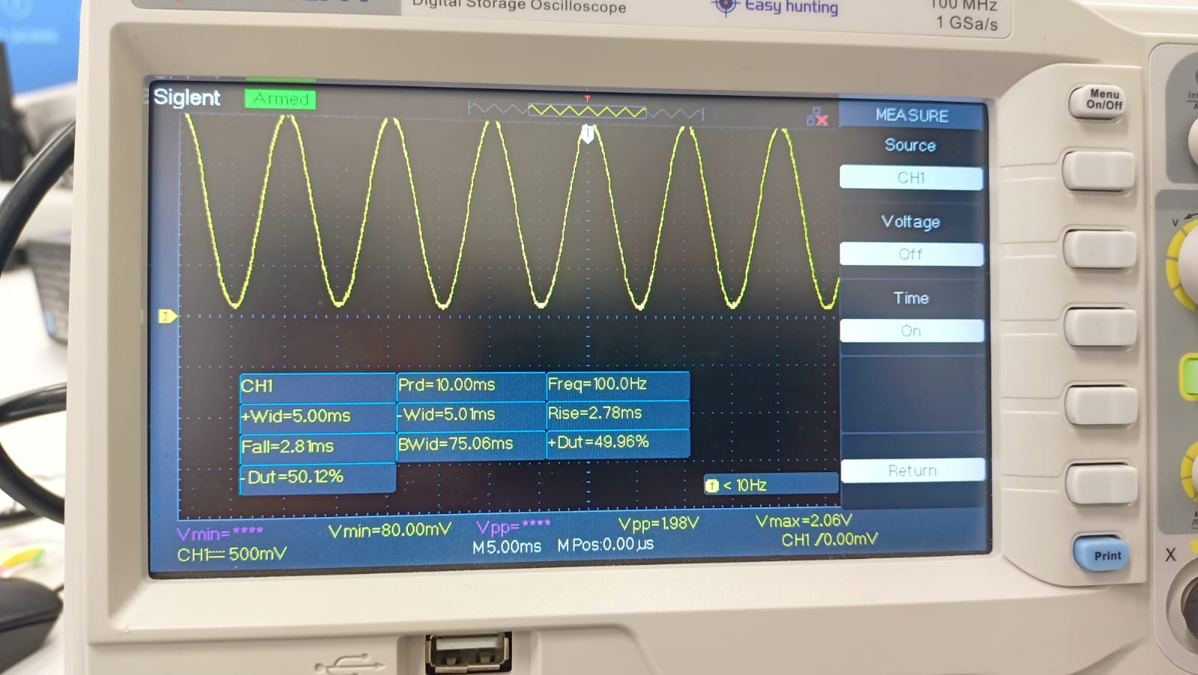
Code for visualizing the signal with ESP32
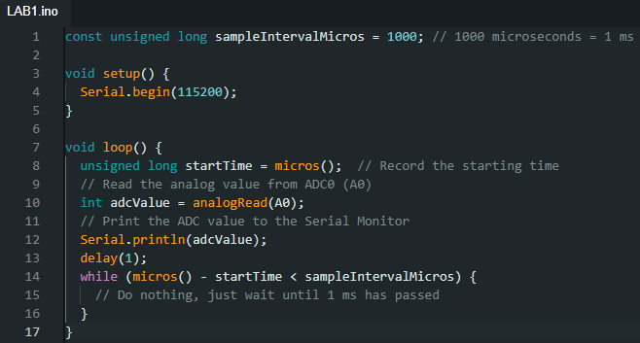

Section 3 – Digital Microphone
Code for the task:
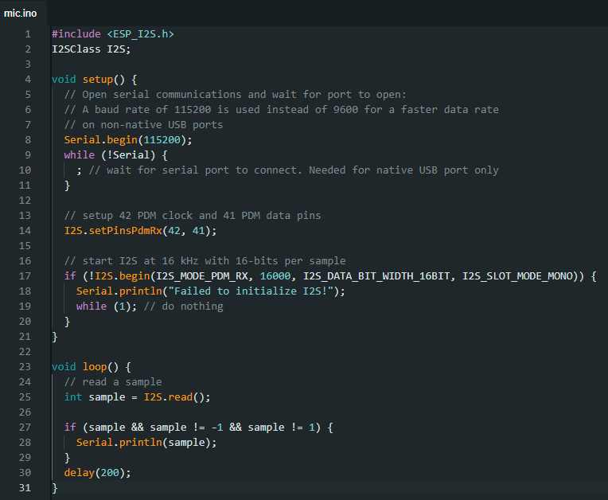
Information about the library used:
Library used: ESP_I2S
It enables communication on ESP32 for audio data processing.
Key Functions used:
- I2S.setPinsPdmRx(42, 41): Configure PDM mic pins (Clock: 42, Data 41)
- I2S.begin(I2S_MODE_PDM_RX, 16000, I2S_DATA_BIT_WIDTH_16BIT, I2S_SLOT_MODE_MONO: Initializes I2S in PDM mode, 16kHz, 16-bit mono.
- I2S.read(): Reads microphone samples.
Functionality:
Code initializes I2S for a PDM microphone, captures 16kHz audio samples, and prints them via serial monitor.
Sample values from the terminal:
00:36:14.830 -> 1326
00:36:15.006 -> 1324
00:36:15.233 -> 1311
00:36:15.406 -> 1321
00:36:15.635 -> 1331
00:36:15.806 -> 1339
00:36:16.022 -> 1332
00:36:16.206 -> 1322
00:36:16.407 -> 1283
00:36:16.626 -> 1388
00:36:16.806 -> 1308
00:36:17.029 -> 1367
00:36:17.206 -> 1300
00:36:17.434 -> 1335
00:36:17.606 -> 1386
00:36:17.836 -> 1269
00:36:18.006 -> 1272
00:36:18.226 -> 1380
00:36:18.427 -> 1349

Values vs Time graph:
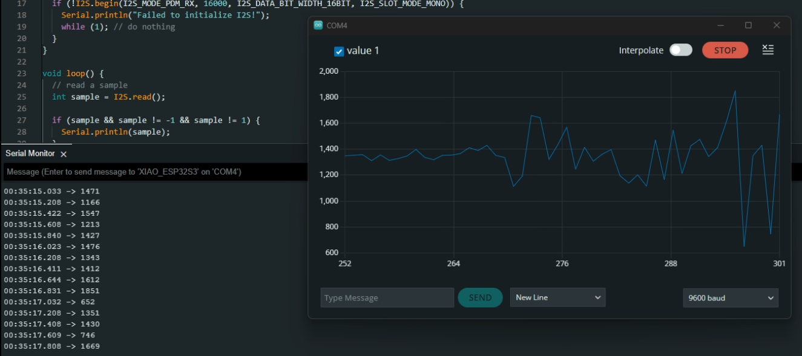

I have also included a screen recording of the experiment in the folder.

Section 4 – Camera (Bonus)
I had to connect to webserver from my phone because of firewall issues. Also included an image downloaded from the camera.
