Homework – 1 Report

Task Explanation:
- CodeBase: The program instructions are stored in main memory starting at address 350.
- DataBase: The operands (data values) are stored in main memory beginning at address 725.
- Operands:
  - Operand 7: Located at DataBase + 50, which is memory address 775.
  - Operand 14: Located in the I/O memory address 30 (separated from the main memory).
- Objective:
  - Retrieve Operand 14 from the I/O device and load it into the Accumulator (AC)
  - Retrieve Operand 7 from main memory at address 775.
  - Subtract Operand 7 from the value in the AC (14 - 7).
  - Store the result into main memory at DataBase address 785.

Sudo Assembly Code:
; Code starts at CodeBase address 350
ORG 350 ; Set the starting address to 350
START: IN 30 ; Instruction 3030:
; "3" indicates an Input operation.
; Reads from I/O device 30 (which holds operand 14)
; and loads it into the accumulator (AC).
SUB 775 ; Instruction 6775:
; "6" indicates a Subtract operation.
; Subtracts the value stored at memory address 775 (operand 7)
; from the accumulator.
; AC = 14 - 7 = 7
STO 785 ; Instruction 2785:
; "2" indicates a Store operation.
; Stores the value in the accumulator into memory address 785,
; which is the target storage location.
HLT ; Halt execution.

Diagram for the operation:
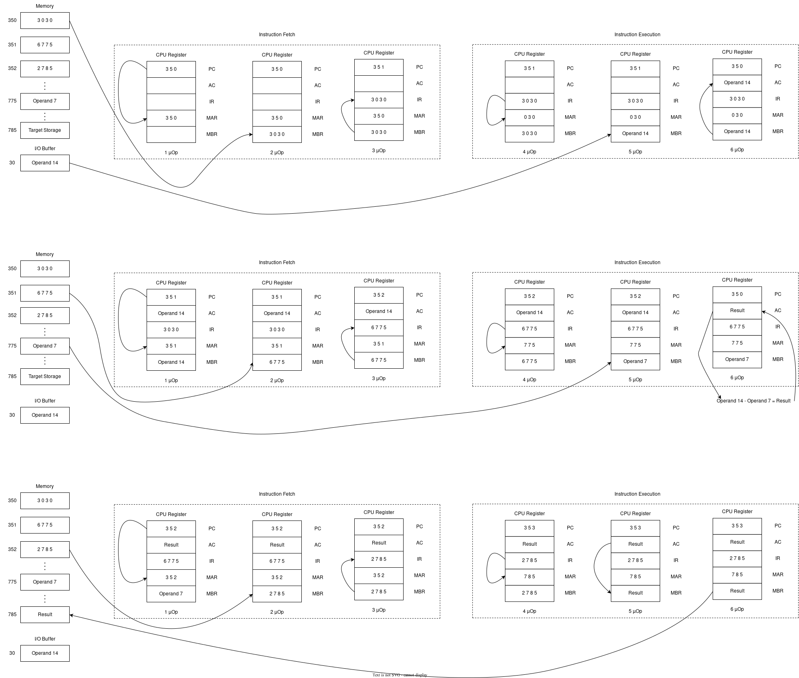
Diagram workflow explanation:

Instruction 1:
1st Micro operation: PC holds the starting address 350, which is loaded into the Memory Address Register (MAR).
2nd Micro operation: The instruction from memory location 350 is fetched and loaded into the Memory Buffer Register (MBR).
3rd Micro Operation: The instruction in the MBR is transferred to the Instruction Register (IR) and the PC is incremented by 1.
4th Micro Operation: The instruction in the IR is decoded. The opcode (hexadecimal 3) indicates that the operand is located at I/O buffer address 030, so 030 is loaded into the MAR.
5thMicro Operation: The operand (14) is retrieved from the I/O buffer (or memory location 030) into the MBR.
6thMicro Operation: The operand (14) in the MBR is loaded into the Accumulator (AC).

Instruction 2:
1st Micro operation: PC points to memory location 351. The content at this location is read and loaded into the MBR.
2nd Micro operation: The instruction 6775 from memory location 351 is fetched into the MBR.
3rd Micro Operation: The instruction in the MBR is transferred to the IR, and the PC is incremented by 1.
4th Micro Operation: The instruction in the IR is decoded. The opcode (hexadecimal 6) indicates a subtraction operation. The operand address 775 is loaded into MAR.
5thMicro Operation: The operand (7) is fetched from memory location 775 into the MBR.
6thMicro Operation: The Accumulator (AC), currently holding 14, subtracts the operand 7 from the MBR. The result is then stored back in the AC.

Instruction 3:
1st Micro operation: PC points to memory location 352. The content at this location is read and loaded into the MBR.
2nd Micro operation: The instruction 2785 from memory location 352 is fetched into the MBR.
3rd Micro Operation: The instruction in the MBR is transferred to the IR, and the PC is incremented by 1.
4th Micro Operation: The instruction in the IR is decoded. The opcode (hexadecimal 2) indicates a store operation, so the operand address 785 is loaded into the MAR.
5thMicro Operation: The result currently stored in the AC is moved to the MBR in preparation for writing.
6thMicro Operation: Finally, the data in the MBR is written to memory location 785.

