LAB – 1 REPORT

Section 1 – Blink
Objective:
Turn the built-in LED on and off at 1-second intervals.
Source Code:
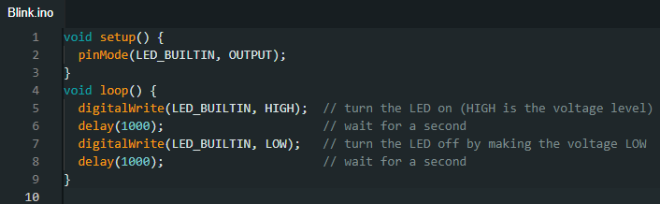
Used Functions:
- pinMode(pin, mode)
  - Library: Arduino core (part of the ESP32 Arduino framework)
  - Purpose: Sets the specified pin to behave as an input or output.
  - Used for: Configuring the built-in LED pin as an output.
- digitalWrite(pin, value)
  - Library: Arduino core
  - Purpose: Sets the digital pin to either HIGH or LOW.
  - Used for: Turning the LED on and off.
- delay(ms)
  - Library: Arduino core
  - Purpose: Pauses the program for the specified number of milliseconds.
  - Used for: Keeping the LED on or off for 1 second intervals.
Functionality:
This code blinks the onboard LED at a 1 Hz frequency.
Additional Evidence:
- A video showing the LED blinking is included in the report folder.
- Screenshot showing LED in ON and OFF states:
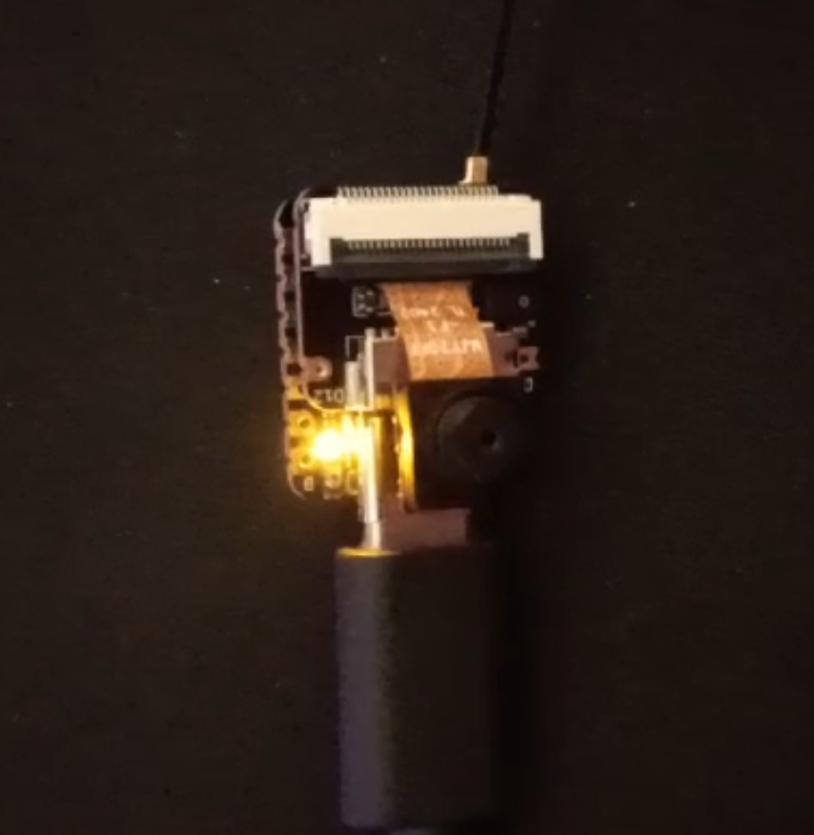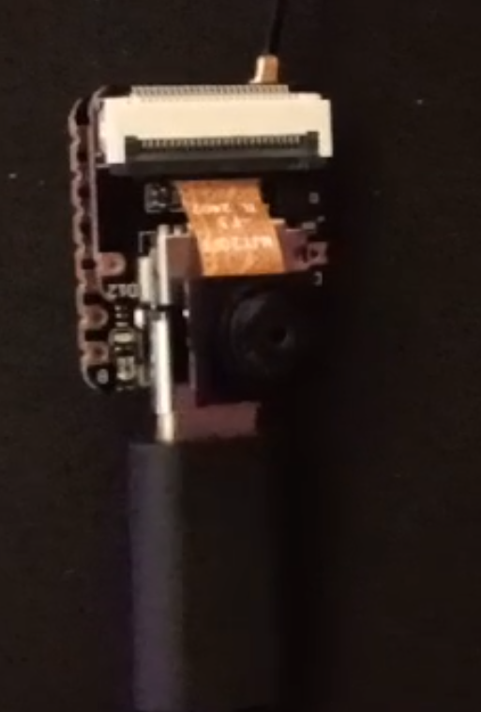

Section 2 – Signal Reading
Objective:
Read analog signal using ESP32 and visualize it over time.
Base Signal Reference:
Oscilloscope image of the reference signal:
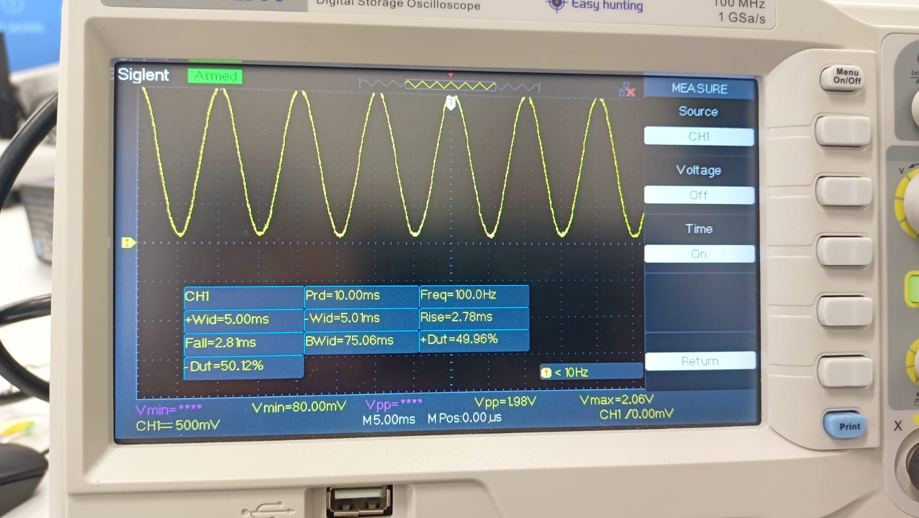
Source Code:
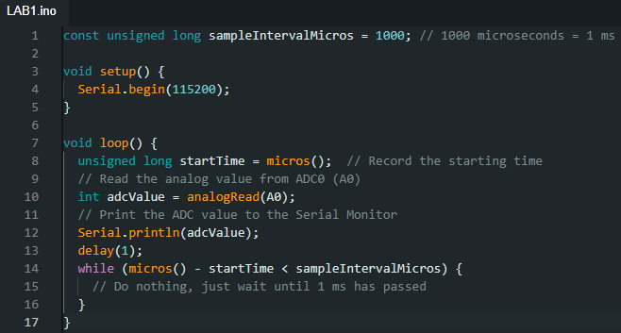
Used Functions:
- Serial.begin(baudRate)
  - Library: Arduino core (Serial communication)
  - Purpose: Initializes serial communication at the specified baud rate.
  - Used for: Starting serial communication to send data to the computer.
- analogRead(pin)
  - Library: Arduino core
  - Purpose: Reads the value from the specified analog pin (returns a value between 0 and 4095 on ESP32 by default).
  - Used for: Reading the analog voltage signal from pin A0.
- Serial.println(value)
  - Library: Arduino core (Serial communication)
  - Purpose: Prints the value to the Serial Monitor, followed by a new line.
  - Used for: Sending sampled analog values to the computer for visualization.
- micros()
  - Library: Arduino core
  - Purpose: Returns the number of microseconds since the program started running.
  - Used for: Implementing precise timing between samples (sampling interval control).
Functionality:
Reads analog values from pin A0 every 1 ms and prints to serial for plotting and analysis.
Values vs Time Graph:
- Screenshot of Serial Plotter showing waveform:
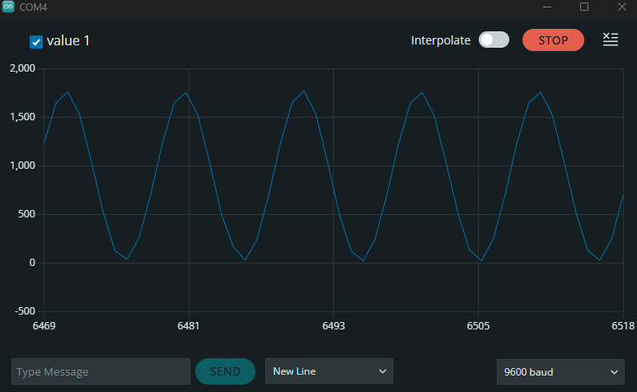

Section 3 – Digital Microphone
Objective:
Capture audio from an onboard PDM microphone using I2S and print sample values.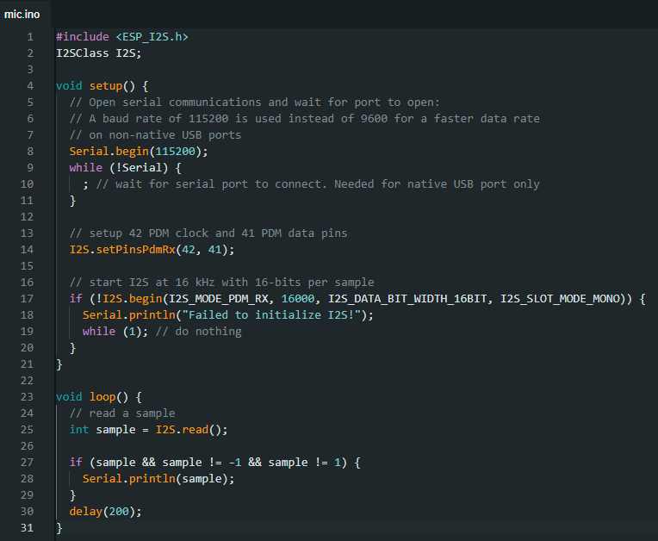
Used Library:
- ESP_I2S.h
  - Purpose: Provides an easy interface for using the I2S peripheral on ESP32 to handle digital audio data.
  - Installed via: Arduino Library Manager or included with the ESP32 board package.
Key Classes and Functions:
- I2SClass I2S
  - From: ESP_I2S library
  - Purpose: Creates an instance of the I2S interface to communicate with I2S devices (e.g., digital microphones).
- I2S.setPinsPdmRx(clockPin, dataPin)
  - From: ESP_I2S library
  - Purpose: Configures the I2S input pins for receiving PDM (Pulse Density Modulation) audio from a digital microphone.
  - Used for: Assigning GPIO 42 (clock) and 41 (data) for microphone input.
- I2S.begin(I2S_MODE_PDM_RX, 16000, I2S_DATA_BIT_WIDTH_16BIT, I2S_SLOT_MODE_MONO)
  - From: ESP_I2S library
  - Purpose: Initializes the I2S interface in PDM receive mode with a 16 kHz sampling rate, 16-bit resolution, and mono audio format.
  - Used for: Setting up the I2S interface to match the digital microphone's output format.
- I2S.read()
  - From: ESP_I2S library
  - Purpose: Reads a single audio sample from the I2S interface.
  - Used for: Capturing real-time audio data from the digital microphone.

Sample Values:
00:36:14.830 -> 1326
00:36:15.006 -> 1324
00:36:15.233 -> 1311
00:36:15.406 -> 1321
00:36:15.635 -> 1331
00:36:15.806 -> 1339
00:36:16.022 -> 1332
00:36:16.206 -> 1322
00:36:16.407 -> 1283
00:36:16.626 -> 1388
00:36:16.806 -> 1308
00:36:17.029 -> 1367
00:36:17.206 -> 1300
00:36:17.434 -> 1335
00:36:17.606 -> 1386
00:36:17.836 -> 1269
Serial Graph Screenshot:
- Screenshot of live graph showing audio signal over time:
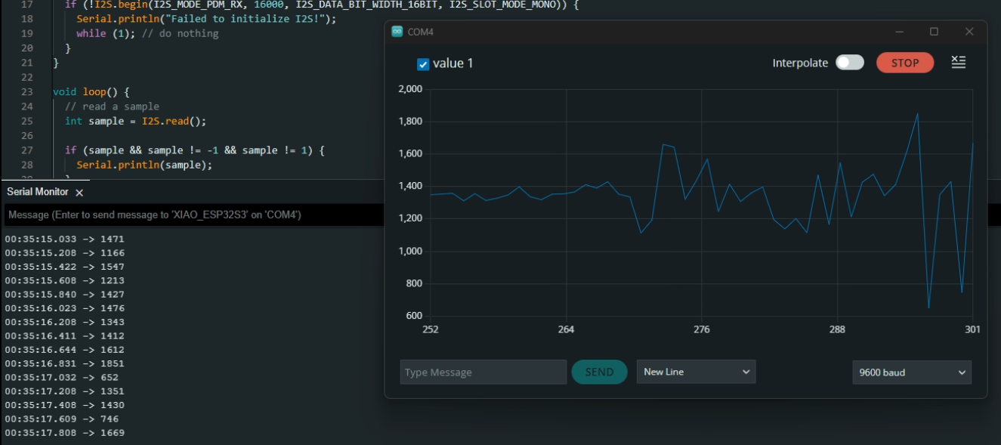
I have also included a screen recording of the experiment in the folder.

Section 4 – Camera (Bonus)
Library and Code Source:
The code used for the ESP32 camera module was taken from the example sketches provided in the ESP32 Camera library within the Arduino IDE. This example sets up a web server that streams video from the camera and allows snapshots via a browser interface.
- Library used: ESP32 board package (includes camera examples)
- Example used: File > Examples > ESP32 > Camera > CameraWebServer
- Functionality: Initializes the onboard camera, connects to Wi-Fi, and hosts a local web server that streams live camera feed.
Note:
Due to firewall issues on the computer, the web server was accessed from a phone connected to the same network. A screenshot of the camera interface and a captured image are included in the report.
