ESP32-CAM Image Acquisition and Object Detection System

INTRODUCTION
This project integrates an ESP32-CAM microcontroller with a Python-based pipeline to capture and process images for real-time object detection. The ESP32 acts as a web server, delivering live camera frames, while Python scripts handle camera configuration, automated image collection, and object detection using a YOLOv11 model.
The primary objective is to generate image datasets and detect specific objects (e.g., insects, tools, or other custom classes) using minimal hardware and open-source software.

SYSTEM SETUP
Hardware
- ESP32-CAM with OV2640 sensor.
- Connected with USB and Wi-Fi
Software Stack
- ESP32 firmware: WebServer Camera sketch (Arduino)
- Python Libraries:requests, serial, re, datetime, cv2, ultralytics
- Object detection model: YOLOv11, custom-trained (best.pt)

Image Acquisition Pipeline
Upon startup, the ESP32 connects to a Wi-Fi network and launches a web server. A Python script communicates with the ESP32 via HTTP requests to:
- Configure the camera through /control
- Capture images through /capture
Camera Settings:
The ESP32 camera was configured for image quality and YOLOv11 compatibility (640x640) using the following settings:
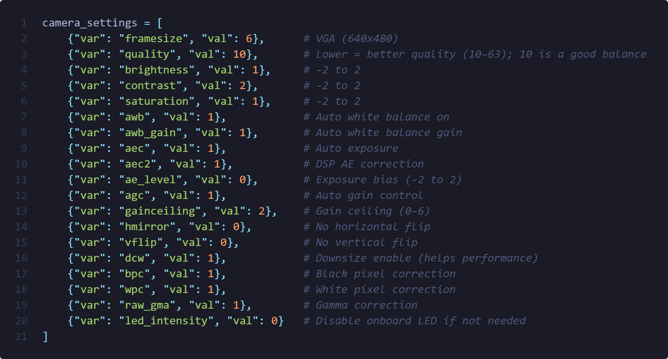
Setting | Value | Description
framesize | 6 | VGA(640x480)
quality | 10 | Lower value = higher JPEG quality
brightness | 1 | Better visibility
contrast | 2 | Emphasize edges
saturation | 1 | Slightly richer colors
awb,aec | 1 | Automatic white and exposure balance
gainceiling | 2 | Avoid overexposure
dcw | 1 | Downsize
For demonstration, the system was configured to capture 150 images over 2.5 minutes, at 1-second intervals.
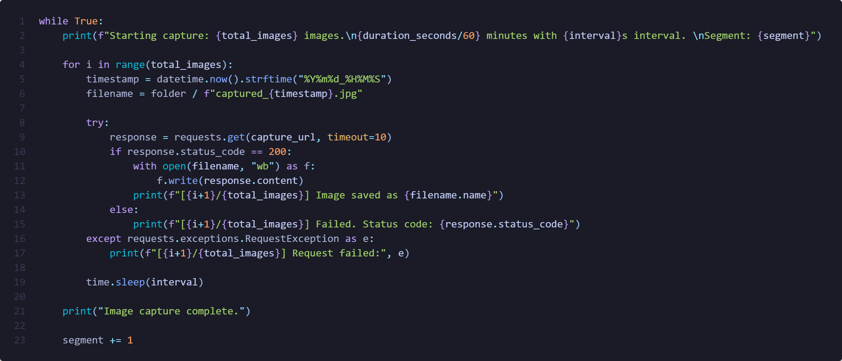

Object Detection Pipeline
Model:
A custom YOLOv11 model trained on relevant object classes is used via the ultralytics package.
For each captured image:
- YOLOv11 performs inference
- The resulting image is annotated with bounding boxes and class labels
- Annotated images are saved to the results/ folder
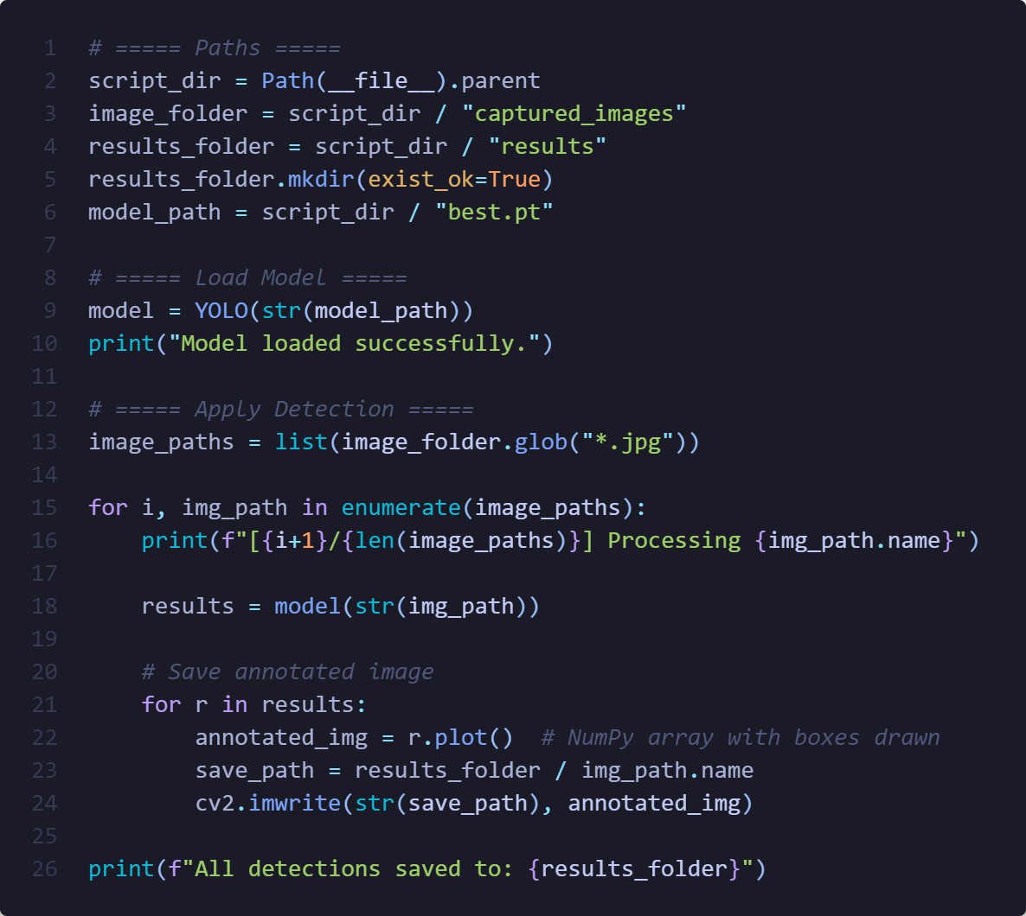

Example results:
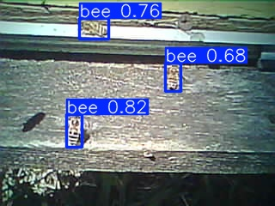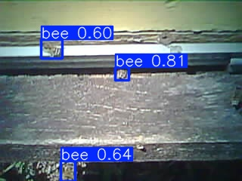

Summary
This system demonstrates how to:
- Build a lightweight Real-time camera system pipeline
- Automate data collection with the ESP32-CAM
- Apply YOLOv11 models for object detection
- Process and store annotated results for further analysis
The approach is scalable for applications such as wildlife monitoring, agriculture, home automation, and research data collection.

