Homework 1 – REPORT

Introduction
In this project, I worked on segmenting blood vessels in retinal fundus images using a U-Net model. The idea is to automatically detect vessel structures from eye images, which is usually a very time-consuming manual process in medical settings. I used a combined Fundus dataset and split it into training, validation, and testing parts (with the /DRIVE/test/ folder used only for testing). The main goal was to train a neural network that can produce a binary segmentation mask showing where the vessels are.
The process included preparing and augmenting the data, setting up and training the U-Net model, and finally testing it using metrics like F1, AUC, and Mean IoU.

U-Net
The U-Net is a popular convolutional neural network architecture for image segmentation. It has a contracting (encoder) path that captures the context of the image and an expanding (decoder) path that helps localize the segmented regions. The skip connections between these two paths help recover spatial information lost during downsampling.
At first, I implemented the U-Net model from scratch following the original paper. However, it was taking too long to train, and the metrics were not very good. So, I replaced the model with a pretrained U-Net that uses a ResNet-34 encoder with ImageNet weights. This version trained much faster and performed noticeably better.
I also made the input and output channels dynamic so I didn’t have to hardcode them:
- in_channels = dataset[0][0].shape[0] -> Represents an eye + mask image
- out_channels = dataset[0][1].shape[0] -> Represents blood vessels
This way, the model can automatically adapt to whatever dataset I’m using without manual tweaking.

Augmentation
Since the dataset wasn’t very large, I used Albumentations to perform data augmentation and make the model more robust. I also resized all images to 584 × 565, which is the smallest image size in the dataset, to avoid size mismatches later.

Here’s what I used in my augmentation pipeline:
- HorizontalFlip / VerticalFlip – to flip the image and mask, adding mirror variations
- Random Rotate90 - Rotates the images by 90 degrees randomly
- Affine transforms – scaling (±5%), rotating (±90°), and shearing (±5°) to add geometric diversity
- RandomBrightnessContrast – small brightness and contrast changes to simulate lighting differences
- HueSaturationValue – slightly adjusts colors for variety
- CLAHE – improves local contrast to highlight vessels
- Elastic / Grid / Optical distortions – randomly warps images to help generalize to small deformations
I made sure that only geometric transformations were applied to the masks and labels (for example, brightness or hue shouldn’t be changed on them). I also wrote a small helper function to augment each image N times so I could easily adjust how many augmented samples to generate.

Dataset
I created a custom PyTorch dataset class called FundusDataset. It converts each image, mask, and label into tensors and normalizes them to the range [0, 1]. Since the labels are just black-and-white images stored as RGB, I reduced them to one channel to save memory and speed up training. One design choice I made was to include the mask as part of the input, so each input had 4 channels (3 from the RGB eye image and 1 from the mask). This helped the model focus only on the visible region of the fundus. Because of small inconsistencies in image sizes (and a weird PyTorch interpolation error), I had to force all inputs and outputs to have the same height and width (584, 565). This fixed most of the crashes I was getting during training. After processing everything, I split the dataset into 80% training and 20% validation and used PyTorch’s DataLoader with a batch_size of 8. That value worked well given my hardware limitation.
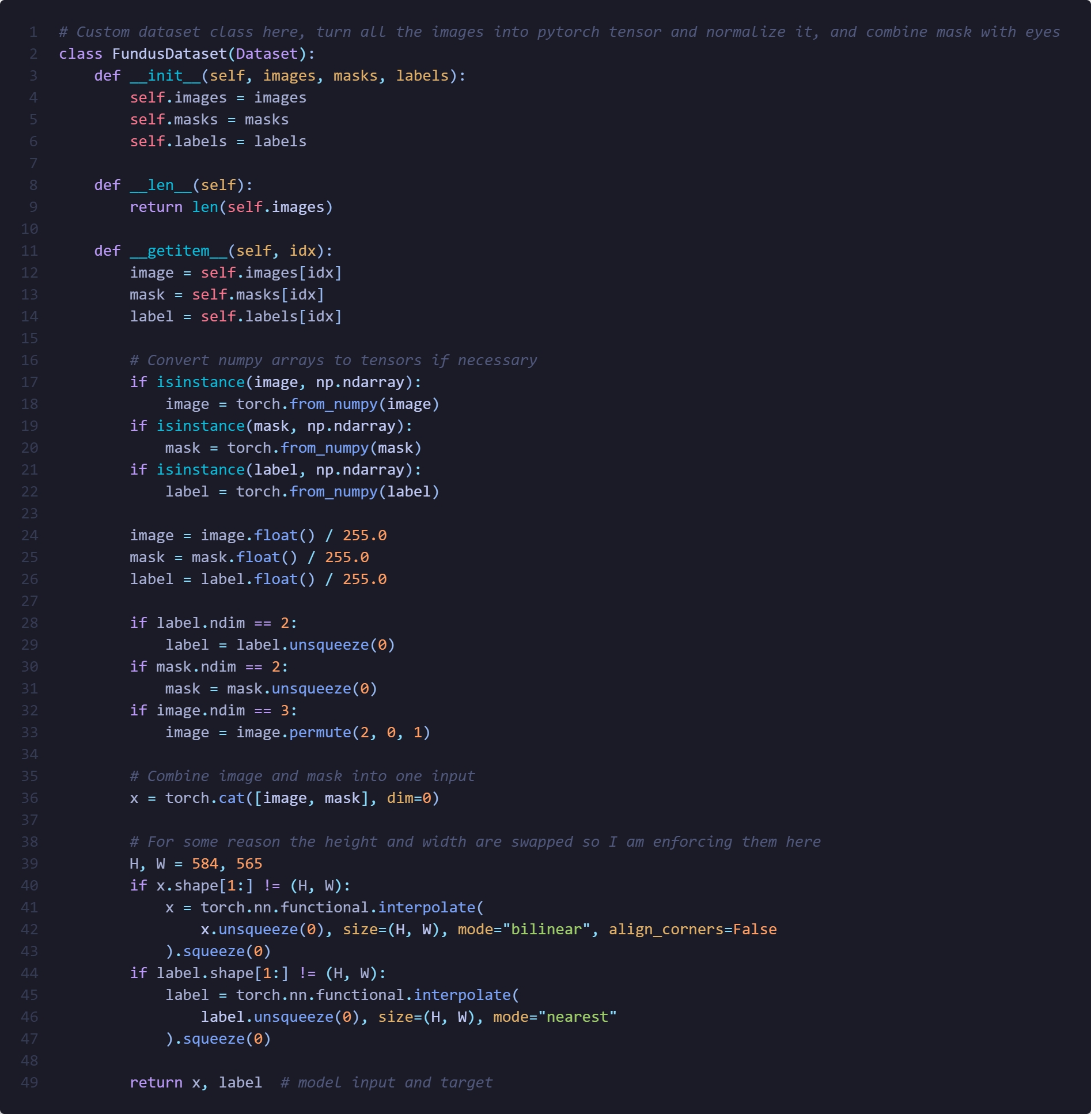

Model Training, Implementation, and Testing
For training, I used the BCEWithLogitsLoss function. It’s a good fit for binary segmentation since it combines the sigmoid activation and binary cross-entropy loss in one step, which is both stable and efficient.
My optimizers were Adam and AdamW with a learning rate of 1e-4 and decay with 1e-5. I trained the model for 10 epochs, but in most runs, the metrics started to level off around epoch 6–7 so going beyond that didn’t really bring noticeable improvement.
Metrics
I tracked the following metrics during training:
- F1 Score – to measure the overlap between predictions and ground truth.
- AUC (Area Under Curve) – to see how well the model distinguishes between vessel and background.
- Mean IoU (Jaccard Index) – to evaluate segmentation overlap accuracy.
These were all implemented using torchmetrics:
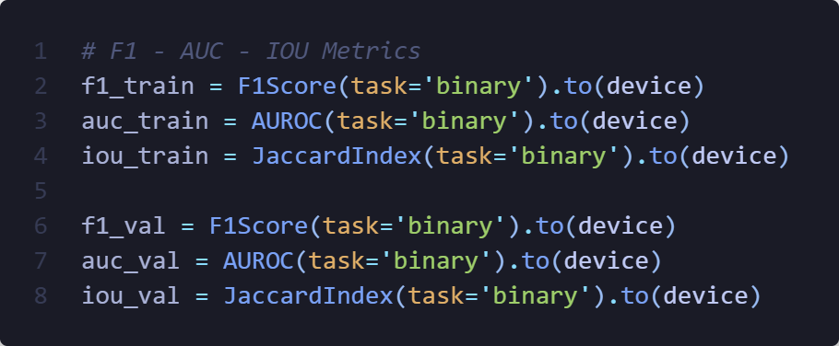
After each epoch, I printed and compared both training and validation metrics. The model with the best validation F1 score was saved as best_model.pth.
The training loop used the standard PyTorch structure:
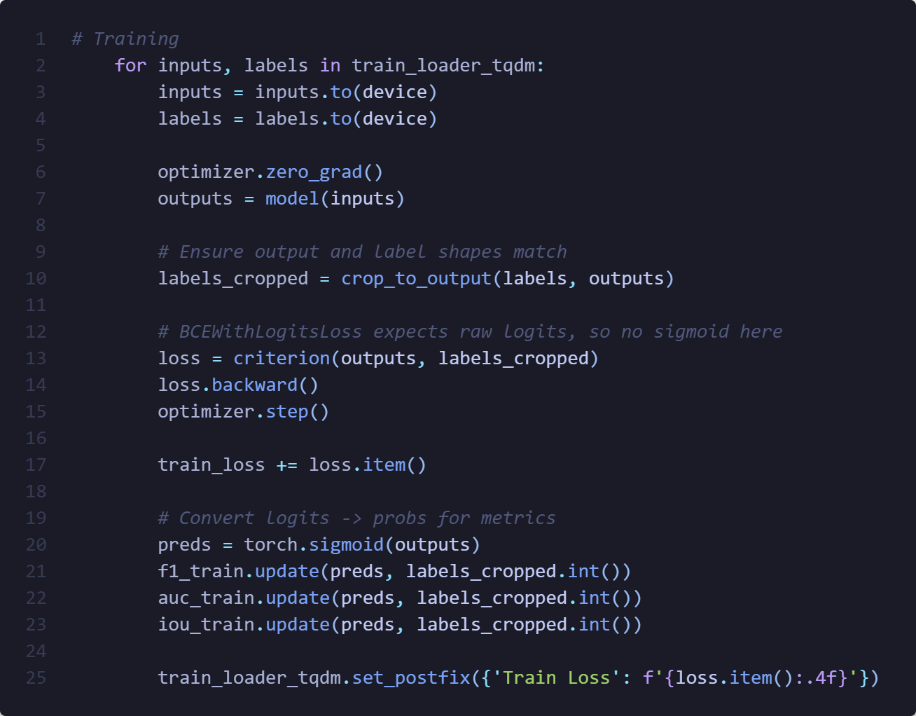
I also added a helper function to crop the output in case the dimensions didn’t perfectly match the labels (because the image size isn’t divisible by 16, which can cause small shape mismatches).
Testing
For evaluation, I used both manual1 and manual2 test label sets from the DRIVE dataset. To get a more robust view of model performance, I also created a union mask that combines both annotations (i.e., a pixel is counted as a vessel if either manual1 or manual2 labeled it). This helps reduce label uncertainty and gives a better sense of how confident the model is when both ground truths agree.
During testing, I ran inference on each sample with torch.no_grad() and generated segmentation masks by applying a 0.5 confidence threshold on the model’s sigmoid output.
Metrics (F1, AUC, and IoU) were calculated separately for manual1, manual2, and the combined union. This made it easier to see how consistent the model’s predictions were across slightly different label sets.
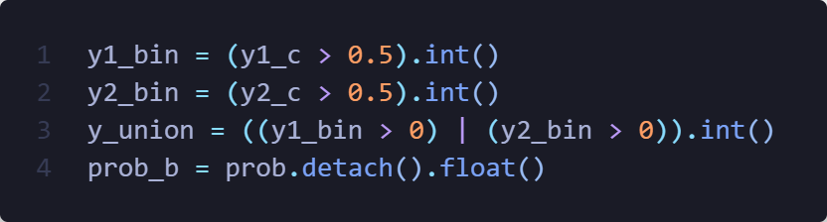
Finally, I saved the predicted masks for visual inspection, which helped confirm that the model was detecting vessel structures with reasonable precision, though some finer vessels were still missed in certain cases.

Results
In my tests, pretrained U-Net with ResNet-34 always performed better than my implementation so I am going to completely omit that from the table below.
However, for both of the models, they have started to slow down on improvements after around 5 or 6 epochs where they started to converge, even changing optimizer and loss function did not really improve their performance where the difference could be attributed to chance.
For all the training, number of augmentation was 4, and epochs was 10.
Model | Optimizer | Loss | Train-F1 | Train-AUC | Train-IoU | Test-F1 | Test-AUC | Test-IoU
Custom | Adam | BCEWithLogitsLoss | 0.57 | 0.84 | 0.34 | 0.62 | 0.85 | 0.61
Pre-Trained | Adam | BCEWithLogitsLoss | 0.64 | 0.96 | 0.48 | 0.79 | 0.97 | 0.65
Pre-Trained | AdamW | BCEWithLogitsLoss | 0.70 | 0.97 | 0.53 | 0.75 | 0.96 | 0.60
Overall, the results confirm that:
- Pretrained encoders speed up convergence and improve performance.
- Both Adam and AdamW work well for this type of task, but it provides slightly smoother training.
- BCEWithLogitsLoss was stable and effective for binary segmentation; other loss functions might give marginal improvements, but the main gains here come from the model architecture and pretraining.

Optional Questions
- What difficulties did you encounter while performing the task and how did you solve/resolve them?:
The main issue I ran into was an internal PyTorch error about image sizes. It happened because the height and width weren’t divisible by 16, which caused mismatched shapes in the network. I fixed it by forcing all inputs and labels to have the same dimensions with interpolation.
Additionally, I have noticed a weird error where pytorch dataset was randomly changing height and width of some of the images at random which I had to implement below logic in order to keep it from happening.
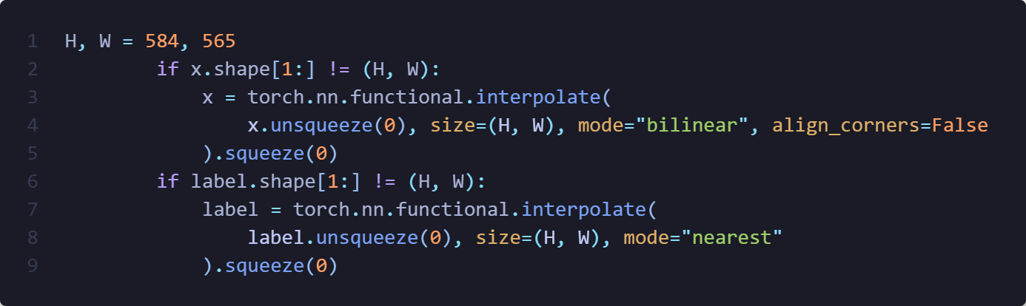

- Did you use data augmentation, and if so, what kind, and why did you choose it?:
Yes, I used quite a bit of data augmentation, and it turned out to be one of the most important parts of the project. The main reason is that fundus datasets are usually pretty small and imbalanced, the blood vessels make up only a small fraction of the pixels in each image, so without augmentation, the model can easily start overfitting or just learning to predict the background.
I combined both geometric and color/intensity transformations to make the model more robust to lighting changes, rotations, and different acquisition conditions. The main transformations I used were:
- Horizontal and vertical flips: simulate mirrored eyes.
- Random rotations (±90°): help the network handle images from slightly different angles.
- Affine transforms (scale, translate, shear): simulate subtle variations in how the eye might appear under the camera.
- Brightness/contrast adjustments and CLAHE (Contrast Limited Adaptive Histogram Equalization): make the model less sensitive to lighting and contrast differences.
- Hue/Saturation changes: account for color shifts across devices.
- Elastic, grid, and optical distortions: mimic realistic deformations in biological tissue or small focus shifts.
Each image was augmented four times, so I ended up with a dataset that was roughly five times larger than the original. That definitely helped the model generalize better, validation loss was more stable and the network didn’t just memorize vessel patterns from a few samples.
- Were you able to train a segmentation model that could distinguish blood vessels in fundus images well enough? How could the segmentation results be improved?:
Yes, the final model was able to segment the main blood vessels quite well. It achieved high AUC scores (around 0.96–0.97), meaning it could reliably distinguish between vessel and background regions. Thicker vessels were detected very accurately, while thinner ones were sometimes missed or fragmented, which is pretty common in fundus segmentation tasks.
The overall segmentation maps looked good visually, but there’s still room for improvement. Some ways to improve results could be:
- Using more data augmentation, especially with small rotations and elastic transformations, to make the model more robust.
- Trying more specialized loss functions like Focal Tversky Loss or Dice + BCE hybrid, which handle class imbalance better.
- Increasing input resolution or using patch-based training, which might help the model capture smaller vessels more precisely.
- Fine-tuning learning rate and number of epochs, since the model started to plateau early (around epoch 6–7).
Overall, the model performs well for a baseline, but there’s definitely potential to make it even better with a few targeted adjustments.

- Did you try different optimizers, loss functions, perform other comparisons, and determine when more accurate segmentation results are achieved?
Yes, I experimented with different optimizers and compared their effects on training and test performance. I started with Adam, which already gave good results, and then tried AdamW to see if weight decay would improve generalization. AdamW performed slightly better during training (especially in F1 and IoU) and converged a bit faster, but the test metrics were quite similar, so the difference wasn’t huge.
For the loss function, I mainly used BCEWithLogitsLoss since it’s stable and works well for binary segmentation. I briefly tried Dice Loss and a BCE + Dice combination, but they didn’t give consistent improvements with my current setup, BCEWithLogitsLoss remained the most reliable overall.
- My own question:
How could this setup handle multiple segmentation classes?
By changing the final output layer to have more than one channel and switching to a loss function like Categorical Cross-Entropy, it could handle multi-class segmentation (for example, separating arteries and veins).

Conclusion
Overall, I successfully implemented and trained a U-Net model for fundus image segmentation. Switching to a pretrained encoder (ResNet-34) made a big difference in both speed and overall performance compared to my custom implementation. The model achieved solid results on the validation and test sets, showing strong ability to segment the main blood vessels in fundus images.
Data augmentation also played an important role, helping the model handle variations in brightness, contrast, and orientation across the dataset.
Although thinner vessels were still challenging to capture perfectly, the results are promising and could be improved further with more data, higher-resolution training, or specialized loss functions.

