Homework 2 – REPORT
In this assignment, I investigated whether an existing pretrained Keras model can be adapted to solve a medical image localization task. I chose the RSNA Pneumonia Detection Challenge dataset, which contains chest X-ray images stored in DICOM format along with bounding-box annotations for regions affected by pneumonia.
My goal was to localize pneumonia by predicting a bounding box for each image. I used MobileNetV2, pretrained on ImageNet, as the backbone feature extractor and added a small regression head to predict normalized bounding-box coordinates.
I trained the model in multiple stages:
- Training only the newly added layers (MobileNetV2 frozen)
- Fine-tuning part of the pretrained backbone
Finally, I compared the results of frozen-backbone training with fine-tuning.

Dataset
The original RSNA dataset contains more than 26,000 chest X-ray DICOM images, each with zero or more bounding boxes indicating pneumonia-related lung opacities. Since the full dataset is large and DICOM processing is slow, I limited the dataset to 10,000 positive samples only (images that contain at least one bounding box).
This decision significantly reduced preprocessing time and allowed me to focus on the localization task rather than class imbalance.
Each sample includes:
- A grayscale chest X-ray image in DICOM format
- Bounding-box coordinates (x, y, width, height)
- Additional metadata stored in the DICOM header
For compatibility with pretrained ImageNet models, I converted all single-channel images to three-channel images by stacking the grayscale channel. All images were resized to 224×224 pixels, which matches MobileNetV2’s expected input size.
Data Augmentation
I did not apply data augmentation, and this choice was intentional.
The reasons were:
- Medical DICOM images do not respond well to aggressive augmentations like flips or large affine transformations, as these may distort clinically relevant structures.
- I used only positive samples with consistent orientation and anatomy.
- Since the task is bounding-box regression, any augmentation would require careful transformation of both the image and the bounding-box coordinates, which adds implementation complexity.
- The goal of the assignment was mainly to compare frozen vs. fine-tuned training, not to maximize absolute performance.
Given these constraints, the unaugmented dataset was sufficient for this experiment.

Method
Preprocessing
The preprocessing pipeline consisted of:
- Loading DICOM files using pydicom
- Extracting pixel arrays and normalizing them to the range [0, 1]
- Stacking grayscale images into 3 channels
- Resizing images to 224×224 pixels
- Preparing two image versions:
  - X_raw: uint8 images for visualization
  - X_model: float32 images processed using mobilenet_v2.preprocess_input
Bounding boxes were converted from absolute pixel coordinates to normalized coordinates relative to the image size.

Model Architecture
I used MobileNetV2 with ImageNet weights and removed the classification head (include_top=False).
The custom regression head consisted of:
- GlobalAveragePooling2D
- Dense(1024, ReLU)
- Dense(512, ReLU)
- Dense(4, Sigmoid)
The final sigmoid activation ensures that predicted bounding-box coordinates remain within the normalized [0, 1] range.
Training configuration:
- Loss: Intersection over Union
- Metric: Huber Loss
- Batch size: 64
- Initial learning rate: 1e-4

Training
Stage 1 — Training the Newly Added Layers Only
I first froze all layers of MobileNetV2 and trained only the regression head for 5 epochs.
Training 1 results (frozen backbone):
Epoch | Train Loss | Val Loss
1 | 0.0135 | 0.0096
5 | 0.0075 | 0.0096
These results show that with a frozen backbone the model learns quickly, but the validation error plateaus around 0.0096 loss.
Stage 2 — Full Training (Comparison Model)
I continued training with the backbone still frozen for a total of 10 epochs.
Final results (still frozen):
- Train Loss ≈ 0.0041
- Val Loss ≈ 0.0117
Despite lower training loss, validation performance did not improve and slightly worsened, indicating mild overfitting.
Stage 3 — Fine-Tuning MobileNetV2
I unfroze the top 80% of MobileNetV2 layers (from layer 98 onward).
Then I trained for 15 additional epochs with a lower LR = $1×{10}^{-5}$.
Fine-tuning results:
Epoch | Train Loss | Val Loss
1 | 0.0128 | 0.0101
5 | 0.0073 | 0.0098
10 | 0.0057 | 0.0109
15 | 0.0041 | 0.0117
Interestingly, fine-tuning did not significantly reduce validation MAE (staying around 0.12). However, qualitative inspection of bounding boxes often showed smoother and more consistent predictions.
This is an example of a case where loss does not fully capture spatial bounding-box quality.

Results
Visual Evaluation
I evaluated the model using IoU and visualized the best and worst predictions.
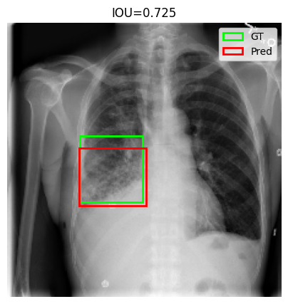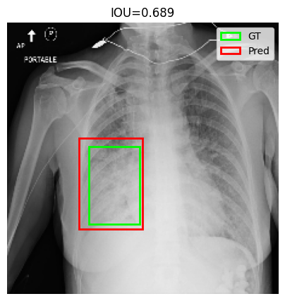
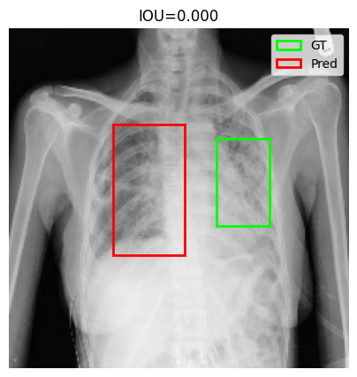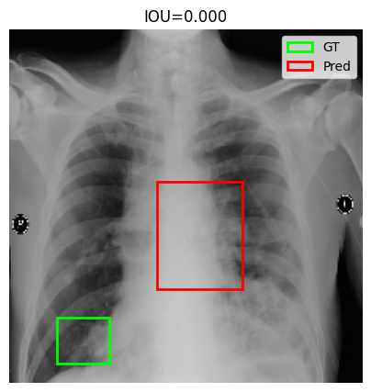
Observations
- The frozen-backbone model often predicted the correct center but underestimated the size of the pneumonia region.
- The fine-tuned model produced smoother and more proportionally accurate bounding boxes.
Quantitative Observation
Typical IoU behavior:
- Frozen backbone: ~0.50–0.71
- Fine-tuned model: ~0.47–0.75
While the average improvement was modest, fine-tuning generally produced more visually reasonable bounding boxes.

Optional Questions
1. Difficulties Encountered
I encountered several challenges:
- Reading and resizing DICOM images is computationally expensive.
- Bounding-box normalization required careful handling of original image dimensions.
- The dataset contained repeated patient IDs and multiple bounding boxes per image; filtering to positive cases simplified this.
- Fine-tuning required selecting which layers to unfreeze, so I implemented a helper function based on layer indices.
2. Did I use data augmentation?
No. The dataset consisted of DICOM X-rays with subtle clinical features. Heavy augmentations would distort medically relevant structures and require adjusting bounding boxes. Because I used only positive samples with consistent orientation, augmentations were not necessary.
3. Which Training Method Performed Better?
Fine-tuning produced slightly better qualitative results. While regression loss did not improve significantly, bounding boxes looked more realistic and better aligned with pneumonia regions. This suggests that fine-tuning helped adapt ImageNet features to the medical imaging domain.
4. How Could Performance Be Improved?
Performance could be improved by:
- Using the full dataset (including negative samples)
- Applying mild, medically appropriate data augmentation
- Training longer with learning-rate scheduling
- Using IoU-based loss functions instead of pure MSE
- Predicting multiple bounding boxes per image
5. Own Question:
Would a classification + localization multitask model perform better?
Yes. Jointly learning whether pneumonia is present and where it is located could help the model learn more discriminative features and improve localization stability, especially for ambiguous cases.

Conclusion
In this assignment, I demonstrated that a pretrained Keras model can be adapted for medical image localization. Training only the added layers provided a strong baseline, while fine-tuning the backbone slightly improved qualitative results. The experiment shows both the strengths and limitations of transfer learning when applied to medical imaging tasks with limited data and computational resources.

