LABARATORY 1 – REPORT

Exploring Google Colab
I have explored the Featured examples and while some of them worked well, other did not due to various different errors which most I tried to fix and will mention later on the report on different title.
I tested several Featured Examples in Colab. While some of them worked well, others produced errors due to deprecated code, library mismatches, missing code. I have explained the ones that were not too simple such as adding a single line of code given by error.

MoveNet Notebook
I created a copy of the MoveNet tutorial in my Google Drive and successfully ran all sections after fixing several errors. I added detailed comments in the notebook explaining the modifications.

Testing on a Custom Dataset
In my copy of the notebook, I have added URLs of 20 images that a single person was posing. I have downloaded these images into a new folder; to process multiple images, I modified the provided example code by wrapping the image loading, decoding, and inference function inside a for loop, to make the system run skeleton detection on all images sequentially.

Results
As requested, I have modified the code to save the visualized images with body part overlay into the drive. Here are some good results as an example.
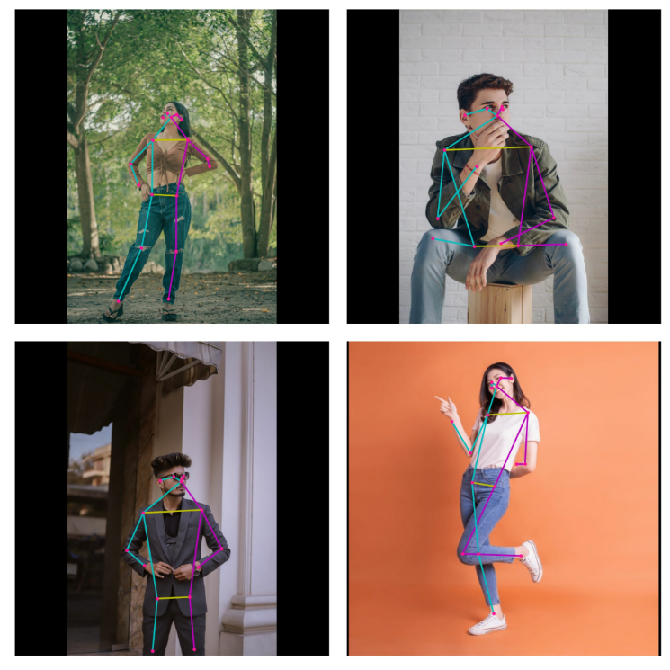

Optional Questions

Problems and Solutions
During the lab, I encountered multiple errors, some of them are not worth mentioning because the solution is either on the error itself such as, “You need to download nltk.download('punkt_tab')”. So here are some problems that I have encountered and fixed:
- Deprecated Code
Function .tosting_rbg() was deprecated in the newer versions of Matplotlib, so it was breaking the run. I have figured out the solution from their library. Only difference is the Alpha channel in the however, it can be completely ignored.
  - Original: np.frombuffer(fig.canvas.tostring_rgb(), dtype=np.uint8)
  - Fixed: np.frombuffer(fig.canvas.buffer_rgba(), dtype=np.uint8)
- GIF Processing Error
When running inference on GIFs, the code crashed after processing the first frame. The error was related to incorrect dimensions for the NumPy array representing the image.
  - Original: fig.canvas.get_width_height()[::-1] + (3,))
  - Fixed: (int(fig.get_figheight() * fig.dpi), int(fig.get_figwidth() * fig.dpi), 4))
- Color Channel Differences
Saved images appeared with unexpected color swaps for red and blue. Turns out the reason for that is Matplotlib uses RBG while OpenCV uses BGR for image files. So I converted the RGB to BGR to save the images properly.
output_bgr = cv2.cvtColor(output_overlay, cv2.COLOR_RGB2BGR)
- Image Decoding Errors
Although all of my images were .jpg and .jpeg, some failed to get decoded. I am not fully certain but from my testing I have figured out that some of the files were encoded differently than usual or their metadata was different than what Tensorflow was expecting (My guess). So I had to remove couple images and replace them with new ones, and then I adjusted the decoding function from .decode_jpeg() to .decode_image() just in case to be safe for different image extensions.

Result Observation
In general, the MoveNet model performed well. In many cases, even when certain body parts were partially or completely out of view, the model was able to reasonably infer their positions. Additionally, it sometimes identified subtle details regarding the location or extension of limbs.

For example, in this image, the model correctly estimated the position of the hips, the approximate location of the right arm (relative to the model), and the extension of the legs. The only minor error was the placement of the right ear, which is completely obscured, making this a reasonable guess by the model.
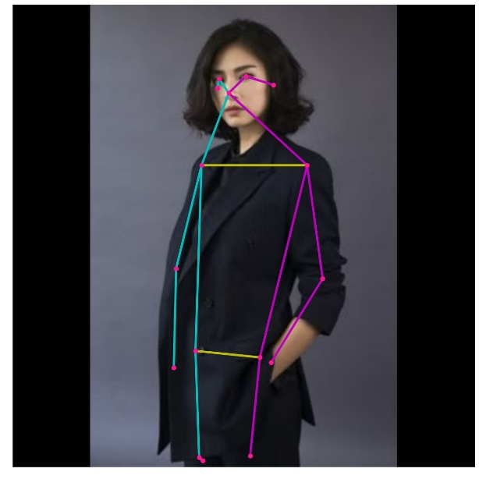
However, in some cases, the model became confused about the number of limbs or the orientation of certain body parts. For instance, in this image below, the model detected two left arms (relative to the model). Both arms were only partially recognized, stopping around the elbows and completely missing forearm. The model also failed to detect the right hip and produced incorrect and multiple positions for the left side of the body.
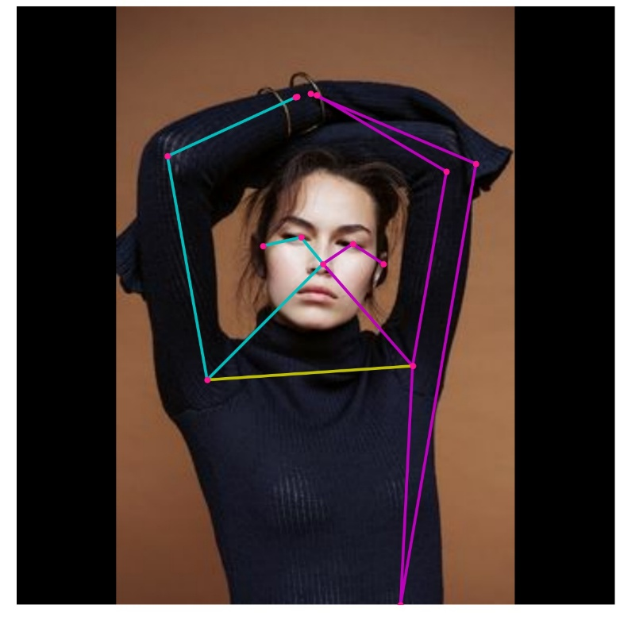

Own Question and Answer
How does MoveNet compare with other pose estimation models, such as OpenPose or BlazePose?
Answer:
MoveNet is built with speed in mind. It’s really lightweighted and can run in real-time, even on devices that don’t have powerful GPUs, which makes it great for mobile or live applications. The trade-off, though, is that it sometimes struggles when there are multiple people in the same frame, when the pose is very unusual, or when clothing of the model is hard to differentiate.
OpenPose, on the other hand, is more of a “heavy-duty” model. It can detect multiple people at once and is very detailed, but the downside is that it’s much slower and harder to run in real time unless you have strong hardware. So it’s better suited for research or offline analysis rather than real-time use.
BlazePose is somewhere in between, but it’s more specialized for health and fitness applications. It doesn’t just detect the main body joints, but also hands and face keypoints, which can be very useful if you want to track more detailed movements, like in yoga, gestures, or physiotherapy apps.
- MoveNet is the best option when you need something fast and efficient, especially for single-person tracking.
- OpenPose is more powerful for multi-person detection but at the cost of speed.
- BlazePose - adds more detail (hands, face) and is optimized for fitness or wellness scenarios.

Personal Comment
Google Colab is very useful, especially with its free access to powerful GPUs. However, in many cases, the free tier is not enough for larger or even medium projects. Even when running on CPU, the browser can start consuming a lot of RAM, even though most of the computations are supposed to be done on Google’s side.
I have used Colab before for my Master’s research, and I still occasionally use it. That said, there are some aspects that make it less convenient: handling large datasets, the sometimes clunky session management, differences in file paths, and errors that are hard to reproduce, such as memory running out or mismatched library versions (e.g., SciPy or NumPy), which can interfere with training. Despite these issues, I still use Colab when I need a quick setup or free GPU access.

