LABARATORY 2 – REPORT

Aim of the Laboratory Work
The aim of this laboratory work is to explore and test various methods of data augmentation using the Albumentations library. Data augmentation increases both the amount and diversity of data, which helps improve the robustness and generalization ability of machine learning models, particularly convolutional neural networks (CNNs) used for image processing tasks.

Implementation and Transformations
The following augmentation pipeline was implemented to demonstrate and test a variety of pixel-level and spatial-level transformations. All transformations were set with probability p=1 for visualization and verification.
Type | Transformation | Description
Pixel-level | Additive Noise | Adds Gaussian noise to each pixel, simulating sensor or lighting variations.
Spatial-level (Image) | Affine | Applies translation, rotation, shear, and scaling.
Spatial-level (Image + Mask) | GridElasticDeform | Warps the image grid elastically, used to simulate non-rigid deformations.
Spatial-level (Image+BBoxes) | Perspective | Applies a 3D perspective distortion.
Spatial-level (Image+Keypoints) | Morphological & RandomGridShuffle | Alters image structure and rearranges small image grids.

Example Output:
Original Image:
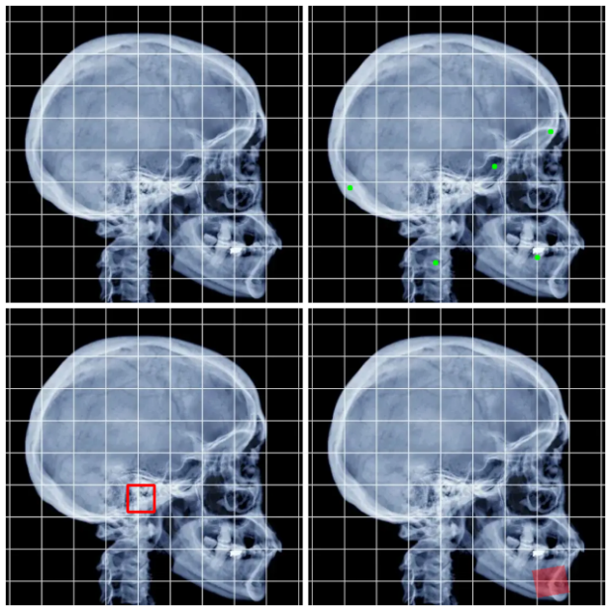
Augmented Image:
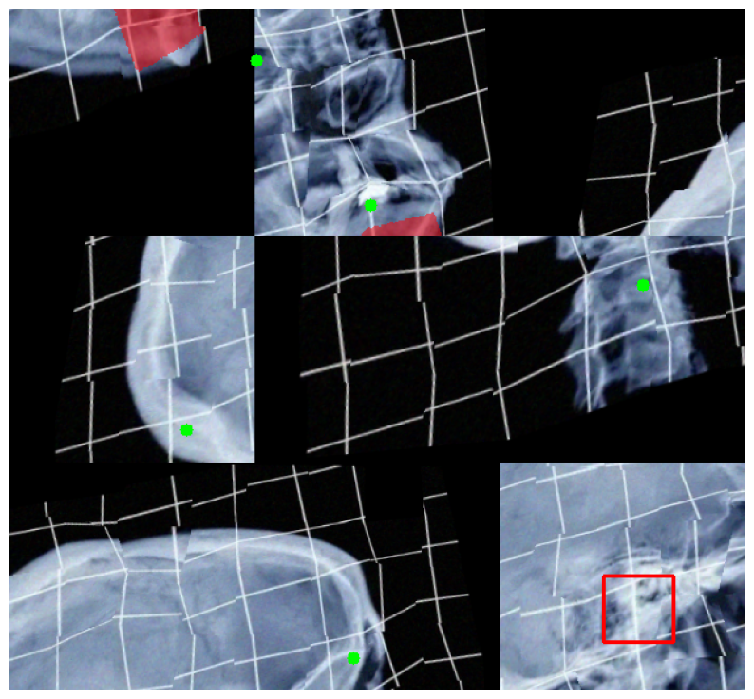
Since I did not have a definitive mask, bounding box, or key points I implemented them myself artificially for demonstration. It is also included in the laboratory code.

Homework Augmentation Pipeline Output:
A second augmentation pipeline was designed for retinal vessel segmentation, with transformations that maintain anatomical structure while increasing variability.
Transformations Applied:
- HorizontalFlip
- VerticalFlip
- RandomRotate90
- Affine
- RandomBrigtnessContrast
- HueSaturationValue
- CLAHE
- OneOf
  - ElasticTransform
  - GridDistortion
  - OpticalDistortion
Logic:
- Flipping and rotation: Introduce spatial variety while preserving object geometry.
- Affine: Slight rotations, shear, scaling to simulate variability.
- Brightness, contrast, hue, saturation: Mimic lighting, camera difference, different states of blood or vessel.
- CLAHE: Improves local contrast in medical images.
- Elastic/Grid/Optical distortion: Adds a mild spatial irregularity without destroying structure.

Examples:
Original:
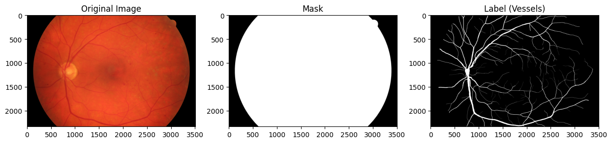

Augmented:
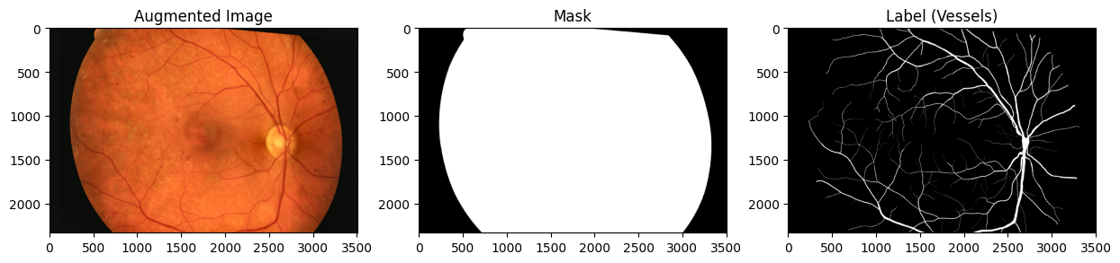

Results and Observations:
- The augmentations successfully altered image appearance, geometry, and pixel-level intensity.
- Pixel-level transformations such as AdditiveNoise and BrightnessContrast were visually realistic and helped simulate sensor noise and lighting variability.
- Geometric transformations like Affine, ElasticTransform, and Perspective effectively increased dataset diversity.
- When applied to medical images, excessive distortion (e.g., strong perspective warping) can destroy critical anatomical structures. Therefore, such transformations should be used cautiously.

Optional Questions:
1. What difficulties did you encounter while performing the task and how did you resolve them?
One challenge was correctly combining different types of augmentations (image, mask, bounding boxes, and keypoints) under a single pipeline. The Albumentations library requires explicit parameter definitions (bbox_params, keypoint_params). Initially, some augmentations misaligned the masks with their corresponding images. This was resolved by using consistent interpolation methods and ensuring all augmentations were compatible with mask transformations.

2. Which image augmentation methods are suitable and which are not when training a neural network to segment blood vessels in retinal images, and why?
Suitable methods:
- Brightness, Contrast, Hue, Saturation adjustments: Simulate realistic changes in lighting.
- Elastic and slight affine transformations: Add geometric variety while preserving vessel structure.
- CLAHE: Enhances local contrast, improving vessel visibility.
Not suitable methods:
- Strong perspective or grid shuffle: These can distort the geometry of blood vessels and degrade segmentation accuracy.
- Morphological or random grid rearrangements: These destroy the spatial relationships crucial for segmentation tasks.
3. How can you determine whether a particular image augmentation method is suitable for the task?
A method is suitable if it:
- Preserves the semantic meaning of the image (e.g., vessel locations remain correct).
- Improves model generalization without reducing accuracy on validation data.
- Produces visually realistic outputs consistent with the domain (e.g., medical imagery should not include unnatural warps).
Testing suitability can be done empirically by training the model with and without the augmentation and comparing validation metrics such as Dice coefficient or IoU.
4. Self-posed question and answer
Question: How can augmentation intensity (e.g., rotation degree, noise level) affect model performance?
Answer:
Excessive augmentation can make training data unrealistic, leading the model to learn irrelevant features. For example, extreme rotation or noise may obscure critical details in retinal vessels. Optimal augmentation intensity should balance diversity and realism, determined experimentally through validation results.

Conclusion:
In this laboratory work, several data augmentation techniques were implemented and tested using the Albumentations library. The results demonstrate that augmentations significantly enhance dataset diversity, which is especially beneficial for tasks with limited data, such as medical image segmentation.
For the retinal vessel segmentation task, controlled augmentations that preserve anatomical structures were found most effective. Excessive or unrealistic transformations can reduce performance.

