LABARATORY 3 – REPORT

Aim of the Laboratory Work
Microscopy images often contain tiny details like cells, nuclei, or other small biological structures that are hard to segment using simple thresholding or edge detection. Convolutional Neural Networks (CNNs) can automatically learn these patterns and have become a key tool in biomedical image analysis.
In this lab, I compared two CNN architectures, U-Net and DeepLabV3 to see how well they segment microscopy images. U-Net is a model originally built for biomedical data, while DeepLabV3 was designed for natural scene segmentation. The goal was to test how these very different designs perform on the same microscopy images and to see where each one succeeds or fails.

Model Architectures:
U-Net
U-Net is a fully convolutional neural network explicitly designed for biomedical image segmentation. Its architecture follows a symmetric encoder–decoder structure:
- Encoder (contracting path): A sequence of convolutional and pooling layers that extract hierarchical features and reduce spatial dimensions.
- Decoder (expanding path): A mirrored sequence of up-convolutions that reconstruct spatial resolution and predict per-pixel class labels.
- Skip connections: Feature maps from each encoder layer are concatenated with corresponding decoder layers. This transfers fine-grained spatial information that is lost during down-sampling.
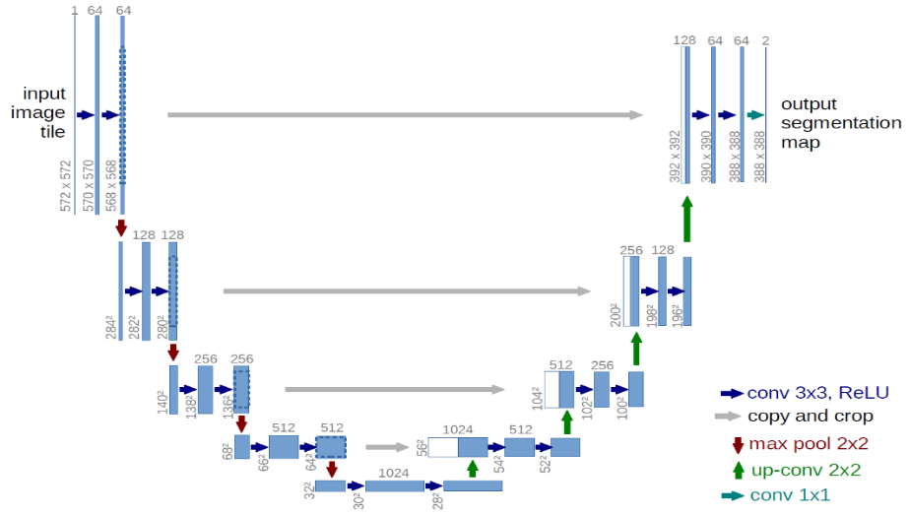
Intuition:
Cells and small biological structures require precise boundary localization. U-Net’s skip connections preserve low-level texture and edge features, allowing the model to retain exact cell boundaries while also leveraging deep semantic features. This design makes U-Net highly data-efficient and ideal for small biomedical datasets.
Architecture summary:
Stage | Operation | Purpose
Encoder | Conv → ReLU → Pool | Extract hierarchical features
Bottleneck | Conv layers | Capture global context
Decoder | UpConv + concat (skip) | Reconstruct spatial details
Output | 1×1 Conv + Sigmoid | Pixel-wise classification

DeepLabV3
DeepLabV3 represents a more modern segmentation architecture originally intended for natural scene understanding (e.g., people, cars, roads). Unlike U-Net, it does not have a decoder path. Instead, it enhances the encoder with dilated (atrous) convolutions and multi-scale context aggregation:
- Backbone encoder: Usually a ResNet-50 or ResNet-101 pretrained on ImageNet, used to extract deep semantic features.
- Atrous Spatial Pyramid Pooling (ASPP): Parallel dilated convolutions with different dilation rates capture objects at multiple spatial scales simultaneously.
- Output head: Combines multi-scale features and predicts pixel classes.
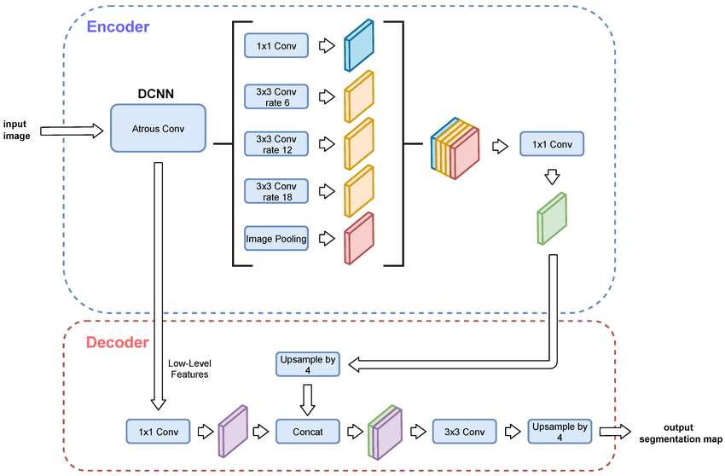
Intuition:
DeepLabV3 focuses on understanding context and large-scale structure in images rather than precise object boundaries. It performs well when objects are large, well-defined, and have strong texture/color differences (e.g., COCO or Pascal VOC datasets). However, this approach can struggle with the tiny, textureless, low-contrast objects often found in microscopy.
Component | Description
ResNet backbone | Strong feature extractor for global context
Atrous convolutions | Preserve resolution while enlarging receptive field
ASPP module | Multi-scale context fusion
Output | Semantic mask via softmax classification

Code:
The code does the following:
- Loads and normalizes four grayscale .tif microscopy images.
- Converts them to 3-channel RGB tensors (since pretrained models expect color input).
- Loads two pretrained CNNs:
  - U-Net with a ResNet-34 encoder (from segmentation_models_pytorch)
  - DeepLabV3 with a ResNet-50 backbone (from torchvision)
- Runs inference on each image and generates segmentation masks.
- Saves the results:
  - results_unet/ for U-Net outputs
  - results_deeplab/ for DeepLabV3 outputs
- Displays side-by-side visualizations to compare the two models.
No retraining was done, the goal was to see how pretrained architectures behave on microscopy data.

Experimental Setup:
- Dataset: 13 .tif grayscale microscopy images (dark and gray background, bright cells).
- Preprocessing: Normalization to [0, 255], grayscale -> RGB (3D for PyTorch), with tensor transformation
- Models:
  - U-Net with ResNet-34 encoder.
  - DeepLabV3 with a ResNet-50 backbone.
- Inference: Models evaluated without retraining to test domain generalization.
- Evaluation: Visual inspection since no ground truth was available.

Results and Observations:
Model | Qualitative Output | Behavior on Microscopy Images
U-Net | Mostly clear, smooth segmentation. Bright regions correspond to cell-like areas and able to recognize curves and cuts. | Identifies some cellular regions with low contrast, able to roughly recognize the shape of the cells as well as density.
DeepLabV3 | In most cases randomly patches and falsely segments with inconsistent masks. | Does not seem like correctly recognizes density or shape. Neither does it able to recognize edges or curves of the cells.

Example outputs:
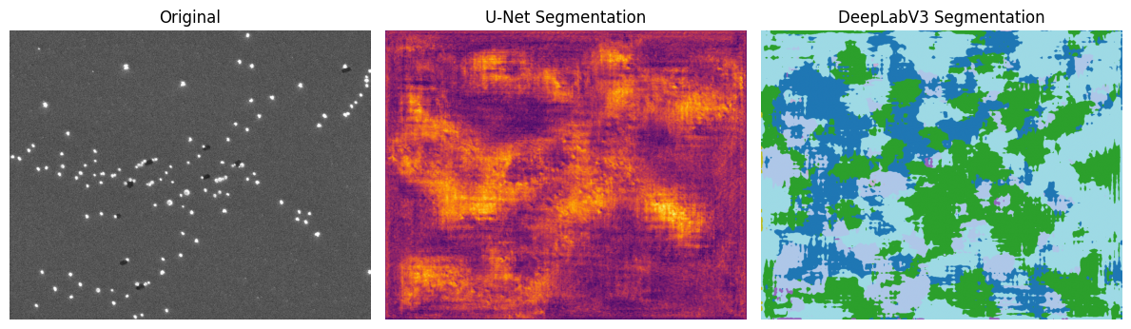
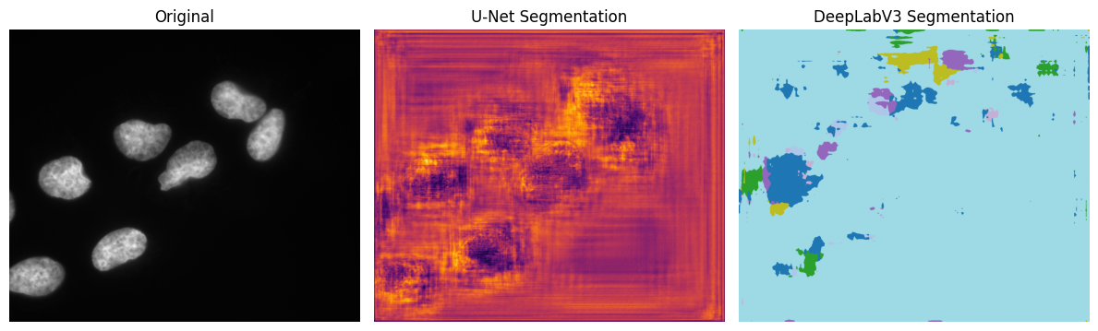

Analysis and Intuition
Why U-Net works better
- Skip connections directly pass edge and boundary details from encoder to decoder, crucial for tiny cellular structures.
- Small receptive field and pixel-level supervision allow U-Net to specialize in local intensity variations typical of microscopy.
- Originally trained for biomedical segmentation tasks — its inductive bias aligns with your data.
Why DeepLabV3 fails
- No decoder path → poor boundary recovery.
- Large receptive field → focuses on global context, not subtle textures.
- Pretraining mismatch: COCO natural images contain macroscopic objects with rich color gradients — very different from grayscale microscopy data.
In summary, U-Net captures fine-scaled structural information, while DeepLabV3 captures coarse contextual information (From what I could find). In microscopy, fine detail dominates, so that U-Net gives a better performance.

Conclusion:
U-Net outperformed DeepLabV3 in segmenting microscopy images.
Its architecture preserves small features and boundaries, critical for biological data, while DeepLabV3’s global, context-based approach doesn’t generalize well to small grayscale cells.
This shows that architectural design matters: models built for biomedical segmentation (like U-Net or StarDist) are far better suited for microscopy than general-purpose segmentation networks.

Optional Questions:
What difficulties did you encounter while performing the task and how did you solve/resolve them?
The biggest issue was that some pretrained models (like Mask R-CNN or Cellpose) didn’t run properly or gave empty outputs. These models were either trained for other domains or had complicated dependencies. I resolved this by switching to DeepLabV3, which worked easily in PyTorch and provided a strong architectural contrast to U-Net, even though its output was poor.

Which CNN architectures are best suited for analyzing microscopy images and why?
Architectures like U-Net, U-Net++, Attention U-Net, or StarDist are best suited for microscopy. They are specifically designed for pixel-level precision and small object segmentation. Their skip connections and dense feature maps help capture tiny details like cell edges and membranes, which are crucial in biomedical images.
How much would retraining DeepLabV3 on microscopy data improve its performance?
If DeepLabV3 were fine-tuned on a microscopy dataset (for example, a cell or nuclei segmentation dataset), its performance would likely improve significantly. The architecture itself isn’t bad — it just lacks exposure to small grayscale textures. Retraining would allow it to adjust its filters to detect cellular patterns instead of large, colorful objects.

