LABARATORY 4 – REPORT

Aim of the Laboratory Work
In this lab, I worked on testing how features extracted from a Convolutional Neural Network (CNN) can be used to find and group similar images.
The idea was to take a pre-trained network, extract activation maps (features) from its layers, and then compare images based on these features using cosine similarity.
The main goal was to see how well these CNN features represent pill images and to compare three different ways of extracting them:
- Flattening the convolutional features
- Using Global Max Pooling
- Using Global Average Pooling

Code:
For this task, I used the ConvNeXtLarge model from Keras with include_top=False so that I could access the convolutional parts without the classification head. I then extracted the features using the three methods mentioned above.
After that, I calculated cosine similarity between the image feature vectors to find the most similar images. Since there were over 26,000 pill images in the dataset, I only used a few hundred for testing so the code would run faster.
The dataset I used was located in:
ePillID_data/classification_data/segmented_nih_pills_224
I also made a visualization function that shows the query image and the top 10 most similar images.
Where I implemented the models and their input and output layers.
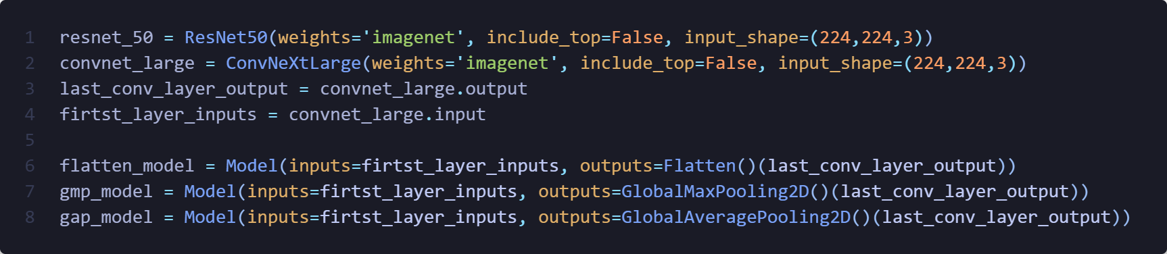
Functions to load the images, process them and extract features with three different model types.
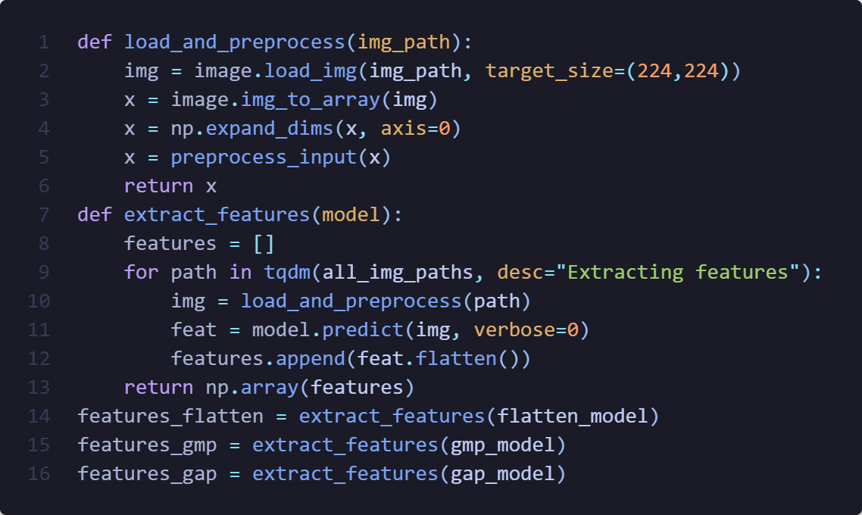
Cosine similarity calculations
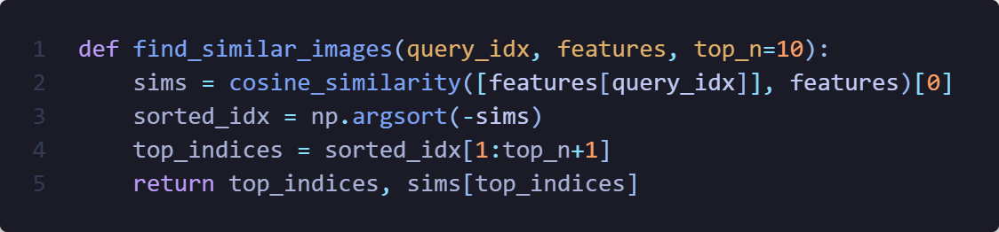
(In the notebook the code is commented, I just removed it here for cleanly show it.)

Results and Observations:
When I tested the system, I picked a few random pill images as queries and looked at the 10 most similar ones found using each feature extraction type.
Here’s what I noticed:
- The Flattened features gave a very detailed representation of the pills. Noticing the depth on the corner of circular pills, similarities of letters and numbers on the pills, and rotation of the pills. However, compared to other two methods, even though the output was mostly correct, the confidence levels were “significantly” (%0.10) lower in most cases than the other two methods.
- For Global Max Pooling, feature confidence was the highest, what I noticed is that this method focused on the writing or engravings on the pills a lot more than the other two methods. On the other hand, the confidence levels and results were still somewhat acceptable if we consider that the color of the pill is less important than what is engraved on it.
- Global Average Pooling gave the best results overall in my opinion. Where the shape, color, and lighting on the pills were very similar, additionally the engravings on them were also close to each other. For confidence levels, they were higher than Flattened features but lower than Max Pooling with seemingly better result quality.
I also noticed that using cosine similarity works well once the feature vectors are normalized. The combined visualization made it easy to see that Global Average Pooling was the most stable across different examples.

Conclusion:
Overall, this lab showed me how powerful CNN features can be for comparing and grouping images without doing any actual classification.
Out of the three approaches, Global Average Pooling clearly worked best, it produced clean, consistent results and was much faster to work with than the Flattened features.

Optional Questions:
1- What difficulties did you encounter while performing the task and how did you solve them?
At first, I had trouble handling such a large dataset, loading and processing all 26k images would’ve taken too long.
I solved this by sampling a few hundred images for testing.
I also had to figure out how to access the right layers in ConvNeXtLarge for the features, but checking the model summary helped.
Finally, plotting three separate graphs for each query was messy, so I rewrote the function to show all three results in one combined figure.
2- Which features allowed you to find the most similar images?
The Global Average Pooling (GAP) features gave the most realistic and consistent results.
The similar pills actually looked similar in shape, engravings, and color, while the other two methods had more mismatches.
3- What could improve the accuracy of this type of similar image search algorithm?
Using a CNN trained specifically on pill images would definitely help.
Also, normalizing features, using metric-learning approaches (like triplet loss), and including metadata such as pill color or imprint could make the results more accurate.
If I wanted to improve this in the future, I would probably:
- Fine-tune the CNN on pill data instead of using ImageNet weights.
- Try using Siamese or Triplet Network to learn a similarity metric directly.
- Maybe combine the visual features with pill metadata (like color or imprint text) for even better matching.
4- My own question: Does the feature size affect how fast similarity search works?
Yes, Flattened features are huge in size, so comparing them takes more time and memory.
The pooled features (GAP or GMP) are much smaller, so cosine similarity runs faster and still gives good results.
So pooling not only simplifies the features but also makes the system more efficient.

