LABARATORY 6 – REPORT

Aim of the Laboratory Work
In this project, I investigated how randomness and hyperparameters affect the training behavior of convolutional neural networks (CNNs).
The main goal was to demonstrate that training a model once is not sufficient for reliable comparison, because neural networks trained from random initialization can behave quite differently across runs.
To study this effect, I trained models multiple times from scratch and examined the variability in their training loss and validation loss curves.
In addition to the required task, I also completed the optional task by modifying several hyperparameters: model size, learning rate, and optimizer.

Dataset
I used the MNIST dataset of handwritten digits (28×28 grayscale images).
I split the official training set into:
- 50,000 images for training
- 10,000 images for validation
The images were converted to tensors using transforms.ToTensor(). No additional preprocessing was applied.

Model Architectures
I implemented three CNN models of increasing complexity.
- SmallCNN
- 2 convolutional layers: 16 → 32 filters
- ReLU + MaxPool after each conv
- 64-unit fully connected layer
- About ~100k trainable parameters
- MediumCNN
- 2 convolutional layers: 32 → 64 filters
- Dropout(0.2) in the FC block
- 128-unit fully connected layer
- LargeCNN
The last model I created is a deeper and wider architecture:
- 3 convolutional layers: 32 → 64 → 128 filters
- MaxPool after every convolution
- 256-unit fully connected layer
- Dropout(0.5) for heavy regularization

Training Setup
All models were trained for 10 epochs using mini-batches of size 64.
I used the same loss function and optimizer within each run to isolate the effects of model size and hyperparameters.
Hyperparameters I adjusted:
- Learning rate: 1e-3 → 1e-4
- Optimizer: Adam → AdamW
- Model size: Small → Medium → Large
Loss function remained CrossEntropyLoss for consistency.

Experiments
Only the model size is changed across these runs, from
SmallCNN -> MediumCNN -> LargeCNN

Runs 1–3 (Main Task + Model Size Test)
All three were trained with the same hyperparameters:
- Learning rate: 1e-3
- Optimizer: Adam
- Loss: CrossEntropyLoss

Runs 4–6 (Optional Task: Hyperparameter Variation)
Here I changed learning rate + optimizer simultaneously and repeated the three-model comparison.
- Learning rate: 1e-4
- Optimizer: AdamW
- Loss: CrossEntropyLoss
I again trained each model five times.

Results
6.1 Variability Across Runs (Main Task)
For runs 1–3, I trained the SmallCNN, MediumCNN, and LargeCNN models using identical hyperparameters (Adam, learning rate 1e-3). Each model was trained five times from a fresh random initialization.
Across these repeated runs, the training loss curves were quite similar within each model. All three architectures showed consistent downward trends, and the differences between runs were relatively small. The MediumCNN achieved slightly lower training loss (around 0.04 at its best), but the improvement over the other two models was minor.
Even though the curves were close, none of the models converged to exactly the same trajectory, and small differences between the five runs were always present. This confirms that randomness in initialization and batch ordering still results in measurable variability.
In contrast, the validation loss curves showed much larger variation.
The similarity observed in the training curves did not carry over to validation performance. The models behaved more differently from one another, and even the five runs of the same model showed noticeably different patterns. The curves did not converge as tightly as they did during training, and the starting and ending loss values varied clearly from run to run.
Although these differences appear small numerically, they become more meaningful as model complexity or dataset difficulty increases.
These behaviors reinforce the fact that evaluating a model based on a single training attempt can be unreliable, especially when comparing models with small performance differences.
6.2 Effect of Hyperparameters (Optional Task)
Runs 4–6 examined the effect of changing the optimizer to AdamW and reducing the learning rate to 1e-4, while keeping the same three model architectures.
In terms of training loss, the overall behavior across the SmallCNN, MediumCNN, and LargeCNN remained similar to the first three runs. Once again, none of the models reached perfect convergence, and differences appeared both between architectures and between repeated runs of the same architecture.
However, the validation loss curves improved noticeably compared to the earlier experiments.
All three models converged more smoothly, with fewer upward spikes or instability. Instead of oscillating from epoch to epoch, the validation losses tended to decrease steadily. This smoother convergence strongly suggests that the hyperparameter changes (lower learning rate + AdamW regularization) helped stabilize generalization.
The five runs for each model still did not start from the same validation loss value, and small variations remained present, but the models converged closer together than in the first three runs, even if they still did not overlap perfectly.
Overall, these results show a meaningful influence of hyperparameters on both convergence quality and stability.

Plots
Run 1
Optimizer: Adam
Learning Rate: 1e-3
CNN: SmallCNN
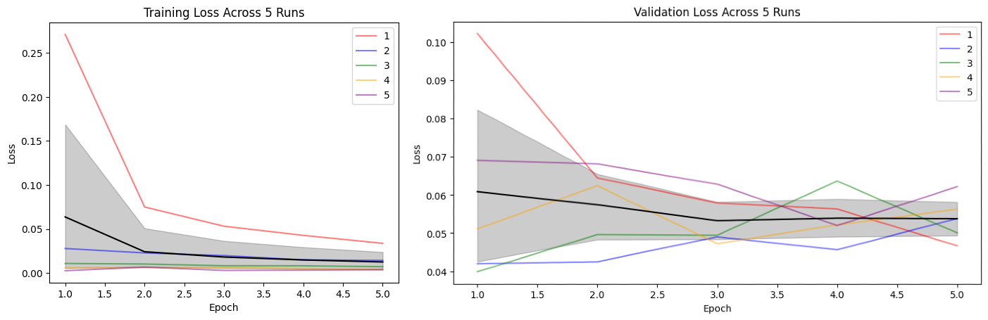
Run 2
Optimizer: Adam
Learning Rate: 1e-3
CNN: MediumCNN
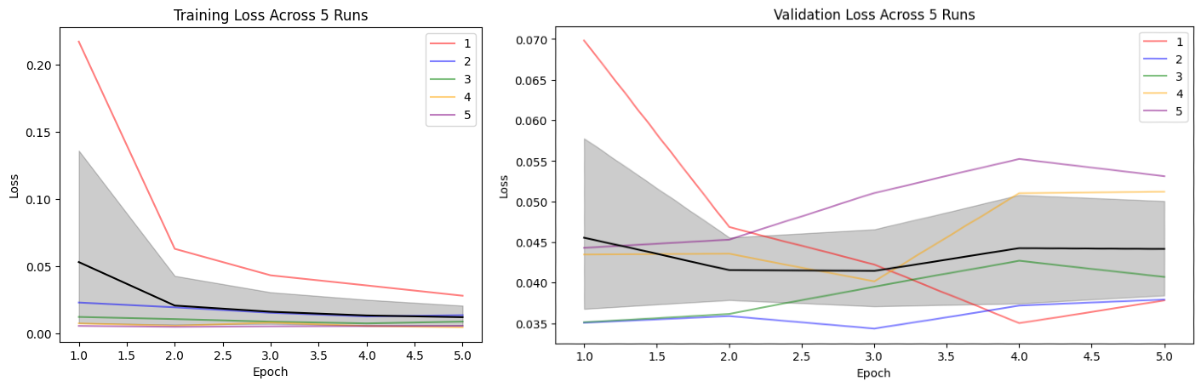
Run 3
Optimizer: Adam
Learning Rate: 1e-3
CNN: LargeCNN
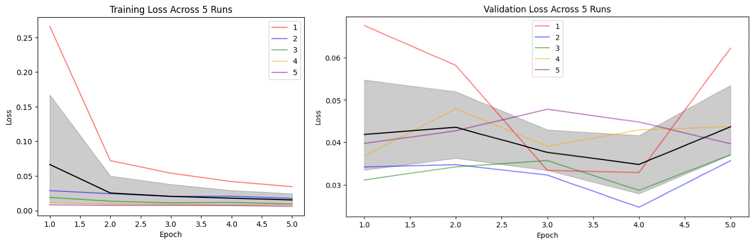
Run 4
Optimizer: AdamW
Learning Rate: 1e-4
CNN: SmallCNN
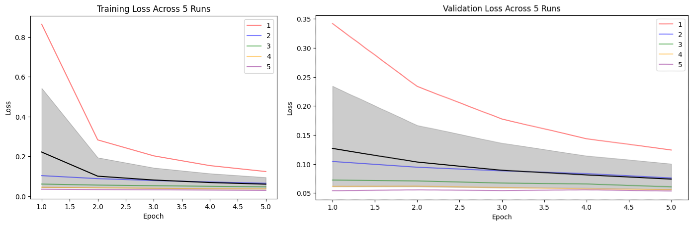
Run 5
Optimizer: AdamW
Learning Rate: 1e-4
CNN: MediumCNN

Run 6
Optimizer: AdamW
Learning Rate: 1e-4
CNN: LargeCNN
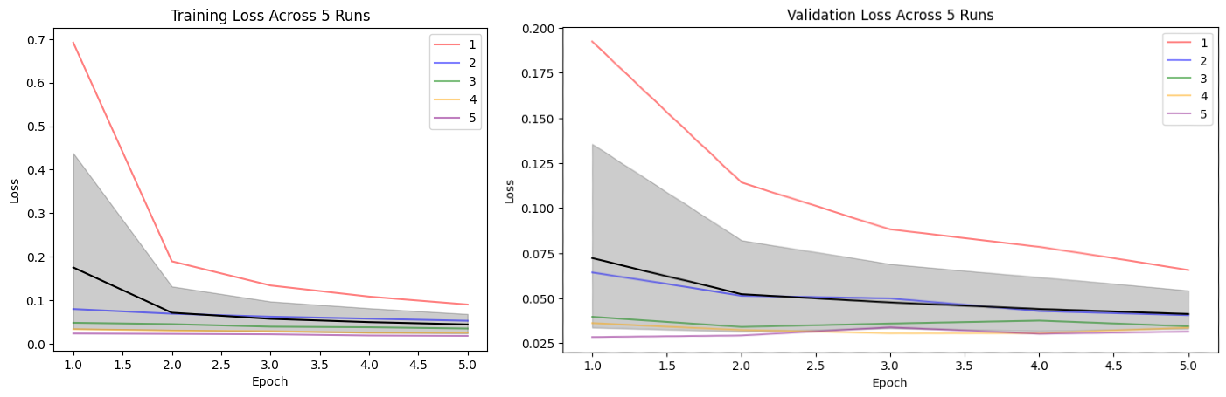

Conclusion
In this project, I demonstrated that CNN training is inherently stochastic and that comparing models using only one training run can be unreliable.
Across all architectures, repeated training attempts produced noticeably different loss curves, confirming that initialization and shuffling introduce meaningful variability.
For the optional task, I modified learning rate, model size, and optimizer.
These experiments showed that:
- Lower learning rates slow convergence but produce smoother curves.
- AdamW provides better regularization for larger models.
- Model capacity amplifies variability across runs.

