Introduction
In this project, I explored how to generate “dream-like” images using GoogleNet (Inception v1) together with the DeepDream algorithm. My goal was to understand how different architectural layers and hyperparameters contribute to the patterns, textures, and distortions that appear in the final visual output.
I started from a base notebook and extended it to support automated experimentation. I modified the code to perform systematic evaluations across a wide range of layer configurations, optimization settings, jitter levels, and octave parameters. I also implemented a logging system that saves both the generated images and the full experiment settings in a structured CSV file for later analysis.

Experimental Setup
I used a pretrained GoogleNet (Inception v1) from PyTorch’s model zoo.
The input image for all experiments was a single photograph, processed through the same preprocessing pipeline and moved to GPU when available.
To make sure consistency and reproducibility, I created a results directory and an experiments.csv file that records:
- experiment ID
- selected layers
- number of octaves
- octave scale
- learning rate
- jitter amount
- optimizer
- output image filename
I used exhaustive loops over several hyperparameter sets to automatically generate images and log each outcome.

Code Modifications
Logging and Output System:
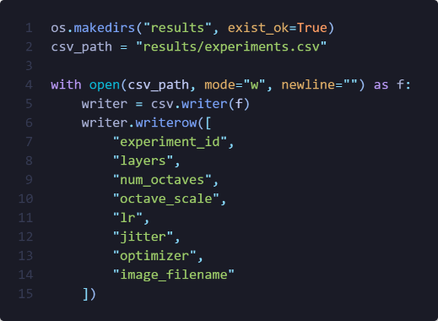
One of the main modifications I made was adding a CSV logging system:

Extended Layer Options:
I created two sets of layer_options:
First batch:
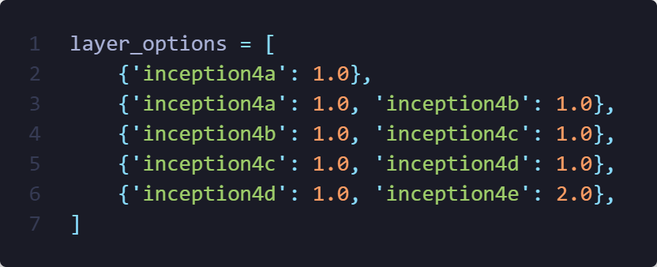
Second batch:
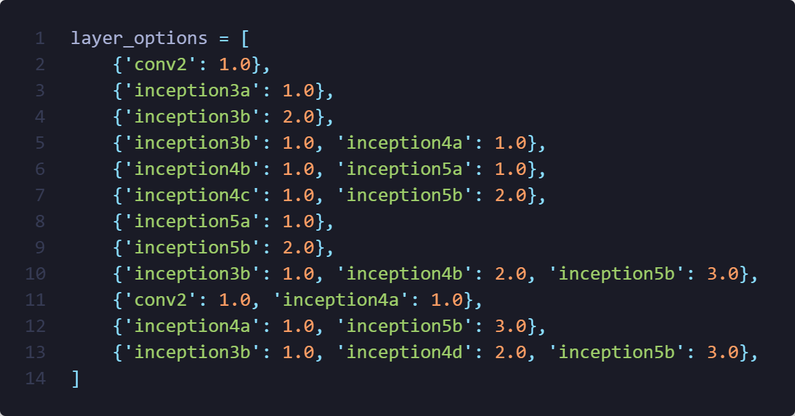
Hyperparameter Ranges
For both experiment batches, I tried:
- Octaves: 3, 5
- Octave scales: 1.2, 1.4
- Learning rates: first run {0.01, 0.05, 0.1}, second run {0.05, 0.1}
- Jitter: {16, 32}
- Optimizer: only Adam
- Iterations: 50
This generated dozens of high-resolution outputs, each influenced by different combinations of parameters.

Result Analysis

Early-Layer Experiments (conv2 Only)
For these experiments, I used only the conv2 layer, which is one of the earliest layers in GoogleNet. Because this layer primarily detects simple edges, color transitions, and low-level textures, I expected that the resulting dream images would not contain complex hallucinated objects. This expectation was confirmed in both outputs.
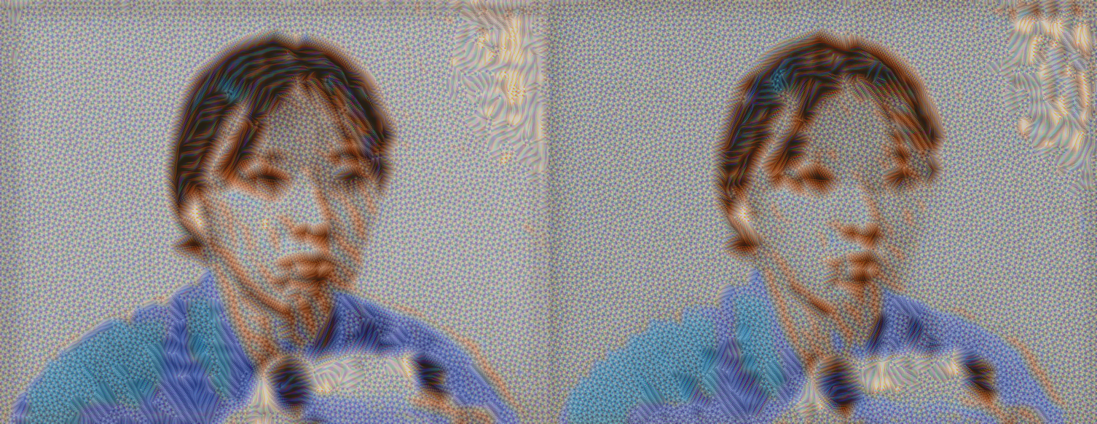
Both images used only the conv2 layer, so the outputs remained simple and mostly emphasized edges and color transitions. As expected from such an early layer, no complex patterns formed; instead, the outline of the person and the colors of the shirt became slightly sharper while the background turned into noise. Both results also showed a consistent distortion in the top-right corner, likely because early layers amplify any small gradient irregularities in high-contrast areas of the original image.
Between the two runs, the image from Experiment 2 (LR = 0.05, jitter = 32) appeared more stable and more smoothly developed, while Experiment 3 (LR = 0.1, jitter = 16) produced harsher noise. The higher learning rate in Experiment 3 caused the optimization to overshoot and exaggerate rough textures, and the lower jitter made the noise more concentrated. Overall, both outputs behaved as expected for shallow-layer DeepDream experiments.

Effect of Octave Count (Experiments 33 vs. 41)
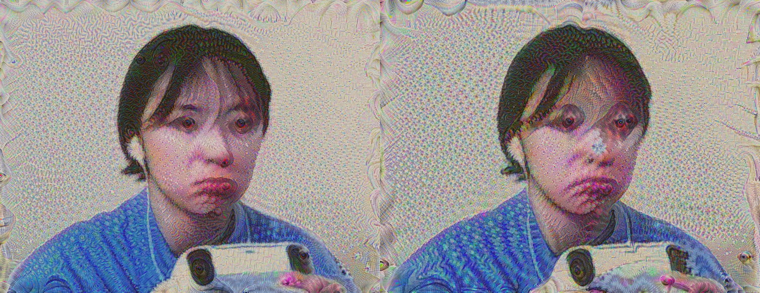
Layers: {'inception3b': 2.0}
LR = 0.05, Jitter = 16, Octave Scale = 1.2
In this comparison, I kept the same deeper layer (inception3b) and changed only the number of octaves. Since inception3b represents mid-level features, both images developed much more strongly than earlier-layer experiments, especially around the person’s eyes, where the model tends to reinforce circular, high-contrast structures. This also explains the slight “eye-splitting” effect and the tendency for new eye-like shapes to appear.
Both outputs showed a spiraling deformation near the corners. This typically happens because multi-scale dreaming enhances repeated gradient directions across octaves; any corner region with strong edges gets amplified repeatedly, producing rotational or swirling artifacts. The main difference between the two is that with 5 octaves (Experiment 41), the image gained significantly more structure. Additional octaves give the model more opportunities to refine and exaggerate patterns across scales, which is why Experiment 41 shows clearer hallucinated features, including the first signs of the model “placing” eye-like textures onto the image, compared to the 3-octave version in Experiment 33.

Stronger Feature Distortion (Experiment 48)
Layers: {'inception3b': 2.0}
LR = 0.05, Jitter = 16, Octave Scale = 1.4, Octave = 5
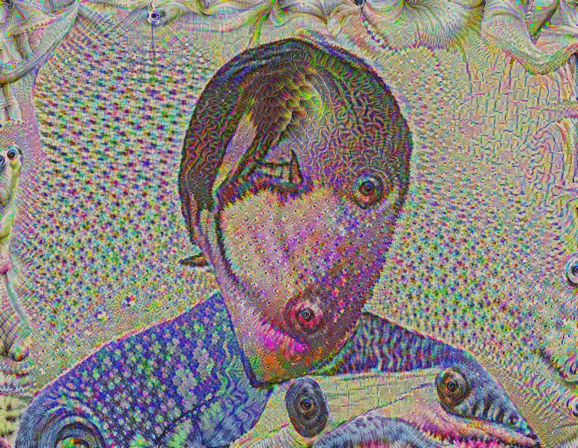
In this experiment, the typical eye-splitting and extra-eye formation seen with inception3b became much more pronounced. Because I used both a higher octave scale (1.4) and a higher learning rate (0.1), the model amplified mid-level features more aggressively, causing large distortions across the entire face. As a result, finer structures such as the nose, lips, and eyebrows are barely preserved, while hair, fingers, and corner regions warped heavily.
The combination of a strong scale factor and an overly high learning rate pushed the optimization toward unstable gradients, which explains the chaotic textures and more severe structural deformation. This produced a genuinely “dream-like” look, with exaggerated artifacts overtaking most of the original image.

Mixed Mid-Layer Activations (Experiments 50 & 62)
Layers: {'inception3b': 1.0, 'inception4a': 1.0}
LR = 0.05, Jitter = 32, Octave = 3 (Ex 50), Octave = 5 (Ex 62)
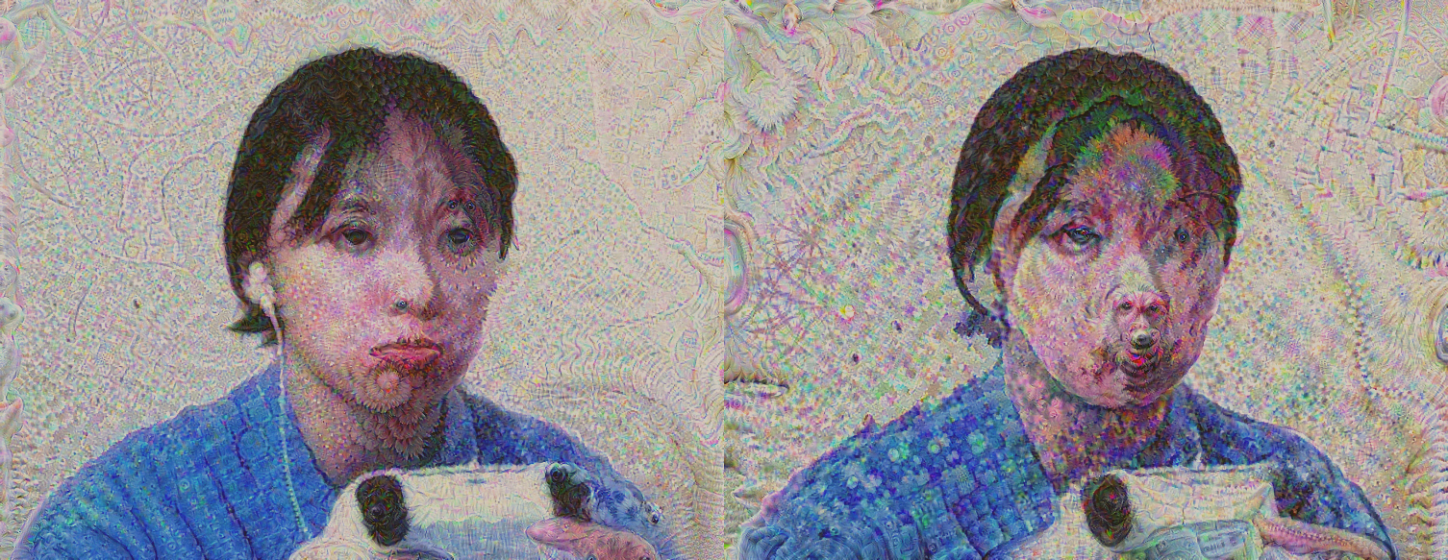
In these experiments, I combined inception3b with inception4a, which activates a wider mix of mid-level features. One of the most noticeable effects was the appearance of “dog-like” faces in various parts of the image. This is a known DeepDream phenomenon: Inception networks were heavily trained on ImageNet categories such as dogs, making dog-related features very strongly encoded. When gradients from multiple mid-layers overlap, these learned animal textures often re-emerge as faint snouts, fur patterns, or partial dog faces. Both images also showed irregular, colorful distortions across the background, resembling a gasoline spill effect. Technically, this comes from interference patterns formed when multiple mid-layer filters amplify color gradients in slightly different directions. These overlapping activations create oily, swirling color shifts and scale-like patterns. Comparing the two runs, Experiment 62 (5 octaves, scale 1.4) naturally produced richer and more varied textures than Experiment 50 (3 octaves, scale 1.2). However, because the learning rate stayed low (0.05), the model preserved most facial structure in both results, avoiding the extreme distortions seen in higher-LR experiments.

Summary of Results
Out of the many experiments I ran, the selected examples highlight the most interesting behaviors I observed. Early layers such as conv2 only produced simple edge sharpening and noise, while deeper layers like inception3b and inception4a generated strong hallucinations such as duplicated eyes, corner spirals, and even faint dog-like features due to ImageNet’s bias toward animal classes. Increasing the number of octaves or the octave scale consistently led to richer and more exaggerated patterns, while higher learning rates caused stronger distortions and reduced facial detail. Overall, these results clearly showed how layer depth and hyperparameter choices directly shape the intensity and style of DeepDream outputs.

Conclusion
In this project, I implemented and extended a DeepDream pipeline using GoogleNet, ran a large set of controlled experiments, and built a logging system to track every generated output. By systematically varying the layers and hyperparameters, I was able to observe how different parts of the network contribute to the final dream-like appearance. Deeper layers produced meaningful and sometimes surprising patterns, while early layers stayed limited to low-level textures. Adjustments to octaves, learning rate, and jitter all influenced how stable or chaotic the results became.
These findings illustrate how deeply the behavior of DeepDream depends on the underlying feature hierarchy of the network and on the optimization parameters used. The experiments gave me a clearer understanding of how convolutional networks represent images internally and how those representations can be pushed to produce artistic, surreal visual effects.

