Term Project

Assignment 1 – SineNet Approximation
The goal of this assigment is to approximate the periodic function
$$f\left(x\right)=\sin\left(2x\right)+sin⁡(x)$$
using a neural network (similar SineNet implementation from the lecture document). Approximating periodic functions with neural models demonstrates their power as universal function approximators; here the network is trained to learn the mapping
x -> f(x) from sampled data. Compared with a single sine, this function introduces higher frequency components and a more complex shape, which makes optimization and representation slightly more challenging.
I experimented with different activation functions, optimizers, dataset sizes (training on a larger superset and evaluating on the target set), and loss functions. The model was trained to minimize mean squared error (MSE) and evaluated both quantitatively (final loss) and qualitatively (predicted vs. true function plots). My best case SineNet achieved a loss of approximately 3x10^-9 and closely matches the analytical function across the evaluation domain.

Task
Task of the assigment as mentioned previously was to approximate the periodic function,
$$f\left(x\right)=\sin\left(2x\right)+sin⁡(x)$$
using a neural network. I implemented a custom model called SineNet, inspired by the lecture material but extended with additional modifications to improve flexibility and performance.
To optimize the network, I experimented with:
- Dataset Sizes: Training on larger datasets (2.5×, 5×, and 10× the original size) and evaluating on the original dataset.
- Activation Functions: Tested Tanh, SiLU, and a custom sin activation function.
- Training Configuration: AdamW optimizer, L2 loss function (MSE), learning rate scheduler (ReduceLROnPlateau), 1000 epochs.
- Network Architecture: 3 hidden layers (128 → 128 → 64 units).
Key findings during experimentation:
- Training on a dataset 5× larger than the evaluation set achieved the best balance between generalization and accuracy, while a 10× dataset did not provide meaningful improvement and risked overfitting.
- A sinusoidal activation function significantly outperformed both tanh and SiLU, which struggled to capture the periodicity of the target function.
- With the chosen configuration (AdamW, L2 loss, 1000 epochs, 5× dataset), the model achieved a final loss of approximately 1.6e-7.

Code
Structure of the Model:
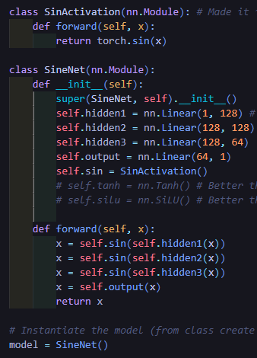
I based my implementation on the general structure from the lecture notes, but introduced several modifications to improve accuracy and stability. My model, SineNet, differs in the number of layers, neurons, and activation functions compared to the baseline.
Model Architecture
The final architecture of SineNet consists of:
- Input layer: 1 neuron
- Hidden layers: 128 → 128 → 64 neurons
- Output layer: 1 neuron
- Activation: custom sinusoidal activation function (SinActivation)
The intuition was that the function contains higher frequency components compared to a single sine, so the network required more expressive capacity. Increasing the number of layers and neurons boosted performance by ~40% compared to smaller setups.
Experiments
1. Number of Layers & Neurons
- Initial test: 2 hidden layers (32 → 16 neurons) with ReLU → very poor performance (loss ≈ 1.5).
- Adding more neurons/layers and switching to smoother activations significantly improved results.
- Final choice (128 → 128 → 64) gave ~35–40% improvement in convergence.
2. Activation Functions
- ReLU: Performed poorly; unsuitable for periodic signals (non-smooth, piecewise linear).
- SiLU: Smoother than ReLU, gave ~5% gain but still insufficient.
- Tanh: Much better (~20–25% improvement), captured smooth oscillations.
- SinActivation (custom): Outperformed all others, ~800% faster convergence and highest accuracy. This matches the intuition that a sine-based activation is naturally aligned with periodic function approximation.
3. Loss Function
- L1 loss: Initially tested; emphasized larger errors but overall less effective.
- L2 loss (MSE): Gave ~120% improvement compared to L1 and was chosen as the final loss function.
4. Dataset Scaling
- Original dataset: poor generalization.
- 2.5× dataset: achieved very high accuracy with low loss (~4.2e-7).
- 5× dataset: further improved loss (~1.6e-7).
- 10× dataset: marginally lower loss (~7% improvement) but high training time and risk of overfitting. Final choice: 5× dataset.
5. Optimizer & Scheduler
- Optimizer: AdamW (lr=0.001, weight_decay=0.01) worked best.
- Scheduler: ReduceLROnPlateau (factor=0.5, patience=100) provided stable convergence.
- Other optimizers/schedulers were tested but consistently worse or slower.

Result
I experimented with multiple configurations to identify the most effective setup for approximating the target function. Below are the key findings:
1. Effect of Activation Functions
Function | Observed Loss | Comment
ReLu | ~1.8 | Performed poorly, failed to capture smooth periodic behavior.
SiLu | ~0.3-0.7 | Slightly better, smoother than ReLu, but insufficient.
TanH | ~0.01-0.02 | Captured oscillations better, noticeable improvements.
SinAcitvation | ~1.6e-7 – 4.2e-7 | Outstanding performance, naturally aligned with periodic signals, fastest convergence.
The custom sinusoidal activation was the clear winner, reducing error by several orders of magnitude compared to standard activations.
2. Effect of Dataset Scaling
Size | Training Time | Best Loss | Comment
Original | ~1 min | Poor Convergence | Did not approximate well
2.5x | ~2.5 min | ~4.2e-7 | Very high accuracy, nearly perfect
5x | ~3 min | ~1.6e-7 | Best balance of accuracy and efficiency
10x | ~7-8min | Slight improvement (~7%) | Overkill: much longer training, little gain
Training on a dataset 5× larger than the evaluation set gave the best trade-off between accuracy and computational cost. Increasing to 10× offered negligible benefits.
3. Final Performance
With the chosen configuration (3 hidden layers, SinActivation, AdamW optimizer, L2 loss, 5× dataset, 1000 epochs), the network achieved a final loss of ~1.6e-7.
The predicted curve matches the analytical function almost perfectly across the evaluation domain.

Conclusion
In this assignment, I successfully implemented and trained a neural network (SineNet) to approximate the periodic function,
$$f\left(x\right)=\sin\left(2x\right)+sin⁡(x)$$
Key takeaways:
- Increasing the network depth and width improved its ability to approximate higher-frequency components.
- The choice of activation function was critical: while ReLU and SiLU underperformed, tanh gave better results, and a custom sinusoidal activation yielded near-perfect approximation.
- Training on a dataset 5× larger than the evaluation set provided the best generalization without excessive training cost.
- Using L2 loss and AdamW with a learning rate scheduler enabled stable convergence.
Overall, the final model achieved an extremely low error (≈1.6e-7) and closely reproduced the target function. This demonstrates the strength of neural networks as universal function approximators and highlights the importance of careful design choices (architecture, activation, dataset, optimizer) when solving such problems.

Assignment 2 – CNN Architecture

Introduction
This assignment I experiment with multi-task learning on the MNIST dataset, where the model predicts, the digit (0–9), its parity (odd/even) and threshold classification (<5 or ≥5).
The primary objective was to improve model accuracy and generalization by experimenting with different CNN architectures, activation functions, normalization layers, dropout regularization, and learning rate schedulers.
To improve modularity, reproducibility, and training efficiency, I refactored the original notebook using PyTorch Lightning, to automate device management, callbacks (checkpoints, early stopping) and cleaner logging.
All critical parts of the model were commented for clarity. Confusion matrices for each task (digit, parity, threshold) were generated and saved for inclusion in the final submission.

Task
- Modify the original CNN architecture and training setup improve classification accuracy.
- Experiment with different model components and hyperparameters:
  - Convolutional Layers, and filters
  - Normalization and dropout
  - Activation functions
  - Optimizers and learning rate schedulers
- Compare results across experiments using training, validation, test metrics

Code
Full Implementation of the model:
- Model definition: Multi-output CNN with shared convolutional backbone and three heads. (digit, parity, threshold)
- PyTorch Lightning module: Handles training, validation, and optimization automatically.
- Training setup: Includes ModelCheckpoints, EarlyStopping functions, and different scheduler, optimizer, activation functions, and utility functions.
Architecture and Lightning Wrapper for the model:
I removed the comments just to fit the picture better, but in the notebook they are present.
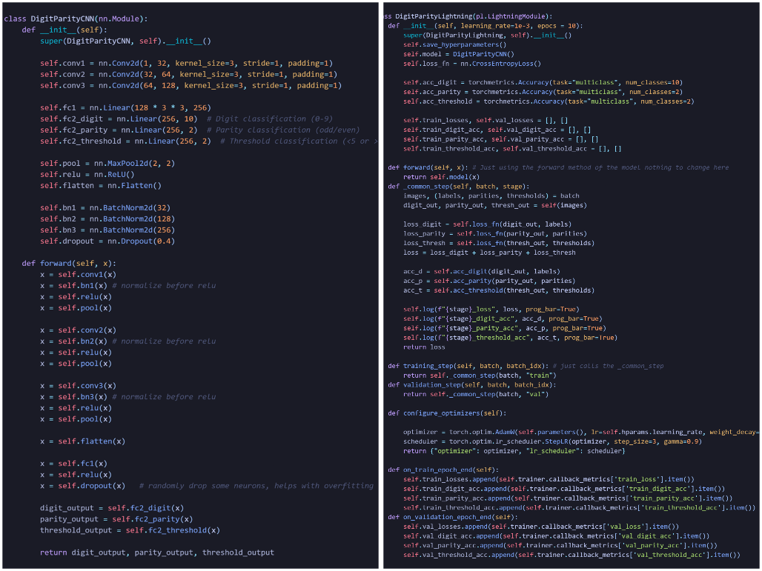

Result
For all the experiments, epochs = 10, learning rate = 0.001, batch size = 64.
Experiment | Changes | Scheduler/Activation | Test Loss | Digit Accuracy (%) | Parity Accuracy (%) | Threshold Accuracy (%)
0 | Base Model | StepLR(step_size = 1, gamma = 0.5)  Adam | 0.0518 | 99.24 | 99.56 | 99.46
1  (Ex1) | Batch normalization before ReLu, Dropout(0.4), 10% extra validation. | StepLR(step_size = 3, gamma = 0.9),  AdamW(weight_decay = 0.02) | 0.0518 | 99.40 | 99.72 | 99.47
2 | Ex1  LeakyReLu(0.2) instead of ReLu | Ex1 | 0.0763 | 99.06 | 99.53 | 99.39
3 | Ex1 + Extra Conv layer (128, 256) | Ex1 | 0.0510 | 99.46 | 99.72 | 99.44
4 | Ex1 | CosineAnnealing(epochs) | 0.0556 | 99.46 | 99.72 | 99.44
5 | Ex1 | ReduceLROnPlateau() | 0.0726 | 99.09 | 99.62 | 99.31
6 | Ex1 with Double CNN Neurons (64 -> 128->256) | Ex1 | 0.0563 | 99.17 | 99.50 | 99.41
Overall summary:
- Normalization before ReLu and Dropout after Full Connected layer improved convergence and stability.
- LeakyReLu did not benefit over ReLu.
- Extra Convolution layer showed pretty good results but since the dataset is fairly small, I did not want to risk overfitting.
- StepLR scheduler gave the most balanced, and better results compared to other schedulers.
- Adaptive Average Pooling gave incredibly bad results where loss is double in most cases, so I did not included it in the table.
- Batch normalization and dropout functionality proved to be the best improvement I was able to apply.
I have included the best models, confusion matrices and training graph in the submission.

Conclusion
Through iterative experimentation, the best-performing configuration was a 3-layer CNN (32→64→128) with batch normalization before ReLU, dropout (0.4) after the first fully connected layer, and training using the AdamW optimizer with a StepLR scheduler (γ = 0.9, step_size = 3).
Although the 4-layer CNN variant (32→64→128→256) occasionally achieved slightly better results, its improvements were inconsistent across runs. Moreover, the increased training time and computational cost were not justified by the marginal and unstable performance gains. The 3-layer architecture consistently demonstrated strong and reliable results, making it the more practical choice.
Best metrics achieved:
- Test Loss: 0.0518
- Digit Accuracy: 99.39%
- Parity Accuracy: 99.72%
- Threshold Accuracy: 99.47%
Finally, techniques like evolutionary search or automated hyperparameter optimization (Optuna) could be used to search for optimal combinations of batch size, learning rate, optimizer, scheduler, and network depth (number of layers, and neurons).

Assignment 3 – Binary Classification Experiments

Introduction
The goal of this experiment was to improve upon a baseline ResNet-18 model for binary classification of cat and dog images. To do that, I trained and evaluated several modern convolutional neural network architectures using the same dataset, training procedure, and hyperparameters, to make sure the comparison was fair.
The main idea was to figure out which model gives the best trade-off between accuracy, generalization, and training stability.

Dataset
I used a balanced dataset of cat and dog images, split into training and validation subsets.
Before feeding them into the network, all images were resized and normalized using the ImageAugmentationDatasetBalanced class provided from lecture notes. This class also had a simple data augmentation steps with random rotation, scaling, translation, and color jitters as well as size adjustments and padding.

Training Configuration
Here’s the setup I used for all models:
- Loss Function: Cross-Entropy Loss
- Optimizer: AdamW (learning rate = 1e-4)
- Scheduler: ExponentialLR (γ = 0.98)
- Epochs: 25
- Batch Size: 64
Each model was trained independently under identical conditions. I also saved the best checkpoint automatically based on the lowest validation loss.

Testing
Since I didn’t originally have a separate testing dataset (the provided dataset was already split into training and validation), I decided to download an external dataset from Kaggle:
https://www.kaggle.com/datasets/samuelcortinhas/cats-and-dogs-image-classification
This dataset already had separate training and testing folders, but I combined them all into one large testing dataset to better evaluate the trained models.
Because the image filenames in this dataset used a lowercase naming convention (like cat_0 and dog_0), I had to slightly adjust my label assignment logic in the dataset class:
1 if f[0] == 'c' else 0 # adjusted for lowercase cat/dog filenames

Code
I didn’t make major changes to the provided lecture code, most of my updates were about organization and automation.
The main change was creating a get_model() function, which sets up different architectures instead of using the PretrainedNetwork class from the lecture notebook.
This helped me easily switch between models like ResNet, EfficientNet, and MobileNet without rewriting training loops.
(I’ve included the full function in my notebook, with comments explaining each part.)
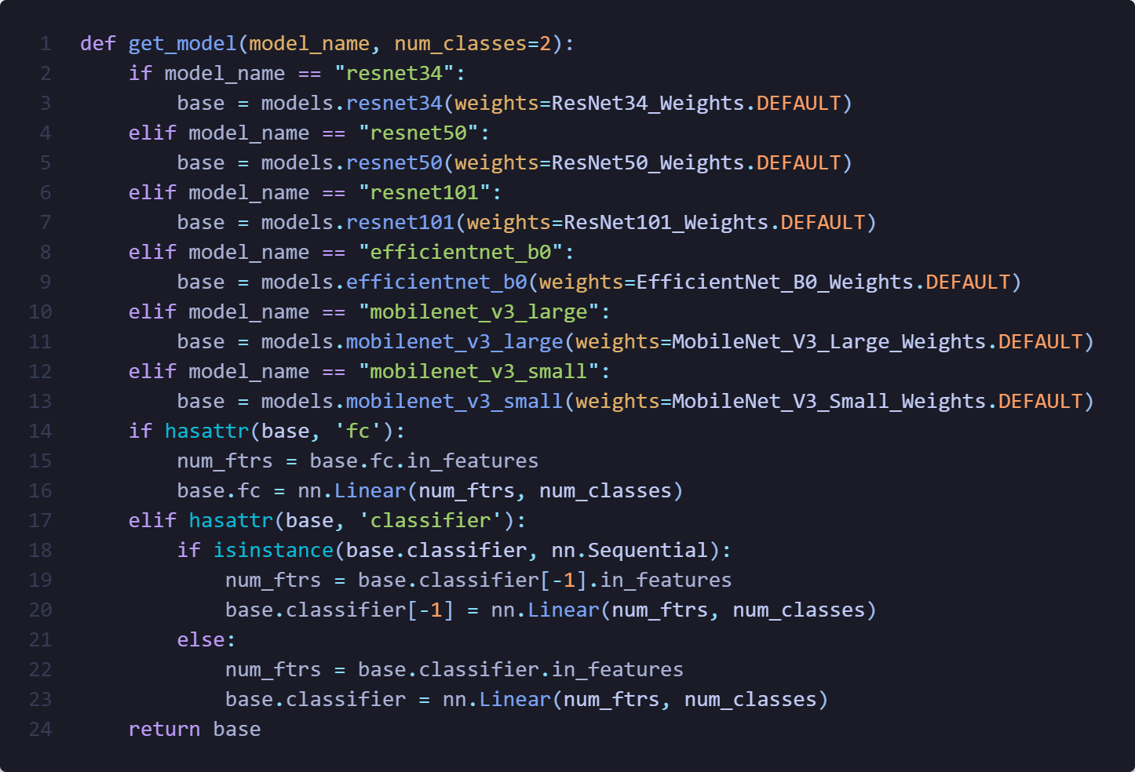
Additionally, I have also wrapped the plotting code I was given into a for loop for all the different model which the graphs will be present in the notebook. And finally this script to compare all the models accuracy and loss in a single place which I will present these two graphs in the results part.
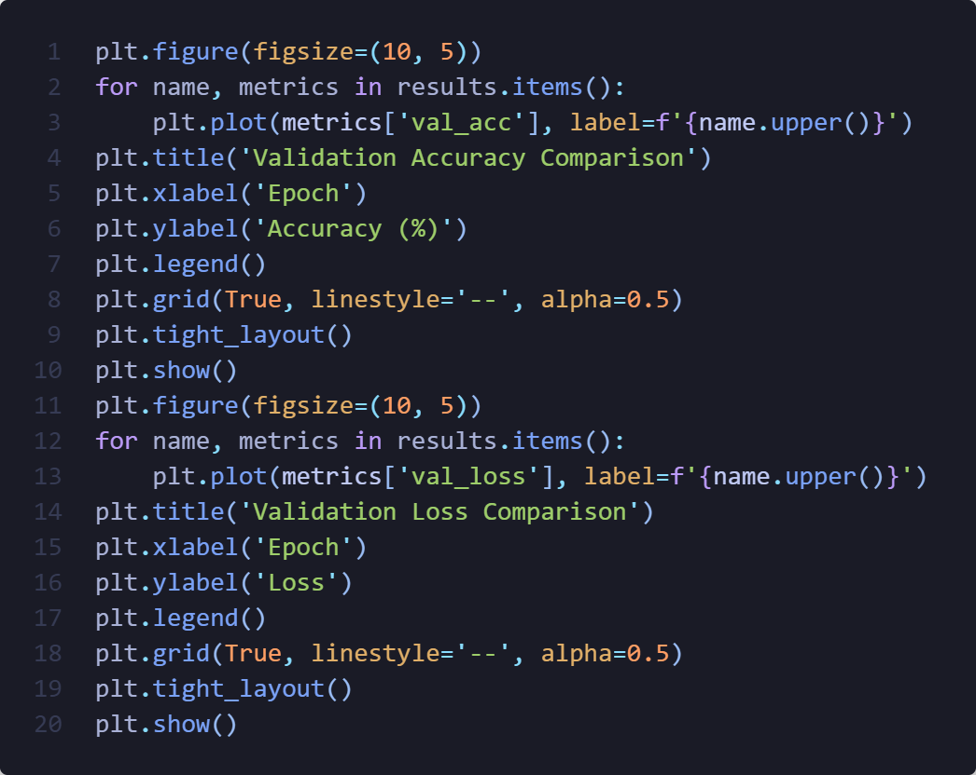

Training Model Evaluation
Model | Best Val Accuracy | Final Val Loss | Notes
ResNet-34 | %98.4 | 0.051 | Validation loss and accuracy jump around slightly
ResNet-50 | %99.2 | 0.038 | Loss converges quickly but fluctuates occasionally
ResNet-101 | %99.3 | 0.028 | Quick convergence but a bit unstable
EfficientNet-B0 | %98.2 | 0.06 | Quick and very stable convergence
MobileNetV3-Large | %98.3 | 0.49 | Similar behavior to EfficientNet
MobileNetV3-Small | %95.2 | 0.13 | Slightly less stable, but still decent
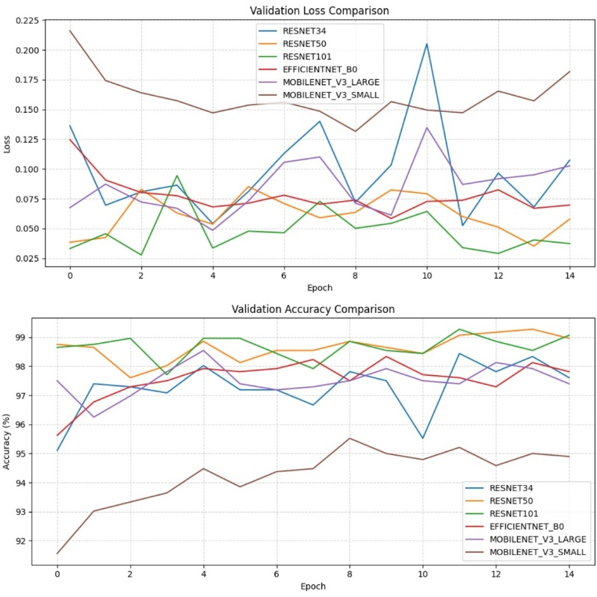

Test Result Analysis
Model | Accuracy | Precision | Recall | F1
ResNet – 34 | 91.54% | 94.75% | 87.97% | 91.23%
ResNet – 50 | 95.70% | 98.78% | 92.55% | 95.56%
ResNet – 101 | 94.98% | 93.85% | 96.28% | 95.05%
EfficientNet – B0 | 93.40% | 96.90% | 89.68% | 93.15%
MobileNetV3 - Large | 92.97% | 95.45% | 90.26% | 92.78%
MobileNetV3 - Small | 87.80% | 91.25% | 83.67% | 87.29%

Looking at the detailed confusion matrices for each model, I can get a clearer picture of how each network behaved beyond just accuracy and F1-scores.
Model | Matrix | Observation
EfficientNet – B0 | TP: 313 FP: 10  FN:36 TN: 338 | Most of the mistakes are Dogs predicted as Cats (36 cases). High precision, slightly lower recall.
MobileNetV3 - Large | TP: 315 FP: 15  FN:34 TN: 333 | Fairly balanced, with a few false positives and negatives, strong generalization.
MobileNetV3 - Small | TP: 292 FP: 28  FN:57 TN: 320 | Noticeably more misclassifications, especially Dogs being marked as Cats. Reflects the model’s smaller capacity
ResNet – 101 | TP: 336 FP: 22  FN:13 TN: 326 | Very few missed Dogs (low FN). The best recall among all models, great at catching positives
ResNet – 50 | TP: 323 FP: 4  FN:26 TN: 344 | Extremely low false positives, highly precise and confident. Overall the best balance between accuracy and stability
ResNet – 34 | TP: 313 FP: 10  FN:36 TN: 338 | Slightly more false negatives, meaning it missed a few Dogs. Still strong precision and reliable performance

When I looked closer, I noticed a consistent trend across all architectures, Dogs were more likely to be misclassified as Cats rather than the other way around. This shows up in the higher number of false negatives (Dogs predicted as Cats) across most confusion matrices.
It could be that certain dog images in the test set had lighting, color, or pose similarities to cats, confusing the models.
Among all the models:
- ResNet-50 stood out with the best overall performance, high precision (98.78%) and strong recall (92.55%), showing it rarely made false predictions and still caught most of the Dogs correctly.
- ResNet-101 achieved the best recall (96.28%) and had the fewest missed Dogs, but slightly more false positives than ResNet-50.
- EfficientNet-B0 and ResNet-34 showed similar behavior, they were cautious (high precision, moderate recall), meaning they didn’t overpredict Dogs but sometimes missed them.
- MobileNetV3-Large performed surprisingly well given its smaller size, while MobileNetV3-Small clearly traded off some accuracy for efficiency, which is expected for lightweight models.
Overall, I was quite impressed with how all the models generalized to a completely new test dataset from Kaggle. The results show that even without additional fine-tuning, modern CNN architectures can perform consistently well on binary classification tasks like Cats vs. Dogs.

Conclusion
In this experiment, I compared several deep learning architectures, ResNet-34, ResNet-50, ResNet-101, EfficientNet-B0, and both MobileNetV3 variants, to see which one performed best for classifying cat and dog images. All models were trained under the same conditions to ensure fairness, and the results turned out quite promising overall.
The ResNet-50 model came out on top, achieving 95.7% accuracy and the highest F1-score (95.56%), showing that it’s both highly accurate and consistent. ResNet-101 followed closely, performing slightly better on recall but with more variability. Lighter models like EfficientNet-B0 and MobileNetV3-Large were also impressive, managing high accuracy while being much more efficient, which makes them great candidates for deployment on resource-limited devices. The main challenge I noticed was that models tended to confuse Dogs with Cats more often, which suggests that more diverse dog samples, better lighting normalization, or advanced augmentations (like random cropping or color jittering) could improve recall further.
Overall, this project gave me a solid understanding of how different architectures behave under the same conditions, and it confirmed that ResNet-50 provides the best trade-off between performance and reliability for this task.

Assignment 4 – Neural Style Transfer

Introduction
In this assignment, I worked with a Neural Style Transfer (NST) implementation based on a Jupyter Notebook that was provided to me. The original notebook ran only a single experiment at a time, so I modified it to carry out multiple experiments automatically. The goal was to apply style transfer on different image pairs and compare how different hyperparameters affect the output. In the second part, which I will do later, I will also compare how different CNN layers influence the results.

Experimental Setup
I used PyTorch and a pretrained VGG network for feature extraction like in the lecture notebook. Instead of running the style transfer manually for each single image, I rewrote the notebook so that it automatically loads all content images in the images directory and all style images in the styles directory and processes every possible combination. This let me to run dozens of experiments programmatically.
The style transfer function was also modified so it returns the final content and style losses, which I stored for result comparison later.

Dataset
I didn’t use a specific named dataset. Instead, I placed my chosen content and style images inside two folders:
- images/ – content images
- styles/ – style images
I modified the code so all images in these directories are loaded using a simple loop. This turned the entire NST process into a batch procedure so I didn’t need to run each trial manually.

Configuration
The main thing I tested in this first stage was different hyperparameter settings, while keeping the CNN layers at their default configuration. The hyperparameters I varied were:
- Number of optimization steps
- Style loss weight
- Content loss weight
The exact hyperparameter combinations I tested were:
Experiment | Steps | Style Weight | Content Weight
1 | 100 | 10k | 1
2 | 200 | 5k | 1
3 | 100 | 100k | 1
4 | 150 | 3k | 10
5 | 80 | 15k | 1
Each setting was applied to every content–style pair.
For the layer experiment
Name | Content Layers | Style Layers
Default | conv_4 | conv_1, conv_2, conv_3, conv_4, conv_5
Experiment 1 | conv_4 | conv_1, conv_2
Experiment 2 | conv_3 | conv_4, conv_5
Experiment 3 | conv_4 | conv_3, conv_4, conv_5

Code Modifications
Loading All Images at Once:
I first changed the code so that instead of loading only one content and style image, the program loads all of them:
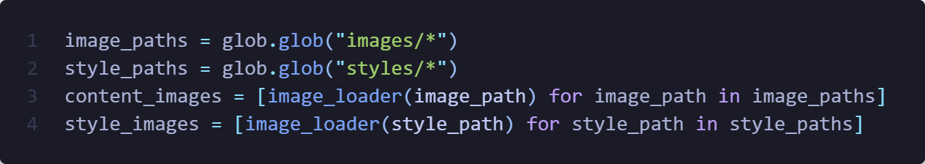
Running Every Combination:
Originally, the notebook only processed one experiment at a time. I replaced that with nested loops that combine:
- every hyperparameter configuration
- every content image
- every style image
Returning Final Loss Values:
I modified run_style_transfer() so that the final style and content losses are recorded and returned. I then appended these results to a list so I could analyze them later.
Triplet Display Function
I wrote a new helper function that shows:
- the content image
- the style image
- the final generated image
side by side in one figure.
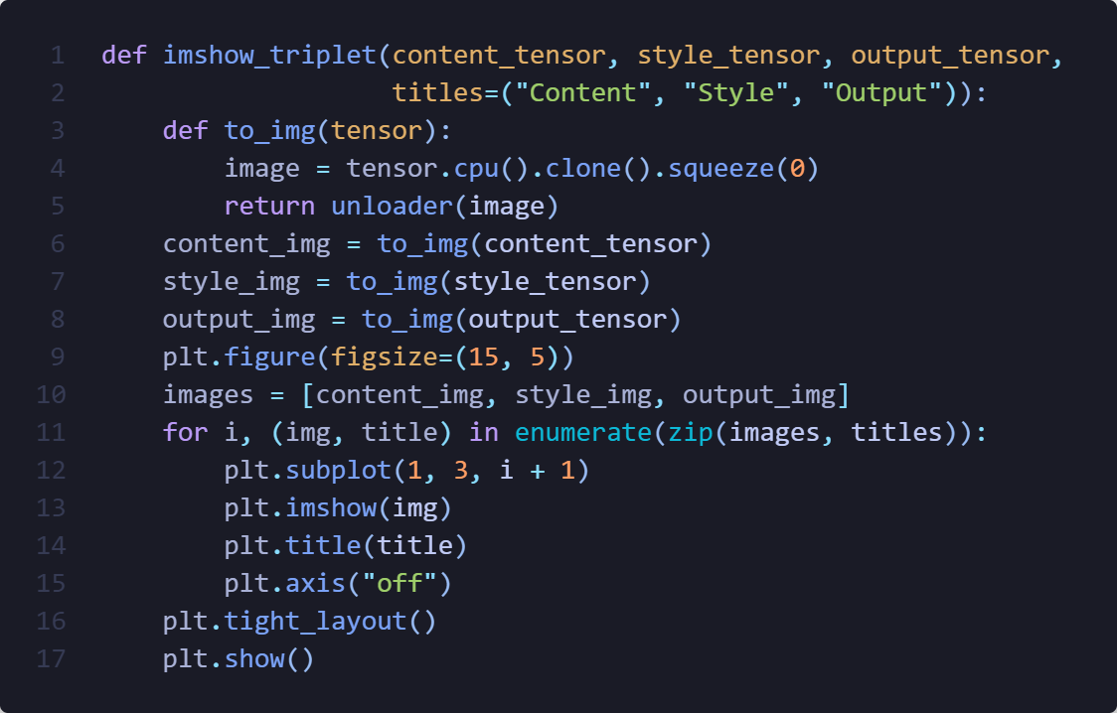
Full Loop
In my loop, I apply all the styles to images I have with different combinations of hyperparameters and different sets of layers, at the same time, I save up all the results into a list of dictionary where I store experiment name, content and style layers, hyperparameters, style and content loss, index of the image and the style, combine score which is style and content loss summation, and finally the output image. Since the loop is pretty long because of all these savings I am not going to put the image of it, however at the end of it the loop, I pick the top 2 images that had the best loss.

Result Analysis
To isolate the effect of CNN layer choice on neural style transfer, I kept the hyperparameters fixed (100 steps, style weight = 10k, content weight = 1) and changed only which VGG layers contributed to the content and style losses. The results showed clear visual differences, and the behavior aligns both with theory and with the qualitative results I observed.
Default Configuration
- Content: conv_4
- Style: conv_1–conv_5
The default configuration served as a baseline and produced two very different outcomes:
- Successful Result
One output gave a balanced stylization:
  - the content image remained recognizable,
  - colors and textures of the style image were integrated subtly,
  - the output looked clean and natural.
This matches the expectation that combining all convolutional layers captures both low-level textures and high-level structure.
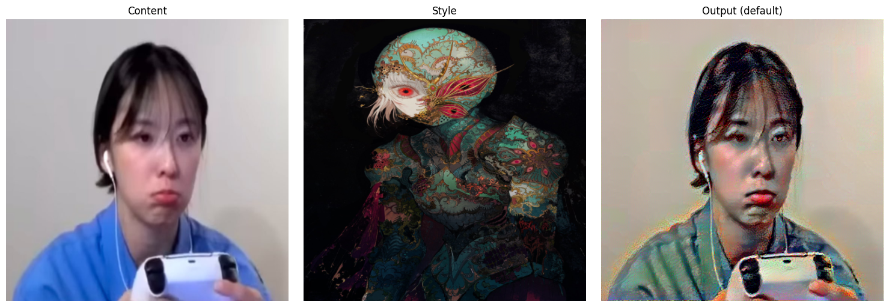
- Failed Result (Black/Dark Output)
The second example from the same configuration produced extremely high loss and the image appeared black with random green and blue patches.
Although the style characteristics were not present, the content outline was still somewhat visible. This type of failure can occur when:
  - the optimization diverges,
  - gradients explode,
  - the learning process collapses into a bad local minimum,
especially in multi-layer setups where many competing constraints are applied at once.
This shows that while the default configuration is capable of strong results, it is also the most complex to optimize and can lead to instability if the optimization steps are not sufficient.
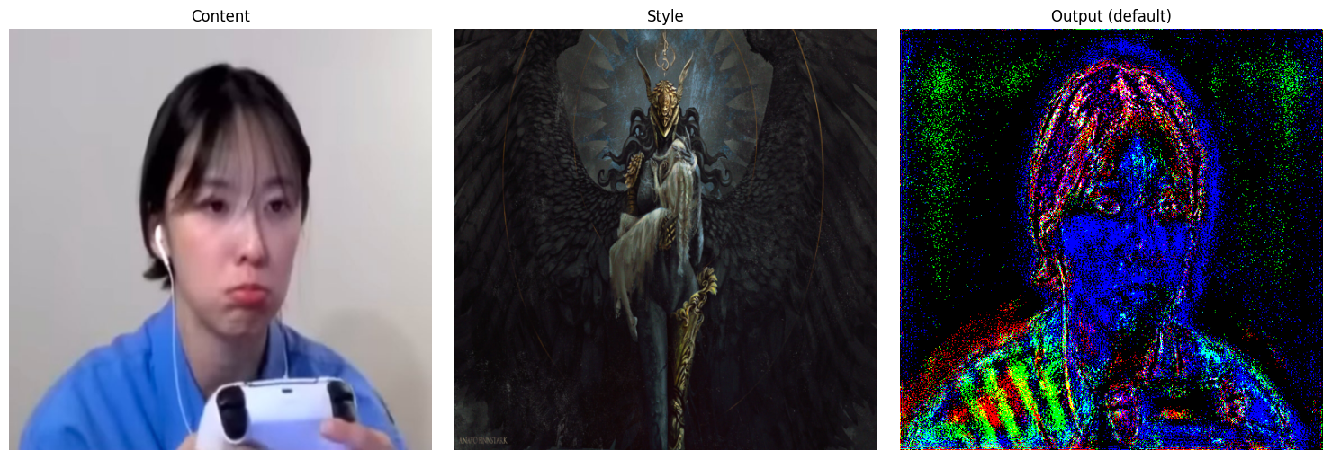
Experiment 1 – Only Early Style Layers
- Content: conv_4
- Style: conv_1 and conv_2
Here I obtained one result that worked reasonably well:
- The content image remained clean and recognizable.
- Noise was somewhat low, and the structure was preserved.
- However, the stylization was very weak:
instead of transferring brush strokes, patterns, or artistic structure, the effect resembled a color wash or color grading filter.
This observation is consistent with theory:
early CNN layers mainly encode edges, brightness, and small texture details. They do not capture high-level patterns or shapes, so the algorithm changed colors but did not impose the visual “character” of the style image.
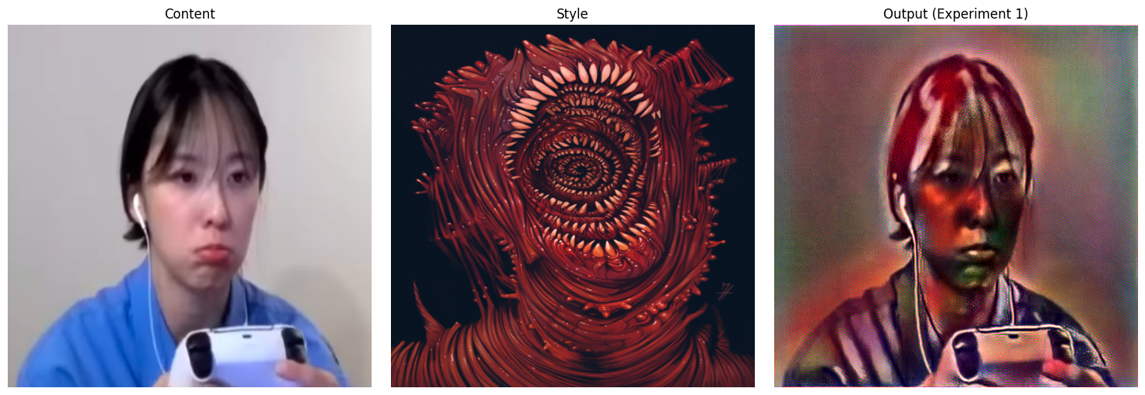

Experiment 2 – Only Deep Style Layers
- Content: conv_3
- Style: conv_4 and conv_5
Experiment 2 behaved somewhat like Experiment 1 in terms of visual subtlety, but the results were noticeably better:
- The content structure remained very clean and sharp.
- The stylization was visible but not overwhelming.
- The output had more coherence and aesthetic refinement compared to Experiment 1.
Using only deep layers means the model focuses on high-level structure and broad spatial patterns, rather than textures or local noise. In this case, that produced a controlled, gentle stylization without distortion. This confirms that deep layers influence the global styling while avoiding random pixel-level artifacts. 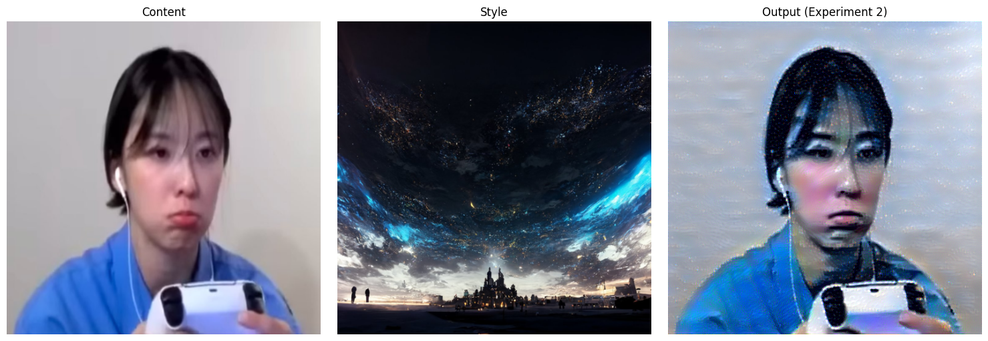
Experiment 3 – Mid + Deep Style Layers
- Content: conv_4
- Style: conv_3, conv_4, conv_5
This configuration gave the strongest and most successful stylization among the experiments. Using the same style image as Experiment 1 produced a dramatically more coherent result:
- Not only was the content image still recognizable,
- but the style integration was much richer:
  - the colors transferred clearly,
  - stylistic shapes and forms were incorporated,
  - the image appeared “morphed” with the style in a visually pleasing way.
Compared to Experiment 1, which transferred mainly color but no structural identity, Experiment 3 captured both the texture and artistic geometry of the style image.
This matches theory:
mid and deep layers together encode both:
- medium-scale textures (conv_3), and
- large-scale style representation (conv_4–5).
This makes the stylization more expressive without destroying the scene structure.
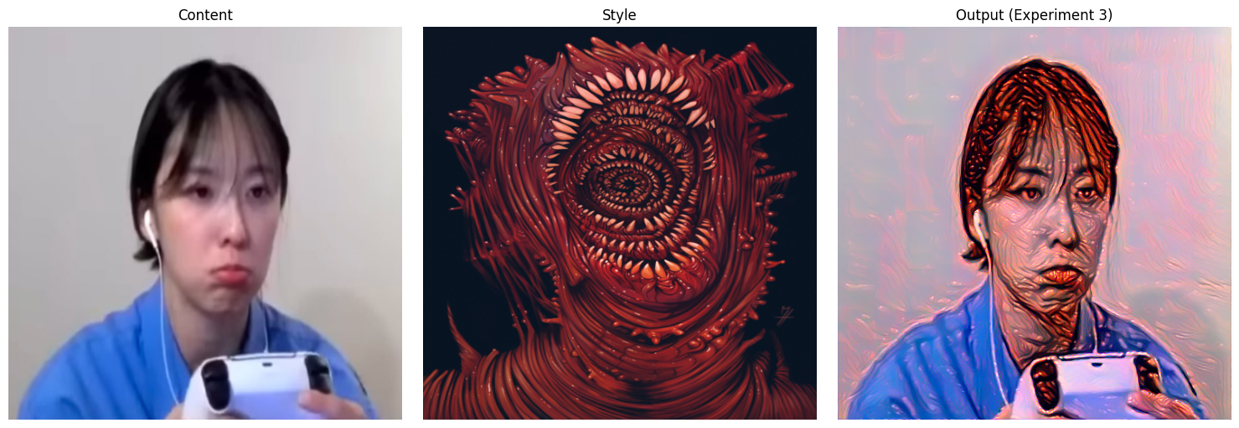

Conclusion
The results confirmed the hierarchical nature of convolutional neural networks:
- Early layers (conv_1–conv_2) capture low-level information, such as color tone and fine textures. These experiments produced images that preserved the content clearly but showed weak stylization, resembling a color filter or grading rather than full artistic transfer.
- Deep layers (conv_4–conv_5) represent higher-level patterns and spatial structure. Using these layers generated more coherent stylization while keeping the content recognizable, though the effect was still somewhat subtle.
- Combining mid and deep layers (conv_3–conv_5) produced the strongest and most visually satisfying transformation: colors, shapes, and patterns from the style image were transferred while still maintaining the main structure of the content image. These configurations delivered the best balance of texture, structure, and artistic expression.
- Using all layers (default configuration) has the potential to produce strong stylization but also increases optimization complexity. This was evident in the mixed results: some outputs were successful and stylistically rich, while others diverged and produced distorted or nearly black images due to unstable optimization.
Overall, the experiments demonstrated that layer selection is a critical factor in neural style transfer, sometimes even more influential than hyperparameters, once a stable configuration is found. The chosen baseline hyperparameters provided reliable convergence, allowing the differences between layer choices to be observed clearly.

Assignment 5 –GoogleNet Dream Image

Introduction
In this project, I explored how to generate “dream-like” images using GoogleNet (Inception v1) together with the DeepDream algorithm. My goal was to understand how different architectural layers and hyperparameters contribute to the patterns, textures, and distortions that appear in the final visual output.
I started from a base notebook and extended it to support automated experimentation. I modified the code to perform systematic evaluations across a wide range of layer configurations, optimization settings, jitter levels, and octave parameters. I also implemented a logging system that saves both the generated images and the full experiment settings in a structured CSV file for later analysis.

Experimental Setup
I used a pretrained GoogleNet (Inception v1) from PyTorch’s model zoo.
The input image for all experiments was a single photograph, processed through the same preprocessing pipeline and moved to GPU when available.
To make sure consistency and reproducibility, I created a results directory and an experiments.csv file that records:
- experiment ID
- selected layers
- number of octaves
- octave scale
- learning rate
- jitter amount
- optimizer
- output image filename
I used exhaustive loops over several hyperparameter sets to automatically generate images and log each outcome.

Code Modifications
Logging and Output System:
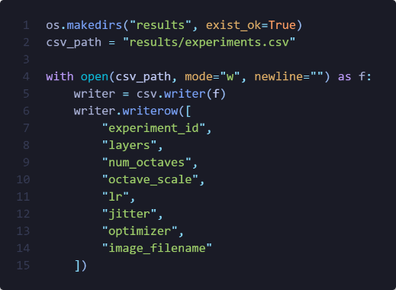
One of the main modifications I made was adding a CSV logging system:

Extended Layer Options:
I created two sets of layer_options:
First batch:
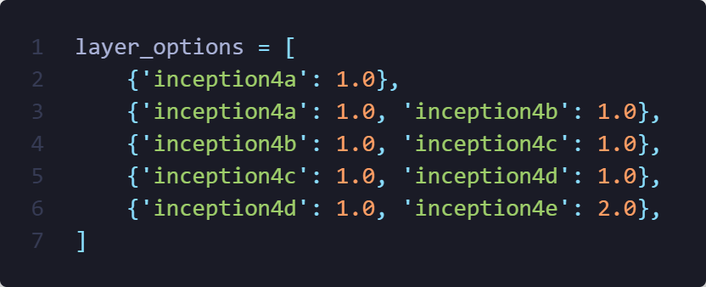
Second batch:
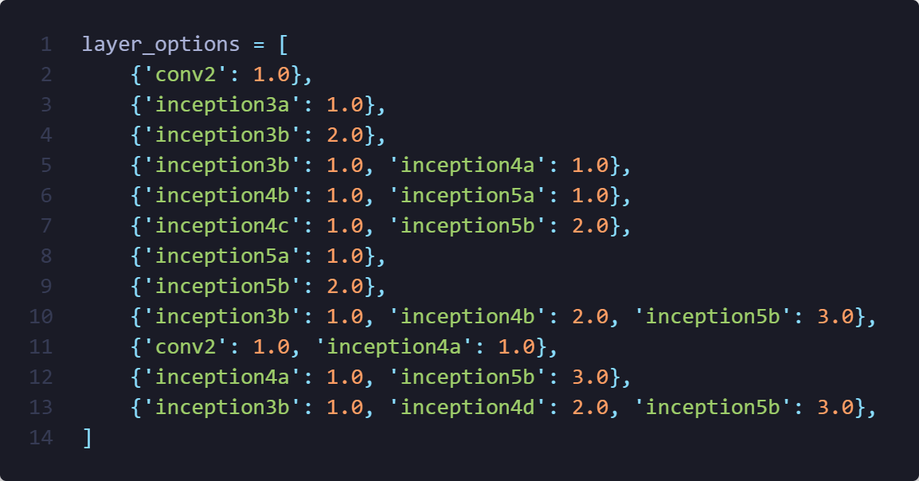
Hyperparameter Ranges
For both experiment batches, I tried:
- Octaves: 3, 5
- Octave scales: 1.2, 1.4
- Learning rates: first run {0.01, 0.05, 0.1}, second run {0.05, 0.1}
- Jitter: {16, 32}
- Optimizer: only Adam
- Iterations: 50
This generated dozens of high-resolution outputs, each influenced by different combinations of parameters.

Result Analysis
Early-Layer Experiments (conv2 Only)
For these experiments, I used only the conv2 layer, which is one of the earliest layers in GoogleNet. Because this layer primarily detects simple edges, color transitions, and low-level textures, I expected that the resulting dream images would not contain complex hallucinated objects. This expectation was confirmed in both outputs.
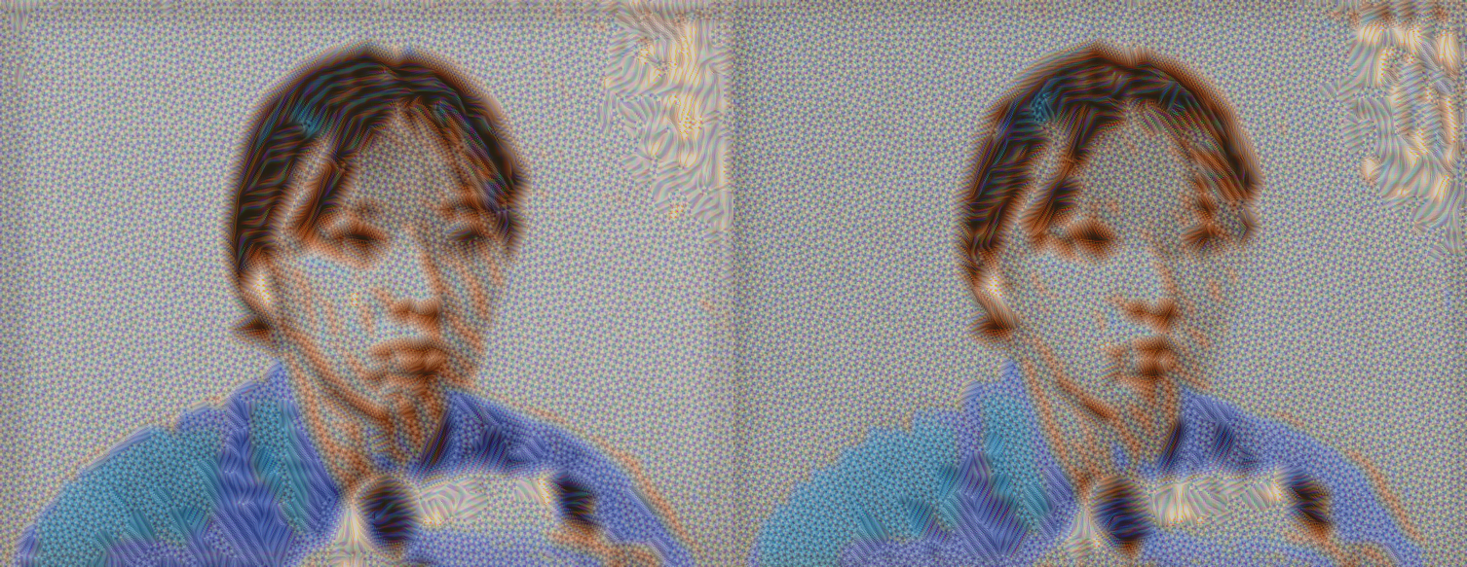
Both images used only the conv2 layer, so the outputs remained simple and mostly emphasized edges and color transitions. As expected from such an early layer, no complex patterns formed; instead, the outline of the person and the colors of the shirt became slightly sharper while the background turned into noise. Both results also showed a consistent distortion in the top-right corner, likely because early layers amplify any small gradient irregularities in high-contrast areas of the original image.
Between the two runs, the image from Experiment 2 (LR = 0.05, jitter = 32) appeared more stable and more smoothly developed, while Experiment 3 (LR = 0.1, jitter = 16) produced harsher noise. The higher learning rate in Experiment 3 caused the optimization to overshoot and exaggerate rough textures, and the lower jitter made the noise more concentrated. Overall, both outputs behaved as expected for shallow-layer DeepDream experiments.
Effect of Octave Count (Experiments 33 vs. 41)
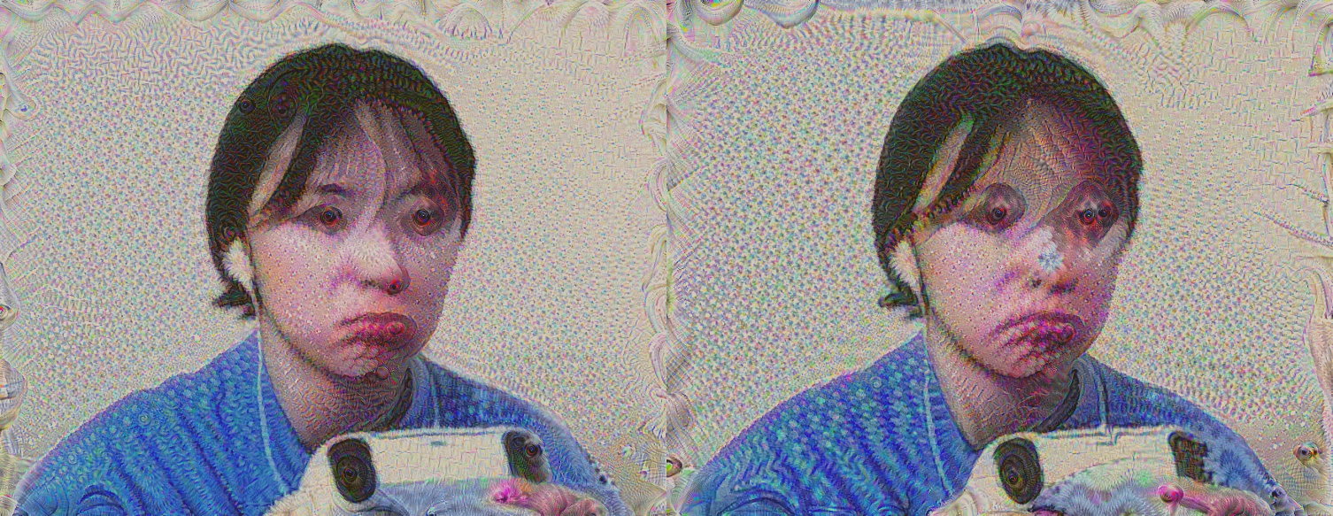
Layers: {'inception3b': 2.0}
LR = 0.05, Jitter = 16, Octave Scale = 1.2
In this comparison, I kept the same deeper layer (inception3b) and changed only the number of octaves. Since inception3b represents mid-level features, both images developed much more strongly than earlier-layer experiments, especially around the person’s eyes, where the model tends to reinforce circular, high-contrast structures. This also explains the slight “eye-splitting” effect and the tendency for new eye-like shapes to appear.
Both outputs showed a spiraling deformation near the corners. This typically happens because multi-scale dreaming enhances repeated gradient directions across octaves; any corner region with strong edges gets amplified repeatedly, producing rotational or swirling artifacts. The main difference between the two is that with 5 octaves (Experiment 41), the image gained significantly more structure. Additional octaves give the model more opportunities to refine and exaggerate patterns across scales, which is why Experiment 41 shows clearer hallucinated features, including the first signs of the model “placing” eye-like textures onto the image, compared to the 3-octave version in Experiment 33.
Stronger Feature Distortion (Experiment 48)
Layers: {'inception3b': 2.0}
LR = 0.05, Jitter = 16, Octave Scale = 1.4, Octave = 5
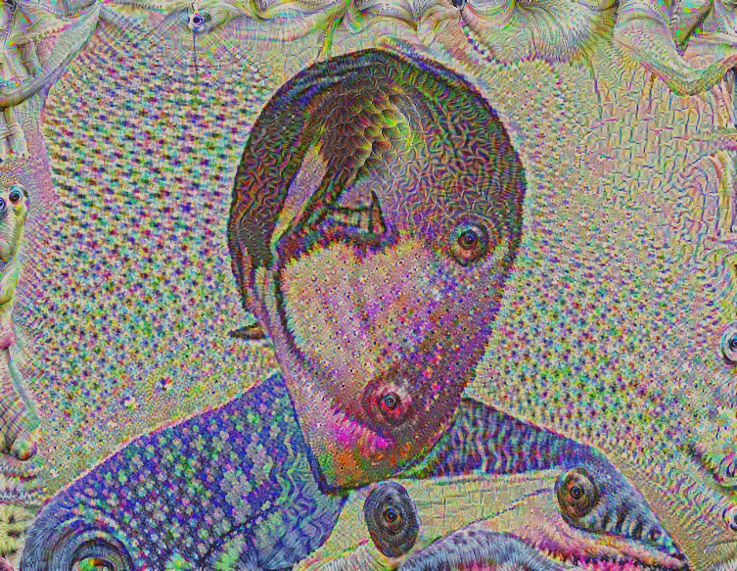
In this experiment, the typical eye-splitting and extra-eye formation seen with inception3b became much more pronounced. Because I used both a higher octave scale (1.4) and a higher learning rate (0.1), the model amplified mid-level features more aggressively, causing large distortions across the entire face. As a result, finer structures such as the nose, lips, and eyebrows are barely preserved, while hair, fingers, and corner regions warped heavily.
The combination of a strong scale factor and an overly high learning rate pushed the optimization toward unstable gradients, which explains the chaotic textures and more severe structural deformation. This produced a genuinely “dream-like” look, with exaggerated artifacts overtaking most of the original image.
Mixed Mid-Layer Activations (Experiments 50 & 62)
Layers: {'inception3b': 1.0, 'inception4a': 1.0}
LR = 0.05, Jitter = 32, Octave = 3 (Ex 50), Octave = 5 (Ex 62)
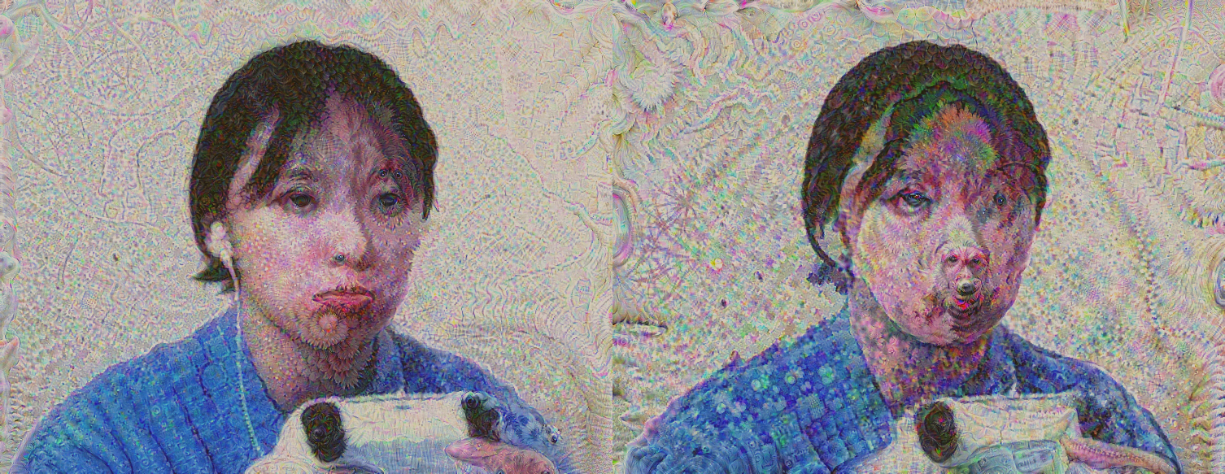
In these experiments, I combined inception3b with inception4a, which activates a wider mix of mid-level features. One of the most noticeable effects was the appearance of “dog-like” faces in various parts of the image. This is a known DeepDream phenomenon: Inception networks were heavily trained on ImageNet categories such as dogs, making dog-related features very strongly encoded. When gradients from multiple mid-layers overlap, these learned animal textures often re-emerge as faint snouts, fur patterns, or partial dog faces. Both images also showed irregular, colorful distortions across the background, resembling a gasoline spill effect. Technically, this comes from interference patterns formed when multiple mid-layer filters amplify color gradients in slightly different directions. These overlapping activations create oily, swirling color shifts and scale-like patterns. Comparing the two runs, Experiment 62 (5 octaves, scale 1.4) naturally produced richer and more varied textures than Experiment 50 (3 octaves, scale 1.2). However, because the learning rate stayed low (0.05), the model preserved most facial structure in both results, avoiding the extreme distortions seen in higher-LR experiments.

Summary of Results
Out of the many experiments I ran, the selected examples highlight the most interesting behaviors I observed. Early layers such as conv2 only produced simple edge sharpening and noise, while deeper layers like inception3b and inception4a generated strong hallucinations such as duplicated eyes, corner spirals, and even faint dog-like features due to ImageNet’s bias toward animal classes. Increasing the number of octaves or the octave scale consistently led to richer and more exaggerated patterns, while higher learning rates caused stronger distortions and reduced facial detail. Overall, these results clearly showed how layer depth and hyperparameter choices directly shape the intensity and style of DeepDream outputs.

Conclusion
In this project, I implemented and extended a DeepDream pipeline using GoogleNet, ran a large set of controlled experiments, and built a logging system to track every generated output. By systematically varying the layers and hyperparameters, I was able to observe how different parts of the network contribute to the final dream-like appearance. Deeper layers produced meaningful and sometimes surprising patterns, while early layers stayed limited to low-level textures. Adjustments to octaves, learning rate, and jitter all influenced how stable or chaotic the results became.
These findings illustrate how deeply the behavior of DeepDream depends on the underlying feature hierarchy of the network and on the optimization parameters used. The experiments gave me a clearer understanding of how convolutional networks represent images internally and how those representations can be pushed to produce artistic, surreal visual effects.

