
ATILIM UNIVERSITY
DEPARTMENT OF ENGINEERING

CMPE 363
INTRODUCTION TO MACHINE LEARNING

Applying Machine Learning Algorithms to Real Life Data

Submitted to: Caner Asbaş

Submitted by: Ozan Berk Gultegin - 17244710034
2023-2024 FALL
ANKARA

Introduction
In this machine learning project, I utilized three distinct datasets to implement and evaluate
K-Nearest Neighbors (KNN), Naive Bayes Classification, and Linear Regression algorithms. Each dataset serves as a unique context for assessing the algorithm's performance.

Dataset 1: IRIS

The first dataset is the widely-used IRIS dataset, consisting of four features and one label. The features include sepal length (sepal_length), sepal width (sepal_width), petal length (petal_length), and petal width (petal_width). All measurements are in centimeter.

- Sepal Length (sepal_length): Measurement of the sepal of an iris flower in centimeters.
Range: 4.3 to 7.9

- Sepal Width (sepal_width): Measurement of sepal width.
Range: 2 to 4.4

- Petal Length (petal_length): Measurement of petal length.
Range: 1 to 6.9

- Petal Width (petal_width): Measurement of petal width.
Range: 0.1 to 2.5

- Species (label): Three distinct classifications:
Values: Iris-setosa, Iris-Versicolor, and Iris-Virginica.

The IRIS dataset comprises 150 samples. Given the numerical nature of the features, the K-Nearest Neighbors algorithm was chosen for implementation.

Test Cases:

1. Samples copied directly from the dataset.
2. Samples extracted from the dataset with associated labels for reference.
3. Randomly generated samples during runtime, created by combining random features from different samples.

Excluding the randomly generated samples (whose quantity is adjustable), there are six copied samples and three extracted samples from the dataset.

ALGORITHM IMPLEMENTATION

K-Nearest Neighbors (KNN) Algorithm
The K-Nearest Neighbors (KNN) algorithm is a straightforward supervised machine learning technique employed for both classification and regression tasks. Its fundamental premise is that data points sharing similar features are likely to belong to the same class or display analogous behaviors.
The algorithm incorporates key aspects such as distance metrics, with Euclidean distance being the most commonly employed (utilized in my implementation as well). Additionally, the K parameter enables adjustment of prediction sensitivity and noise. Several considerations come into play when employing KNN. Notably, the algorithm's scalability may pose challenges with larger datasets, potentially leading to diminished performance. Furthermore, attention to feature scaling is essential. In situations where no specific weights are assigned to individual features, but the values exhibit substantial differences, the algorithm's results may be impacted. Therefore, data scaling or normalization becomes imperative. (It's worth noting that this concern did not apply to my dataset, as the values were already on a reasonable scale.)

Reason of Implementation
Implementing the K-Nearest Neighbors (KNN) algorithm on the Iris dataset is well-justified for several reasons. The dataset, comprising features that naturally exhibits distinct class separations among its three iris species. KNN's non-parametric nature adapts well to the dataset's characteristics without imposing assumptions about data distribution. Additionally, the numeric nature of the features aligns with KNN's preferences, and its effectiveness on small to medium-sized datasets, like the 150-sample Iris dataset, ensures reliable predictions for multi-class classification tasks. Overall, KNN offers a robust and straightforward approach for accurate species classification in the Iris dataset.

Approach
My strategy for handling the IRIS dataset through K-Nearest Neighbors (KNN) implementation adhered to a traditional and straightforward approach. The dataset's inherent qualities, including well-scaled features, rendered it particularly suited for the KNN algorithm. I opted for a conventional implementation, staying faithful to the principles taught in our Machine Learning classes and lab sessions.

Results
These are test cases that I have used on my algorithm. Label’s on the corresponding comment lines are directly taken from the dataset to show the algorithms success.
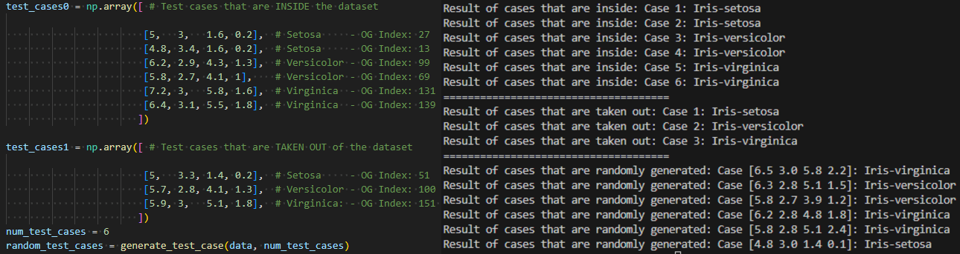

Results of my test cases. For random test case’s I did not have a legitimate way of proving that they are correct but if the dataset observed closely likeness of the values to the corresponding label’s does make sense.Given k = 3.

Dataset 2: Milk Quality
Reference: https://www.kaggle.com/datasets/cpluzshrijayan/milkquality

Second dataset I have utilized is called milk quality. There are seven features and one label on this set. Features include of pH, Temperature, Taste, Odor, Fat, Turbidity and Colour. Label is named Grade.
- pH: pH measurement is consistent with scientific means.
Range: 3 to 9.5

- Temperature: Measured with Celsius(C).
Range: 34 to 90

- Taste: Is a binary classification to determine if it is Good or Bad.
Range: 1 and 0

- Odor: Is a binary classification to determine if it is Good or Bad.
Range: 1 and 0

- Fat: Is a binary classification to determine if it is High or Low:
Range: 1 and 0

- Turbidity: Is a binary classification to determine if it is High or Low:
Range: 1 and 0

- Colour: Defines the color of the milk(Measurement is not given on documentation):
Range: 240 to 255

- Grade: Label of the dataset defines the quality of the milk:
Values: low, medium, high

The milk quality dataset comprises 1050 samples. Since dataset contains binary features and numerical values as well as classification type of labeling, I wanted to challenge myself with numerical instances by applying Naive Bayes Classification.

Test Cases:

1. Samples extracted from the dataset with associated labels for reference.
2. Randomly generated samples during runtime, created by combining random features from different samples.

Excluding the randomly generated samples (whose quantity is adjustable), there are six copied samples and three extracted samples from the dataset.

ALGORITHM IMPLEMENTATION

Naive Bayes Classifier Algorithm
Naive Bayes Classifier is a probabilistic machine learning algorithm, used for classification. It is based on the assumption that the features are conditionally independent given the class labels. This assumptions allow the algorithm to efficiently utilize the high dimensional datasets.

Reason of Implementation
Naive Bayes Classifier implementation to this dataset is not the optimal option. On the other hand it is reasonable to implement since I have mixed type features such as numeric and binary. As well as, assumption of independence between features since there are some that scientific and some that are peculiar but can still apply to majority of people. Lastly, multi-class classification is well suited for Naive Bayes Classifier.

Approach
My strategy was to handle binary features traditionally and the way that I have been thought in the class and labs. On the other hand, numerical features(pH, Temperature, and Colour) were the actual challenge of the implementation for me. Until I was working on this algorithm I had no knowledge about Gaussian probability calculations and Probability Density Function(PDF) to handle numeric values accordingly. I had to research for the PDF and learn how it works and if it is applicable and giving meaningful results. Lastly, since the dataset had large number of samples the probability for any label was technically going to zero, which I had to handle with probability normalization where I had to take exponent of the probabilities to get a more human-like results for better understanding.

Results
These are test cases that I have used on my algorithm. Label’s on the corresponding comment lines are directly taken from the dataset to show the algorithms success.
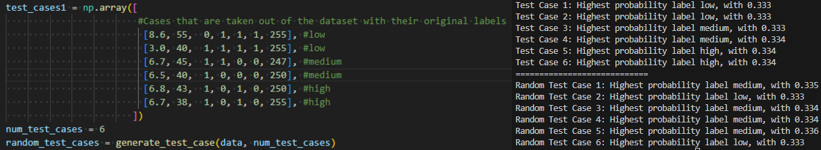

To better clarify the probabilistic of my outcome. The probability shown in the output is rounded to have three digits. On top of that, actual probabilities received was so mathematically so minimal I had to put them in an exponent function in order to get a clear understanding of the output. It would seem like the most difference is 0.001 to 0.002 but compared to the actual probability of the results these values are highly valuable distinctive.

Dataset 3: Forest Fire Weather

Third dataset I have utilized is called Forest Fire Weather. There are some features I did not used in this dataset so I will excluding them here. At the same time in the documentation of t
- Temperature: Measured with Celsius(C). (Used as label)
Range: 22 to 42

- RH: Relative Humidity. Measured by %RH
Range: 21 to 90

- Ws: Wind Speed. Measured by meters per second m/s
Range: 6 to 29

- Rain: Rainfall. Measured by millimeters.
Range: 0 to 16.8

- FFMC: Fine Fuel Moisture Code. Measure Moister content in a forest. Unit: kg/m^2
Range: 28.6 to 96

- DMC: Duff Moisture Code. Moister content of decomposed organic matter. Unit: kg/m^2
Range: 0.7 to 65.9

- DC: Drought Code. Measures dryness of deep soil.
Range: 6.9 to 220

- ISI: Initial Spread Index.
Range: 0 to 19

- BUI: Buildup Index
Range: 1.1to 68

- FWI: Fire Weather Index
Range: 0 to 31.1

The milk quality dataset comprises 1050 samples. Since dataset contains binary features and numerical values as well as classification type of labeling, I wanted to challenge myself with numerical instances by applying Naive Bayes Classification.

Test Cases:

1. Six samples extracted from the dataset with associated labels for reference.

ALGORITHM IMPLEMENTATION

Linear Regression Algorithm
Linear regression is a fundamental supervised machine learning algorithm for regression tasks. It models the relationship between independent variables (features) and a dependent variable (label) as a linear equation, aiming to minimize the difference between predicted and actual values. The algorithm estimates coefficients to define the best-fitting line, facilitating predictions and insights. Widely applied in fields like economics and finance, linear regression is valued for its interpretability and simplicity.

Reason of Implementation

Linear regression is a suitable approach when exploring the linear inter-dependencies between various weather related features. It is particularly effective when the relationship between different factors and Temperature can be reasonably approximated.

Approach
My approach to this dataset was fairly traditional. On the other hand my label indirectly depending on the date kind of complicated things for me to visualize them properly hence the odd line in between my predictions. As well as some value deviations in the dataset forced me to standardized my data.

Results
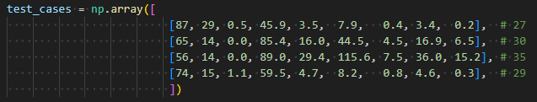
The comment lines on the each test case shows the actual value they had on the dataset. I tried my best to make it easily observable by the value of my predictions and by the graph.

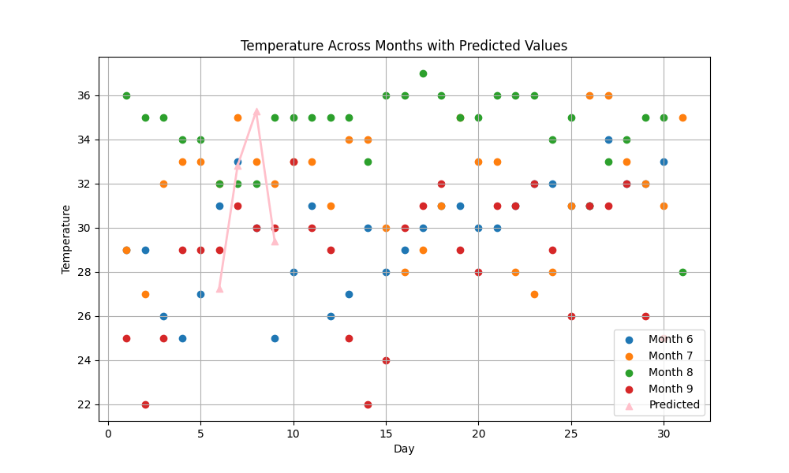

CONCLUSIONS

In assessing the outcomes and efficacy of the implemented machine learning algorithm, the results demonstrated a commendable alignment with real-world data. In terms of performance, the K-Nearest Neighbors (KNN) algorithm excelled, exhibiting a time complexity of O(n*k), surpassing the Naive Bayes Classifier with O(m*n + m*#testCases). Conversely, the Linear Regression algorithm exhibited the least favorable performance, characterized by a time complexity of O(n^3). Nevertheless, each of the three algorithms yielded outcomes that were both reasonable and reliable, effectively capturing the nuances of the dataset and accurately predicting new entries.

In theory, my Naive Bayes Classifier exhibited a tendency to generate exceedingly low probabilities that approached zero. I attribute this phenomenon to both the dataset's size and my suboptimal feature optimization. Conversely, my K-Nearest Neighbors (KNN) algorithm consistently achieved 100% accuracy when k exceeded 2. This outcome suggests the presence of closely situated data points within my IRIS dataset, contributing to occasional noisy results.
In the case of my Linear Regression implementation, the indirect relationship between the label and other features posed a significant challenge. This intricacy hindered my ability to effectively represent the data, leading to inefficiencies in both code execution and data visualization.

APPENDIX

KNN Algorithm Code:
import numpy as np
import pandas as pd
import os

def generate_test_case(dataset, num_test_cases):
num_columns = dataset.shape[1] - 1
random_indices = np.random.choice(len(dataset), num_test_cases, replace=True)
random_test_cases = []
for index in random_indices:
test_case = dataset.iloc[index, :num_columns].values
random_test_cases.append(test_case)

return np.array(random_test_cases)

def euclidean_distance(train_point, test_point):
train_point = np.asarray(train_point, dtype=np.float64)
test_point = np.asarray(test_point, dtype=np.float64)
return np.sqrt(np.sum((train_point - test_point) ** 2))

def knn_classifier(train_features, train_labels, test_point, k):
distances = np.zeros(len(train_labels))
for i, train_feature_point in enumerate(train_features):
distances[i] = euclidean_distance(test_point, train_feature_point)

nearest_indices = np.argsort(distances)[:k]
nearest_labels = train_labels[nearest_indices]
unique_labels, counts = np.unique(nearest_labels, return_counts=True)
max_count = np.max(counts)

if np.sum(counts == max_count) > 1:
return 'UNIDENTIFIED'
else:
predicted_label = unique_labels[np.argmax(counts)]
return predicted_label

script_path = os.path.dirname(os.path.realpath(__file__))
# Data Manipulation
data_name = "IRIS.csv"
data_path = os.path.join(script_path, data_name)
data = pd.read_csv(data_path)
labels = data["species"].values
features = data.iloc[:, :-1].values

k_value = 3

test_cases0 = np.array([ # Test cases that are INSIDE the dataset

[5, 3, 1.6, 0.2], # Setosa - OG Index: 27
[4.8, 3.4, 1.6, 0.2], # Setosa - OG Index: 13
[6.2, 2.9, 4.3, 1.3], # Versicolor - OG Index: 99
[5.8, 2.7, 4.1, 1], # Versicolor - OG Index: 69
[7.2, 3, 5.8, 1.6], # Virginica - OG Index: 131
[6.4, 3.1, 5.5, 1.8], # Virginica - OG Index: 139
])

test_cases1 = np.array([ # Test cases that are TAKEN OUT of the dataset

[5, 3.3, 1.4, 0.2], # Setosa - OG Index: 51
[5.7, 2.8, 4.1, 1.3], # Versicolor - OG Index: 100
[5.9, 3, 5.1, 1.8], # Virginica: - OG Index: 151
])
num_test_cases = 6
random_test_cases = generate_test_case(data, num_test_cases)

for index,test_case in enumerate(test_cases0):
predicted_label = knn_classifier(features, labels, test_case, k_value)
print(f"Result of cases that are inside: Case {index+1}: {predicted_label}")
print("=====================================")
for index,test_case in enumerate(test_cases1):
predicted_label = knn_classifier(features, labels, test_case, k_value)
print(f"Result of cases that are taken out: Case {index+1}: {predicted_label}")
print("=====================================")
for index,test_case in enumerate(random_test_cases):
predicted_label = knn_classifier(features, labels, test_case, k_value)
print(f"Result of cases that are randomly generated: Case {random_test_cases[index]}: {predicted_label}")

Naive Bayes Classifier Algorithm Code:
import numpy as np
import pandas as pd
import os

def generate_test_case(dataset, num_test_cases):
num_columns = dataset.shape[1] - 1
random_indices = np.random.choice(len(dataset), num_test_cases, replace=True)
random_test_cases = []
for index in random_indices:
test_case = dataset.iloc[index, :num_columns].values
random_test_cases.append(test_case)

return np.array(random_test_cases)

def normalization(x): # Probability normalization
exp_x = np.exp(x - np.max(x))
return exp_x / exp_x.sum()

def bayesClassifier(test_case, features, labels):
label_counts, results, counts = {}, {}, {}
label_names, l_counts = np.unique(labels, return_counts=True)

for index, label_name in enumerate(label_names):
label_counts[label_name] = l_counts[index]
results[label_name] = 0 # Initialize as 0 for log-probabilities
counts[label_name] = 0

label_probabilities = {label: count / len(labels) for label, count in label_counts.items()}

epsilon = 1e-9
for column in range(len(features[0])):
if isinstance(test_case[column], (int, float)):
for label in label_counts: # Numerics

# Gaussian probability calculation for numeric values since I can not turn them into binary or string
mean = np.mean(features[labels == label, column]) # Numerics mean
std = np.std(features[labels == label, column]) # Numerics standart deviation
# Probability density for numerical values (PDF)
# Ref: https://en.wikipedia.org/wiki/Probability_density_function
likelihood = (1 / (np.sqrt(2 * np.pi) * std)) * np.exp(-(test_case[column] - mean)**2 / (2 * std**2))

results[label] += np.log(likelihood + epsilon)
else: # Binary
for label in label_counts:
counts[label] = np.sum((features[:, column] == test_case[column]) & (labels == label))
results[label] += np.log((counts[label] + epsilon) / (label_counts[label] + epsilon))

for label in label_probabilities:
results[label] += np.log(label_probabilities[label])

results = {label: np.exp(value) for label, value in results.items()}
normalized_results = normalization(list(results.values())) # Result normalization to avoid very small numbers

return {label: probability for label, probability in zip(results.keys(), normalized_results)}

script_path = os.path.dirname(os.path.realpath(__file__))
# Data Manipulation
data_name = "milknew.csv"
data_path = os.path.join(script_path, data_name)
data = pd.read_csv(data_path)
label_column = data["Grade"]
labels = label_column.values
features = data.iloc[:, :-1].values

test_cases1 = np.array([
#Cases that are taken out of the dataset with their original labels
[8.6, 55, 0, 1, 1, 1, 255], #low
[3.0, 40, 1, 1, 1, 1, 255], #low
[6.7, 45, 1, 1, 0, 0, 247], #medium
[6.5, 40, 1, 0, 0, 0, 250], #medium
[6.8, 43, 1, 0, 1, 0, 250], #high
[6.7, 38, 1, 0, 1, 0, 255], #high
])
num_test_cases = 6
random_test_cases = generate_test_case(data, num_test_cases)

for index, test_case in enumerate(test_cases1):
result = bayesClassifier(test_case, features, labels)

values = np.array(list(result.values()))
max_index = np.argmax(values)
max_key = list(result.keys())[max_index]

print(f"Test Case {index+1}: Highest probability label {max_key}, with {round(result[max_key],3)}")
print("============================")
for index, r_test_case in enumerate(random_test_cases):
result = bayesClassifier(r_test_case, features, labels)

values = np.array(list(result.values()))
max_index = np.argmax(values)
max_key = list(result.keys())[max_index]

print(f"Random Test Case {index+1}: Highest probability label {max_key}, with {round(result[max_key],3)}")

Linear Regression Code
import numpy as np
import pandas as pd
import os
import matplotlib.pyplot as plt

def standardization(data):
mean = np.mean(data)
deviation = np.sqrt(np.mean(data**2) - mean**2)
standardized = (data - mean) / deviation
return standardized

def leastSquares(features, label):
features = np.c_[np.ones(features.shape[0]), features]
# A == (X^T * X)^-1 * X^T * Y
trans = features.transpose()
mult = np.matmul(trans, features)
inv = np.linalg.inv(mult)
sec = np.matmul(inv, trans)
beta = np.matmul(sec, label)
return beta

def draw(x_features, betas, labels):
predicted = np.dot(test_intercept_standardized,beta_standardized)
plt.figure(figsize=(10, 6))
for month in data['month'].unique():
month_data = data[data['month'] == month]
plt.scatter(month_data['day'], month_data['Temperature'], label=f'Month {month}')

plt.scatter([6, 7, 8, 9], predicted, marker='^', color='pink', label='Predicted')
plt.plot([6, 7, 8, 9], predicted, color='pink', linestyle='-', linewidth=2)

plt.title("Temperature Across Months with Predicted Values")
plt.xlabel('Day')
plt.ylabel('Temperature')
plt.legend()
plt.grid(True)
plt.show()

# Data Manipulation
script_path = os.path.dirname(os.path.realpath(__file__))
data_name = "Forest_Fire.csv"
data_path = os.path.join(script_path, data_name)
data = pd.read_csv(data_path)
labels = data["Temperature"].values
features = data.iloc[:, 4:-2].values

test_cases = np.array([
[87, 29, 0.5, 45.9, 3.5, 7.9, 0.4, 3.4, 0.2], # 27
[65, 14, 0.0, 85.4, 16.0, 44.5, 4.5, 16.9, 6.5], # 30
[56, 14, 0.0, 89.0, 29.4, 115.6, 7.5, 36.0, 15.2], # 35
[74, 15, 1.1, 59.5, 4.7, 8.2, 0.8, 4.6, 0.3], # 29
])

standardized_features = np.apply_along_axis(standardization, axis=0, arr=features)
beta_standardized = leastSquares(standardized_features, labels)
test_cases_standardized = np.apply_along_axis(standardization, axis=0, arr=test_cases)
test_intercept_standardized = np.c_[np.ones(test_cases_standardized.shape[0]), test_cases_standardized]
predicted_temperature_standardized = np.dot(test_intercept_standardized, beta_standardized)
print("Standardized Coefficients (Beta):", beta_standardized)
print("Predicted Temperature (Standardized):", predicted_temperature_standardized)
draw(test_intercept_standardized, beta_standardized, labels)

