CHAPTER – 1 INTRODUCTION

The QuickCylinder LPG Gas Booking System represents a significant technological advancement in the domain of utility management, specifically aimed at streamlining the distribution and consumer management of liquefied petroleum gas (LPG). In many developing and developed regions alike, LPG remains a primary energy source for domestic and commercial cooking, heating, and industrial applications. Despite its critical role in daily life, the traditional supply chain and booking infrastructure have often been plagued by inefficiencies, lack of transparency, and poor user experiences.

QuickCylinder is designed to address these fundamental challenges by providing a robust, highly interactive, and seamless digital platform that connects consumers directly with distributors and administrators. By leveraging modern web technologies—such as a React-based frontend built with Vite and a Spring Boot Java backend—the platform offers a responsive, glassmorphism-themed user interface paired with a secure, scalable, and transactional server architecture.

The system introduces features like real-time consumer verification via 17-digit LPG IDs, dynamic pricing based on city and cylinder type, and a comprehensive administrative portal for managing bookings, tracking statuses, and overseeing users. Ultimately, QuickCylinder aims to bridge the gap between traditional utility distribution and modern digital expectations, ensuring that essential resources are delivered with speed, accuracy, and utmost reliability.

Summary of Project

QuickCylinder is a full-stack, enterprise-grade web application engineered to modernize the end-to-end process of booking and managing LPG cylinders. At its core, the application provides a user-centric dashboard where consumers can securely log in, verify their existing LPG connection using their unique 17-digit consumer number, and place orders for various cylinder types, including 14.2kg domestic, 19kg commercial, and 5kg portable variants.

The booking flow is heavily fortified with real-time validation against a centralized database, ensuring that only authenticated consumers can initiate transactions. Once an order is placed, users can securely process payments through a simulated gateway supporting UPI, Card, Net Banking, and Wallet options, followed by real-time tracking of their delivery status. On the administrative side, the system features a powerful portal that empowers operators to oversee the entire lifecycle of a booking. Administrators can view registered users, approve or decline pending bookings, dispatch cylinders, and mark them as delivered.

The architecture relies on a MariaDB relational database to maintain data integrity across users, connections, bookings, and historical statuses. Through its dynamic React frontend and robust Spring Boot backend, QuickCylinder delivers a cohesive, end-to-end solution that significantly reduces manual overhead and improves the overall efficiency of gas distribution operations.

Background of project

The inception of the QuickCylinder project stems from the universal necessity for efficient energy distribution and the growing consumer demand for digital convenience. Historically, booking an LPG cylinder involved visiting a local distributor, standing in queues, or relying on easily congested telephonic booking systems. While Interactive Voice Response (IVR) systems and early web portals provided some relief, they often suffered from poor user interfaces, frequent downtimes, and a lack of real-time visibility into order status.

Consumers were frequently left in the dark regarding their delivery schedules, while distributors struggled with manual record-keeping, disjointed payment reconciliations, and inefficient route planning. Furthermore, the lack of stringent, automated verification often led to fraudulent bookings or black-market diversion of subsidized domestic cylinders. Recognizing these systemic bottlenecks, the QuickCylinder initiative was conceptualized to overhaul the entire ecosystem.

The goal was not merely to digitize the booking process, but to create an intelligent, data-driven platform that integrates identity verification, dynamic regional pricing, seamless payments, and administrative oversight into a single, unified workflow. By utilizing contemporary software development practices, including RESTful API design, JWT-based authentication, and responsive UI frameworks, the project seeks to set a new standard for how essential public utilities are managed and delivered in the digital age.

Existing System

The existing landscape of LPG gas booking systems is largely fragmented and relies heavily on legacy infrastructure that struggles to meet modern consumer expectations. Most conventional systems operate through a combination of manual agency visits, SMS-based requests, or basic IVR telephonic menus. These methods, while functional, are inherently limited in their capacity to provide real-time feedback, interactive user experiences, or comprehensive order tracking.

Web portals, where they exist, are often characterized by outdated, non-responsive designs that are difficult to navigate on mobile devices, leading to high user frustration and abandonment rates. Furthermore, existing systems often lack integrated payment gateways, forcing consumers to rely on cash-on-delivery or separate, unlinked digital payment methods, complicating reconciliation for distributors. From an administrative perspective, the current systems are highly siloed. Distributors and central administrators typically rely on disparate software or manual ledgers to track inventory, verify consumer credentials, and manage dispatch logistics.

This disjointed approach makes it difficult to detect anomalies, track delivery delays, or generate actionable insights regarding regional demand patterns. The absence of a unified, real-time dashboard means that customer support is often reactive rather than proactive, with operators unable to easily trace the status of a specific booking without navigating through multiple, disconnected database systems.

Proposed System

The proposed QuickCylinder system offers a paradigm shift by introducing a fully integrated, cloud-ready web application that unifies the consumer experience and administrative oversight into a single, highly performant platform. For consumers, the system provides a sleek, modern, glassmorphism-themed interface built with React, ensuring a highly intuitive and visually engaging booking experience across all devices.

The proposed workflow introduces a mandatory, automated verification step where consumers must authenticate their 17-digit LPG ID against the backend database before proceeding, effectively eliminating fraudulent or erroneous bookings. The system also features a comprehensive payment module supporting diverse digital payment methods, generating real-time transactional receipts and order tracking timelines. For administrators, the proposed system introduces a secure, feature-rich dashboard that aggregates real-time data across the entire network.

Administrators have granular control over the booking lifecycle, with the ability to accept, decline, dispatch, and mark orders as delivered, instantly updating the consumer's tracking interface. Built on a Spring Boot REST API and backed by a robust MariaDB relational database, the architecture ensures high availability, transactional security, and strict data consistency. This modern stack not only resolves the inefficiencies of legacy systems but also provides a scalable foundation capable of accommodating future enhancements and integrations.

CHAPTER – 3

SOFTWARE AND HARDWARE REQUIREMENTS

Software Requirements
    - Frontend: React.js
    - Backend: Springboot
    - Database: MySQL
    - Operating System: Windows 11
    - IDE: VS Code, GitHub
    - Deployment: Vercel

Hardware requirements

    - Processor : Intel CORE i7
    - RAM : 16GB
    - Hard Disk : 512GB SSD

CHAPTER – 4
SYSTEM DESIGN

System Architecture

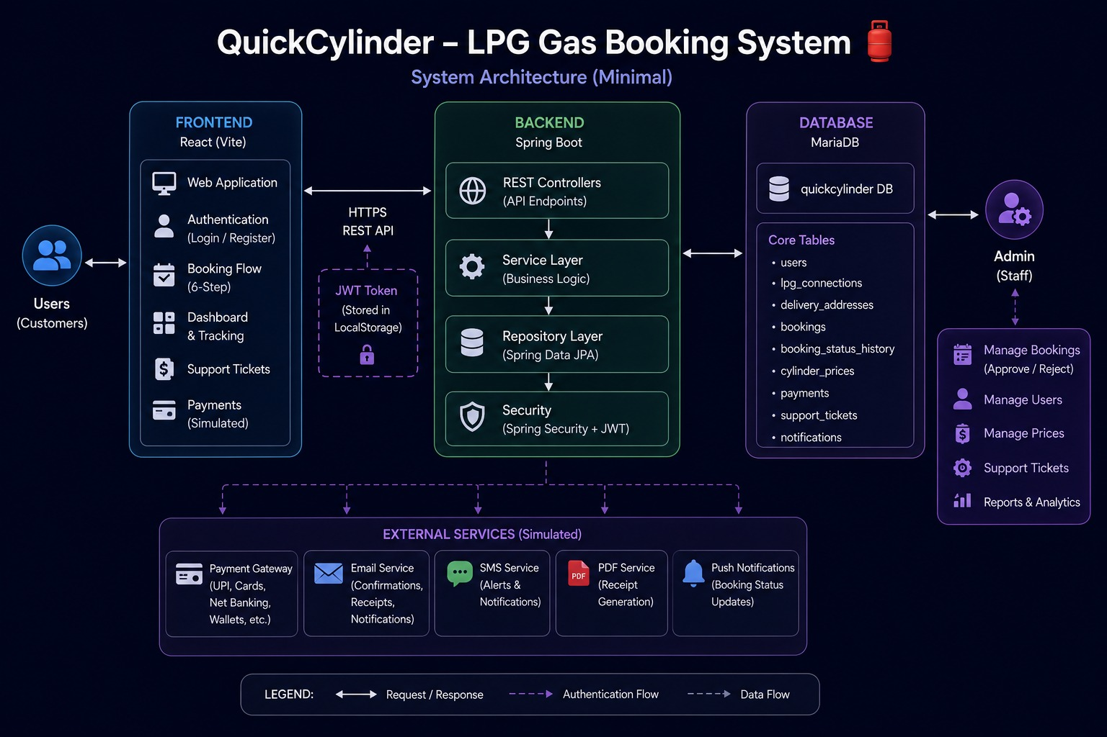

Fig.1: System Architecture

The system architecture diagram visually maps out the structure and interconnections of the "QUICK CYLINDER" application, offering a streamlined representation of its core components.

Data Flow Diagram

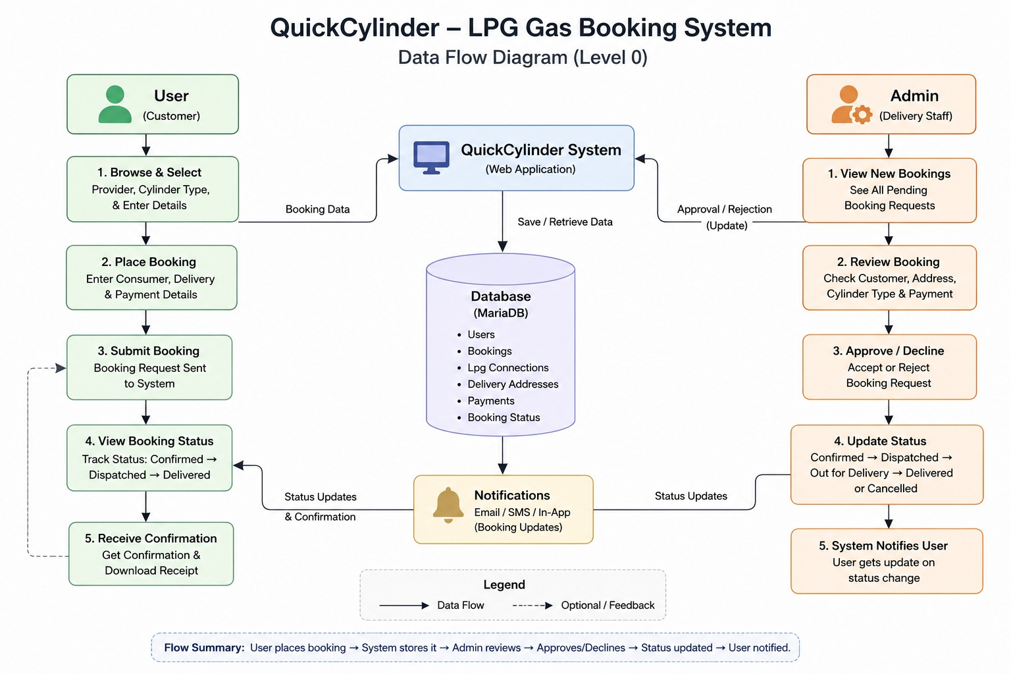

Fig. 2: Data Flow Diagram

The data flow diagram succinctly visualizes how information flows within "QUICK CYLINDER" aiding system comprehension efficiently.

Screen Shots:
Home page
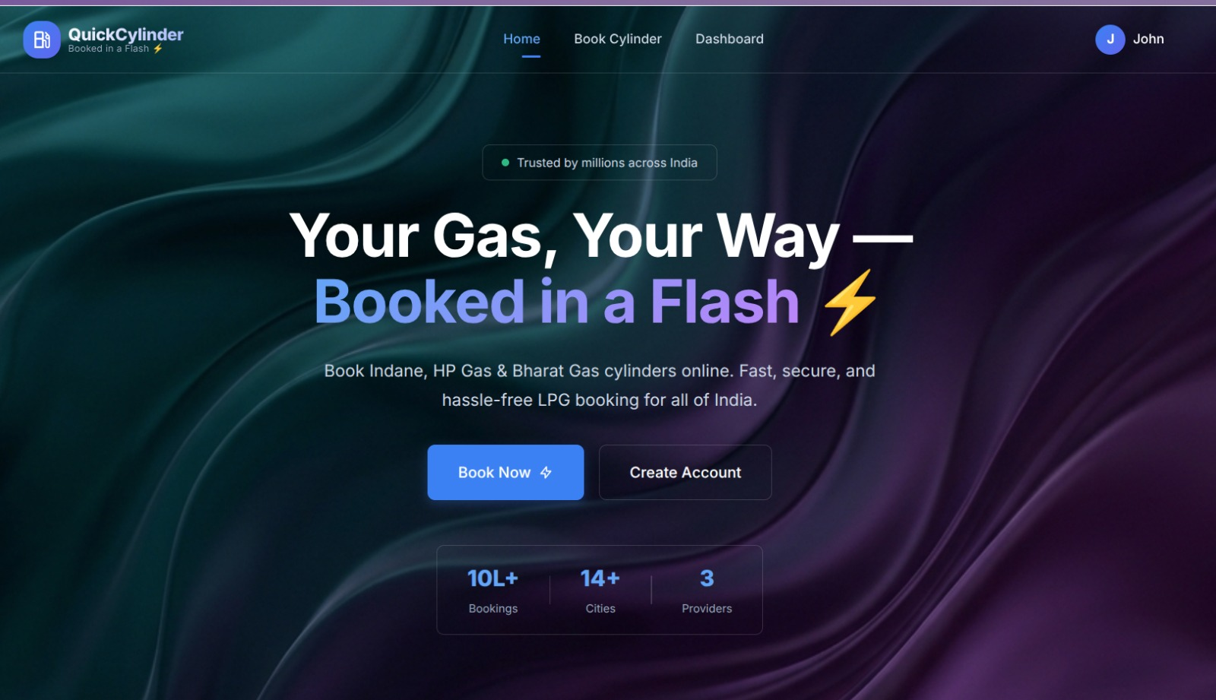

Fig.3: Home Page

Signup Page

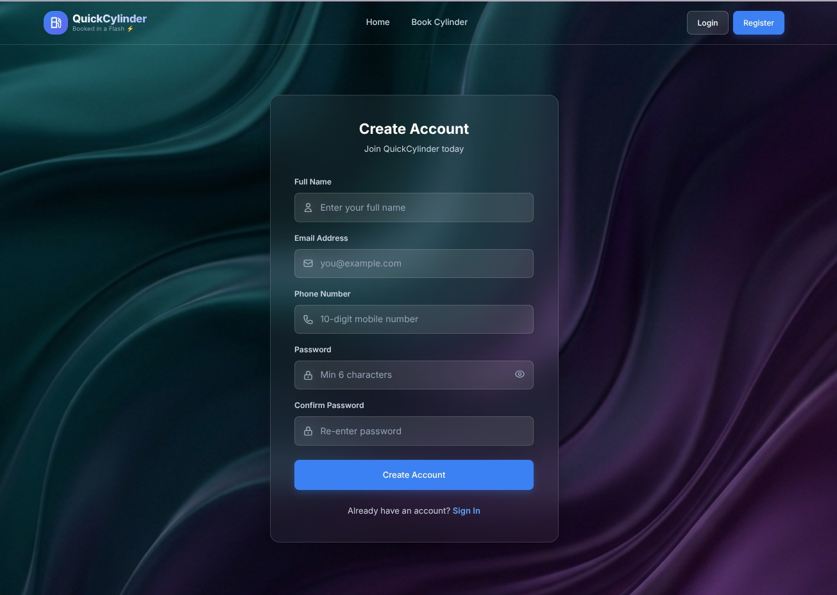

Fig.4: Sign-up Page

Sign-in Page

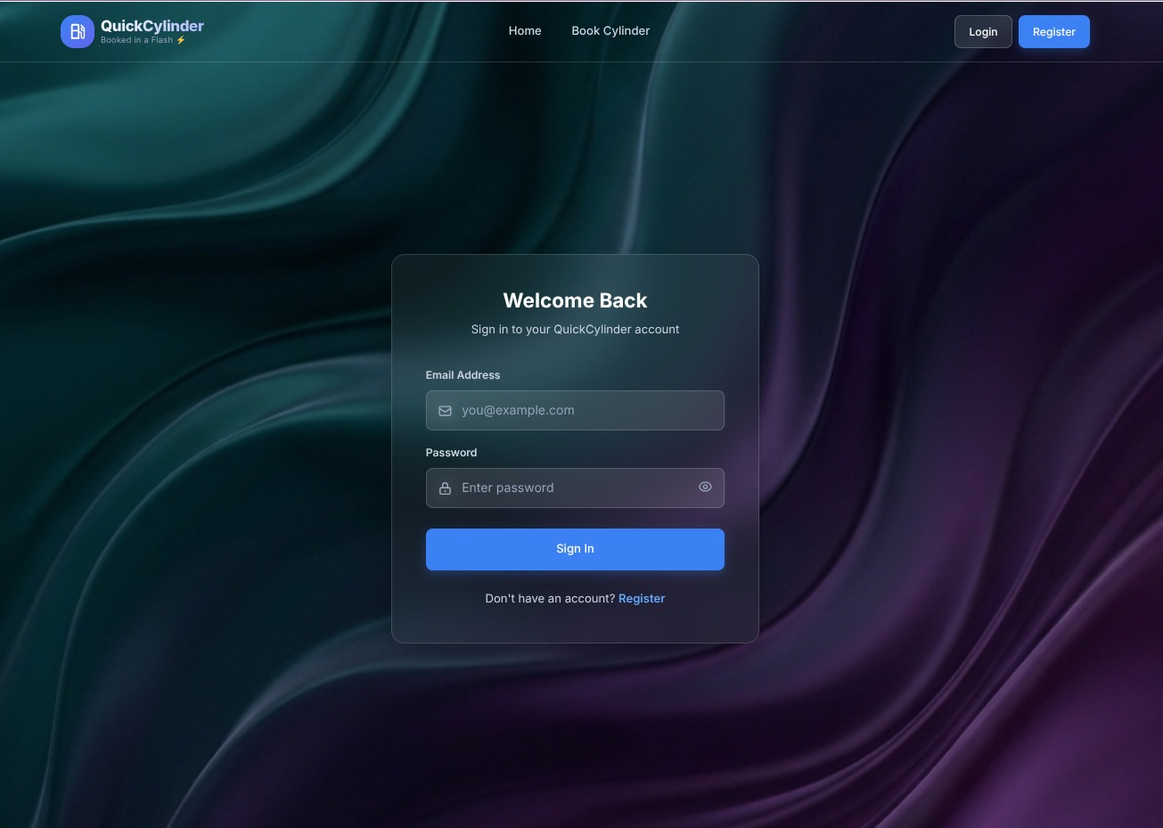

Fig.5: Sign-In Page

User dashboard:

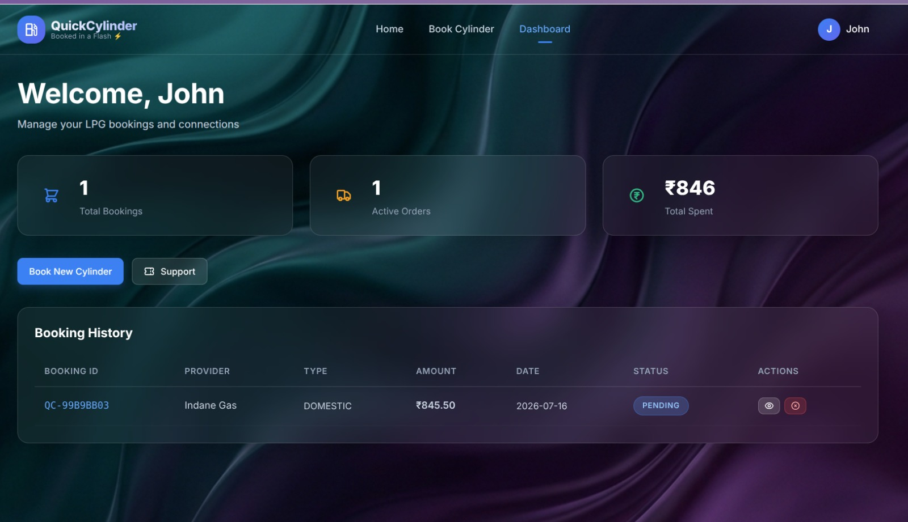

Fig.6: User Dashboard

LPG Booking Page:

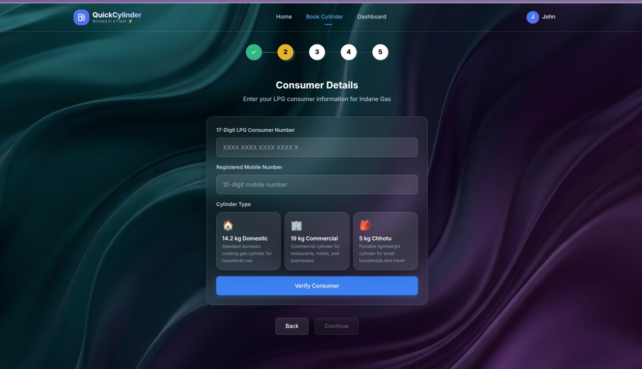

Fig 7: Details Page

CHAPTER – 6 CONCLUSION

In conclusion, the QuickCylinder Gas Booking System successfully addresses the critical limitations of traditional utility distribution by delivering a comprehensive, secure, and user-centric digital platform. By transitioning from fragmented, legacy methods to a unified web application, the project significantly enhances operational efficiency, transparency, and consumer satisfaction.

The implementation of rigorous authentication protocols, such as JWT-based session management and 17-digit consumer ID verification, ensures high standards of security and data integrity, safeguarding both user information and provider resources. The visually striking, responsive frontend design ensures accessibility and ease of use, bridging the digital divide for consumers of varying technical proficiencies. Simultaneously, the robust Spring Boot backend and MariaDB architecture provide administrators with the real-time insights and control necessary to manage complex logistical operations effectively.

QuickCylinder not only automates the rudimentary aspects of booking and payment processing but also establishes a reliable framework for real-time order tracking and dispute resolution. Ultimately, this project serves as a testament to the transformative power of modern web technologies when applied to essential public services, proving that utility management can be both highly secure and exceptionally user-friendly.

CHAPTER-6

FUTURE SCOPE

While the current iteration of QuickCylinder provides a robust foundation for LPG booking and management, there remains extensive potential for future enhancements and scalability. One primary area for expansion is the integration of geographic information systems (GIS) and real-time GPS tracking. By providing delivery personnel with a dedicated mobile application, consumers could track the exact physical location of their cylinder in transit, akin to modern food delivery platforms, further increasing transparency.

Additionally, the system could incorporate machine learning algorithms to analyze historical booking data and seasonal trends, enabling distributors to optimize their inventory management and predict regional demand surges before they occur. Another significant future scope involves expanding the payment ecosystem to include subscription-based models or automated recurring bookings for commercial clients, significantly reducing administrative overhead for businesses.

Furthermore, integrating a chatbot or AI-driven customer support module within the application could handle routine queries, troubleshoot verification issues, and process cancellations automatically. Finally, the platform could be scaled horizontally to accommodate multi-tenant architectures, allowing multiple independent gas providers to utilize the QuickCylinder infrastructure as a Service (SaaS), thereby transforming it into an industry-wide standard for utility distribution.

